Case Study of Kick Starter

- What are three conclusions we can make about Kickstarter campaigns given the provided data?
Theater is the most popular category followed by music, technology, film & video. As far as success is concerned, music hits the chart, followed by theater, film & video.

Journalism is less popular and profitable than other categories, chance of failure of Journalism is greater.

Classical music, documentary, electronic music, hardware, metal, nonfiction, pop, radio & podcasts, rock, shorts, tabletop games and television have 100% chance of successful crowdfunding in Kickstarter campaigns.
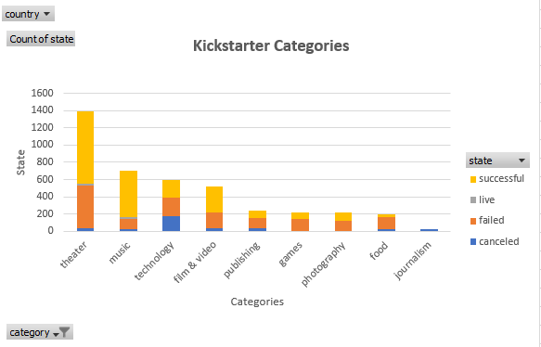

The chances of failing projects rapidly decrease from January to February and remain low from February to April, the chances of success at peak in May.
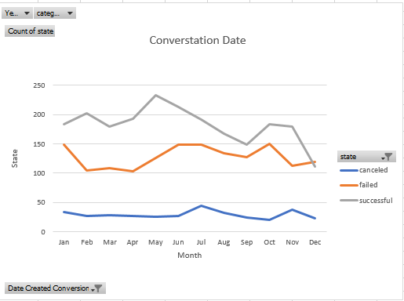

- What are some of the limitations of this dataset?

Need broader range of crowdfunding firms for more accurate analysis. This dataset only indicates a single crowdfunding “Kickstarter” only

Sample (4000) is still a small subset of total projects launched by kickstart. Since analysis is done on much smaller dataset, so the results could be skewed.

- What are some other possible tables/graphs that we could create?

For more accurate analysis, more comprehensive table/chart needs to be created including subcategories & time-lines.

