COMPANYON | 26/10/2017

U S E R M A N U A L

- Getting Started
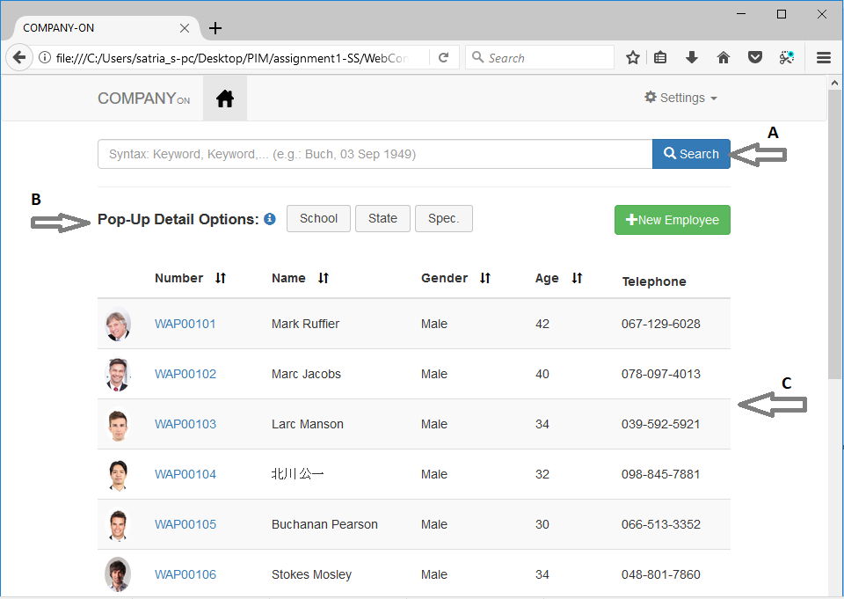
A. Universal Search Bar B. Pop-Up Detail Options C. Results Table

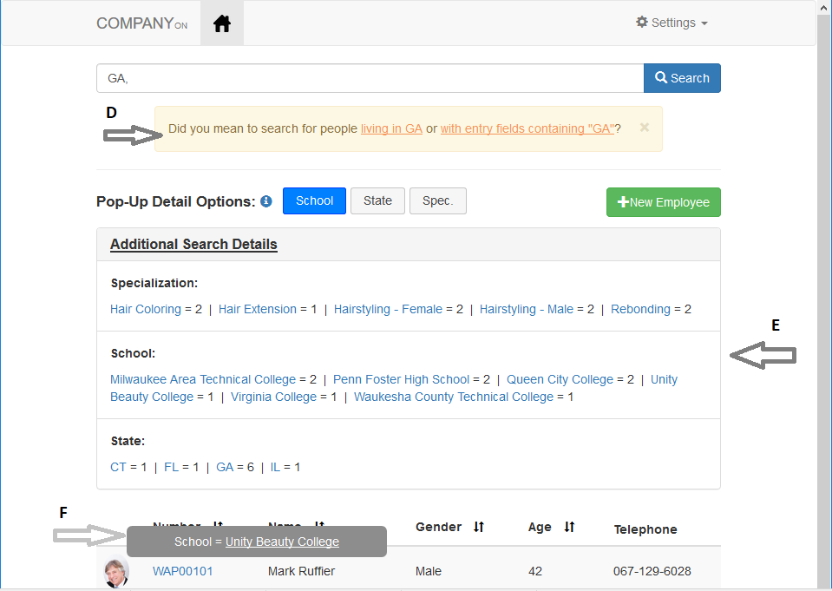
D. Ambiguity Prevention E. Statistical Distribution Table F. Pop-Up Display

- Search
- Basic Keyword Search
Type any keyword inside the Search Bar (A), and any results will be displayed on the Results Table (C).
- Multiple Keyword Search
User can also perform search using multiple keywords separated by a comma (, ).
- Autocomplete Function
As user types his/her keywords, a drop-down categorized autocomplete panel will appear to suggest possible intended words to the user. The autocomplete panel can also be initialized by pressing the “Down” button on the keyboard.
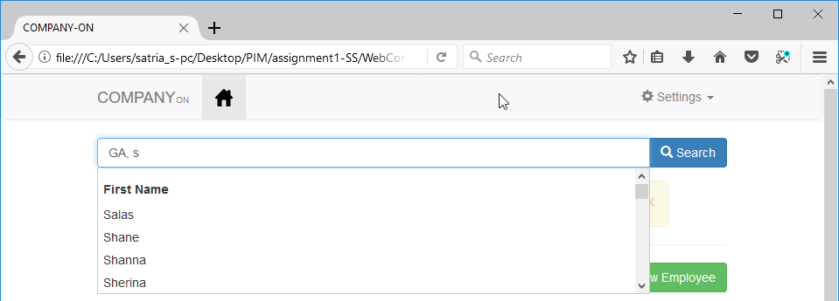
- Results Analysis
- Table Sorting
By default, results are sorted based on employee number. However, in the event that users want to sort the result based on other categories (e.g. Age), a sorting feature can be executed by clicking on the sorting icon to the right of each table heading. Only headings with the sorting icon can be used.
- Statistical Distribution Panel
The Statistical Distribution Panel (E) only appears when a search is performed with a valid search query and matching datasets are found. It is by default collapsed, and clicking on the heading will unfold information pertaining to the distribution of the search results across various categories.
- Ambiguity Prevention
When keywords used are not specific, ambiguous results might appear. In such cases, an alert message prompting the user to clarify their intentions will appear (D). Choosing one of the options provided will further refine the search result automatically. The Statistical Distribution Panel will also be automatically updated.
- Pop-Up Display
To further get insights of each individual, a pop-up display (F) will appear upon selecting one/more options from the “Pop-Up Detail Options” (B) and then clicking the profile picture of any of the employees. Clicking on the image again will disengage the pop-up display.

- Search and Re-Search
Users can quickly perform and fine-tune their searches using both the Statistical Distribution Panel (E), Pop-Up Display (F), and even the “Gender” Category in Results Table (C). Clicking on any of the available keyword options in these displays will automatically add/remove those keywords depending on whether it has already been inserted previously. This makes specifying/broadening searches simple, enabling users to quickly get to the search result they truly want.

