FileDownloader & FileDownloaderUI
Set the FileDownloaderUI project as the start up project and Run.
You can test just the downloading functionality on the Download File tab: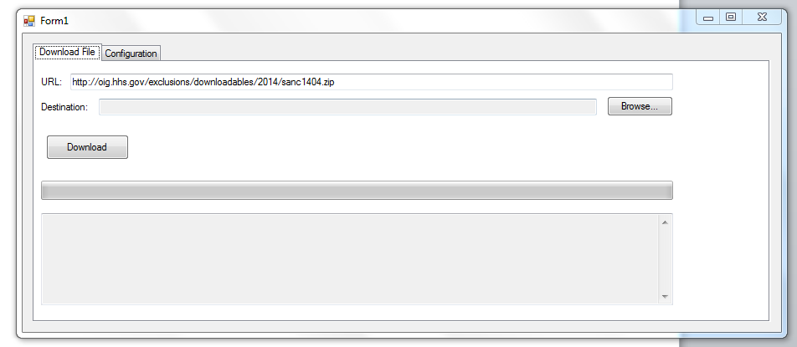
Enter the URL, choose the destination, and click Download.
To test the automatic URL generator, use the Configuration tab.
Click ‘Open’ and open a configuration file (the current one is in the Configs folder of the FileDownloaderUI project, called testconfig.xml).
Here you can add, edit, and delete file patterns in the listbox on the left. Save the config file with the Save button.
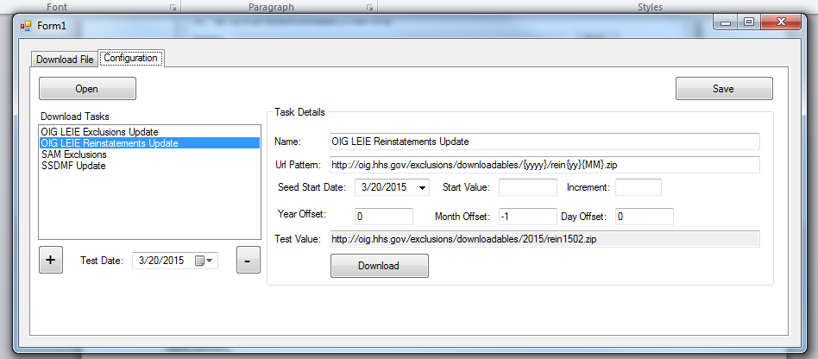
The Url can use the following patterns:
- {Seed} – Will be replaced by the next incremental seed value, by the Increment amount per day, starting with Start Value, and from the Seed Start Date. The calculation for the Seed value looks like this:
(SeedStartValue.Value + ((_formatDate.Date - SeedStartDate.Value.Date).TotalDays * SeedIncrement.Value))

- {Date Part} – Here you can use any valid values for the DateTime.ToString() method (see here: https://msdn.microsoft.com/en-us/library/az4se3k1%28v=vs.110%29.aspx)

You can change the test date and click the Download link to test out different date values to see if they match with files available in the past.
You can add offsets for the year, month, and day that will be applied to the current date. For example, for the OIG files, the current file names are for the previous month, so we would apply a “-1” month offset to the pattern.

