P2.c
Print name using puts
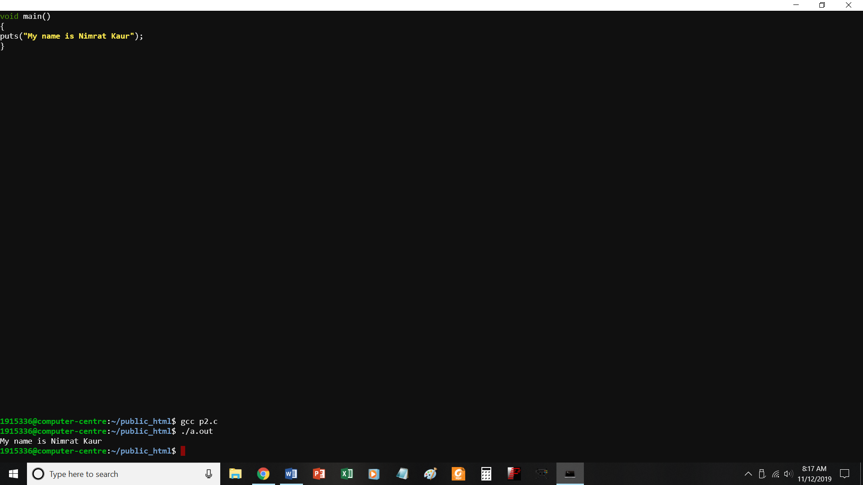
//print name using puts
#include <stdio.h>
void main()
{
puts("My name is Nimrat Kaur");
}

P3.c
Print address of college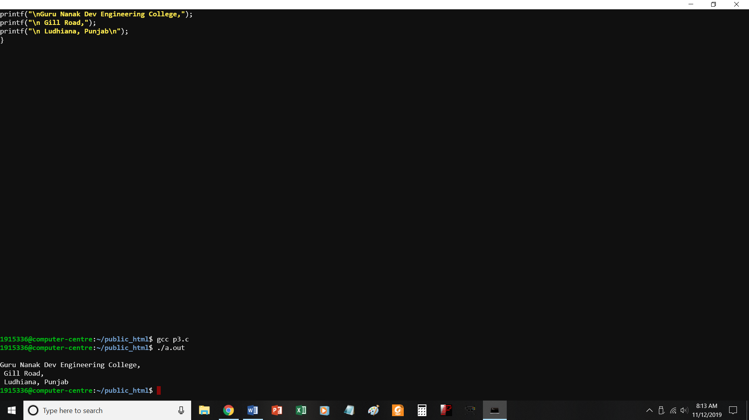
//PROGRAM TO PRINT ADDRESS OF COLLEGE
#include <stdio.h>
void main()
{
printf("\nGuru Nanak Dev Engineering College,");
printf("\n Gill Road,");
printf("\n Ludhiana, Punjab\n");
}

P4.c
Find sum of two numbers
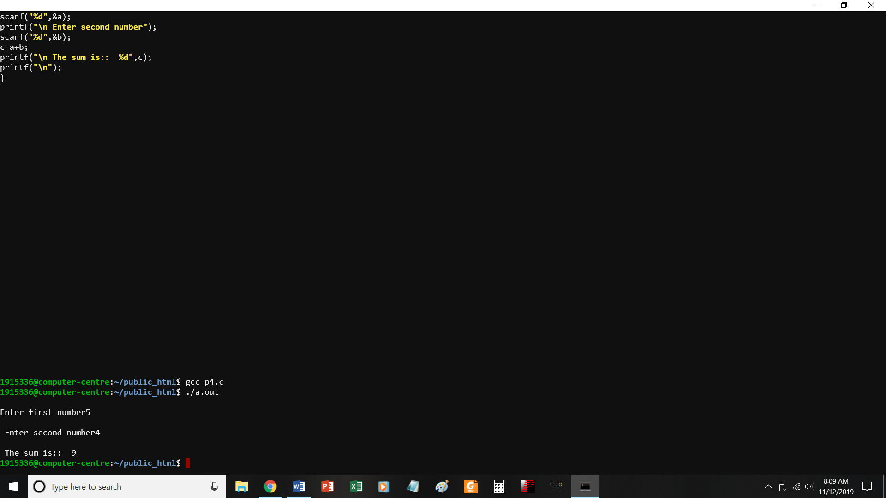
//PROGRAM TO FIND SUM OF TWO NUMBERS
#include <stdio.h>
void main()
{
int a,b,c;
printf("\nEnter first number");
scanf("%d",&a);
printf("\n Enter second number");
scanf("%d",&b);
c=a+b;
printf("\n The sum is:: %d",c);
printf("\n");
}

P5.c
To print quotient and remainder
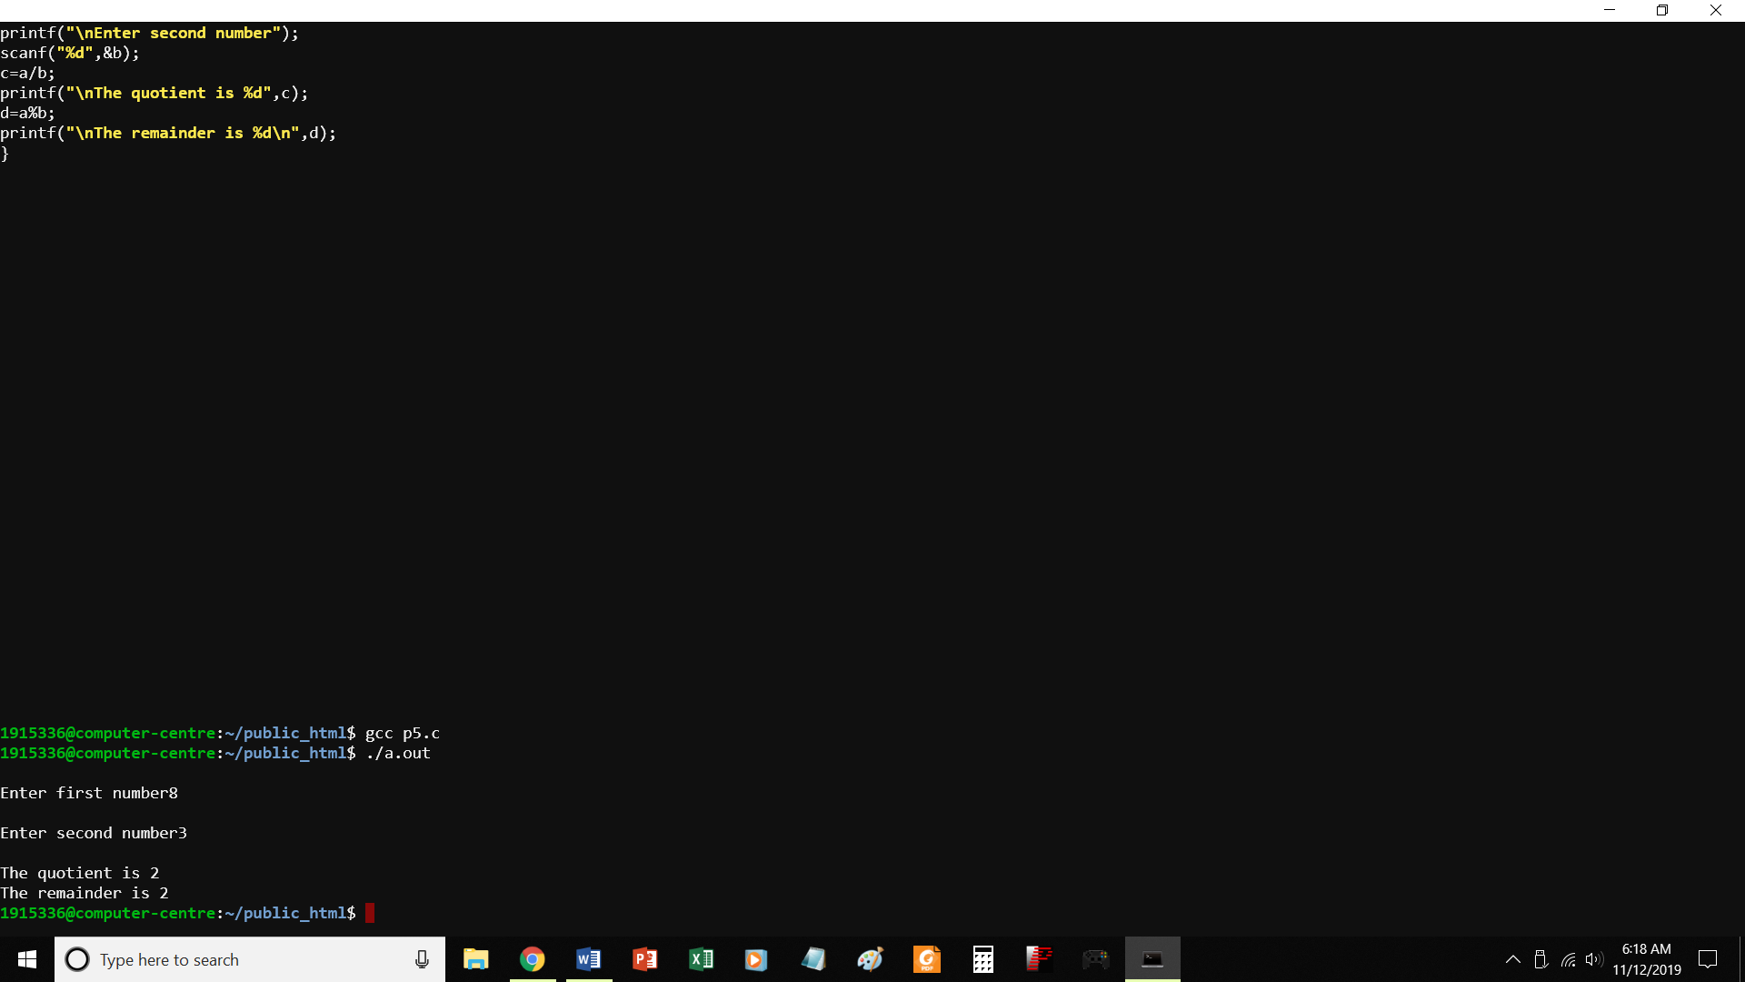
//PROGRAM TO PRINT THE QUOTIENT AND REMAINDER
#include <stdio.h>
void main()
{
int a,b,c,d;
printf("\nEnter first number");
scanf("%d",&a);
printf("\nEnter second number");
scanf("%d",&b);
c=a/b;
printf("\nThe quotient is %d",c);
d=a%b;
printf("\nThe remainder is %d\n",d);
}

P5-1.c
Swap 2 numbers without using third variable
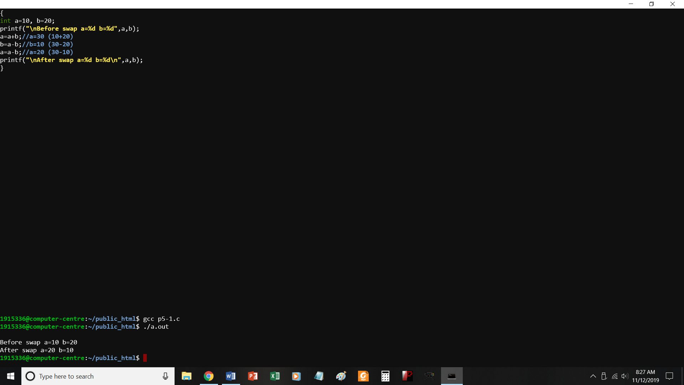
//swap two numbers without using third variable
#include<stdio.h>
int main()
{
int a=10, b=20;
printf("\nBefore swap a=%d b=%d",a,b);
a=a+b;//a=30 (10+20)
b=a-b;//b=10 (30-20)
a=a-b;//a=20 (30-10)
printf("\nAfter swap a=%d b=%d\n",a,b);
}

P6.c to check if a number is odd or even
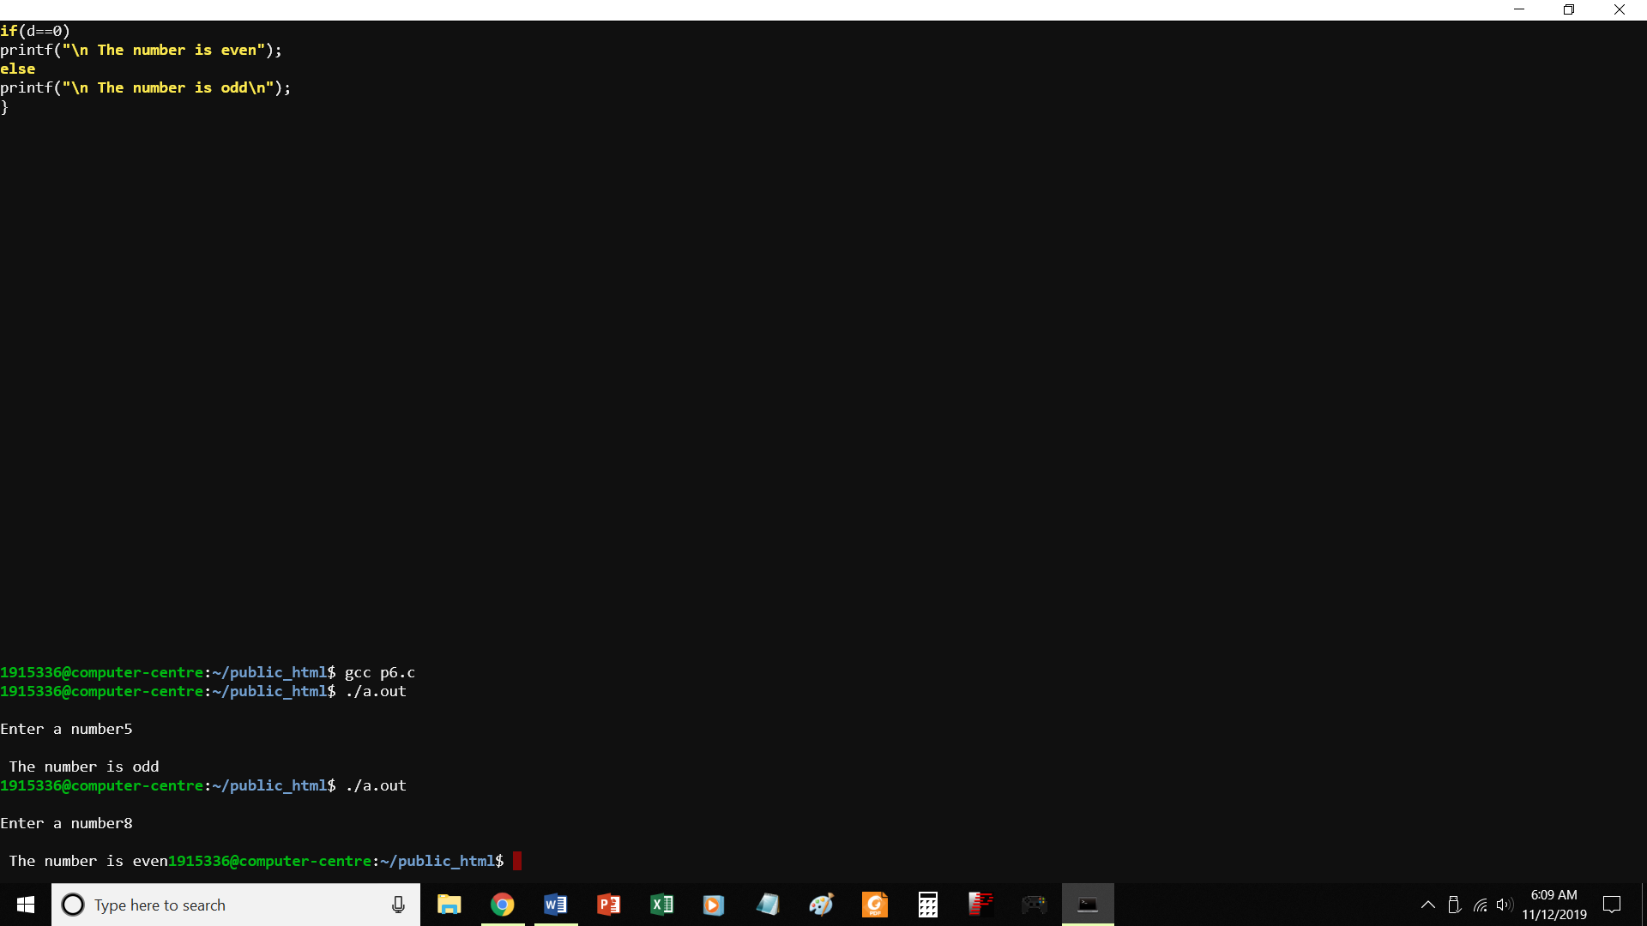
//PROGRAM TO CHECK IF A NUMBER IS EVEN OR ODD
#include <stdio.h>
void main()
{
int a,d;
printf("\nEnter a number");
scanf("%d",&a);
d=a%2;
if(d==0)
printf("\n The number is even");
else
printf("\n The number is odd\n");
}

P7.c find greater of two numbers
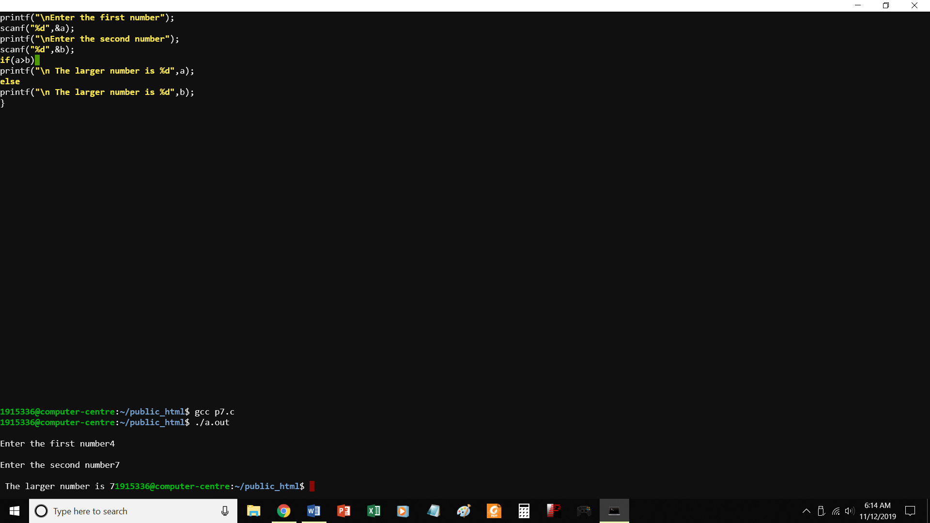
//program to find greater of two numbers
#include <stdio.h>
void main()
{
int a,b,c;
printf("\nEnter the first number");
scanf("%d",&a);
printf("\nEnter the second number");
scanf("%d",&b);
if(a>b)
printf("\n The larger number is %d",a);
else
printf("\n The larger number is %d",b);
}

P8.c Find largest of three numbers
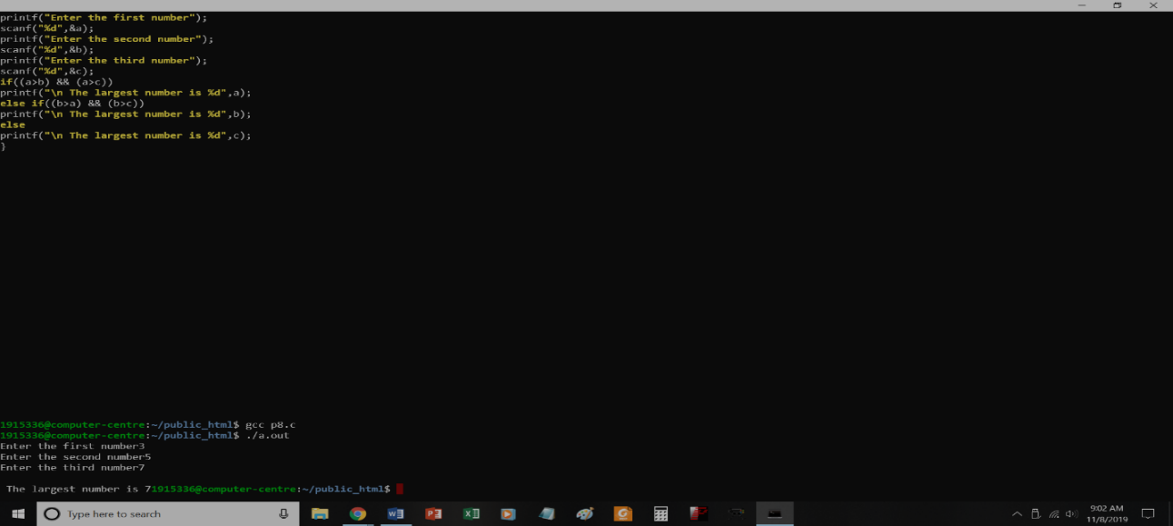

P9.c
Program to print grade of students according to marks entered

#include <stdio.h>
void main()
{
int marks;
printf("Enter the marks of the student out of 100::");
scanf("%d",&marks);
if(marks>=90)
printf("\nO Grade\n");
else if(marks>=75 && marks<90)
printf("\nA Grade\n");
else if(marks>60 && marks <75)
printf("\nB Grade\n");
else if(marks>=50 && marks <60)
printf("\nC Grade\n");
else if (marks>=40 && marks <50)
printf("\nD Grade\n");
else
printf("\nE Grade\n");
}

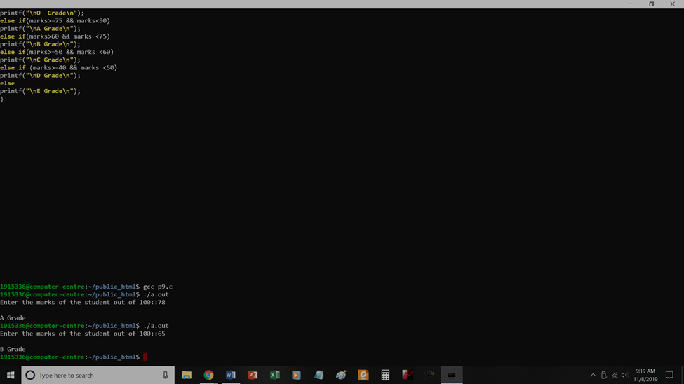

P10.c
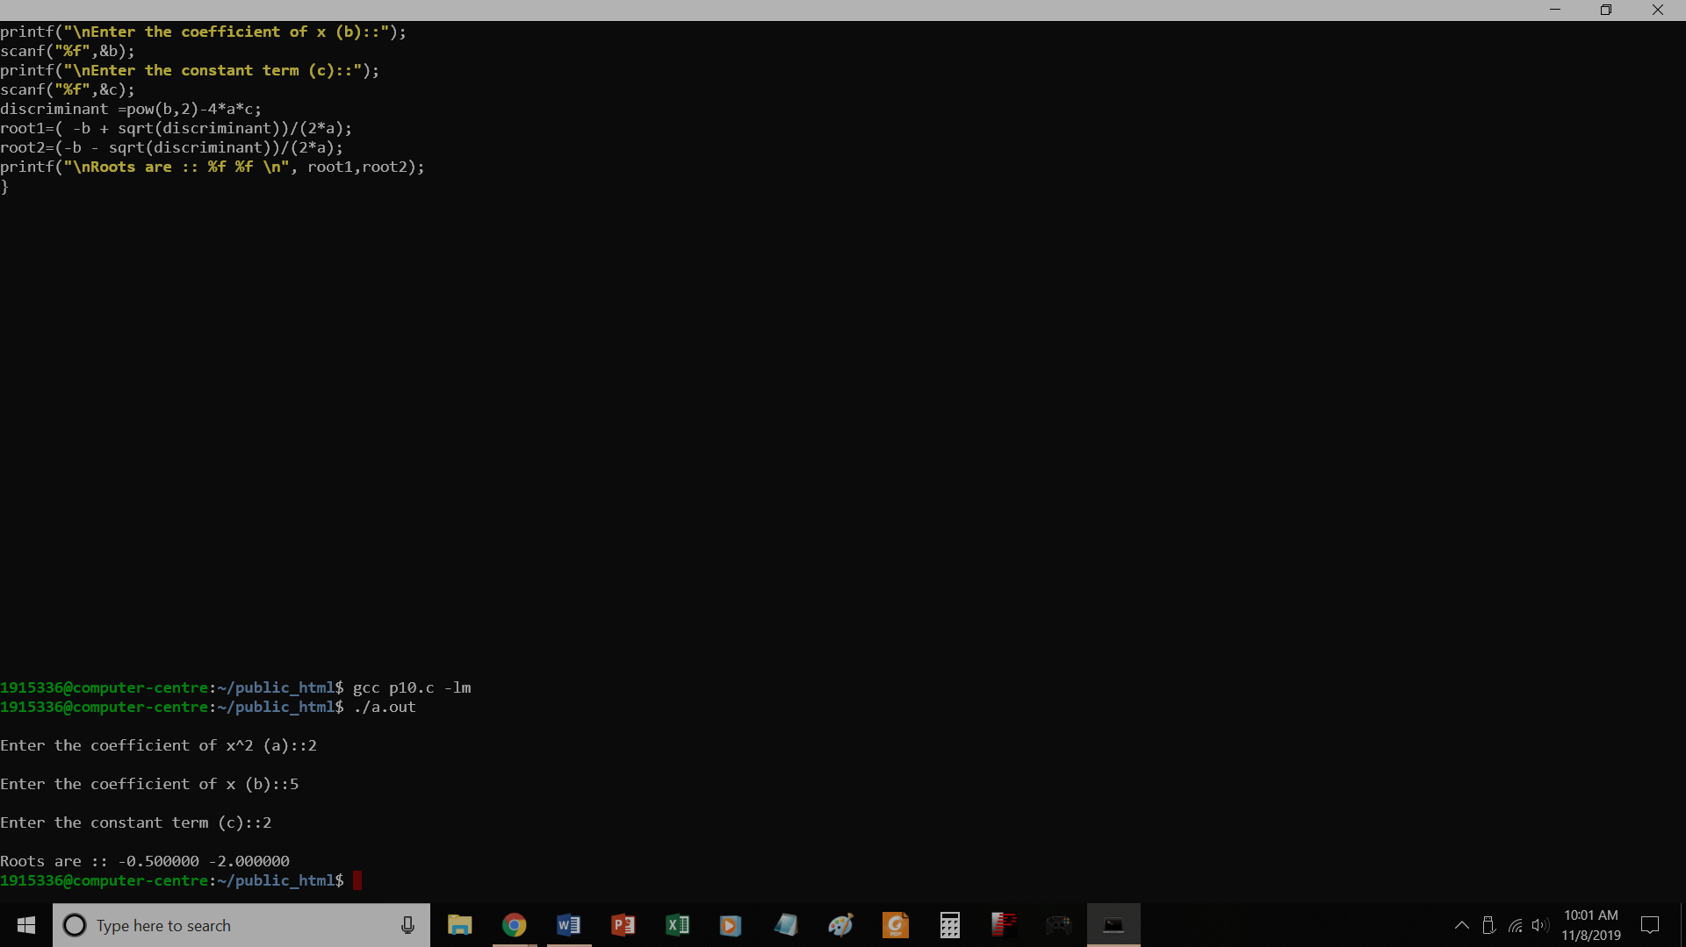
// Find roots of a quadratic equation
#include <stdio.h>
#include<math.h>
void main()
{
float a,b,c,discriminant;
float root1, root2;
printf("\nEnter the coefficient of x^2 (a)::");
scanf("%f",&a);
printf("\nEnter the coefficient of x (b)::");
scanf("%f",&b);
printf("\nEnter the constant term (c)::");
scanf("%f",&c);
discriminant =pow(b,2)-4*a*c;
root1=( -b + sqrt(discriminant))/(2*a);
root2=(-b - sqrt(discriminant))/(2*a);
printf("\nRoots are :: %f %f \n", root1,root2);
}

P11.c
To check whether a year is leap year or not
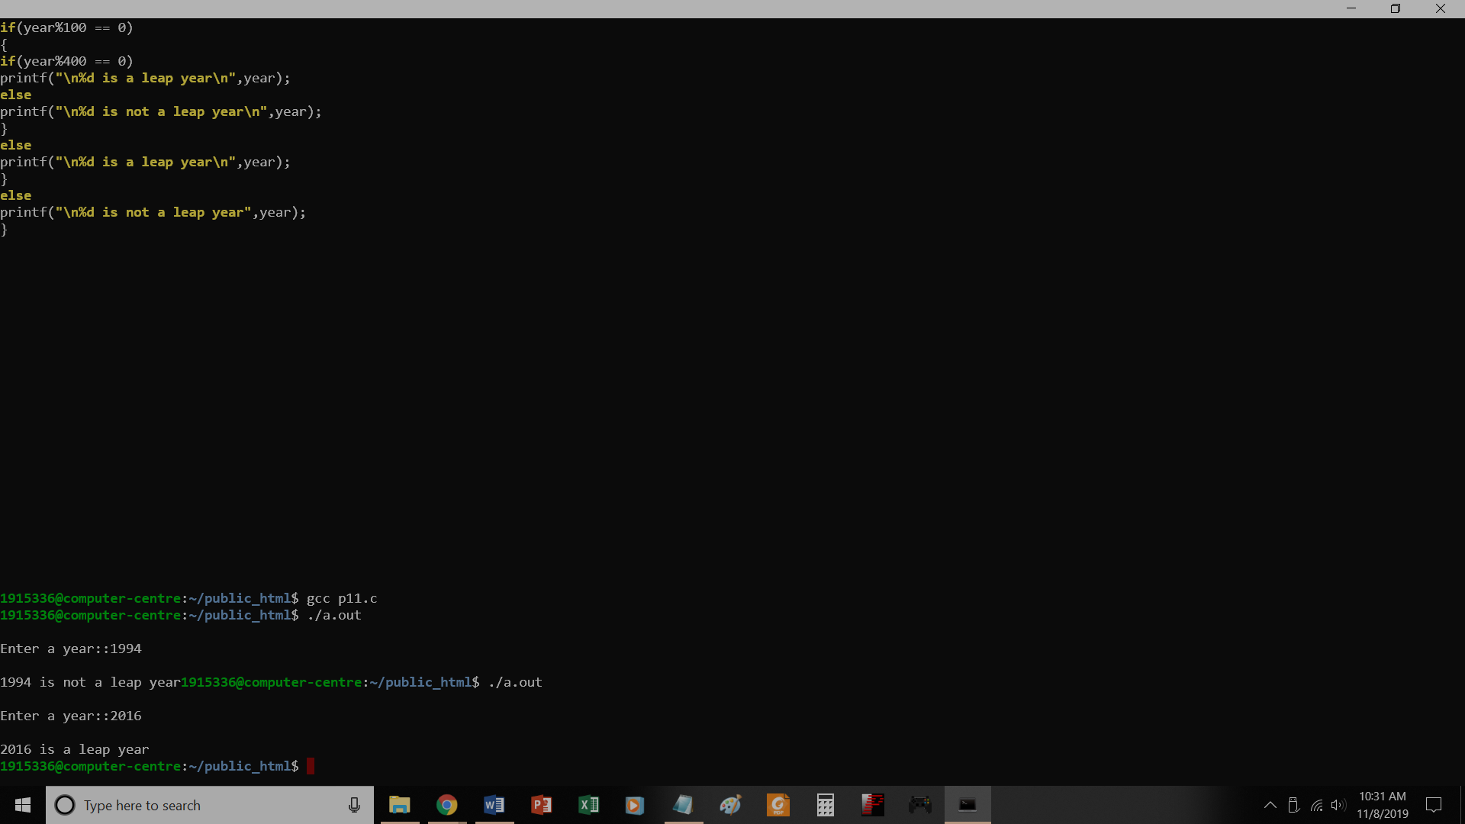
// To check whether a year is leap year or not
#include<stdio.h>
void main()
{
int year;
printf("\nEnter a year::");
scanf("%d",&year);
if(year%4==0)
{
if(year%100 == 0)
{
if(year%400 == 0)
printf("\n%d is a leap year\n",year);
else
printf("\n%d is not a leap year\n",year);
}
else
printf("\n%d is a leap year\n",year);
}
else
printf("\n%d is not a leap year",year);
}

P12.c
Program to generate multiple of 5
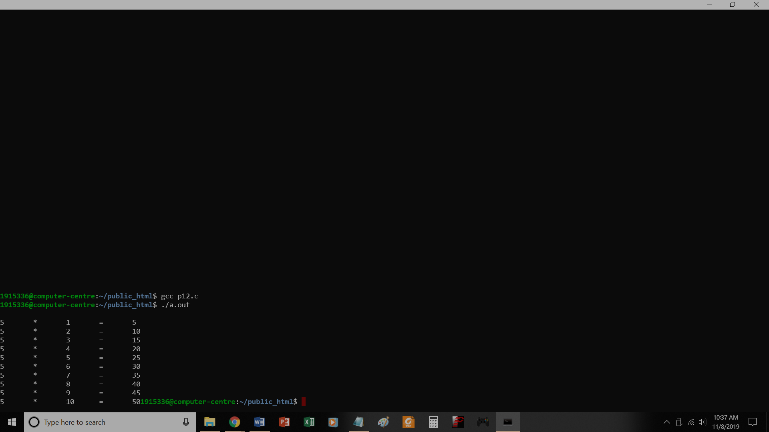
// Program to generate multiple of 5
#include<stdio.h>
void main()
{
int i;
for (i=1;i <=10; i++)
printf("\n5\t*\t%d\t=\t%d",i,5*i);
}

P13.c
To make simple calculator using switch
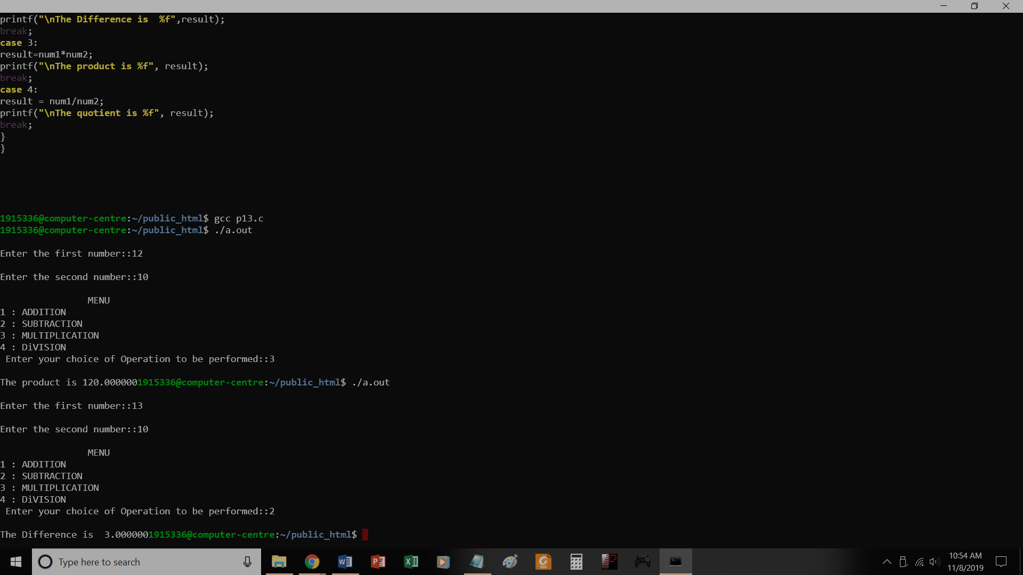
// To make simple calculator using switch

#include<stdio.h>
void main()
{
int num1, num2, choice;
float result;

printf("\nEnter the first number::");
scanf("%d",&num1);
printf("\nEnter the second number::");
scanf("%d",&num2);
printf("\n\t\tMENU");
printf("\n1 : ADDITION");
printf("\n2 : SUBTRACTION");
printf("\n3 : MULTIPLICATION");
printf("\n4 : DiVISION");
printf("\n Enter your choice of Operation to be performed::");
scanf("%d",&choice);
switch(choice)
{
case 1:
result = num1+num2;
printf("\nThe Sum is %f", result);
break;
case 2:
result=num1-num2;
printf("\nThe Difference is %f",result);
break;
case 3:
result=num1*num2;
printf("\nThe product is %f", result);
break;
case 4:
result = num1/num2;
printf("\nThe quotient is %f", result);
break;
}
}

P14.c
Calculate reverse of a number
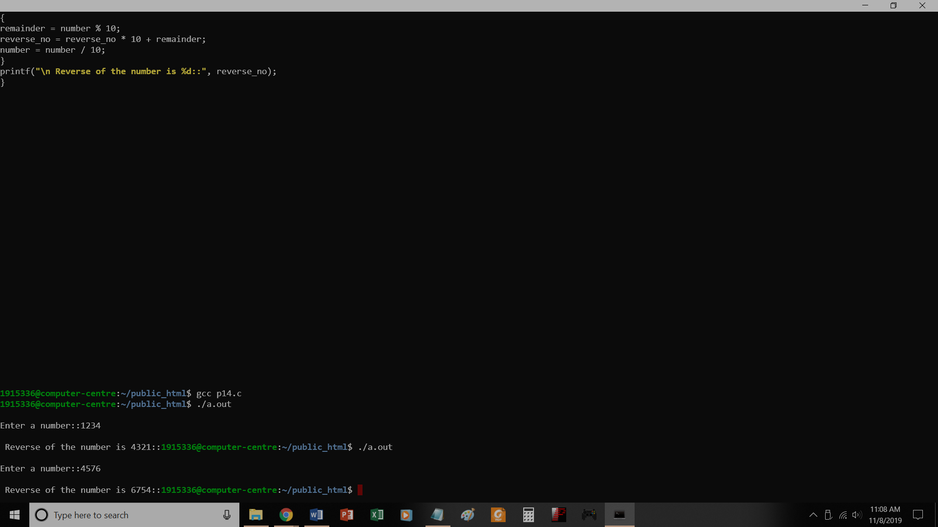
// Calculate reverse of a number
#include<stdio.h>
void main()
{
int number, remainder, reverse_no=0;
printf("\nEnter a number::");
scanf("%d",&number);
while(number != 0)
{
remainder = number % 10;
reverse_no = reverse_no * 10 + remainder;
number = number / 10;
}
printf("\n Reverse of the number is %d::", reverse_no);
}

P15.c
Check whether a number is palindrome

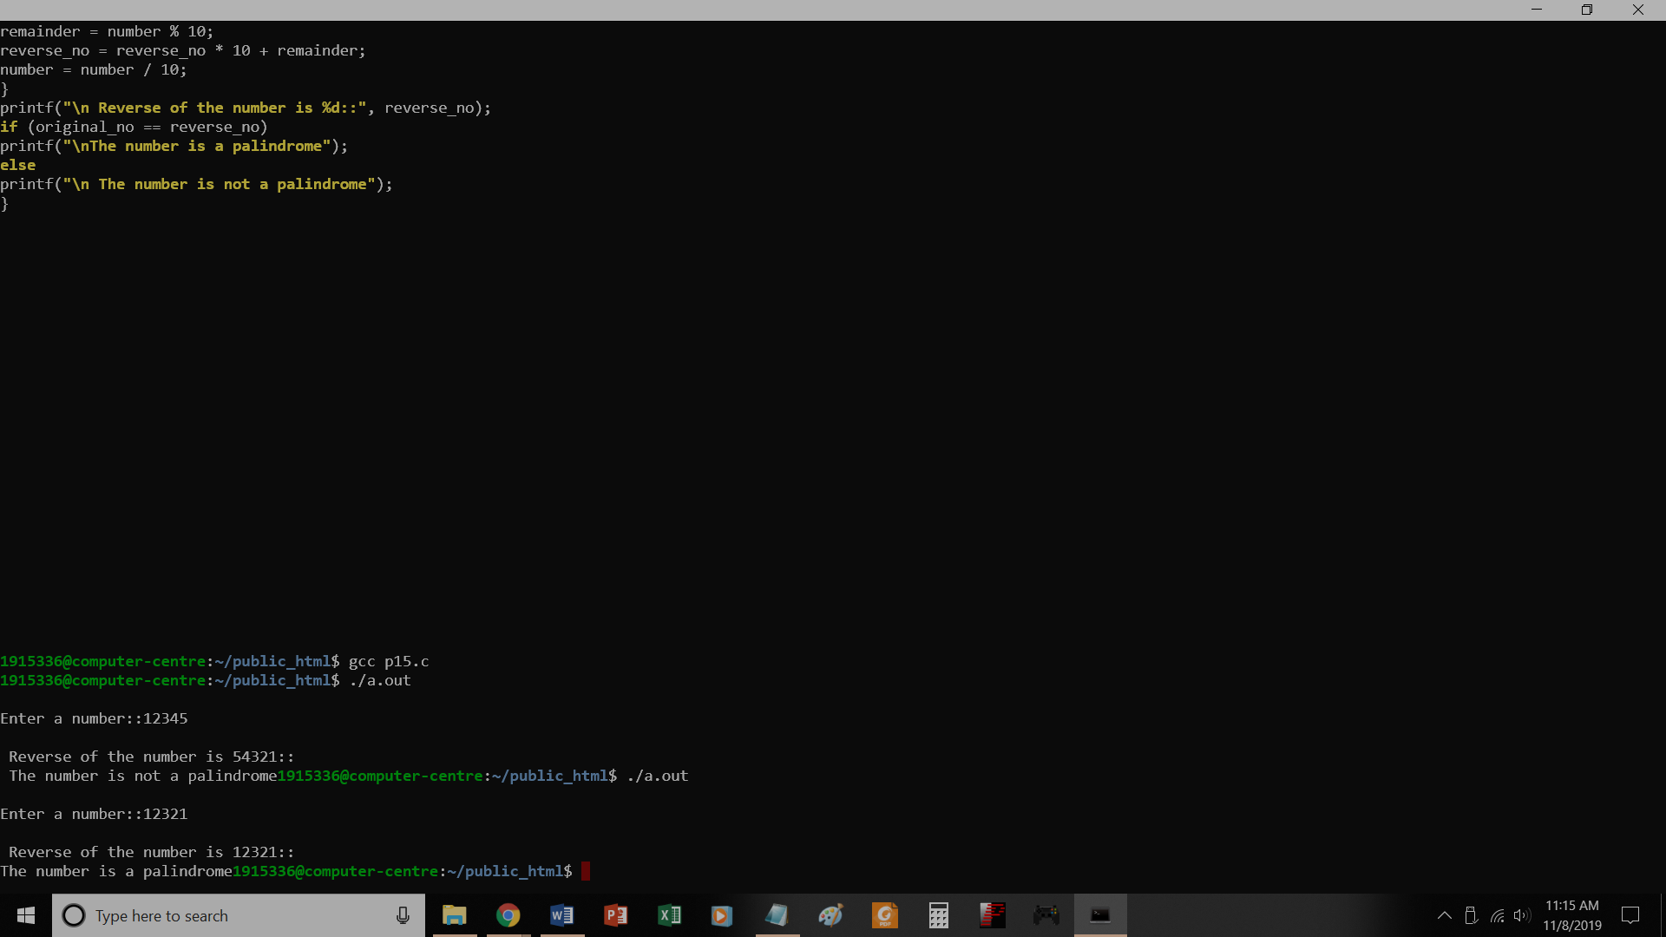

// Check whether a number is palindrome

#include<stdio.h>
void main()
{
int number, remainder, original_no, reverse_no=0;
printf("\nEnter a number::");
scanf("%d",&number);
original_no=number;
while(number != 0)
{
remainder = number % 10;
reverse_no = reverse_no * 10 + remainder;
number = number / 10;
}
printf("\n Reverse of the number is %d::", reverse_no);
if (original_no == reverse_no)
printf("\nThe number is a palindrome");
else
printf("\n The number is not a palindrome");
}

P16.c
Prime or not
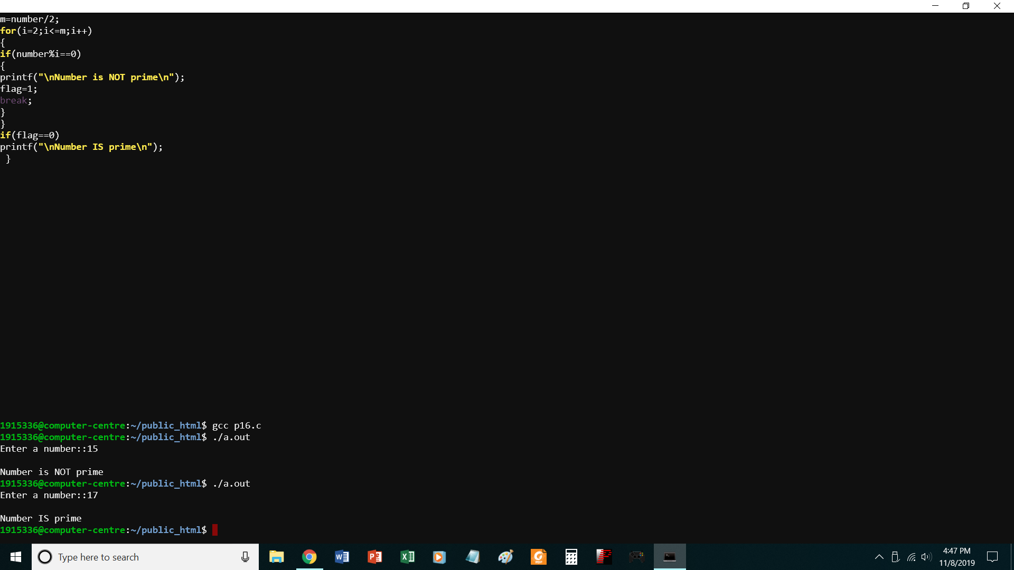
//PROGRAM TO CHECK WHETHER A NO. IS PRIME OR NOT
#include<stdio.h>
void main()
{
int number,i,m=0,flag=0;
printf("Enter a number::");
scanf("%d",&number);
m=number/2;
for(i=2;i<=m;i++)
{
if(number%i==0)
{
printf("\nNumber is NOT prime\n");
flag=1;
break;
}
}
if(flag==0)
printf("\nNumber IS prime\n");
}

P17.c
Prime numbers 1 to 100
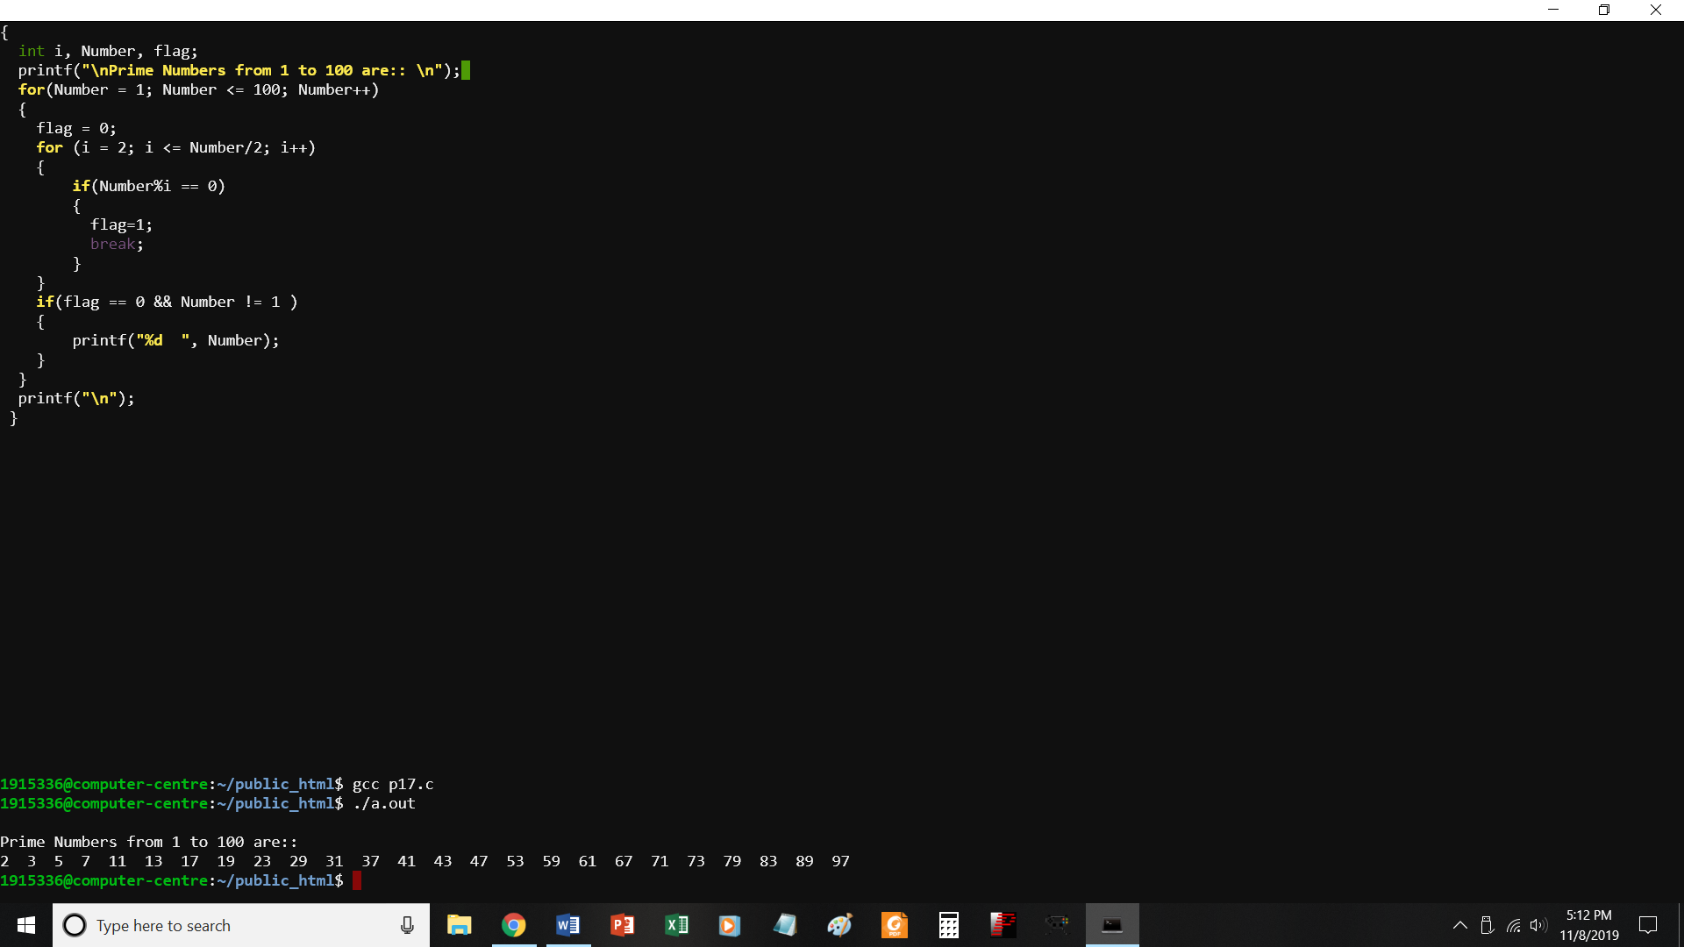
//PROGRAM TO PRINT PRIME NUMBERS FROM 1 TO 100
#include <stdio.h>
void main()
{
int i, Number, flag;
printf("\nPrime Numbers from 1 to 100 are:: \n");
for(Number = 1; Number <= 100; Number++)
{
flag = 0;
for (i = 2; i <= Number/2; i++)
{
if(Number%i == 0)
{
flag=1;
break;
}
}
if(flag == 0 && Number != 1 )
{
printf("%d ", Number);
}
}
printf("\n");
}

P18.c
To check whether a number is Armstrong or not
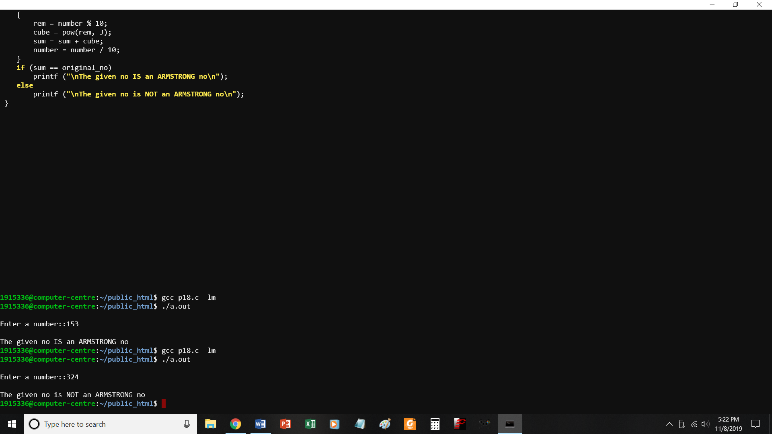
//PROGRAM TO CHECK WHETHER A NO. IS AN ARMSTRONG NUMBER OR NOT
#include<stdio.h> #include <math.h>
void main()
{
int number, sum = 0, rem = 0, cube = 0, original_no;
printf ("\nEnter a number::");
{
rem = number % 10;
cube = pow(rem, 3);
sum = sum + cube;
number = number / 10;
}
if (sum == original_no)
printf ("\nThe given no IS an ARMSTRONG no\n");
else
printf ("\nThe given no is NOT an ARMSTRONG no\n");
}

P19_1.c
Program to generate pattern
1
1 2
1 2 3
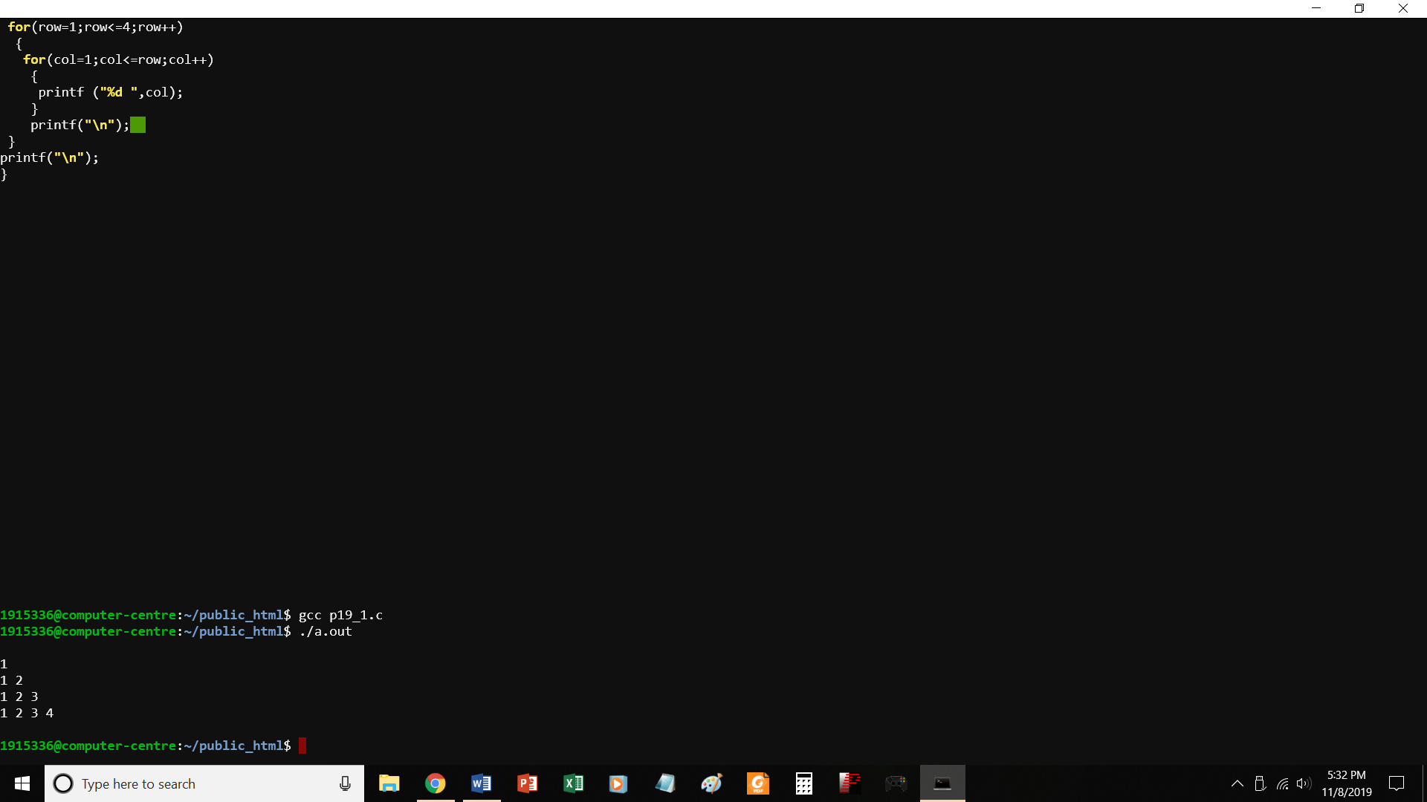
//PROGRAM TO PRINT A PATTERN
#include<stdio.h>
void main()
{
int row, col;
printf("\n");
for(row=1;row<=4;row++)
{
for(col=1;col<=row;col++)
{
printf ("%d ",col);
}
printf("\n");
}
printf("\n");
}

P19_2.C
TO PRINT A PATTERN
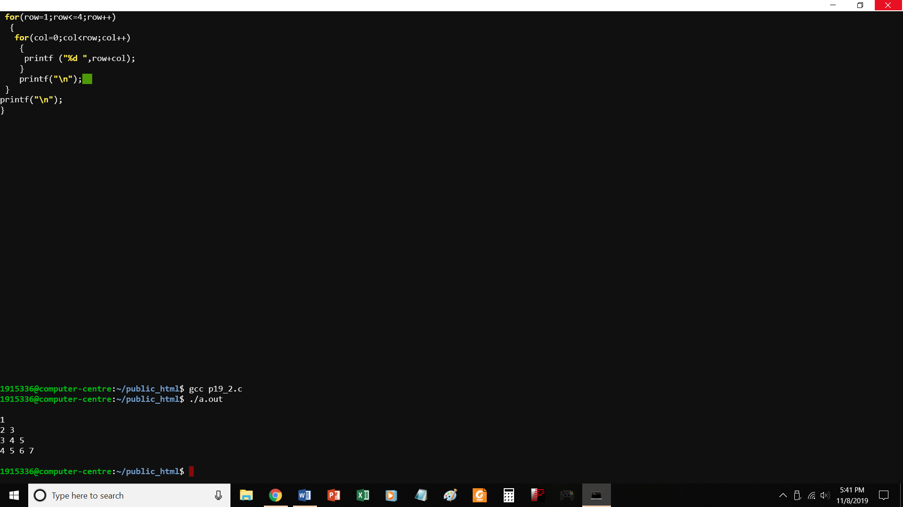
//PROGRAM TO PRINT A PATTERN -2
#include<stdio.h>
void main()
{
int row, col;
printf("\n");
for(row=1;row<=4;row++)
{
for(col=0;col<row;col++)
{
printf ("%d ",row+col);
}
printf("\n");
}
printf("\n");
}

P19_3.c
Print a pattern
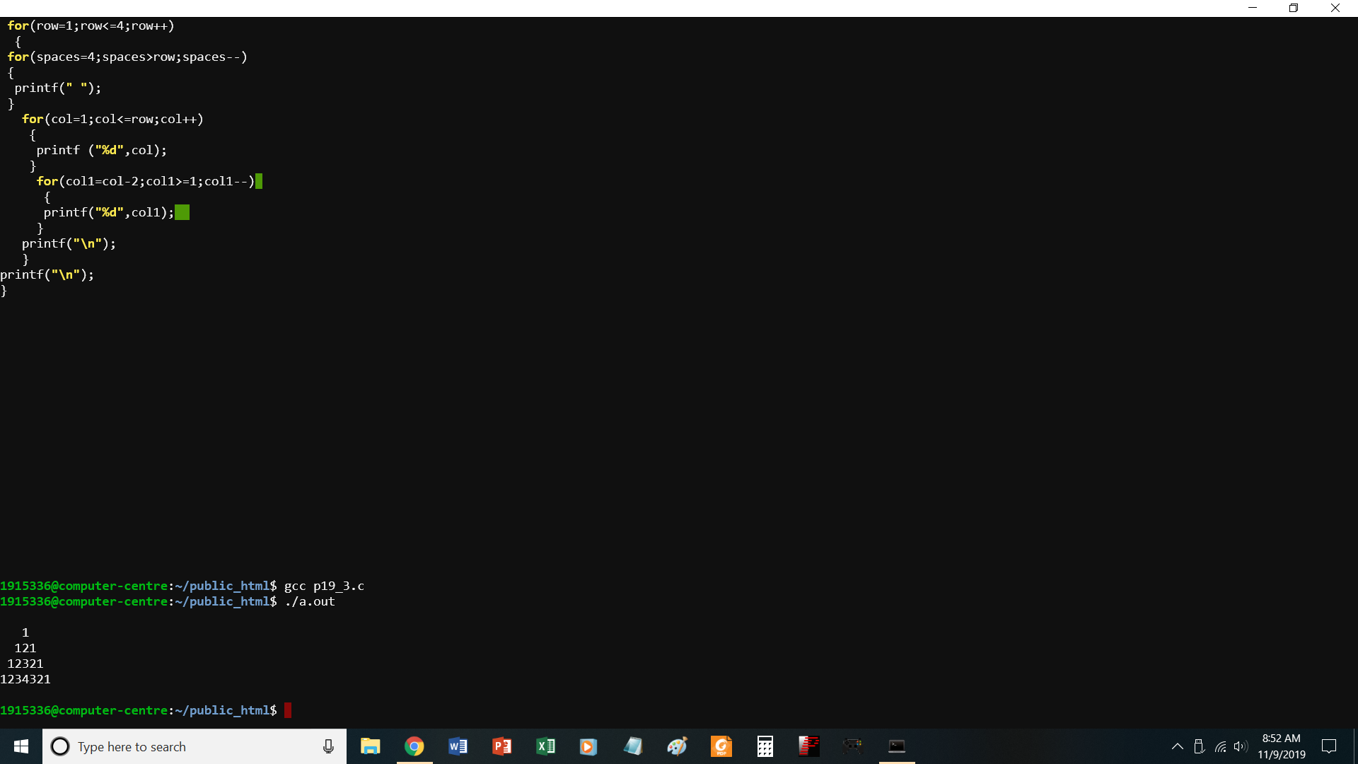

//PROGRAM TO PRINT A PATTERN -3
#include<stdio.h>
void main()
{
int row, col,col1,spaces;
printf("\n");
for(row=1;row<=4;row++)
{
for(spaces=4;spaces>row;spaces--)
{
printf(" ");
}
for(col=1;col<=row;col++)
{
printf ("%d",col);
}
for(col1=col-2;col1>=1;col1--)
{
printf("%d",col1);
}
printf("\n");
}
printf("\n");
}

P20.c
Find largest element from 1-D array
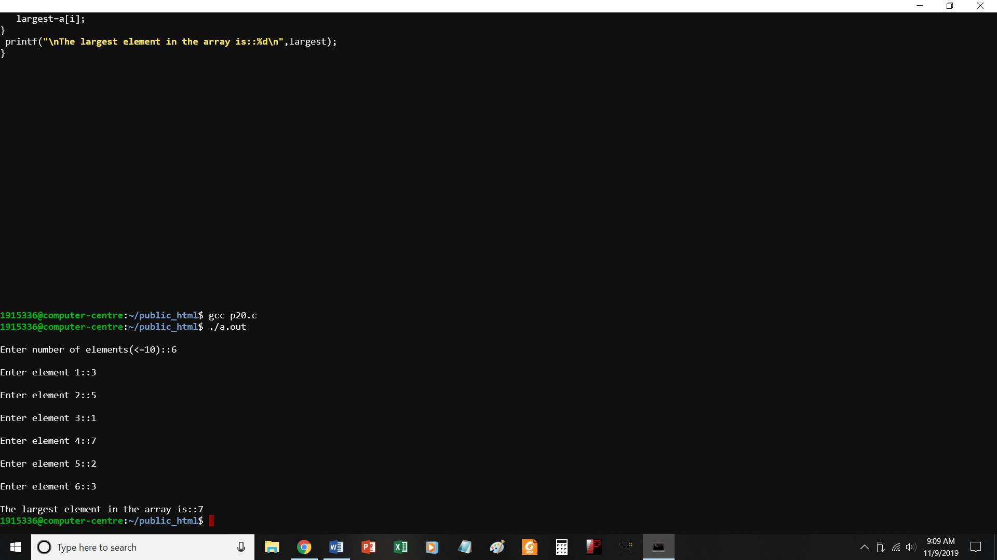
//PROGRAM TO FIND LARGEST ELEMENT FROM 1-D ARRAY
#include<stdio.h>
void main()
{
int a[10],i, largest,n;
printf("\nEnter number of elements(<=10)::");
scanf("%d",&n);
for(i=0;i<=n-1;i++)
{
printf("\nEnter element %d::",i+1);
scanf("%d",&a[i]);
}
largest=a[0];
for(i=1;i<=n-1;i++)
{
if(a[i]>largest)
largest=a[i];
}
printf("\nThe largest element in the array is::%d\n",largest);
}

P21.c
Find sum of n elements of array
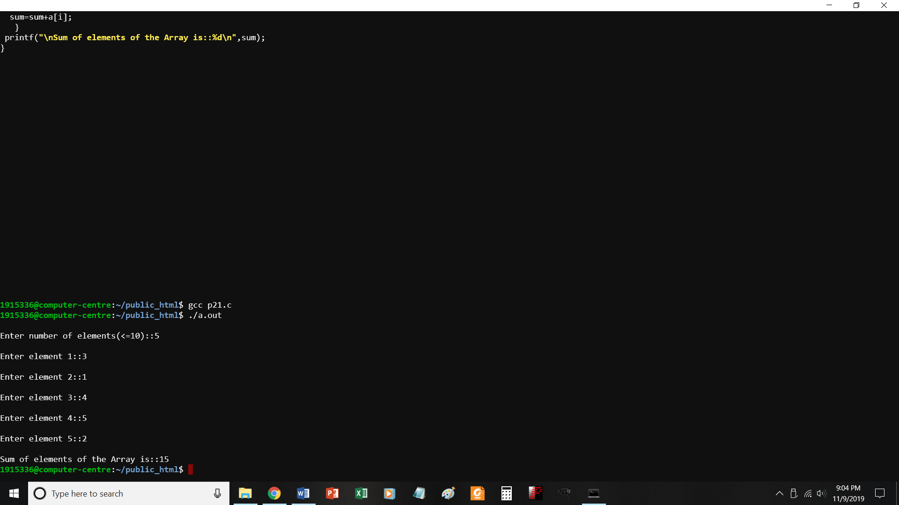
//PROGRAM TO FIND SUM OF N ELEMENTS OF AN ARRAY
#include<stdio.h>
void main()
{
int a[10],i, sum=0,n;
printf("\nEnter number of elements(<=10)::");
scanf("%d",&n);
for(i=0;i<=n-1;i++)
{
printf("\nEnter element %d::",i+1);
scanf("%d",&a[i]);
}
for(i=0;i<=n-1;i++)
{
sum=sum+a[i];
}
printf("\nSum of elements of the Array is::%d\n",sum);
}

P22.c
To add 2 matrices
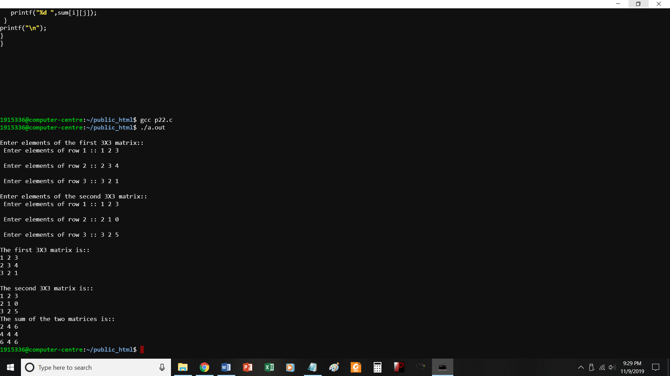
//PROGRAM TO FIND SUM OF TWO MATRICES
#include<stdio.h>
void main()
{
int a[3][3],b[3][3], sum[3][3],i,j;
printf("\nEnter elements of the first 3X3 matrix::");
for(i=0;i<=2;i++)
{
printf("\n Enter elements of row %d :: ", i+1);
for(j=0;j<=2;j++)
{
scanf("%d",&a[i][j]);
}
}
printf("\nEnter elements of the second 3X3 matrix::");
for(i=0;i<=2;i++)
{
printf("\n Enter elements of row %d :: ", i+1);
for(j=0;j<=2;j++)
{
scanf("%d",&b[i][j]);
}
}
printf("\nThe first 3X3 matrix is::\n");
for(i=0;i<=2;i++)
{
for(j=0;j<=2;j++)
{
printf("%d ",a[i][j]);
}
printf("\n");
}

printf("\nThe second 3X3 matrix is::\n");
for(i=0;i<=2;i++)
{
for(j=0;j<=2;j++)
{
printf("%d ",b[i][j]);
}

P23.c
Multiply 2 matrices
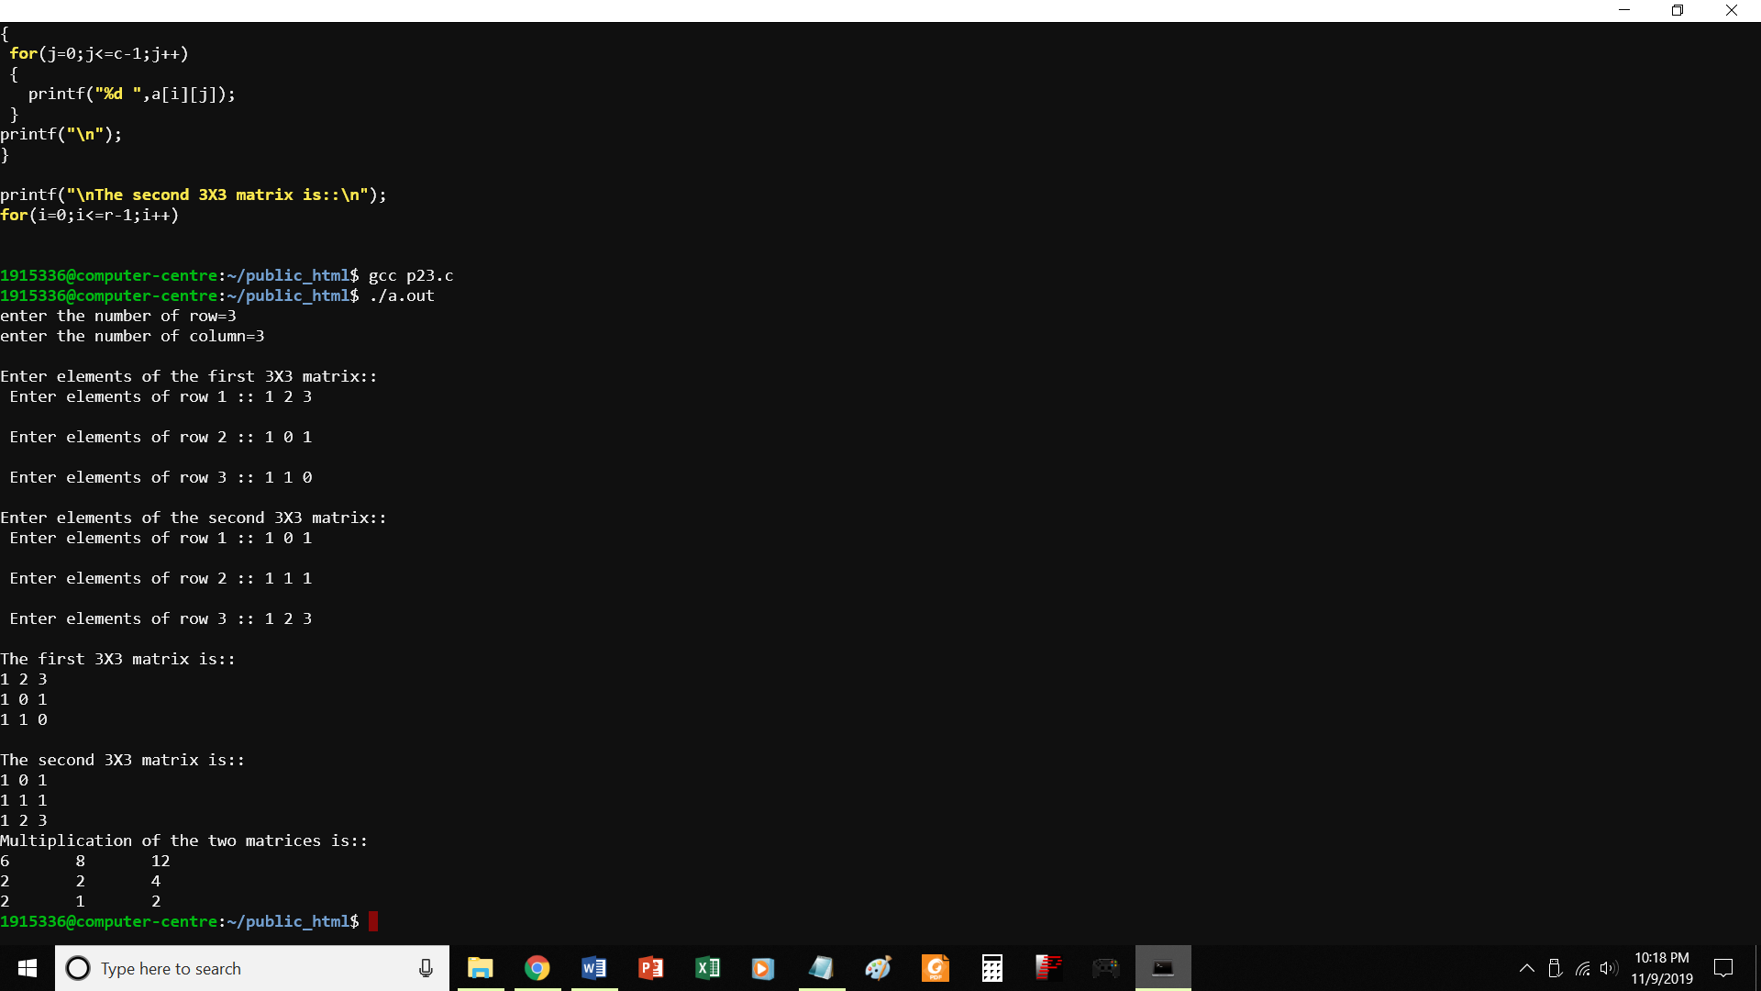
//PROGRAM TO FIND PRODUCT OF TWO MATRICES
#include<stdio.h>
#include<stdlib.h>
int main()
{
int a[10][10],b[10][10],mul[10][10],r,c,i,j,k;
printf("enter the number of row=");
scanf("%d",&r);
printf("enter the number of column=");
scanf("%d",&c);
printf("\nEnter elements of the first 3X3 matrix::");
for(i=0;i<=r-1;i++)
{
printf("\n Enter elements of row %d :: ", i+1);
for(j=0;j<=c-1;j++)
{
scanf("%d",&a[i][j]);
}
}
printf("\nEnter elements of the second 3X3 matrix::");
for(i=0;i<=r-1;i++)
{
printf("\n Enter elements of row %d :: ", i+1);
for(j=0;j<=c-1;j++)
{
scanf("%d",&b[i][j]);
}
}
printf("\nThe first 3X3 matrix is::\n");
for(i=0;i<=r-1;i++)
{
for(j=0;j<=c-1;j++)
{
printf("%d ",a[i][j]);
}
printf("\n");
}

printf("\nThe second 3X3 matrix is::\n");
for(i=0;i<=r-1;i++)
{
for(j=0;j<=c-1;j++)
{
printf("%d ",b[i][j]);
}
printf("\n");
}
printf("Multiplication of the two matrices is::\n");
for(i=0;i<r;i++)
{
for(j=0;j<c;j++)
{
mul[i][j]=0;
for(k=0;k<c;k++)
{
mul[i][j]+=a[i][k]*b[k][j];
}
}
}
//for printing result
for(i=0;i<r;i++)
{
for(j=0;j<c;j++)
{
printf("%d\t",mul[i][j]);
}
printf("\n");
}
}

P24.c
Tp find whether a string is palindrome
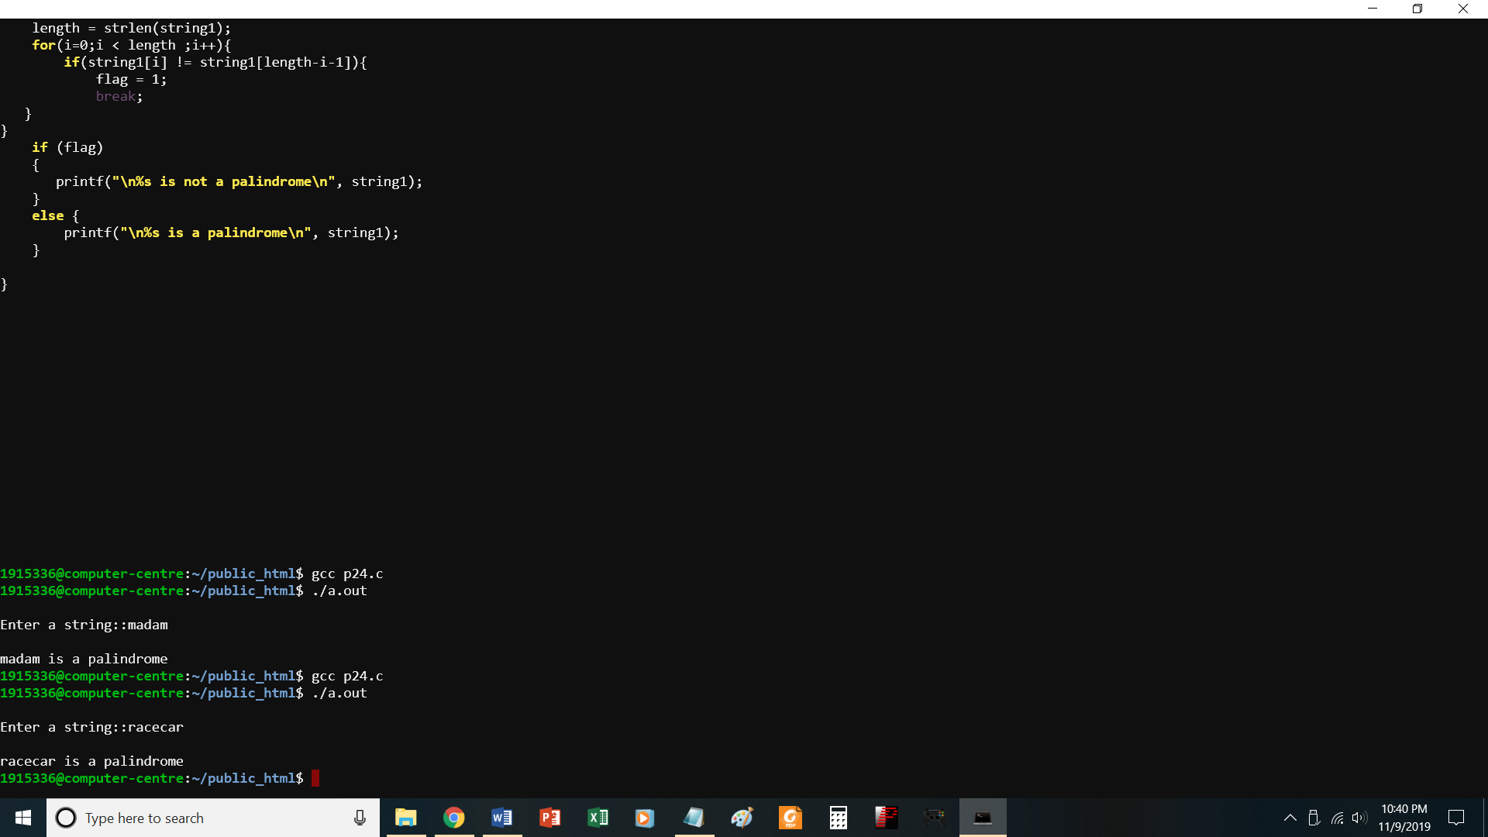
//PROGRAM TO CHECK WHETHER A STRING IS PALINDROME
#include<stdio.h>
#include<string.h>
void main()
{
char string1[20];
int i, length;
int flag = 0;
printf("\nEnter a string::");
scanf("%s", string1);
length = strlen(string1);
for(i=0;i < length ;i++){
if(string1[i] != string1[length-i-1]){
flag = 1;
break;
}
}
if (flag)
{
printf("\n%s is not a palindrome\n", string1);
}
else {
printf("\n%s is a palindrome\n", string1);
}

}

P25.c
To perform basic string operations
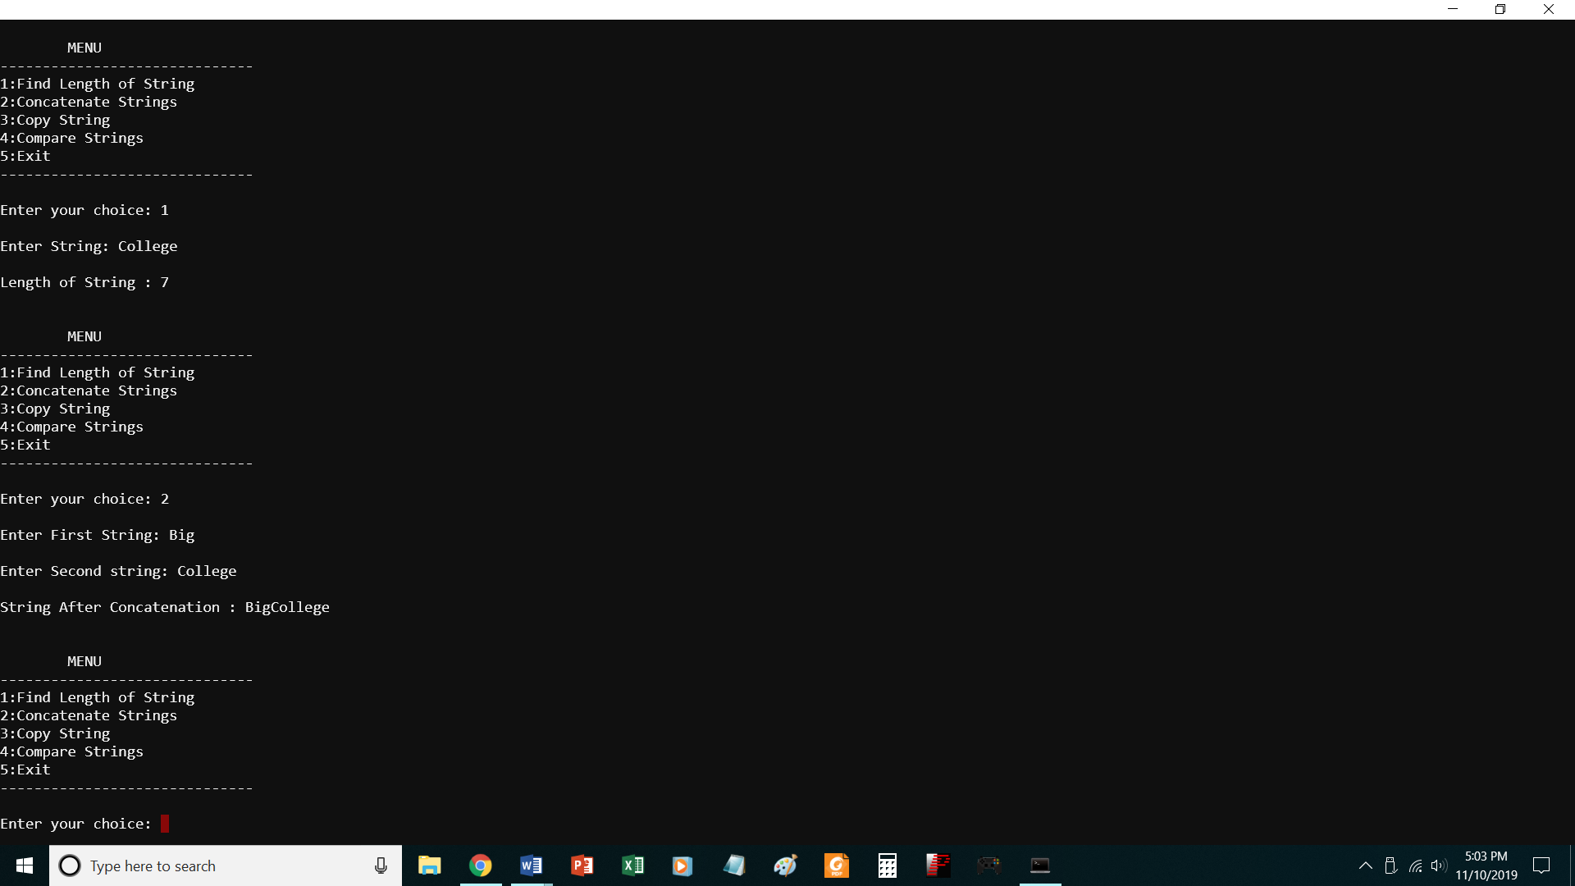
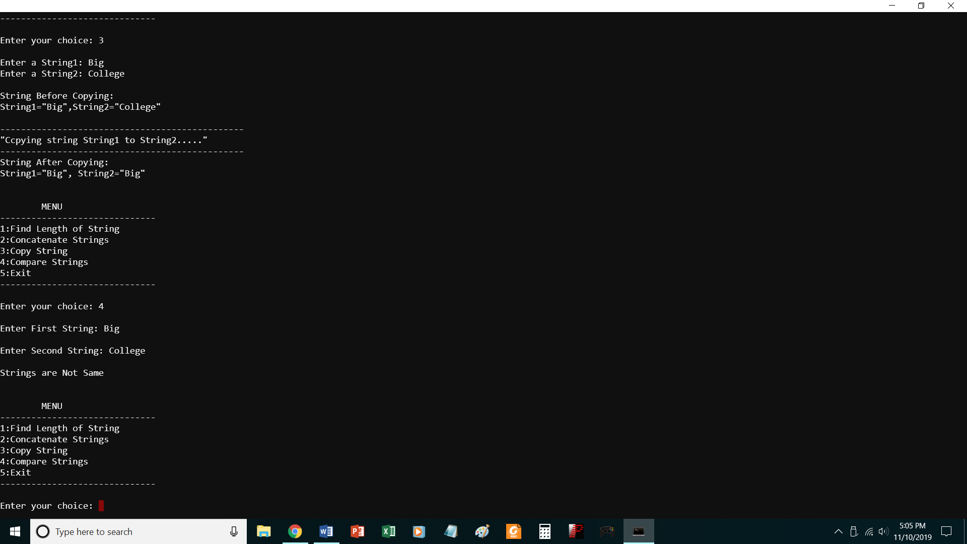
// To perform basic string operations

#include<stdio.h>
#include<string.h>
#include<stdlib.h>
void main()
{
char str1[20],str2[20];
int ch,i,j;
do
{
printf("\n\tMENU");
printf("\n------------------------------\n");
printf("1:Find Length of String");
printf("\n2:Concatenate Strings");
printf("\n3:Copy String ");
printf("\n4:Compare Strings");
printf("\n5:Exit");
printf("\n------------------------------\n");
printf("\nEnter your choice: ");
scanf("%d",&ch);
switch(ch)
{
case 1:
printf("\nEnter String: ");
scanf("%s",str1);
i=strlen(str1);
printf("\nLength of String : %d\n\n",i);
break;
case 2:
printf("\nEnter First String: ");
scanf("%s",str1);
printf("\nEnter Second string: ");
scanf("%s",str2);
strcat(str1,str2);
printf("\nString After Concatenation : %s\n\n",str1);
break;
case 3:
printf("\nEnter a String1: ");
scanf("%s",str1);
printf("Enter a String2: ");
scanf("%s",str2);
printf("\nString Before Copying:\nString1=\"%s\",String2=\"%s\"\n",str1,str2);
strcpy(str2,str1);
printf("\n-----------------------------------------------\n");
printf("\"Ccpying string String1 to String2.....\" \n");
printf("-----------------------------------------------\n");
printf("String After Copying:\nString1=\"%s\", String2=\"%s\"\n\n",str1,str2);
break;
case 4:
printf("\nEnter First String: ");
scanf("%s",str1);
printf("\nEnter Second String: ");
scanf("%s",str2);
j=strcmp(str1,str2);
if(j==0)
{
printf("\nStrings are Same\n\n");
}
else
{

printf("\nStrings are Not Same\n\n");
}
break;
case 5:
exit(0);
break;
default:
printf("\nInvalid Input. Please Enter valid Input.\n\n ");
}
}while(ch!=5);
}

P26.c
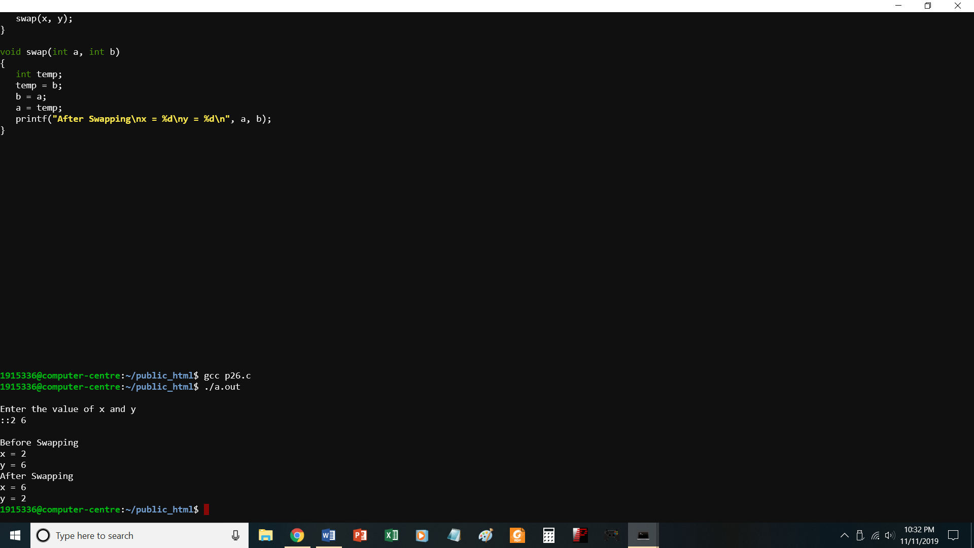
//PROGRAM TO SWAP TWO NUMBERS USING CALL BY VALUE
# include <stdio.h>
void swap(int, int);
int x,y;
void main()
{
//int x, y;
printf("\nEnter the value of x and y\n::");
scanf("%d %d",&x,&y);
printf("\nBefore Swapping\nx = %d\ny = %d\n", x, y);
swap(x, y);
}

void swap(int a, int b)
{
int temp;
temp = b;
b = a;
a = temp;
printf("After Swapping\nx = %d\ny = %d\n", a, b);
}

P26-1.c
Print numbers using call by reference
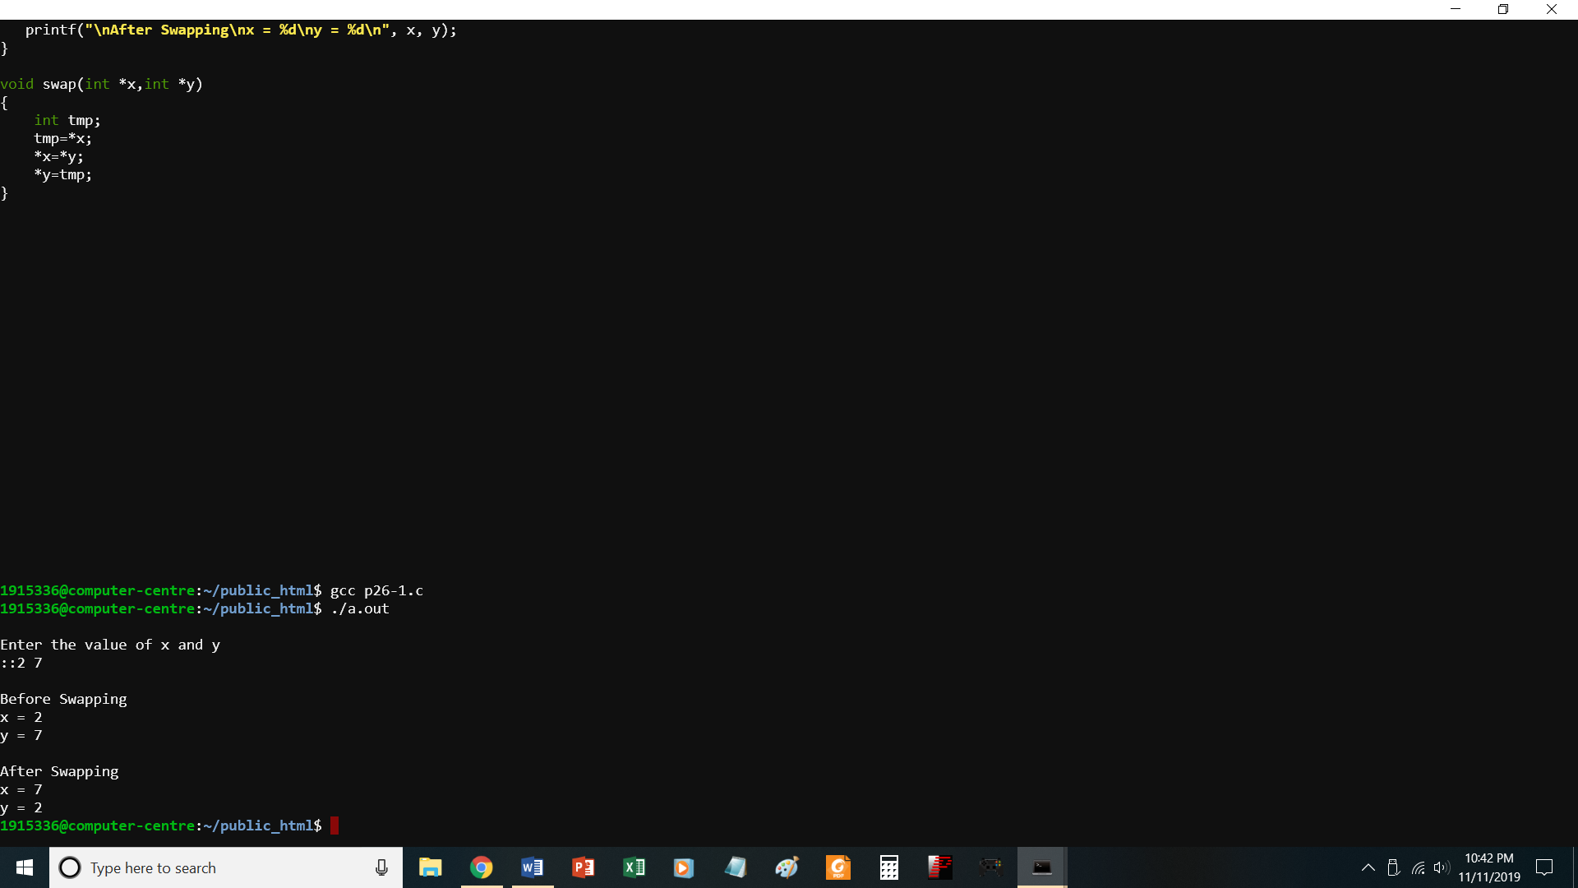

//PROGRAM TO SWAP TWO NUMBERS USING CALL BY REFERENCE
# include <stdio.h>
void swap(int *, int *);
int x,y;
void main()
{
//int x, y;
printf("\nEnter the value of x and y\n::");
scanf("%d %d",&x,&y);
printf("\nBefore Swapping\nx = %d\ny = %d\n", x, y);
swap(&x,&y);
printf("\nAfter Swapping\nx = %d\ny = %d\n", x, y);
}

void swap(int *x,int *y)
{
int tmp;
tmp=*x;
*x=*y;
*y=tmp;
}
P27-1.c
To find factorial of a number without using recursion
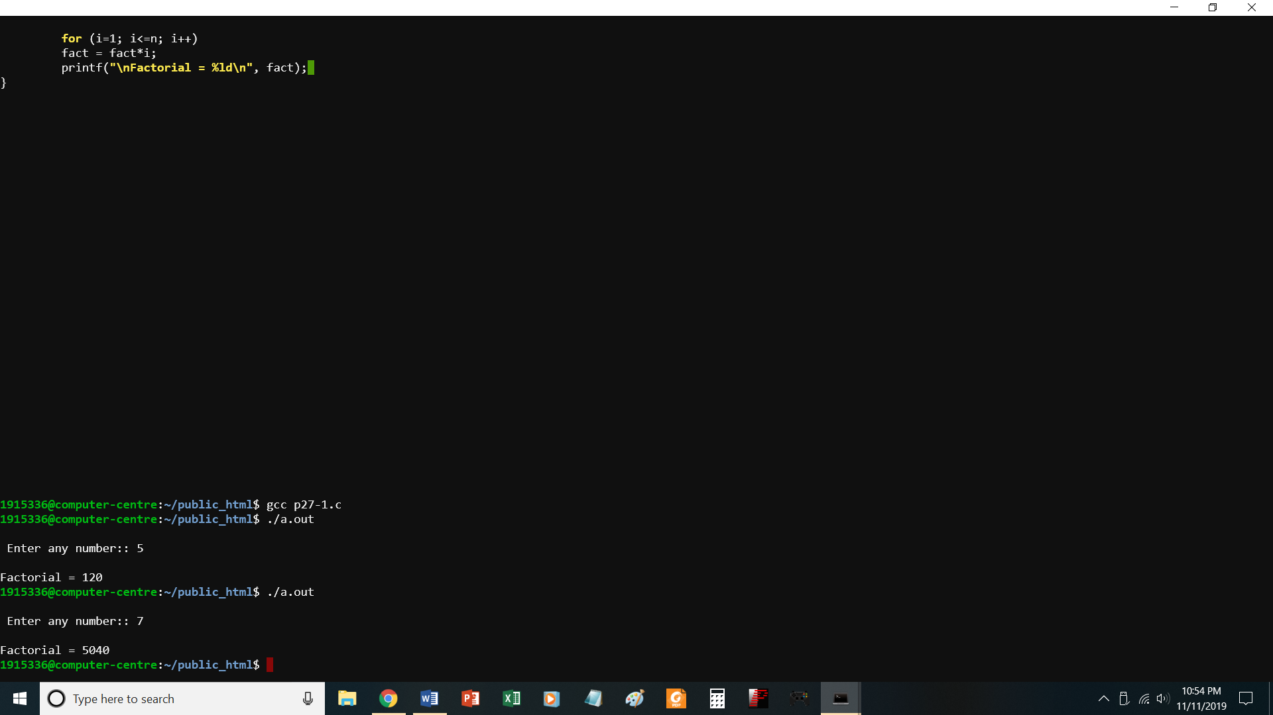
//PROGRAM TO FIND FACTORIAL OF A NUMBER WITHOUT USING RECURSION
#include <stdio.h>
void main()
{
int n, i;

printf("\n Enter any number:: ");
scanf("%d", &n);

for (i=1; i<=n; i++)
fact = fact*i;
printf("\nFactorial = %ld\n", fact);
}

P27-.c
Factorial of a number using recursion

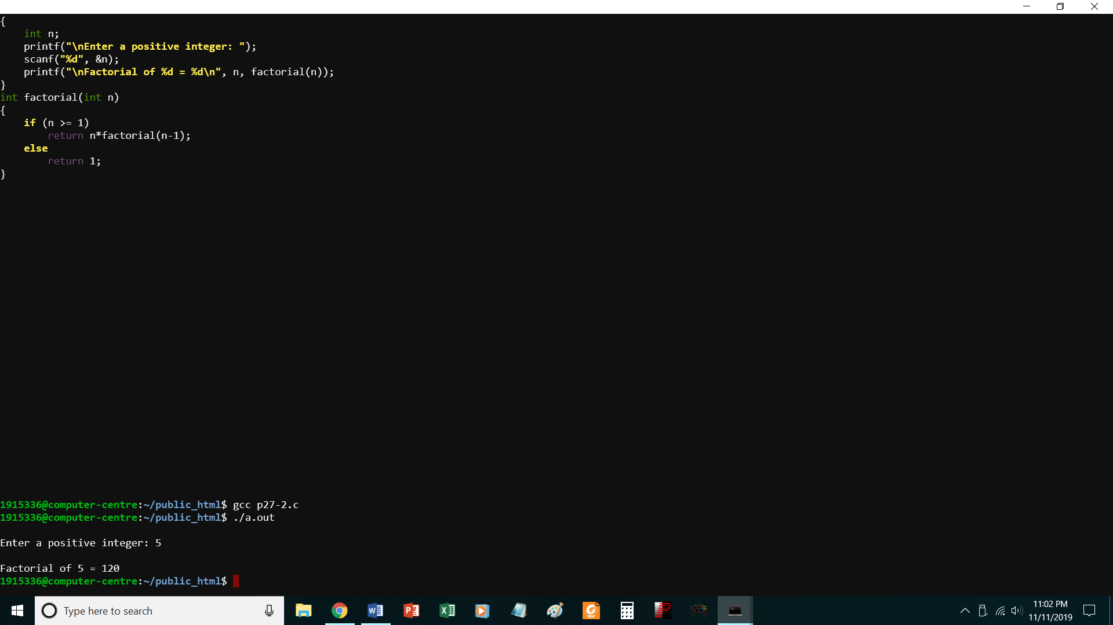

//PROGRAM TO FIND FACTORIAL OF A NUMBER USING RECURSION
#include <stdio.h>
int factorial(int n);
void main()
{
int n;
printf("\nEnter a positive integer: ");
scanf("%d", &n);
printf("\nFactorial of %d = %d\n", n, factorial(n));
}
int factorial(int n)
{
if (n >= 1)
return n*factorial(n-1);
else
return 1;
}

P28-1.c
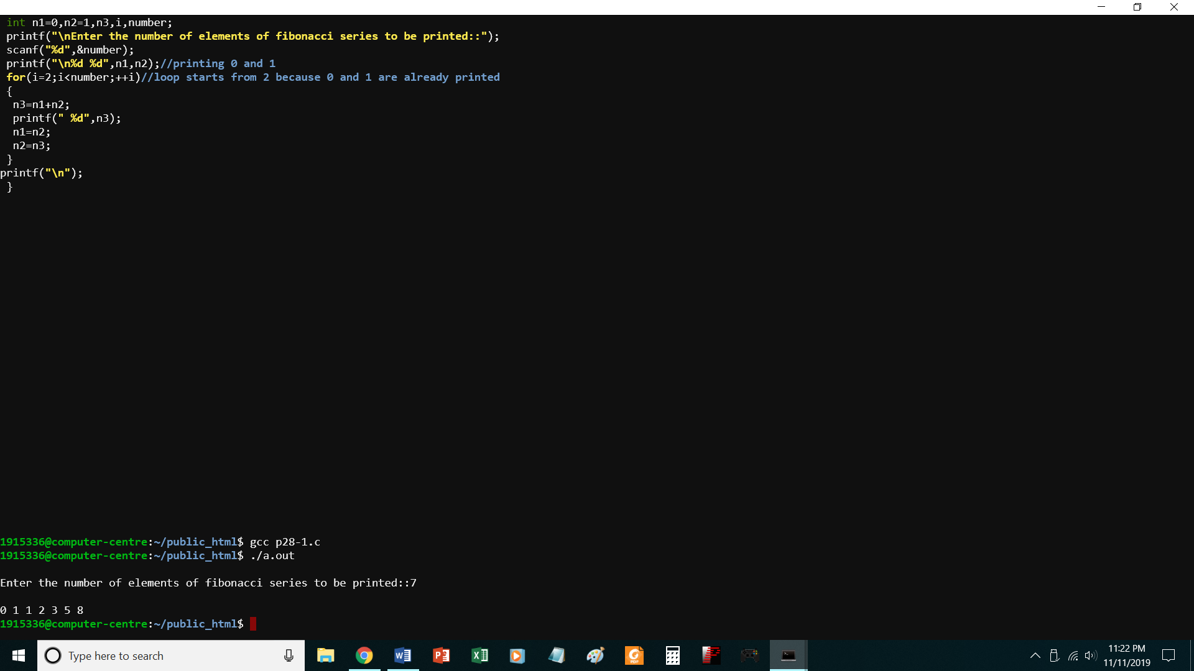
// Print Fibonacci series without recursion
#include<stdio.h>
void main()
{
int n1=0,n2=1,n3,i,number;
printf("\nEnter the number of elements of fibonacci series to be printed::");
scanf("%d",&number);
printf("\n%d %d",n1,n2);//printing 0 and 1
for(i=2;i<number;++i)//loop starts from 2 because 0 and 1 are already printed
{
n3=n1+n2;
printf(" %d",n3);
n1=n2;
n2=n3;
}
printf("\n");
}

P28-2.C
PRINT FIBONACCI SERIES USING RECURSION
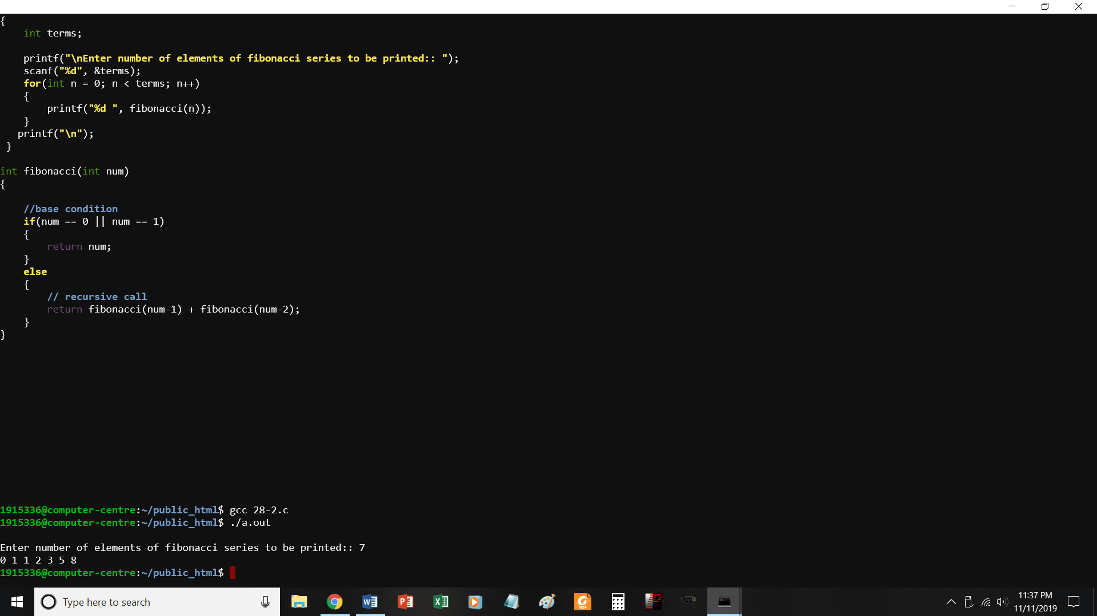
//PROGRAM TO PRINT FIBONACCI SERIES USING RECURSION
#include<stdio.h>
int fibonacci(int);
void main()
{
int terms;

printf("\nEnter number of elements of fibonacci series to be printed:: ");
scanf("%d", &terms);
for(int n = 0; n < terms; n++)
{
printf("%d ", fibonacci(n));
}
printf("\n");
}

int fibonacci(int num)
{

//base condition
if(num == 0 || num == 1)
{
return num;
}
else
{
// recursive call
return fibonacci(num-1) + fibonacci(num-2);
}
}

P29.c
Print average of 5 numbers using recursion

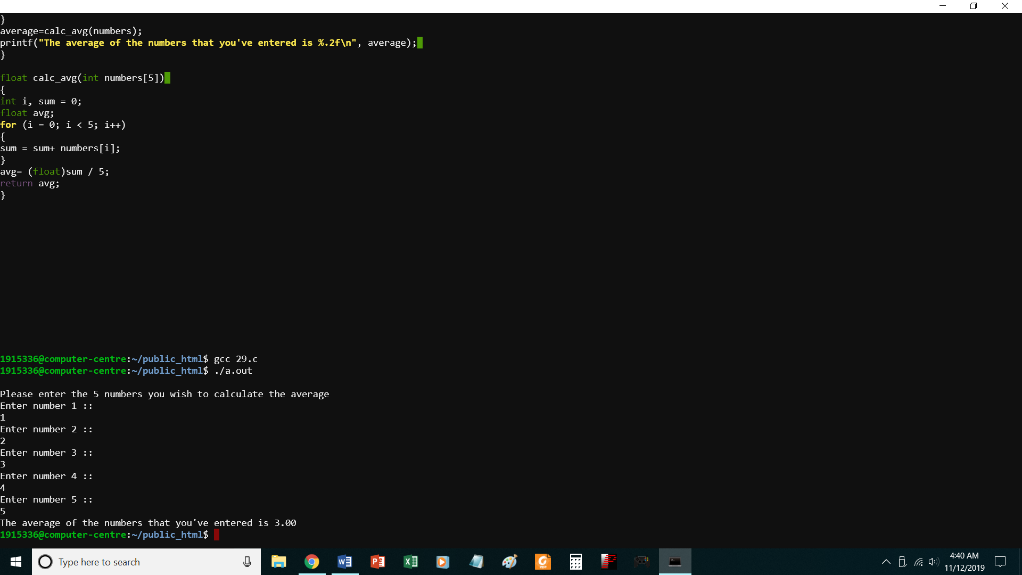

//PROGRAM TO CALCULATE AVERAGE OF 5 NUMBERS USING FUNCTIONS
#include<stdio.h>
float calc_avg(int[]);
void main()
{
int i;
int numbers[5];
float average;
printf("\nPlease enter the 5 numbers you wish to calculate the average\n");
for (i = 0; i < 5; i++)
{
printf("Enter number %d :: \n",i+1);
scanf("%d", &numbers[i]);
}
average=calc_avg(numbers);
printf("The average of the numbers that you've entered is %.2f\n", average);
}

float calc_avg(int numbers[5])
{
int i, sum = 0;
float avg;
for (i = 0; i < 5; i++)
{
sum = sum+ numbers[i];
}
avg= (float)sum / 5;
return avg;
}
P30.c perform linear and binary search
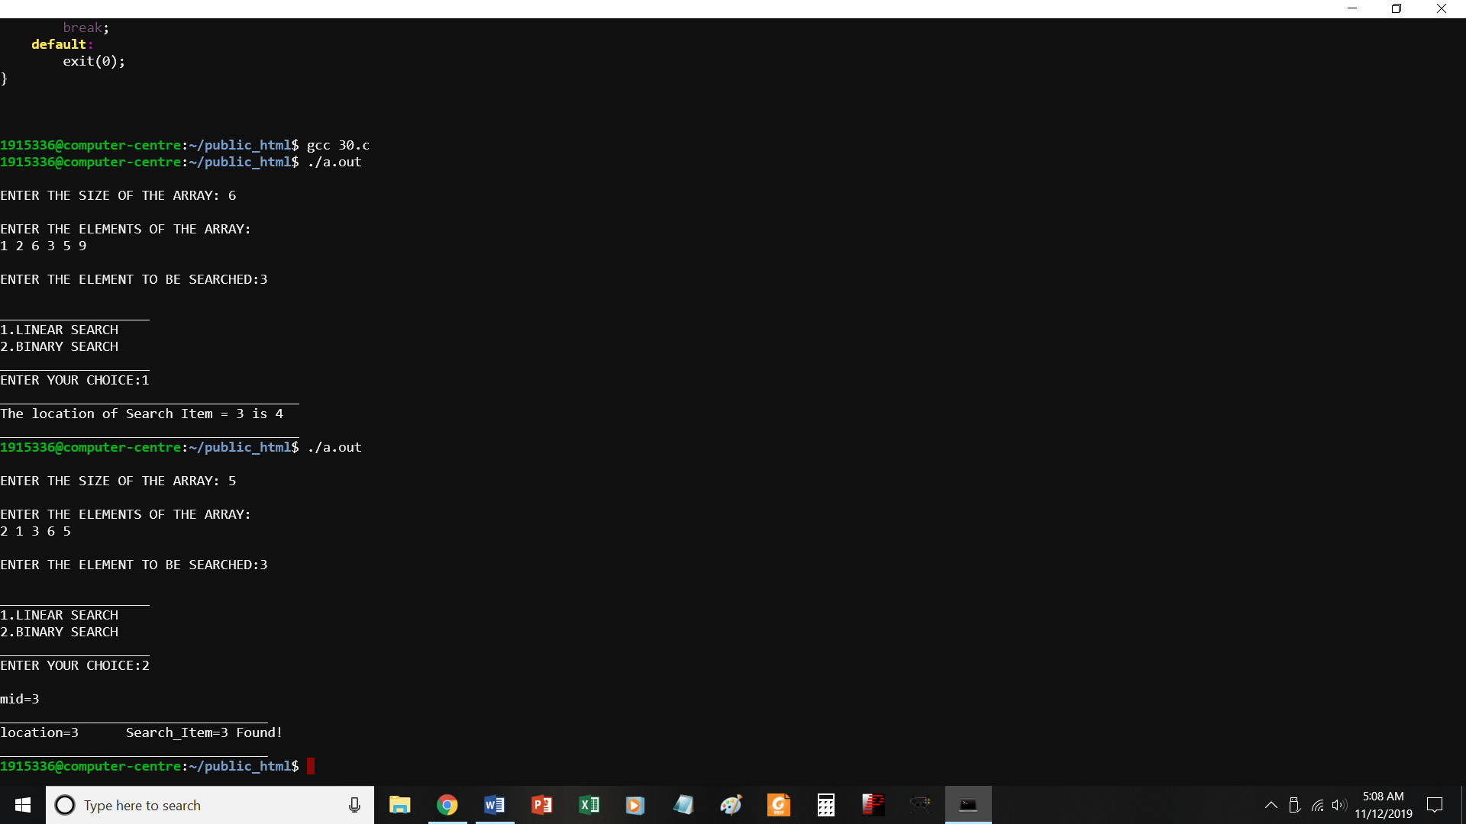

//Program to implement linear search and Binary search */

#include <stdio.h>
#include <stdlib.h>
void main()
{

int array[10],search_item,i,j,n,low,high,location,choice;
void linear_search(int search_item,int array[10],int n);
void binary_search(int search_item,int array[10],int n);
/* read the elements of array */
printf("\nENTER THE SIZE OF THE ARRAY: ");
scanf("%d",&n);
printf("\nENTER THE ELEMENTS OF THE ARRAY:\n");
for(i=1;i<=n;i++)
{
scanf("%d",&array[i]);
}
/* Get the Search element */
printf("\nENTER THE ELEMENT TO BE SEARCHED:");
scanf("%d",&search_item);
/* Choice of Search Algorithm */
printf("\n___________________\n");
printf("1.LINEAR SEARCH\n");
printf("2.BINARY SEARCH\n");
printf("___________________\n");
printf("ENTER YOUR CHOICE:");
scanf("%d",&choice);
switch(choice)
{
case 1:
linear_search(search_item,array,n);
break;
case 2:
binary_search(search_item,array,n);
break;
default:
exit(0);
}
/* LINEAR SEARCH */
void linear_search(int search_item,int array[10],int n)
{
int i,location;
for(i=1;i<=n;i++)
{
if(search_item == array[i])
{
location = i;
printf("______________________________________\n");
printf("The location of Search Item = %d is %d\n",search_item,location);
printf("______________________________________\n");
}
}
}

/* Binary Search to find Search Key */

void binary_search(int search_item,int array[10],int n)
{
int mid,i,low,high;
low = 1;
high = n;
mid = (low + high)/2;
printf("\nmid=%d\n",mid);
i=1;
while(search_item != array[mid])
{
if(search_item <= array[mid])
{
low = 1;
high = mid+1;
mid = (low+high)/2;
}
else
{
low = mid+1;
high = n;
mid = (low+high)/2;
}
}
printf("__________________________________\n");
printf("location=%d\t",mid);
printf("Search_Item=%d Found!\n",search_item);
printf("__________________________________\n");
}

P31.c
To perform bubble sort
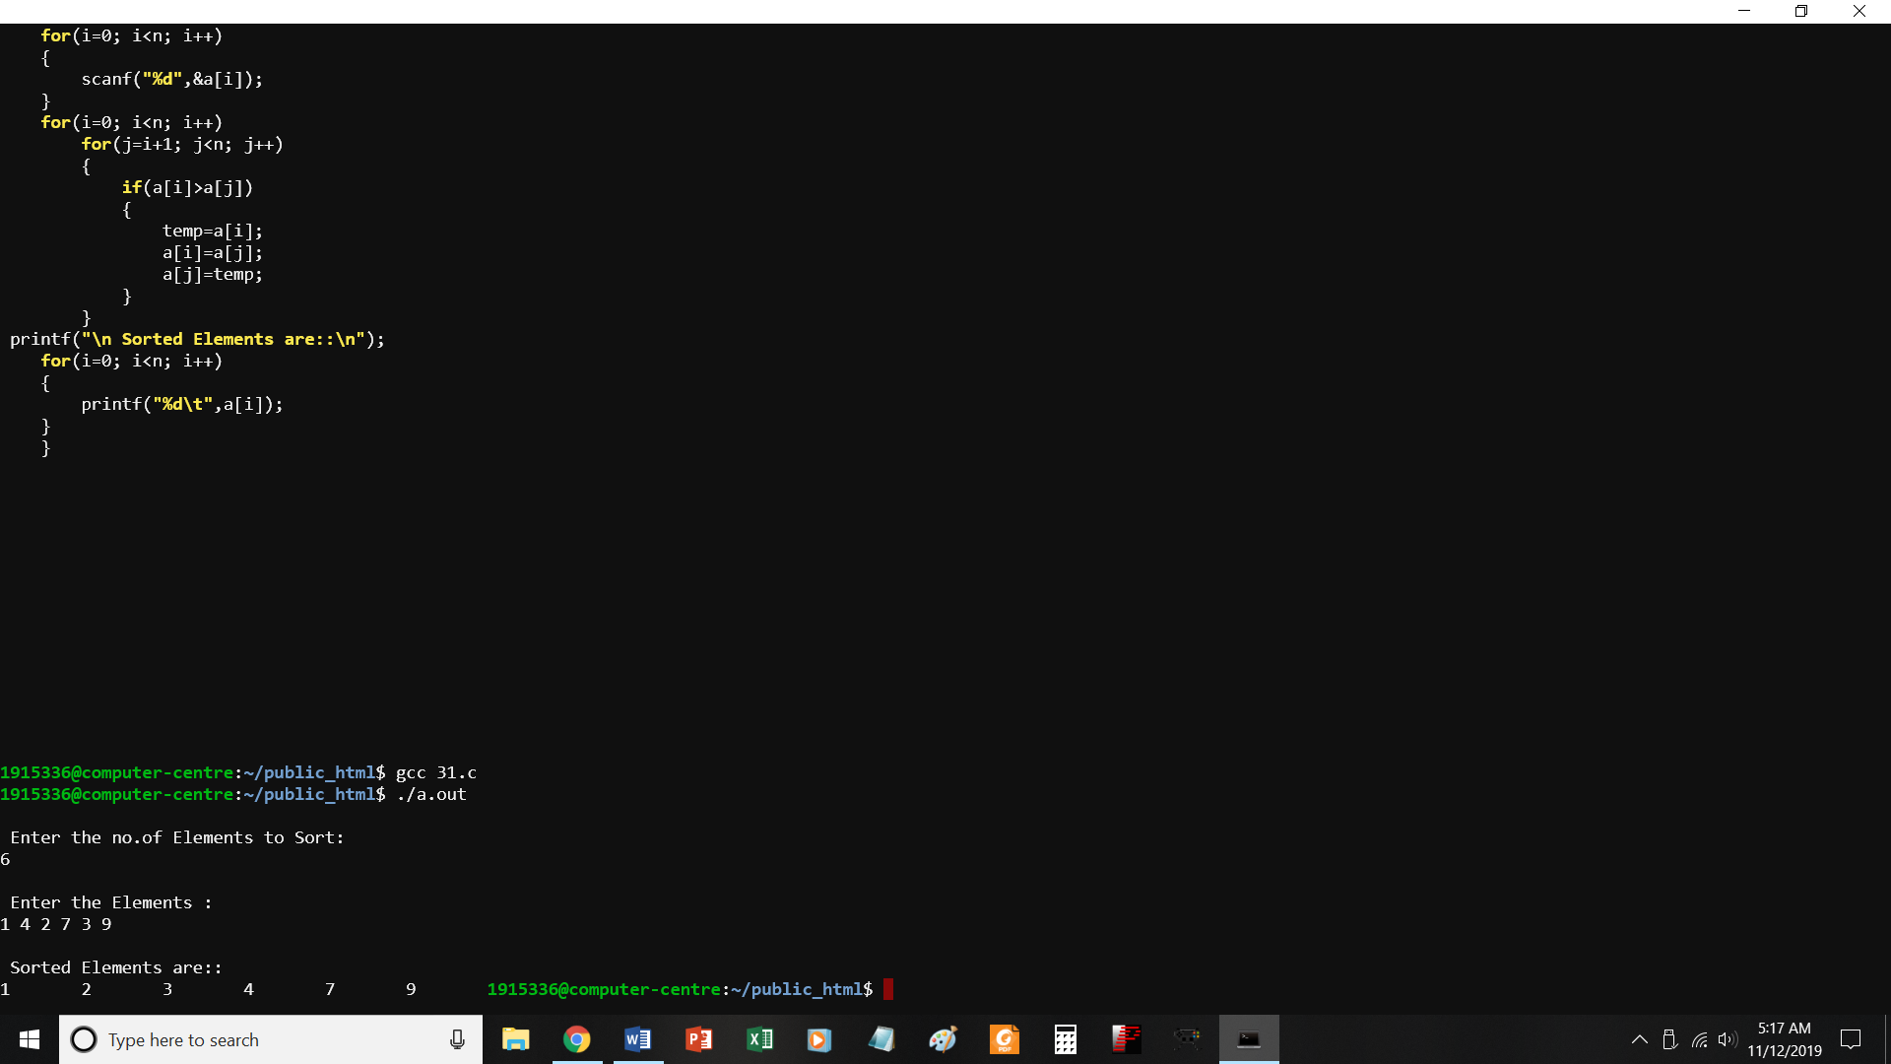
//PROGRAM TO IMPLEMENT BUBBLE SORT
#include<stdio.h>
void main()
{
int a[10],i,j,temp,n;
printf("\n Enter the no.of Elements to Sort: \n");
scanf("%d",&n);
printf("\n Enter the Elements : \n");
for(i=0; i<n; i++)
{
scanf("%d",&a[i]);
}
for(i=0; i<n; i++)
for(j=i+1; j<n; j++)
{
if(a[i]>a[j])
{
temp=a[i];
a[i]=a[j];
a[j]=temp;
}
}
printf("\n Sorted Elements are::\n");
for(i=0; i<n; i++)
{
printf("%d\t",a[i]);
}
}
P32.c
Store info of 10 students using array of structures
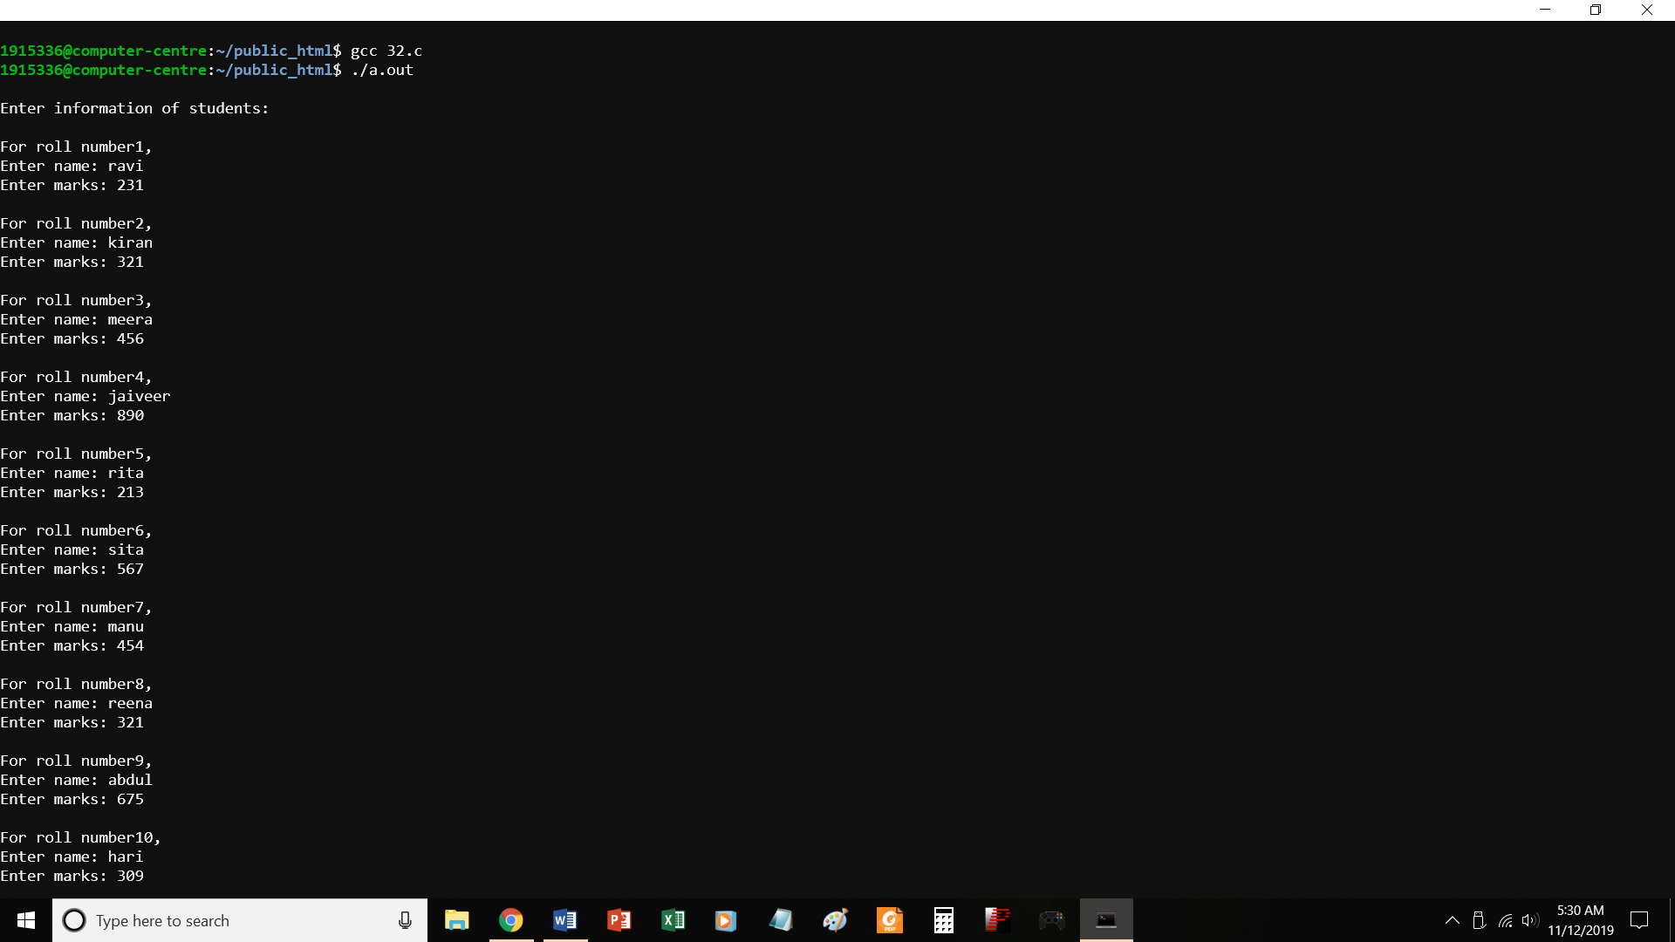
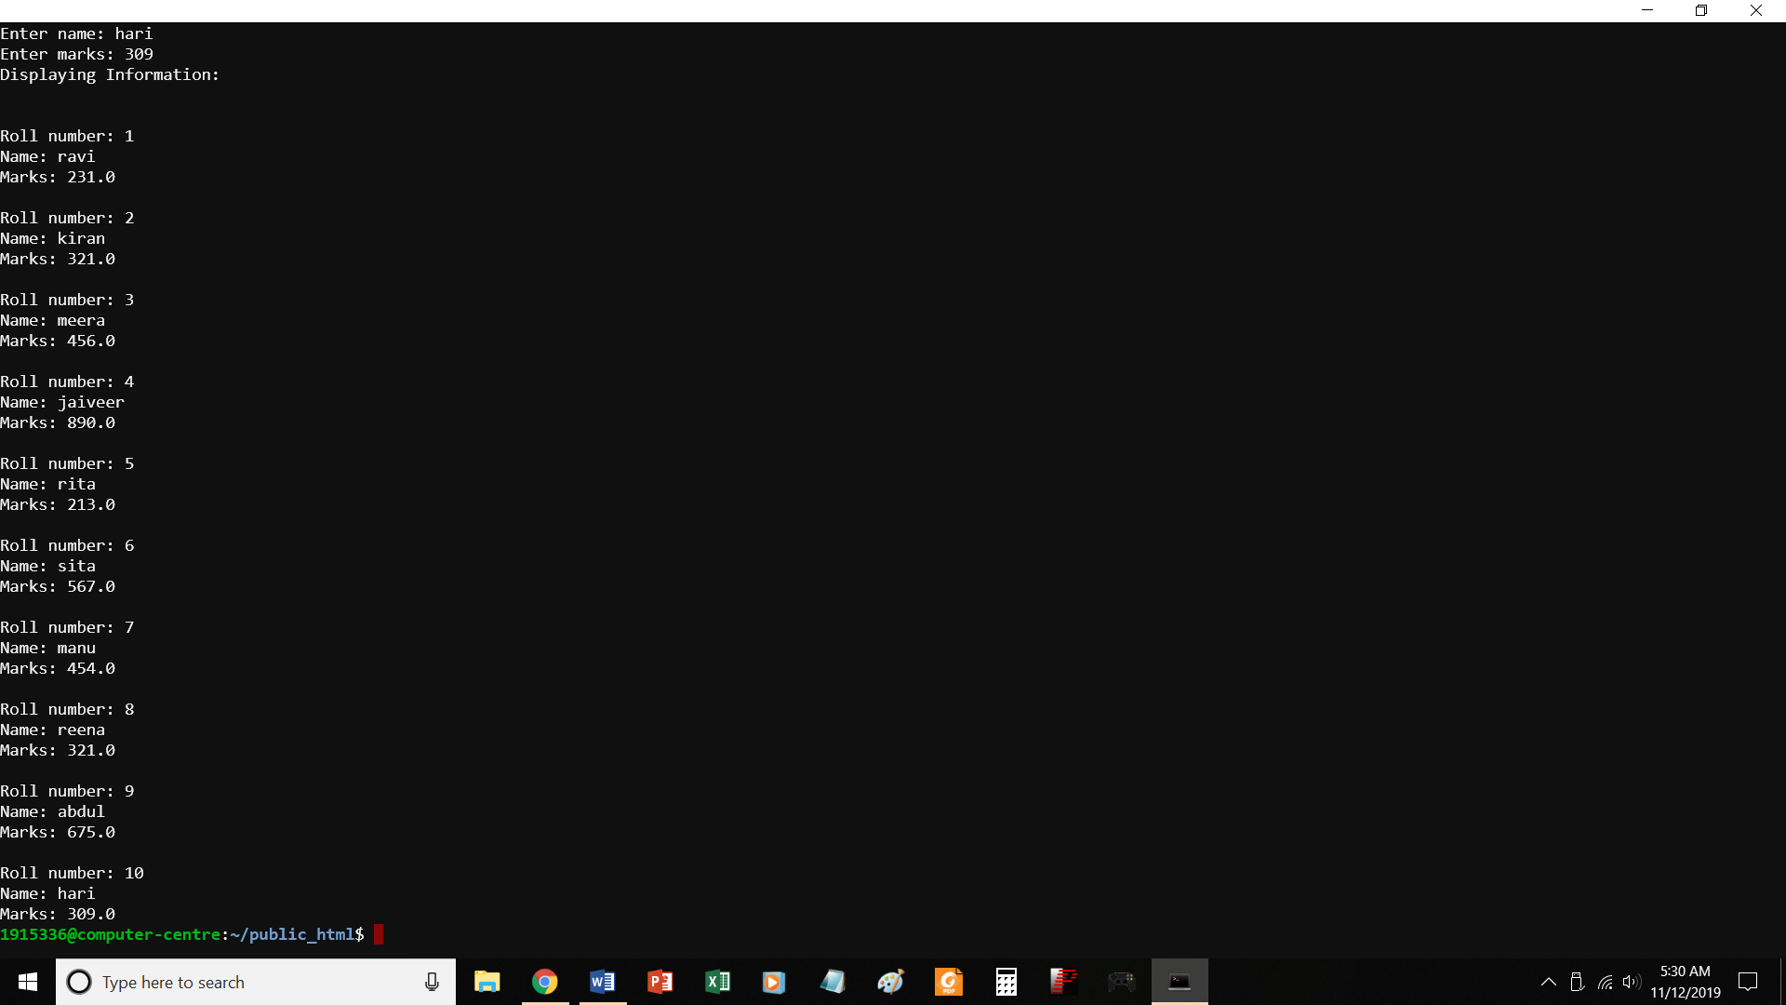
//PROGRAM TO STORE INFO OF 10 STUDENTS USING ARRAY OF STRUCTURES
#include <stdio.h>
struct student
{
char name[50];
int roll;
float marks;
} s[10];
void main()
{
int i;
printf("\nEnter information of students:\n");
// storing information
for(i=0; i<10; ++i)
{
s[i].roll = i+1;
printf("\nFor roll number%d,\n",s[i].roll);
printf("Enter name: ");
scanf("%s",s[i].name);
printf("Enter marks: ");
scanf("%f",&s[i].marks);
// printf("\n");
}
printf("Displaying Information:\n\n");
// displaying information
for(i=0; i<10; ++i)
{
printf("\nRoll number: %d\n",i+1);
printf("Name: ");
puts(s[i].name);
printf("Marks: %.1f",s[i].marks);
printf("\n");
}
}

P33.c
Program to print transpose of a matrix
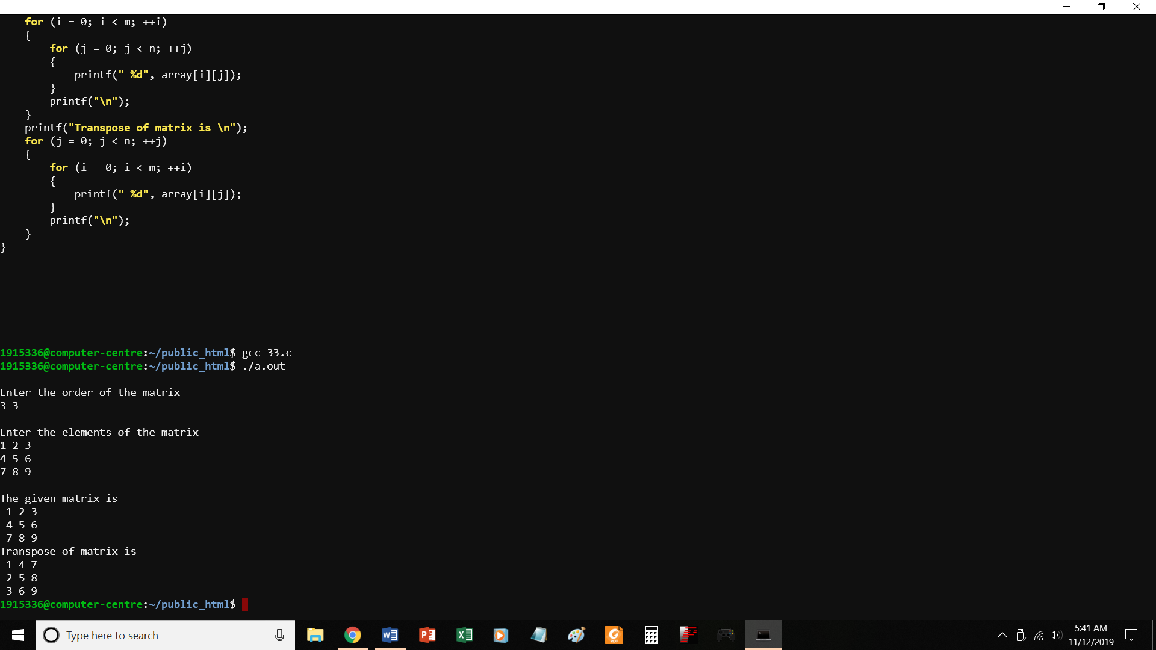
//PROGRAM TO PRINT TRANSPOSE OF A MATRIX
#include <stdio.h>
void main()
{
static int array[10][10];
int i, j, m, n;
printf("\nEnter the order of the matrix \n");
scanf("%d %d", &m, &n);
printf("\nEnter the elements of the matrix\n");
for (i = 0; i < m; ++i)
{
for (j = 0; j < n; ++j)
{
scanf("%d", &array[i][j]);
}
}
printf("\nThe given matrix is \n");
for (i = 0; i < m; ++i)
{
for (j = 0; j < n; ++j)
{
printf(" %d", array[i][j]);
}
printf("\n");
}
printf("Transpose of matrix is \n");
for (j = 0; j < n; ++j)
{
for (i = 0; i < m; ++i)
{
printf(" %d", array[i][j]);
}
printf("\n");
}
}

P34.C
PRINT ADDRESS OF VARIABLES USING POINTERS

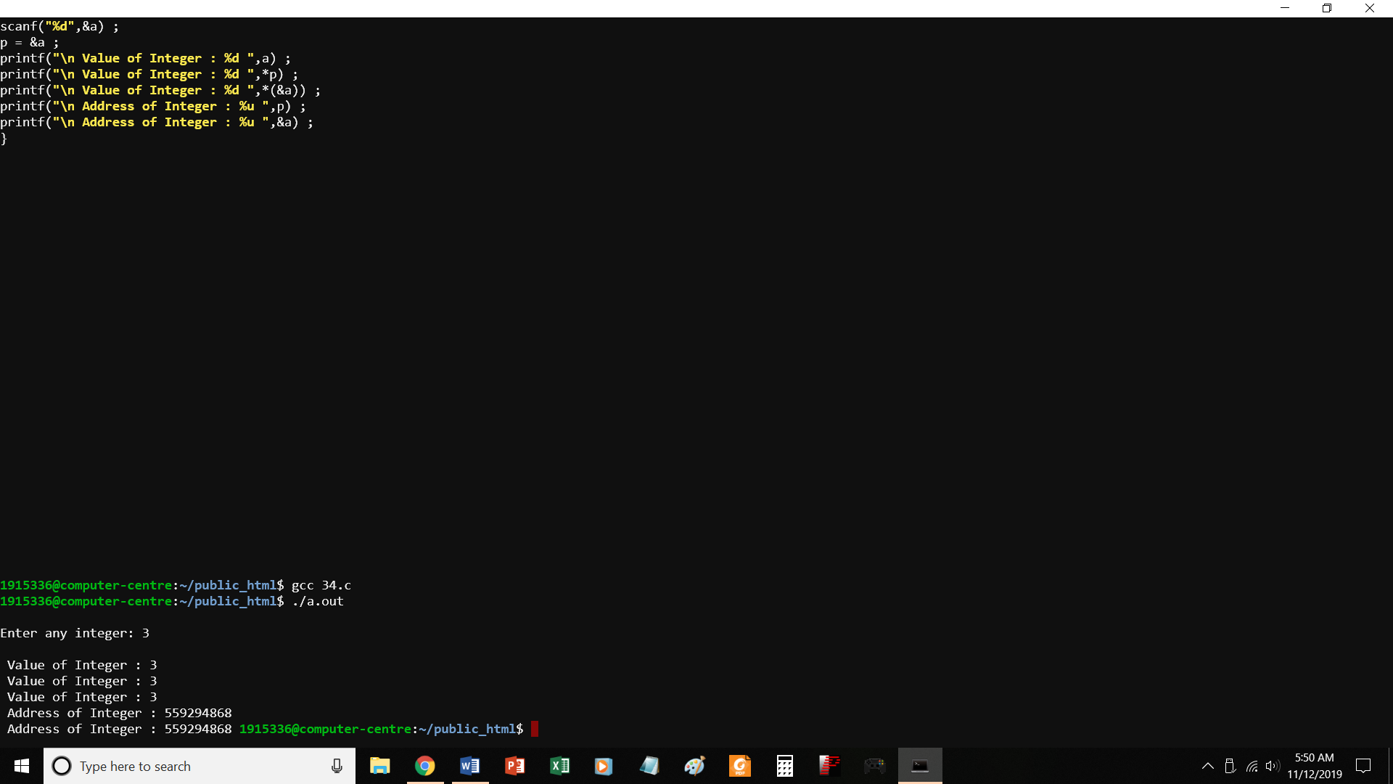
//PROGRAM TO PRINT ADDRESS OF VARIABLES USING POINTERS
#include <stdio.h>
void main( )
{
int a ;
int *p ;
printf("\nEnter any integer: ") ;
scanf("%d",&a) ;
p = &a ;
printf("\n Value of Integer : %d ",a) ;
printf("\n Value of Integer : %d ",*p) ;
printf("\n Value of Integer : %d ",*(&a)) ;
printf("\n Address of Integer : %u ",p) ;
printf("\n Address of Integer : %u ",&a) ;
}

P35.c Access array elements using pointers
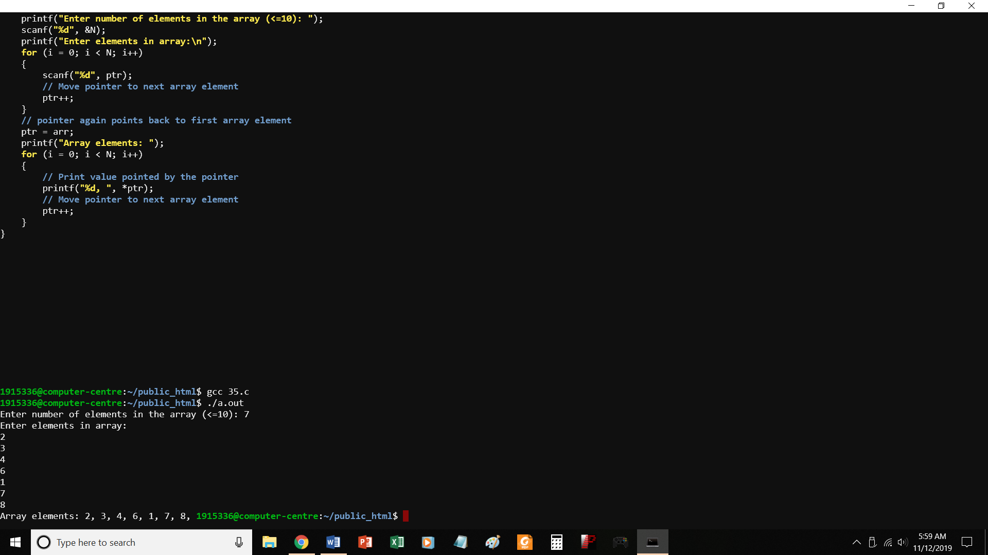
//PROGRAM TO ACCESS ARRAY ELEMENTS USING POINTERS

#include <stdio.h>
void main()
{
int arr[10];
int N, i;
int * ptr = arr; // Pointer to arr[0]

printf("Enter number of elements in the array (<=10): ");
scanf("%d", &N);
printf("Enter elements in array:\n");
for (i = 0; i < N; i++)
{
scanf("%d", ptr);
// Move pointer to next array element
ptr++;
}
// pointer again points back to first array element
ptr = arr;
printf("Array elements: ");
for (i = 0; i < N; i++)
{
// Print value pointed by the pointer
printf("%d, ", *ptr);
// Move pointer to next array element
ptr++;
}
}

