Testing Project 2

By Gabrielle Neafsey-Wroten

Introduction

Welcome! This is a GUI that will allow you, the user, to interact with a collection of Tweets, and even add to or remove from the existing collection.

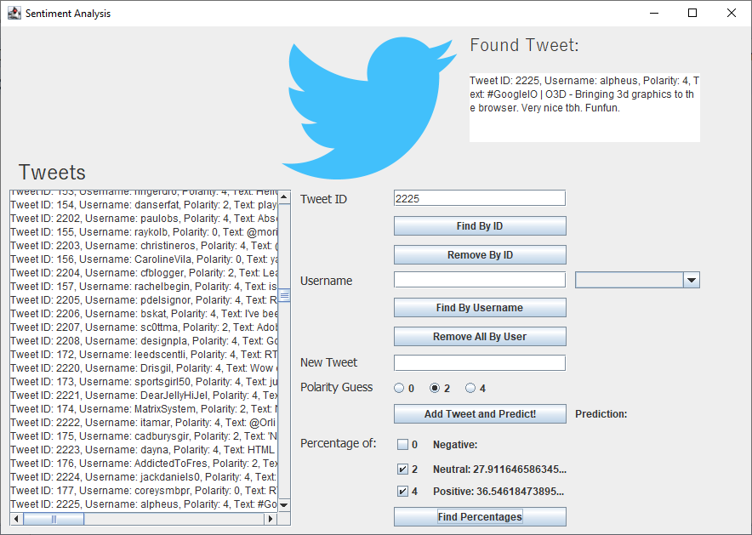

Searching for Tweets

To search for specific Tweets, you can type the exact ID number of the Tweet you seek into the Tweet ID field, or you can look them up by username in the Username field. Looking up Tweets by username will populate a dropdown list with Tweet ID numbers for you to choose from. Whichever way you choose, you will click “Find By ID” or “Find By Username” (and if you do the latter you will select the Tweet ID you want from the dropdown list), and the Tweet will populate in the text area box at the top right of the window.

Removing Tweets

To remove a single Tweet, type the ID number of the Tweet you want to remove into the Tweet ID text field and click the “Remove By ID” button. To remove all Tweets in the collection owned by one user, type the username into the Username text field and click the “Remove All By User” button.

Adding a Tweet and Predicting Its Polarity

To add a new Tweet, you must enter your username into the Username text field. Then type your Tweet out in the New Tweet text field. Feel free to make a prediction on your Tweet’s polarity by clicking one of the radio buttons! By default, the program will predict a neutral polarity (2) for your Tweet. Click the “Add Tweet and Predict!” button to add your Tweet to the collection and see the result!

Finding Percentages of Positive, Neutral, and Negative Tweets

To find out what percentage of Tweets in the collection correspond to what polarity, click any or all of the check boxes and click the “Find Percentages” button.