PHOTO VIEWER

ABSTRACT

This is a Photo viewer; it is designed in java programming language as a simple console application. In this project, we are going to show the slide show of the images.
In this we are also going to show collage view of images, we can do text editing on images, we can add GIF, borders, emoji to it. We can also save the slideshow and pictures after editing. This project is User friendly software. In this project the images of all file formats can be viewed. Normally, the photo viewers’ work especially in a particular version of windows but our project is java based and therefore could run in any version. In this project, we are going to show slide show with the help of swing library and GUI interface.

TABLE OF CONTENTS Page No.
Certificate i
Acknowledgement ii
Abstract iii
- Introduction
  - The Beginning of Java 1
  - Features of Java 1
  - About Project 3
- Materials and Methods
  - Technology used 4
  - Packages imported 4
  - Methods used 5
- Results
  - Result Snapshot 8
- Discussion
  - Future Scope 12
  - Conclusion 12
References 13

List of Figures Page No.
- Image Editor 8
- Different image options 8
- File choose option in edit image 9
- Before editing the image 9
- After editing the image 10
- Slideshow 10
- Slideshow created 11

CHAPTER 1 INTRODUCTION

The Beginning of Java

Java is an object-oriented programming language developed by Sun Microsystems in 1991 and released in 1995 as a core component of Sun’s Java platform. The language derives much of its syntax from C and C++, but has a simpler object model and fewer low level facilities. The Java language was designed to be small, simple, and portable across platforms and operating systems. The Java language was developed as part of a research project to develop software for consumer electronics devices— television sets, VCRs, toasters, and the other sorts of machines we can buy at any department store. Java’s goals at that time were to be small, fast, efficient, and easily portable to a wide range of hardware devices.

Features of Java

Features of Java are as follows:

- Compiled and Interpreted

- Platform Independent and portable

- Object- oriented

- Robust and secure

- Distributed

- Familiar, simple and small

- Multithreaded and Interactive

- High performance

- Dynamic and Extensible

- Compiled and Interpreted: Basically a computer language is either compiled or interpreted. Java comes together both these approach thus making Java a two-stage system. Java compiler translates Java code to Byte-code instructions and Java Interpreter generate machine code that can be directly executed by machine that is running the Java program.
- Platform Independent and portable: Java supports the feature portability. Java programs can be easily moved from one computer system to another and anywhere. Changes and upgrades in operating systems, processors and system resources will not force any alteration in Java programs.
- Object- oriented: Java is truly object-oriented language. In Java, almost everything is an Object. All program code and data exist in objects and classes. Java comes with an extensive set of classes; organize in packages that can be used in program by Inheritance.
- Robust and secure: Java is a most strong language which provides many securities to make certain reliable code. It is design as garbage –collected language, which helps the programmers virtually from all memory management problems.
- Distributed: Java is called as Distributed language for construct applications on networks which can contribute both data and programs. Java applications can open and access remote objects on Internet easily. That means multiple programmers at multiple remote locations to work together on single task.
- Simple and small: Java is very small and simple language. Java does not use pointer and header files, go to statements, etc.
- Multithreaded and Interactive: Multithreaded means managing multiple tasks simultaneously. Java maintains multithreaded programs. That means we need not wait for the application to complete one task before starting next task.
- High performance: Java performance is very extraordinary for an interpreted language, majorly due to the use of intermediate byte-code. Java architecture is also designed to reduce overheads during runtime. The incorporation of multithreading improves the execution speed of program.
- Dynamic and Extensible: Java is also dynamic language. Java is capable of dynamically linking in new class, libraries, methods and objects. Java can also establish the type of class through the query building it possible to either dynamically link or abort the program, depending on the reply.

About Project

The Photo Viewer is designed in java programming language as a simple console application. In this project, we are going to show the slide show of the images. In this we are also going to show collage view of images, we can do text editing on images, we can add GIF, borders, emoji to it.
In this project, we are going to show slide show with the help of swing library and GUI interface.

Swing Library: Java Swing is a lightweight java graphical user interface toolkit that includes various widgets. It contains various packages for desktop application. Swing includes built-in controls such as image buttons, sliders, toolbars and text areas to display HTTP.
Some of the advantages of Photo Viewer are:

- User friendly software.

- In this project, the images of all file formats can be viewed.

- Normally, the photo viewers’ work especially in a particular version of windows but our project is java based and therefore could run in any version.

CHAPTER 2 MATERIALS AND METHODS

Technology Used

JAVA: Java is a programming language and computing platform first released by Sun Microsystems in 1995. There are lots of applications and websites that will not work unless you have Java installed, and more are created every day. Java is fast, secure, and reliable. Object – Oriented language java is an object-oriented language similar to C++, but simplified to eliminate language features that cause common programming errors. Java source code files (files with a.java extension) are compiled into a format called bytecode (files with a. class extension), which can then be executed by a Java interpreter. Compiled Java code can run on most computers because
NETBEANS: NetBeans is an integrated development environment (IDE) for Java. NetBeans allows applications to be developed from a set of modular software components called modules. NetBeans runs on Microsoft Windows, macOS, Linux and Solaris. In addition to Java development, it has extensions for other languages like PHP, C, C++ and HTML5. Javadoc and Javascript. Applications based on NetBeans, including the NetBeans IDE, can be extended by third party developers.
NOTEPAD: Notepad is a simple text editor for Microsoft Windows and a basic text-editing program which enables computer users to create documents. It has been included in all versions of Microsoft Windows since Windows 1.0 in 1985. Features Notepad is a common text-only (plain text) editor. The resulting files—typically saved with the .txt extension—have no format tags or styles, making the program suitable for editing system DOS environment and, occasionally, source code for later compilation or execution, usually through a command prompt. It is also useful for its negligible use of system resources; making for quick load time and processing time, especially on under-powered hardware. Notepad supports both left-to-right and right-to-left based languages.

Packages Imported

    - Java.awt- it is the main package of AWT (Abstract Windowing Toolkit). It contains classes for graphics and also defines the graphical user interface (GUI) framework for JAVA.
    - Java.awt.event- this package is used for event handling in the AWT.

    - Java.awt.image- this package is used as the image control. It is a superclass for all image classes representing graphical images
    - Jawa.awt.color- The color class states color in the default SRGB color space or colors in arbitrary color spaces identified by a ColorSpace
    - Jawa.awt.geom- This package provides the Java 2D classes for defining and performing operations on objects related to two dimensional geometry.
    - Java.io- This package provides for system input and output through data streams, serialization and the file system.
    - Java.imageio- It is the main package of the Java Image I/O API It includes:
- Javax.imageio.event
- Javax.imageio.metadata

Java.swing-
- Java.swing.event- Provides for events for swing components
- Java.swing.filechooser- Contains classes and interfaces used by the JFileChooser component.

Methods used:

MouseListener Interface:

The Java MouseListener is notified whenever you change the state of mouse. It is notified against MouseEvent. The MouseListener interface is found in java.awt.event package. It has five methods.

The signatures of 5 methods found in MouseListener interface are given below:

  - public abstract void mouseClicked(MouseEvent e);
  - public abstract void mouseEntered(MouseEvent e);
  - public abstract void mouseExited(MouseEvent e);
  - public abstract void mousePressed(MouseEvent e);
  - public abstract void mouseReleased(MouseEvent e);

paint (graphics g):

When an applet starts executing, paint( Graphics g ) is automatically called. It paints the screen. If you want other methods to produce graphics, you must pass the parameter g2 to them from paint.

Set color (graphics):

This method sets this graphics context's current color to the specified color. All subsequent graphics operations using this graphics context use this specified color.

reset:

reset() method will restore all of these defaults within the class

keypreesed:

Invoked when a key has been pressed.

initialize:

If you don't explicitly declare a constructor in a class, the Java compiler will create a default constructor on the fly, then translate that default constructor into a corresponding instance initialization method.

makeImageRotate:

Helps to rotate the image

resize image:

Helps to resize the image

setValue:

this method is invoked when the user makes change to the image slider

setActionSlided:

Set a boolean value the actionSlided variable

setActionResized:

Set a boolean value the actionResized variable

makeTransparency:

This method works well if the background of the image has a single color value (e.g. white, blue, etc.)

setText:

Assign values to the variables used in drawing text on the image

init:

When an applet is loaded by the Java plugin of a browser or by an applet viewer, it will first call the Applet.init method. Any initializations that are required to use the applet should be executed here. The init method is the first method called in an Applet or JApplet.

CHAPTER 3 RESULT
3.1 Result Snapshots
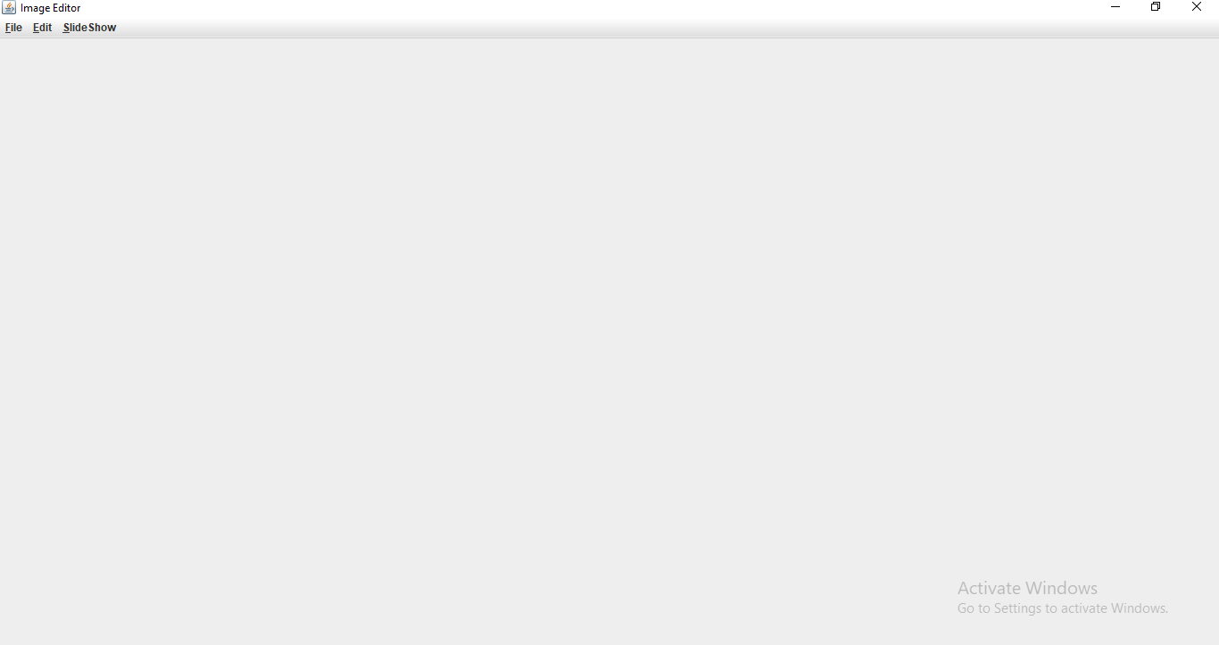

Fig 3.1 Image Editor
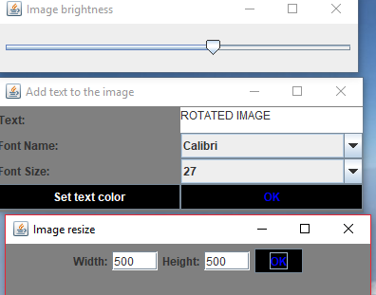

Fig 3.2 Different image option

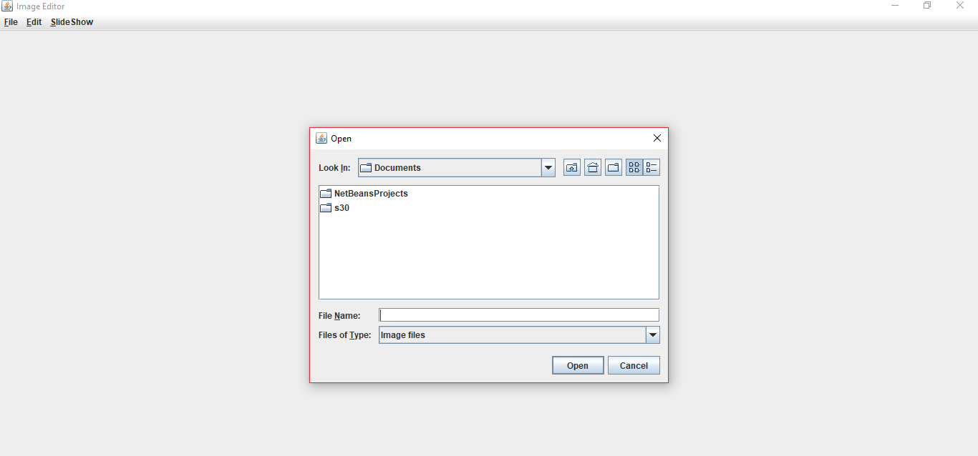

Fig 3.3 File choose option in edit image
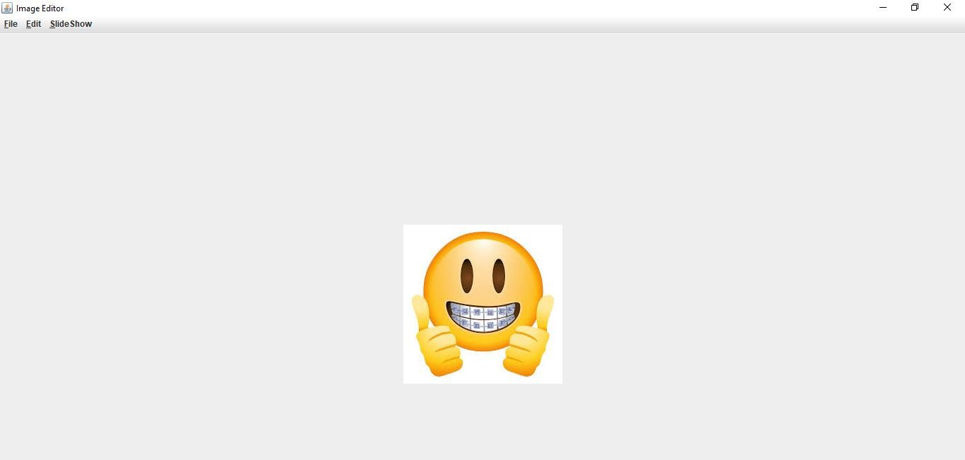

Fig 3.4 Before editing the image

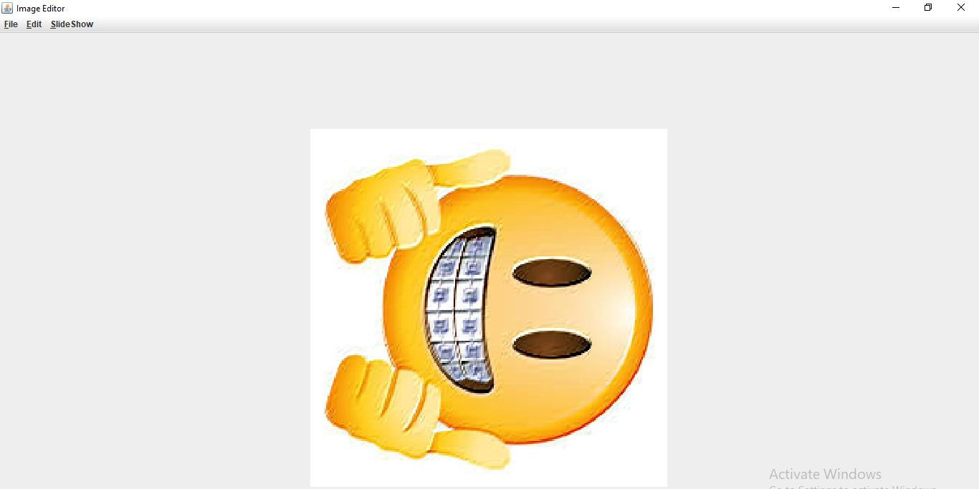

Fig 3.5 After editing the image
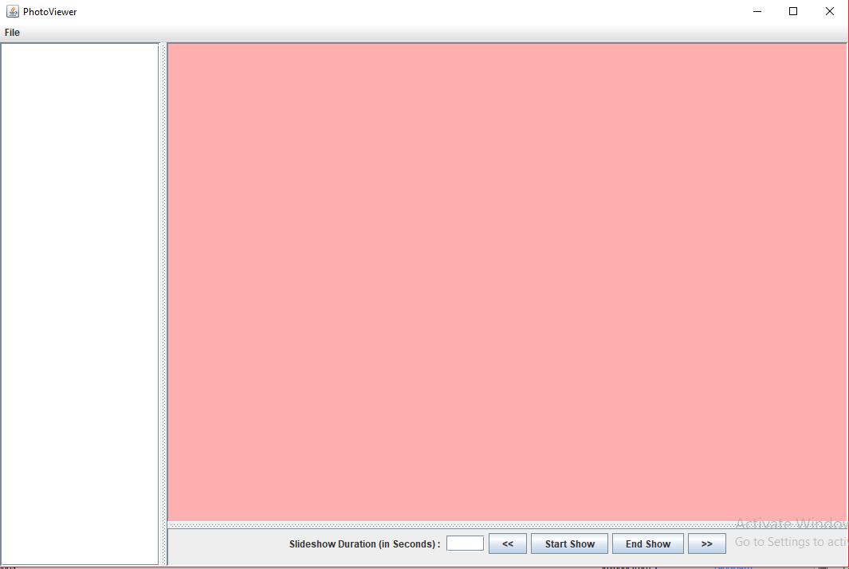

Fig 3.6 Slideshow

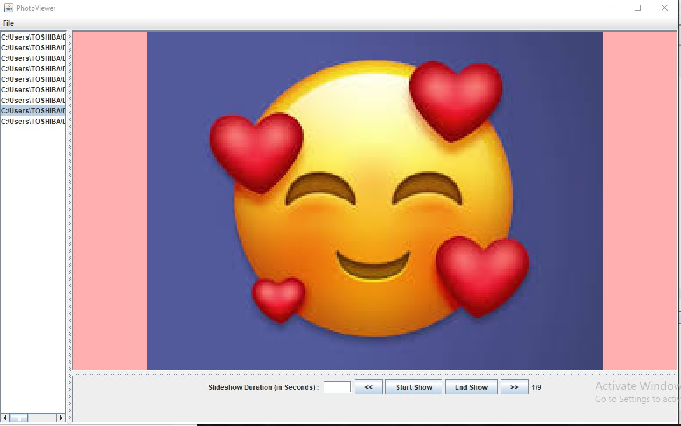

Fig 3.7 Slideshow created

CHAPTER 4 DISSCUSION

41. FUTURE SCOPE

The Photo Viewer that we made is not the final project. We will develop this project in the future. Many new features can be added to this Photo Viewer. We will add more editing features in the slideshow. We will add the option of music in this Photo Viewer. The user can choose the music of his/her choice and even he/she can also decide the time interval of music. We will try to add more features to this project.

CONCLUSION

In this project, we have showed the slide show of the images. In this we have made the collage view of images, we can do text editing on images; we can add GIF, borders, emoji to it. We can save the photos after editing. We can make the slideshow by choosing the pictures which we want to show and enen we can also save the slideshow. This project helped us to make a Photo viewer by using Java and how to import packages and call methods in Java.

REFRENCES

    - H. Schildt, Java the complete reference, Mcgraw Higher Ed, New Delhi, 2011.
    - J. Jukowski, Mastering Java, Sybex Inc, New Delhi, 2002.
    - https://www.javatpoint.com/java-awt
    - https://www.tutorialspoint.com/javaexamples/java_simple_gui.htm

