Assembly instructions

M3 Inserts.

Buffer tower

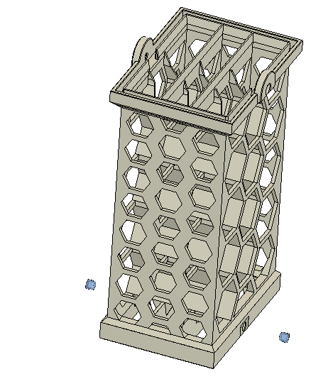

Interface block
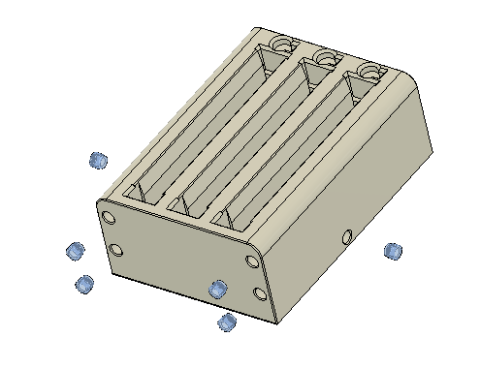

Case
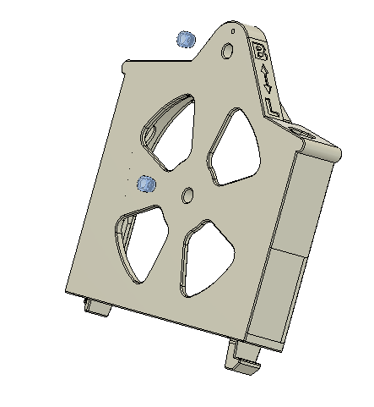

6x3 Magnets

Interface block
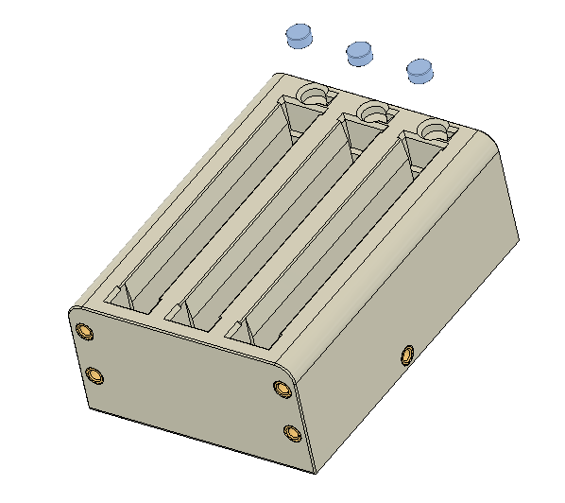

Case
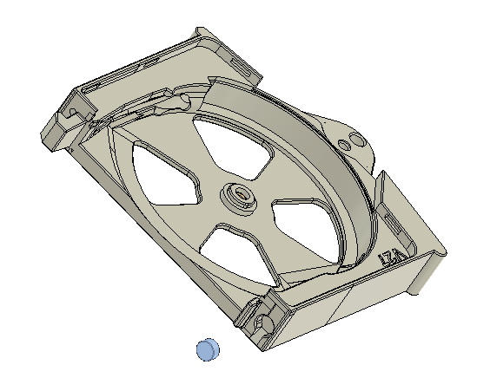

Assembling the parts.

The buffer tower stack.
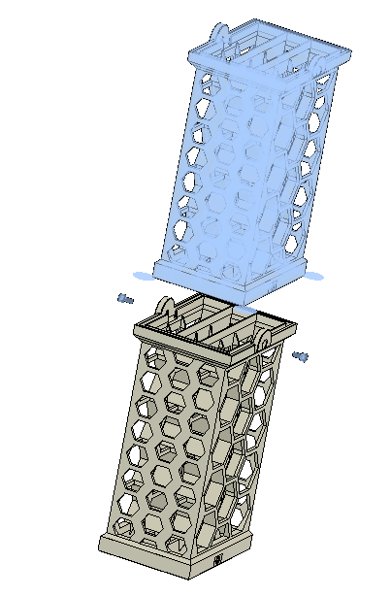
Use as many tower as you need.

M3x6 SHCS

Assembling the interface block to the Buffer tower
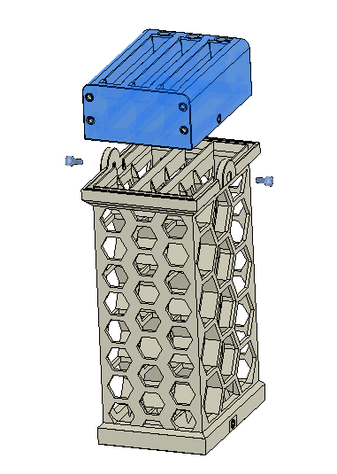

M3x6 SHCS

Assembling the buffer Head

Inserting the bearing to the wheel
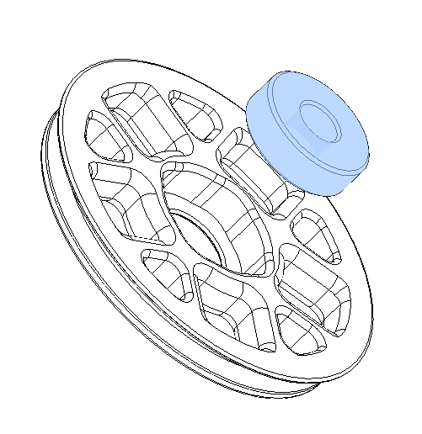
608ZZ bearing

Assembling the wheel to the head case
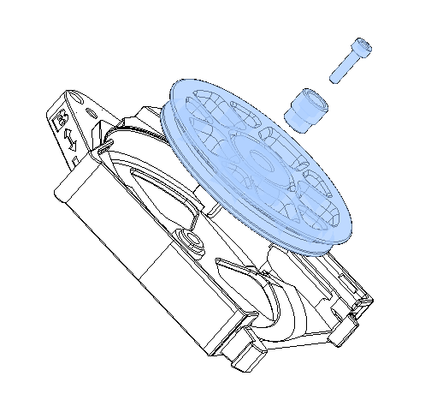
M3x12 SHCS

Wheel Hub

Assembling the guide to the head
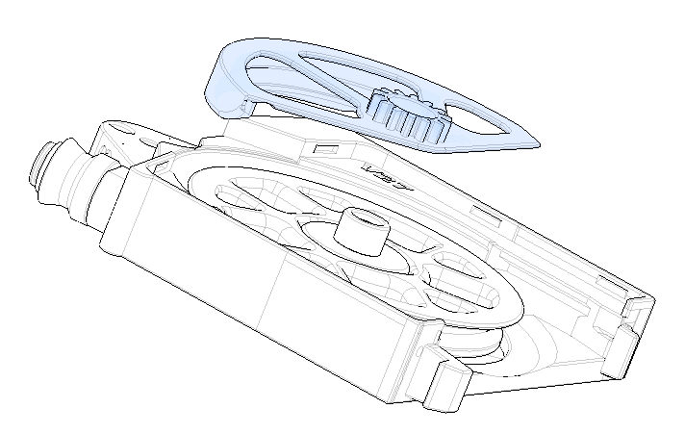

Optional spring and ball bearing.
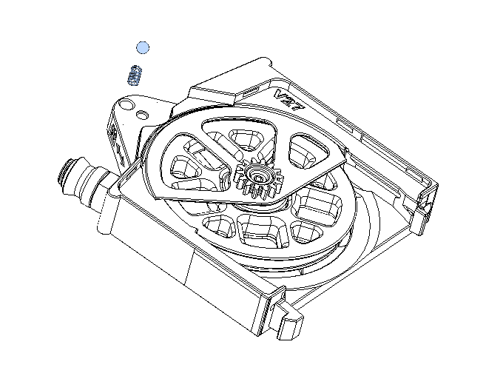
4mm ball
3.5x6x0.5 spring

Assembling the lever.
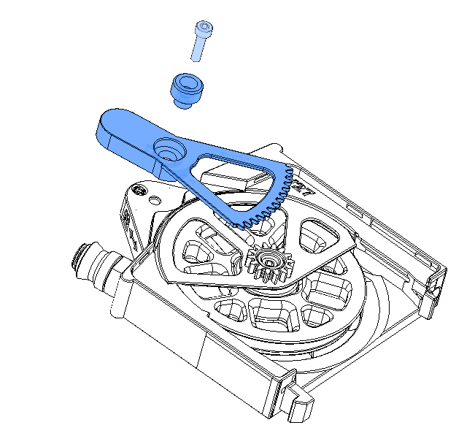
M3x12 SHCS
Lever Hub

Adjusting the gear.
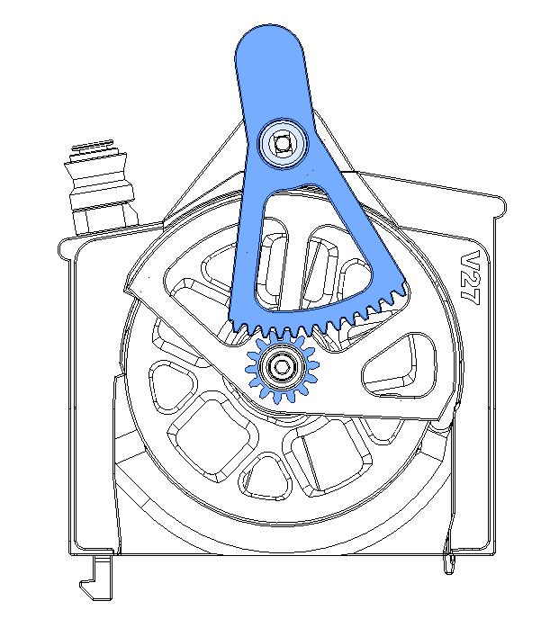

2 free teeth.

Closing the head
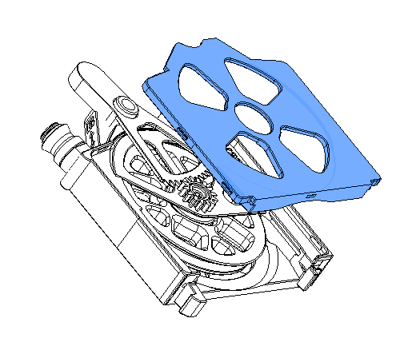

Installing the head on the interface block.
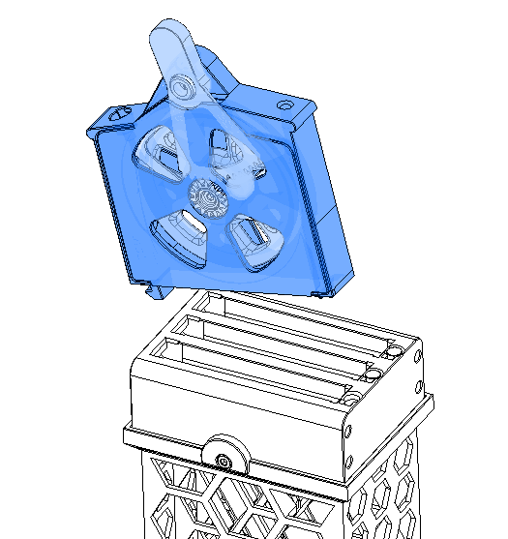
Insert the hook first, then tilt the head so the magnets stick together.

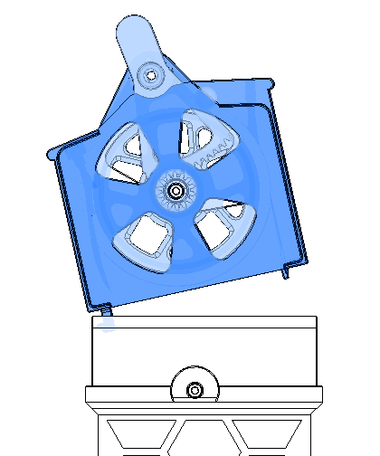

Usage
Input from spool

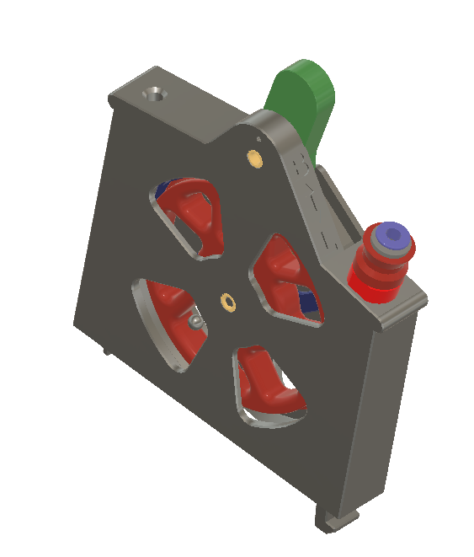
Filament loading position

Output to ERCF

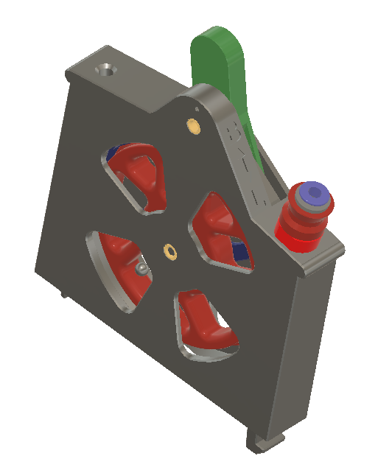
Printing / buffering position

