**CSCE 5320.002 - Scientific Data Visualization.**

Ganesh Gundekarla

11700551

Report of activity 1

1. Introduction to tableau .
2. Launch the tableau application and then we will be importing the data set that is being provided and here we will be choosing excel format , since the given data set is in xlsx format.

Then we get the table fields and attributes in the tableau where we can draw relationships.

Tutorial -1 :

Goal of this tutorial is to undestand the basic outlines of the tableau application and then be able to understand the relationships between the various attributes and draw conclusions using the graphs.

Attribues are sales type , sales cost and then the channel type.,

Bar graph visualization using horizontal bars.

Figure 1 : this is used to visualize the sales types with the different channel types contributing to the growth along with the sum of the sales cost.

Another form of visualization :

Figure 2 : the same above one can be also visualized using the stacked option where the above one is represented in a vertical manner where the type of channel type is taken as in the columns.

Brief visualization : here , we use the circle views in order to have a brief description by differentiating the domestic and international type. We get here a breif visualization of the sales on the y axis.

Figure 3:

Question 1 :

1. Horizontal bar visualization
2. Attributes: sales cost , channel type and pay types.

Visualization : 1

Visualizing sales cost which is varied across different channel types.

Figure 4: this gives us a view of total sales cost for different types of channels and along with we have the paytypes which is filtered out through colors.

Visualization 2 is basically a stacked bar visualization of the above one.

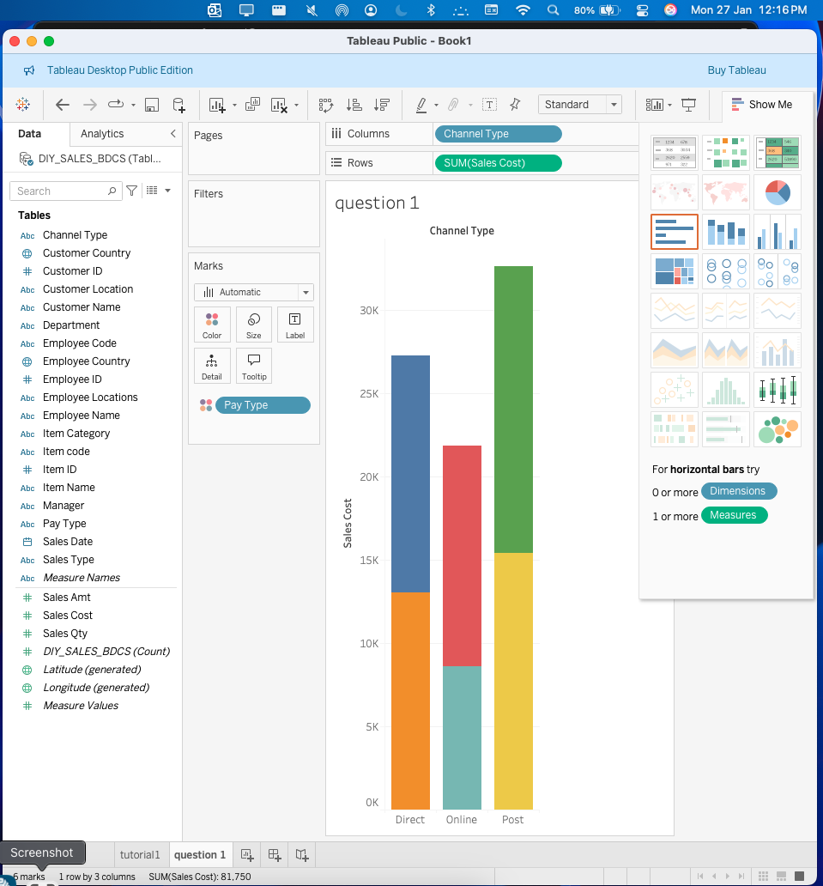

Figure 5

Tutorial 2 :

Attributes : sales type , department and sales cost and item category.

Figure 6 of the tutorial deals with a much more deepeer dive into the visualization than the tutorial 1

We have visulaization of a total cost of each department in both domestic and the international ones along with the sales type.

Figure 7 : pie chart to visualize relation among different attributes.

Sales cost vs sales type.

Bar chart for side by side comparison which is done across diff attributes.

Fig 8 :

Question 2 :

Attributes we will be using : item category , sales type and sales amount , channel type.

Visualization one : we try to visualize the amount of sales that has occurred in each category using horizontal bar chart.

Fig 9 shows the cellular has more sales than the cometics and the electronics one .

Visualiztion two :

Figure 10: we have the sales type , and the channel type of revenue and the item category of the each sales lined up and this gives an accurate representation of how the domestic and the international has gained their income through different sales.

