**Deliverable 5**

**Team Delta**

**Website link :** [**https://emed-frontend.onrender.com/**](https://emed-frontend.onrender.com/)

**User Manual:**

How to use our website.

**General:**

Every new user or an existing user that interacts with our Emed pharmacy website will must and should have an account which is composed of unique credentials. This will consist of a completely unique username, or an email address provided by the user and that should come with a unique password.

In our website, our administrator or the one who manages of databases will be able to create the accounts of our current existing doctors while the patients / users will get to create their very own accounts. In addition, our users when logging in must specify their blood group so that whenever they choose to be a blood donor, the patients who require emergency blood could easily be mapped to those donors.

**Front Option page:**

a. Here, our page will be providing us with three options and user is allowed to pick his role .

b. Here the user will be presented with options like admin , patient and doctor , which means that the website can be having three different types of persons that uses our website.

c. Here, each role after logging in can be having his own use pages on the website , like the user gets the general page where he gets to order medicines or to book an appointment , whereas the doctor is taken to his page where he/she is being presented with the appointments he / she is being scheduled with .

d. Each different type of user will be containing their own features which are very important in our project .

e. Admin page will be composed of listing all the number appointments and number of donors we currently have and also the number of patients and doctors .

f. THis admin page will allow us to gain valuable insights on how many patients we have recieved and how many doctors we have to keep those all patients occupied.

g. In the doctors side , the page will have all the appointments the doctor is currently being appointed with and we can also have the option where the doctor can cancel the appointments.

h. The patient page is completely as described which has all options to buy medicine or make appointments or have a checkout on the medicine.

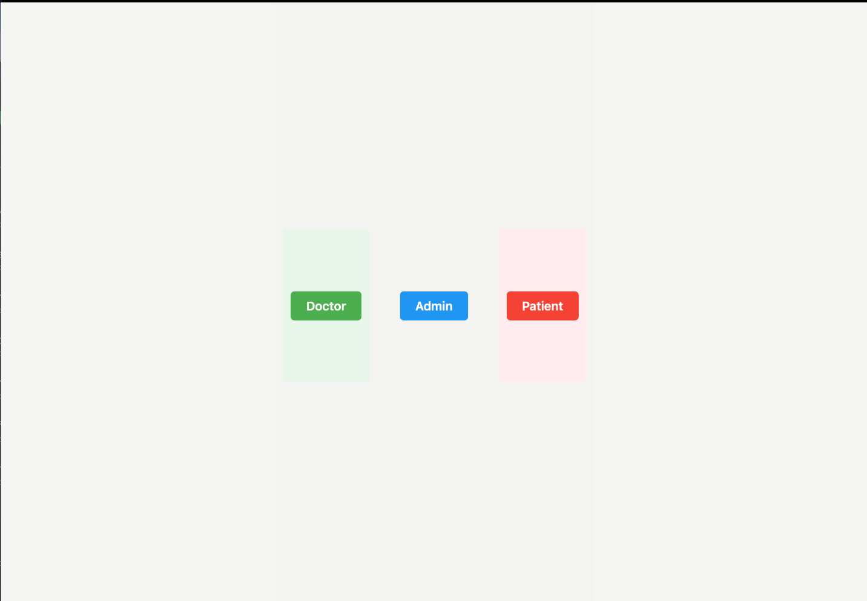

**The User Signup:**

**A) How to sign up as a new user:**

1. At the top right corner, we have a login/register to give both options to a new user or an existing user. 2.Click on the login/register button to get redirected into a new page where we can either sign up or login.

3. Now, fill in the required details and then enter confirm.

4. This now takes us to the landing home page with us signed in with a message saying welcome back

[username]

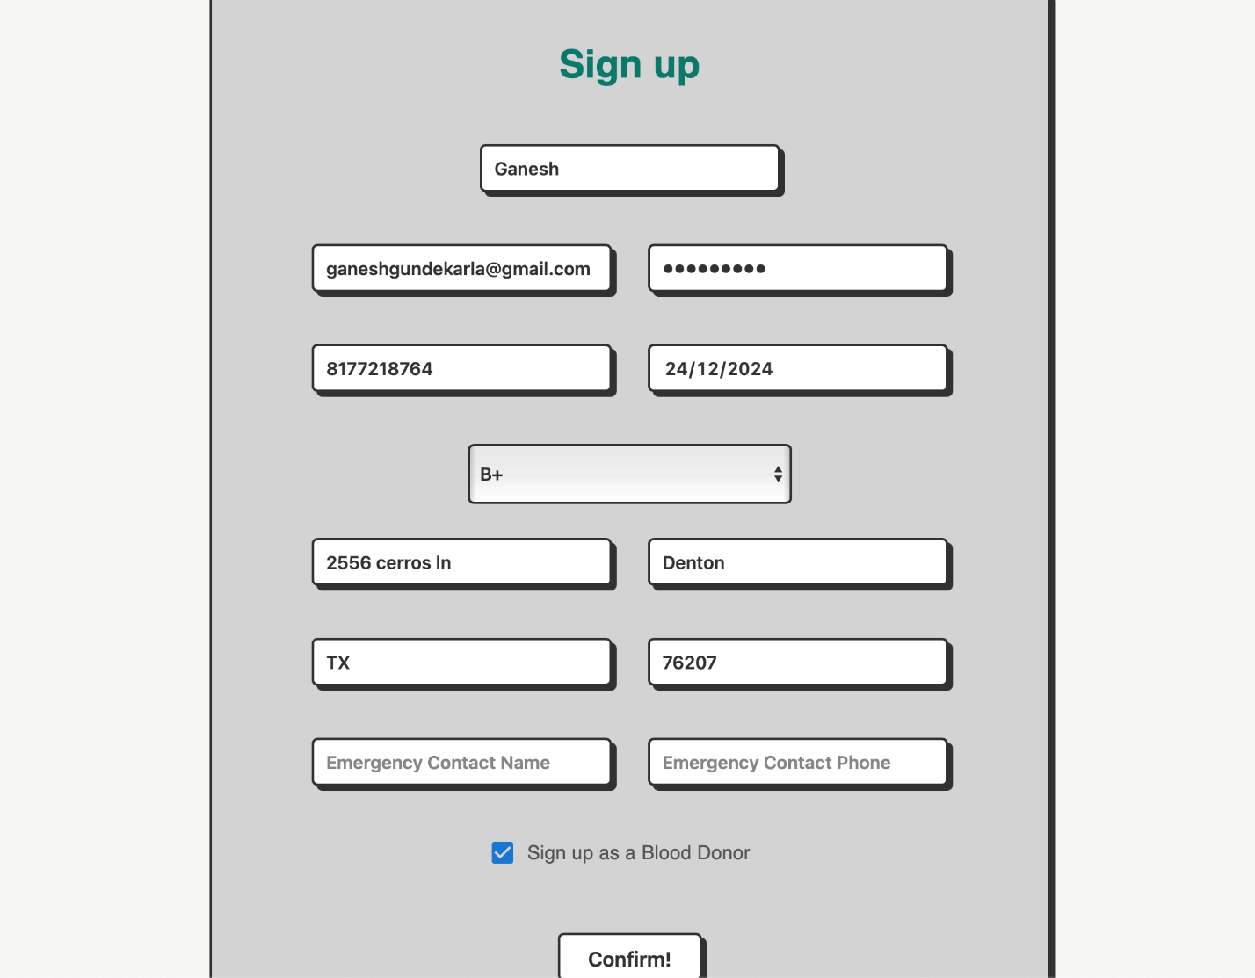

**B) How to login from an existing user:**

1. In the home page on the top right corner, click on the login/register button which directs us to login or signup page.

2. Now switch to login mode.

3.In the login page, enter your email address and password.

4. Now click on Let’s go! Button.

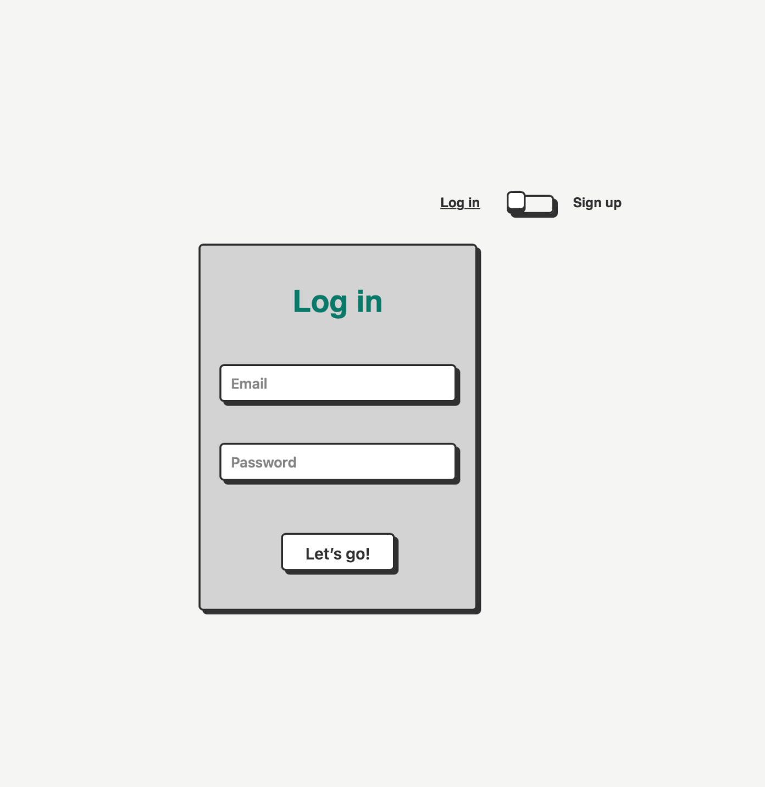

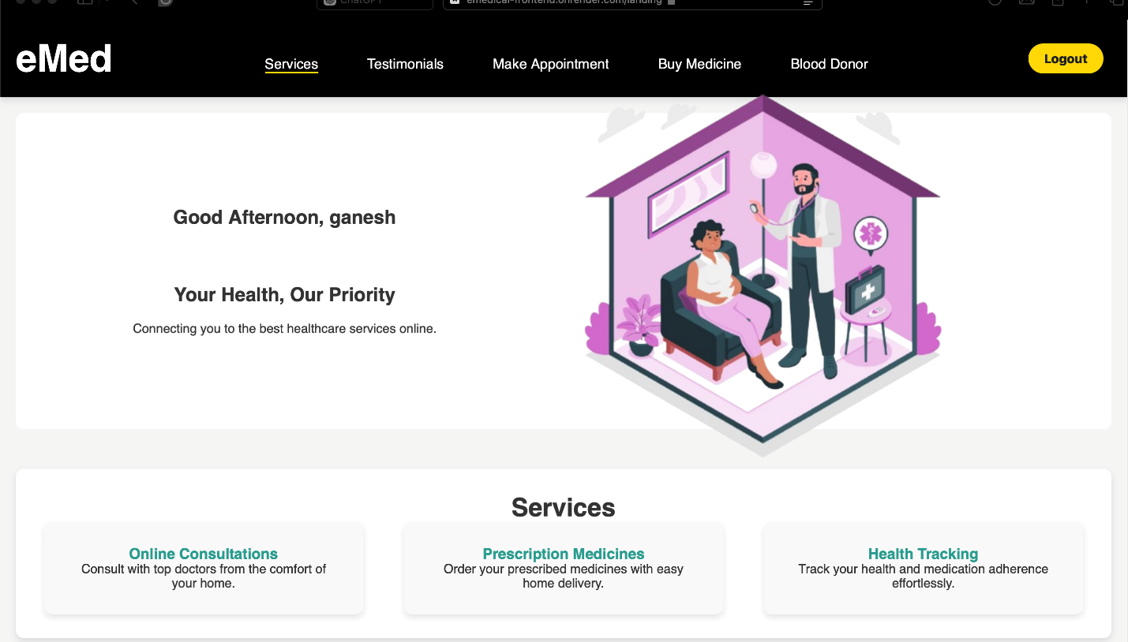

**C)Steps on how to book an appointment:**

1. In the home page, as you slide down, under the ‘Make an Appointment ‘section, select ‘Book now ‘to make an appointment.

2. Fill in the required details and enter your appointment date and time.

3. You are also presented with an option to select / choose your required doctor with his expertise in that field and press ‘BOOK APPOINTMENT

4.Then, in our phase 2 we also added a view your appointment page where we can be able to view all our upcoming appointments.

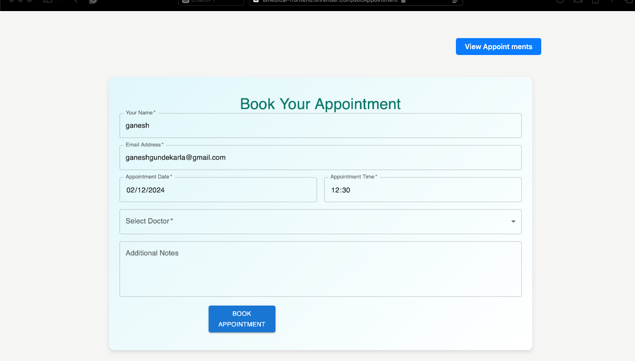  
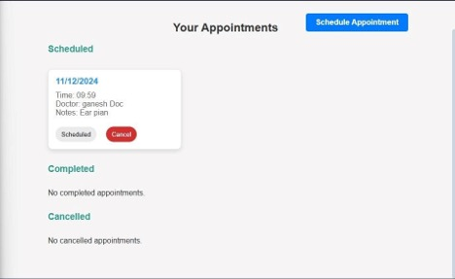

5. Here, we will be able to see all our appointments and then we can also schedule another appointment.

**D) Steps on how to order medicines:**

1. In the landing page at in the bottom we will be having a ‘Order Medicines’ section where we can order medicines which are available currently.

2. After this we get redirected from the landing page to the medicines page where we are presented with a wide variety of medicines.

3. Here, we can choose the medicine with the number of the number of tablets, and it can be added to the cart.

4. After we are done, we can press ‘Go to Cart’ which takes us to the cart page.

Here we have a proceed to checkout page which takes us to the final billing stage which will be

Implemented later.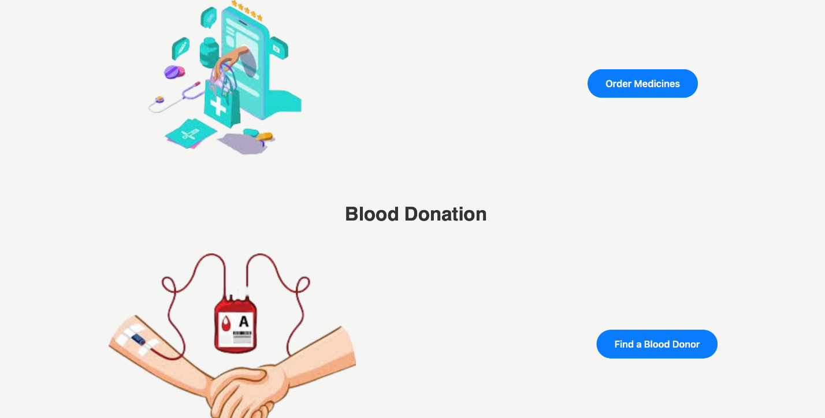

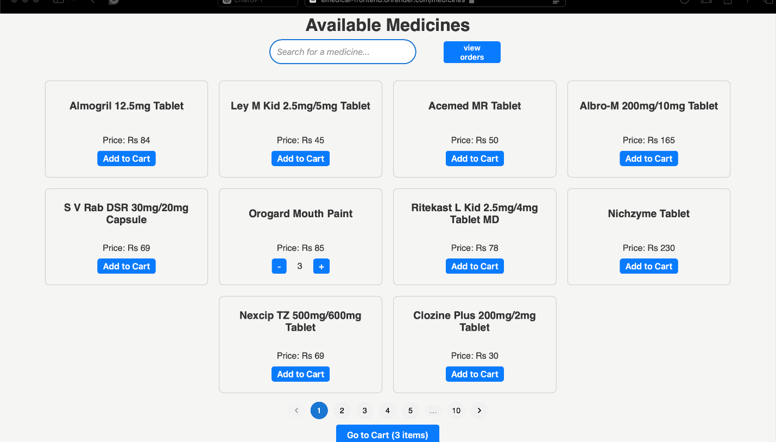

**Proceed to Checkout page: using stripe:**

a. Here, after getting our order done and proceeding to our cart, then we are able to checkout through the order medicines page, and we can enter our details.

b. Then, on this part, we need to enter the card details which includes our code with the month and year of expiration of our card.

c. Then upon entry of successful card details and the month and the year, the order gets done and will be successfully submitted.

d. Stripe access and process payments using credit cards and it makes sure that it will securely handle payment information , it also provides us with a client side libs that help us tokenize some highly sensitive information , and encryption is being done which is then sent to the stripe which even stripe cannot be able to decode it .

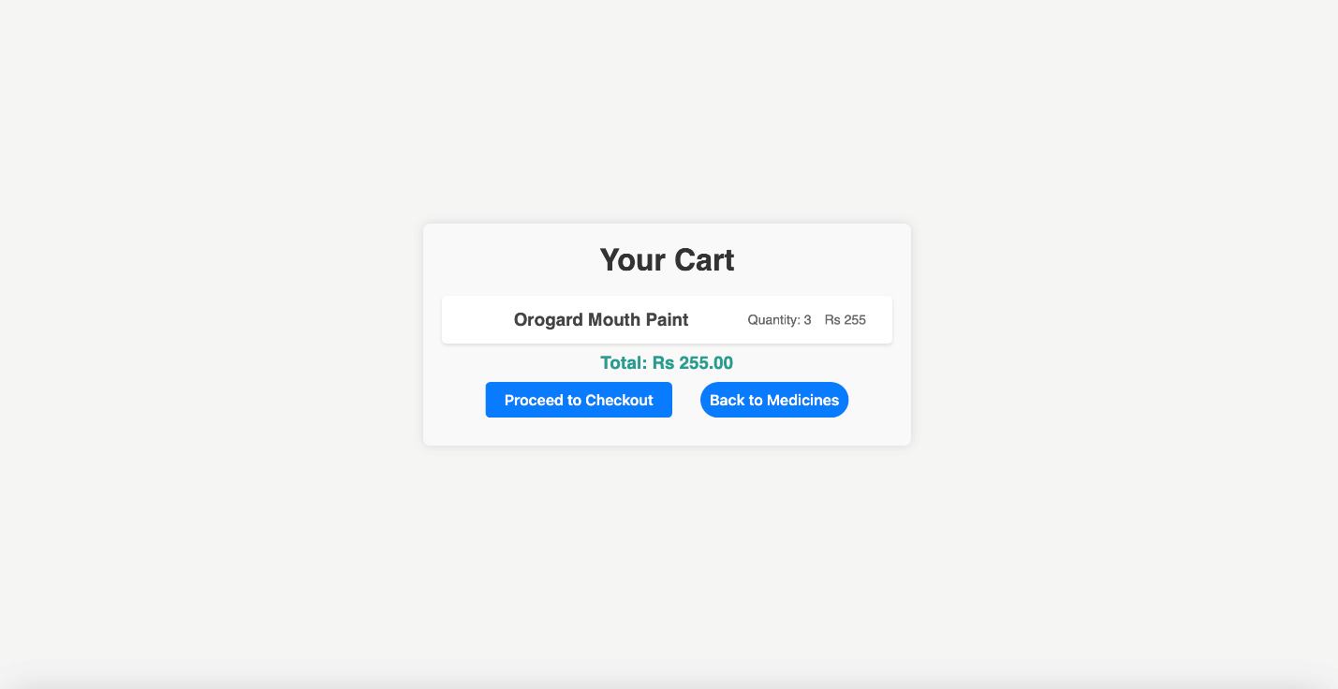 

**Doctor login / signup:**

a. After the user, what if a doctor will try to access our website and

b. If he is new, he / she is required to sign up which takes you to a page where you are allowed to sign in with the qualifications and details of his previous qualifications.

c. Then, he / she is logged into his page where he / she is presented with the details of his/her appointments.

d. Then, we will be able to login into the doctor’s page as the doctor's side of our website which looks like this:

E. Then the doctor will be presented with a dashboard where he will be presented with all the upcoming events, and all will be presented in a summary view.

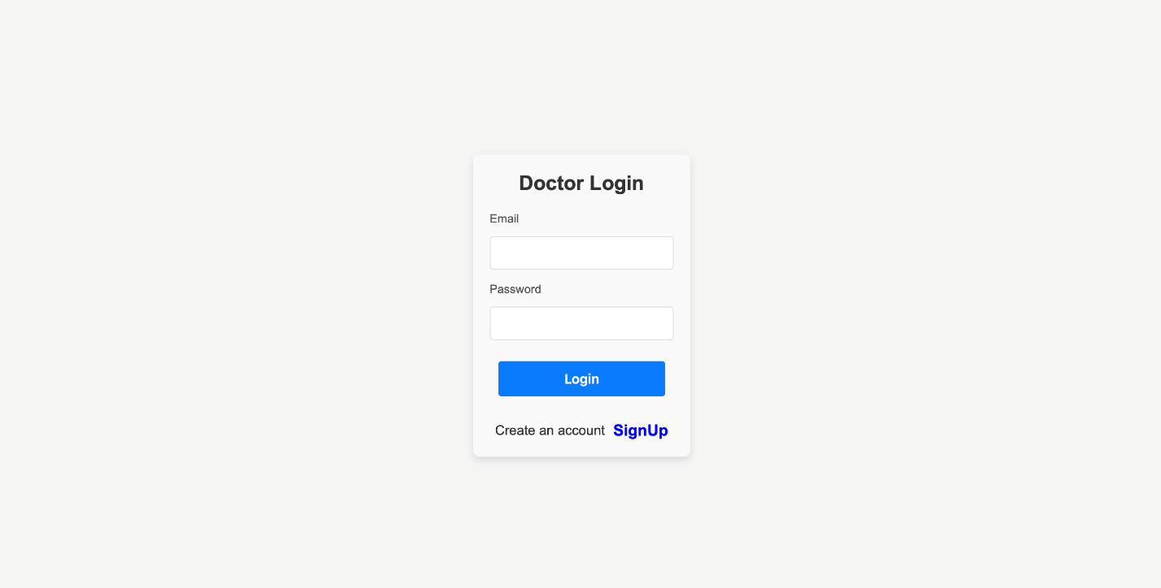

Dashboard view:

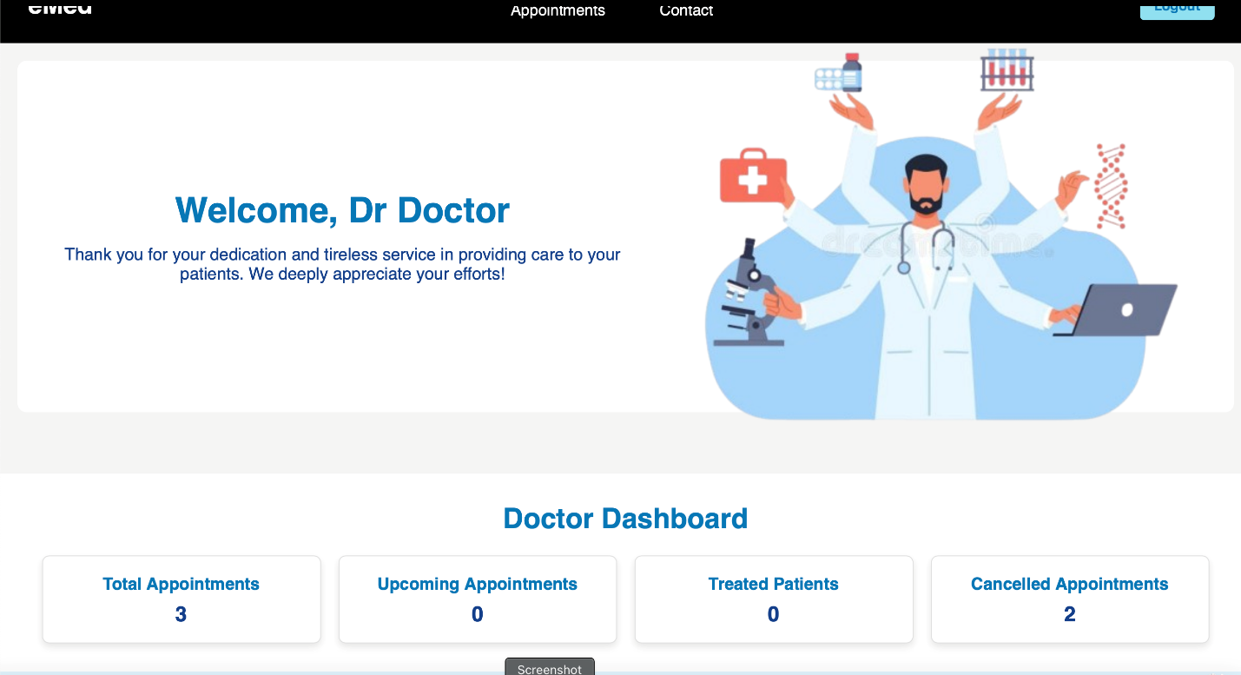

The Doctor also can have the access to his / her upcoming appointments

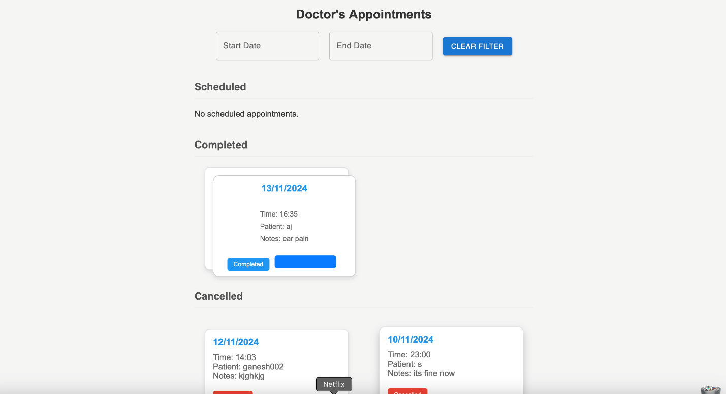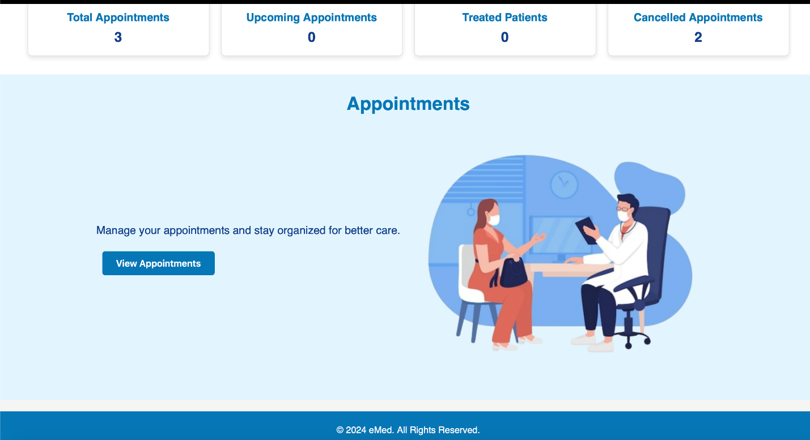

**Blood Donors page :**

a. In our page, blood donors can be able to donate their blood by signing up for them in the signup page itself by clicking on the option that says ‘sign in as a blood donor’ which makes the patient as a blood donor as well.

b. Then, we can show up with all the donors which are available to able to contact them and get some support on blood donation.

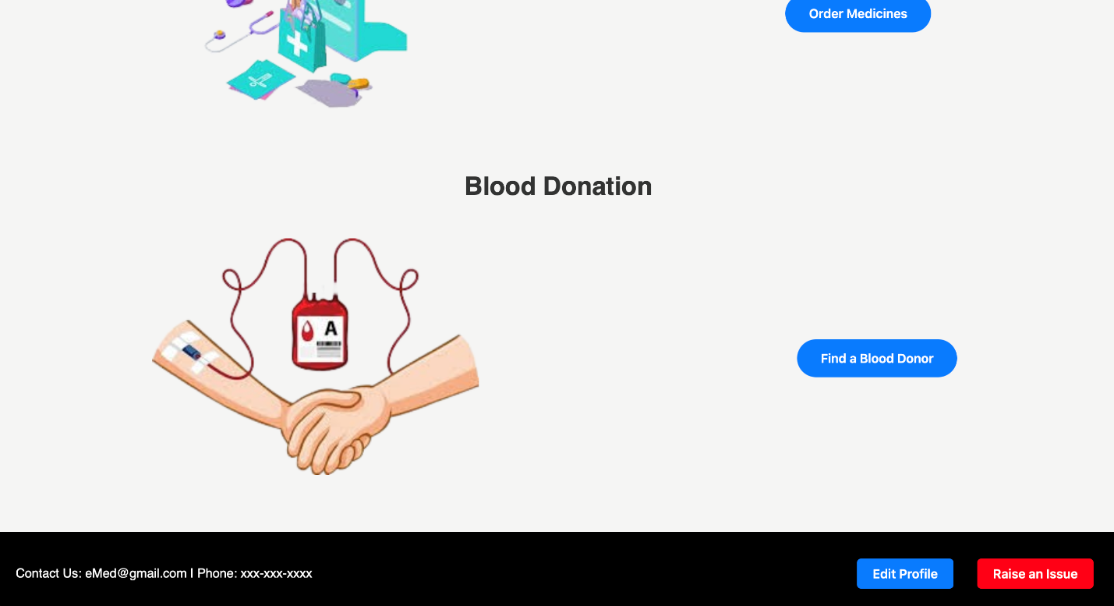

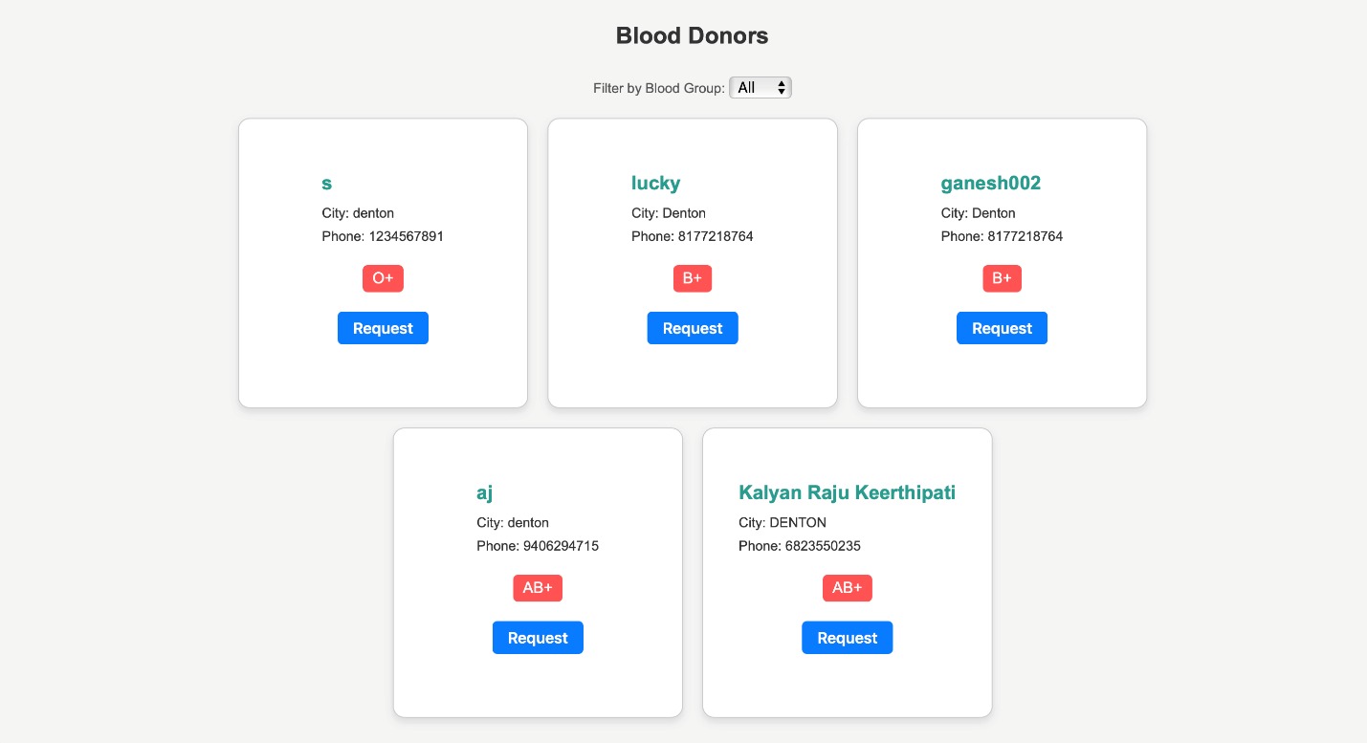we have also implemented a search filter that lets you sort out the donors based on the blood type :

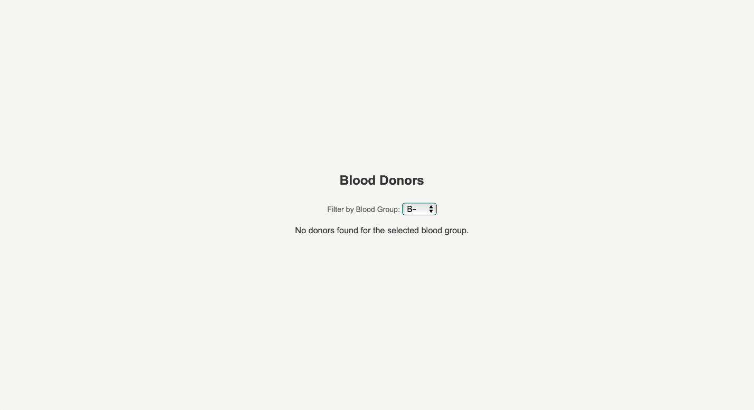we can request for the blood using getting in touch with them .

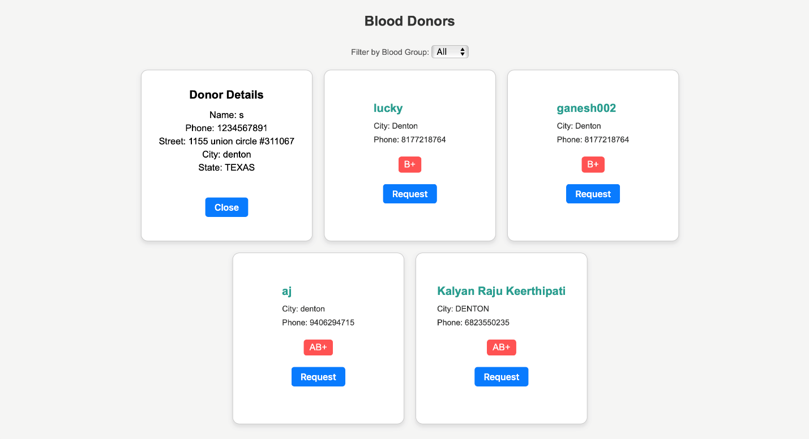

**Admin Users page:**

a. Our website admin can be able to manage and view everything that has happened in the website.

b. In our intro page, where we can be able to login into the admin page which is secured and only our admin can be able to do it.

c. When the admin logs into the website, the admin gets presented with multiple logs on recent activity that’s been going with the website.

d. Here, the admin can be able to have an overview of everything going on with the donors, appointments and patients logged in and the number of doctors present.

e. This way we are being presented with all the important information on the admin page like all the registered users and all the registered doctors.

F. We will be able to see all the registered number of users along with their important information and even the registered doctor's information is presented on a page properly.

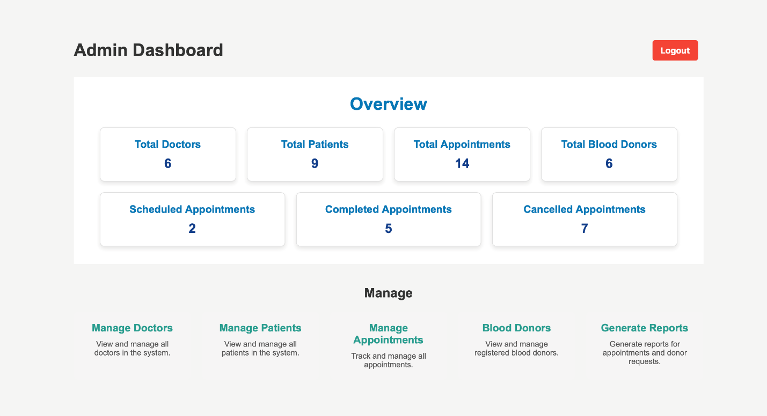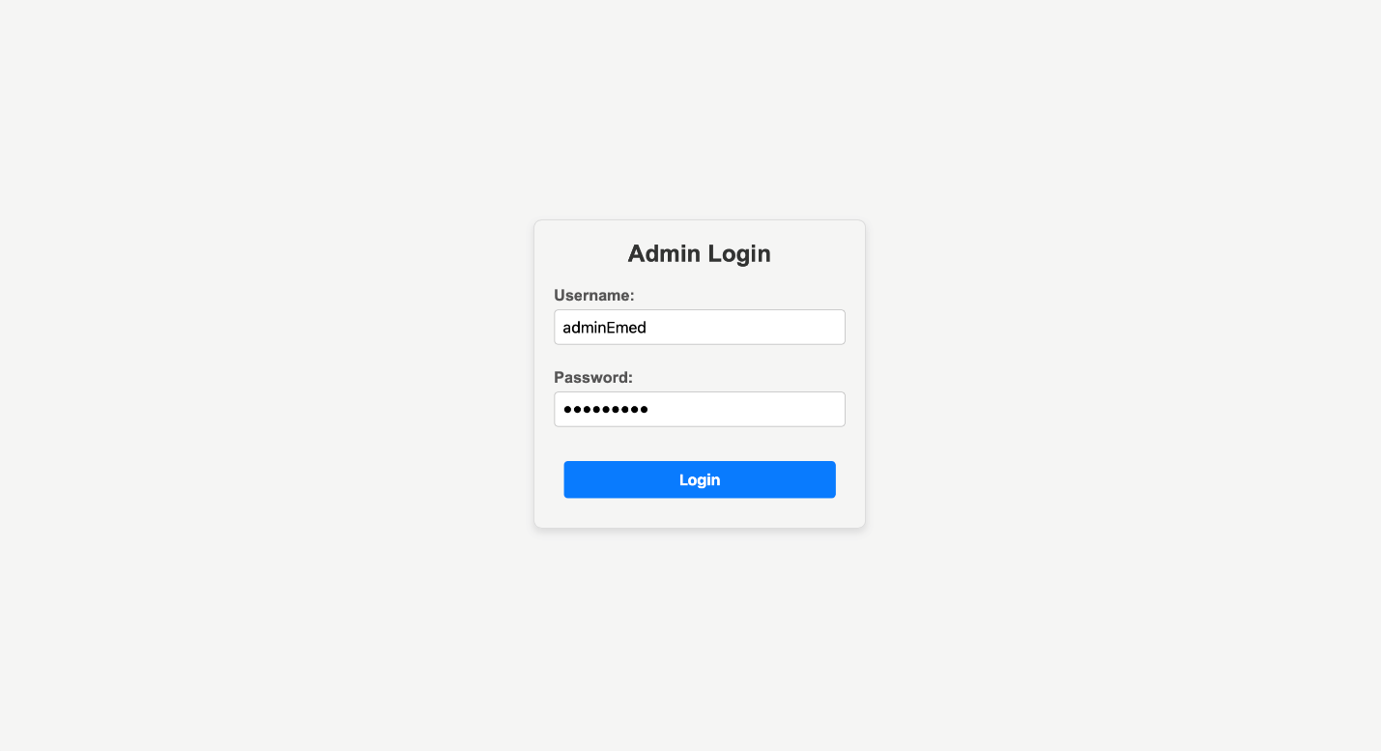

In this phase we have given most of the rights to the admin by being able to add or delete records present in our database . It is a privilege that is provided solely to the admin. Admin can manipulate the users , the patients list .

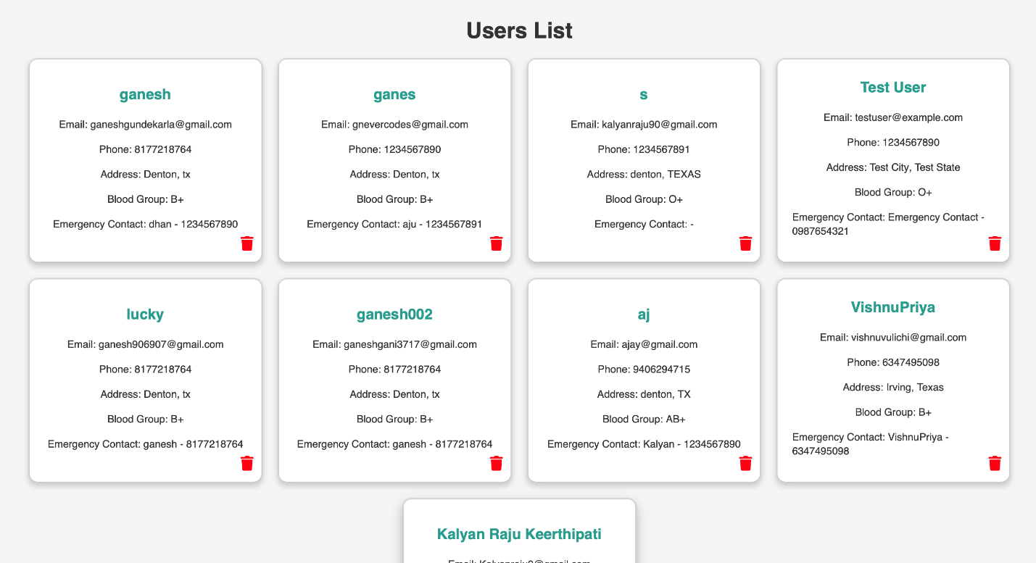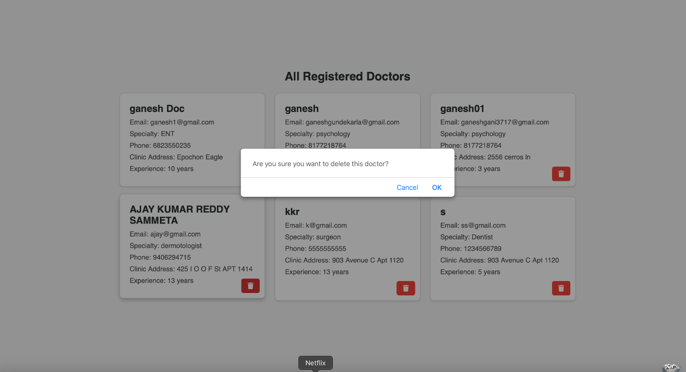

Added functionality : Raise an issue :

1. Here , user feedback can be crucial when it comes to running a website and the user reviews must be carefully considered in order to expand our website.
2. Hence , we have added a user review which is allowed only when we are logged in and it takes all the feedback from it to the admin so that the admin can make necessary changes .
3. This way the user gets to interact with the admin and can make this website much more interactive.

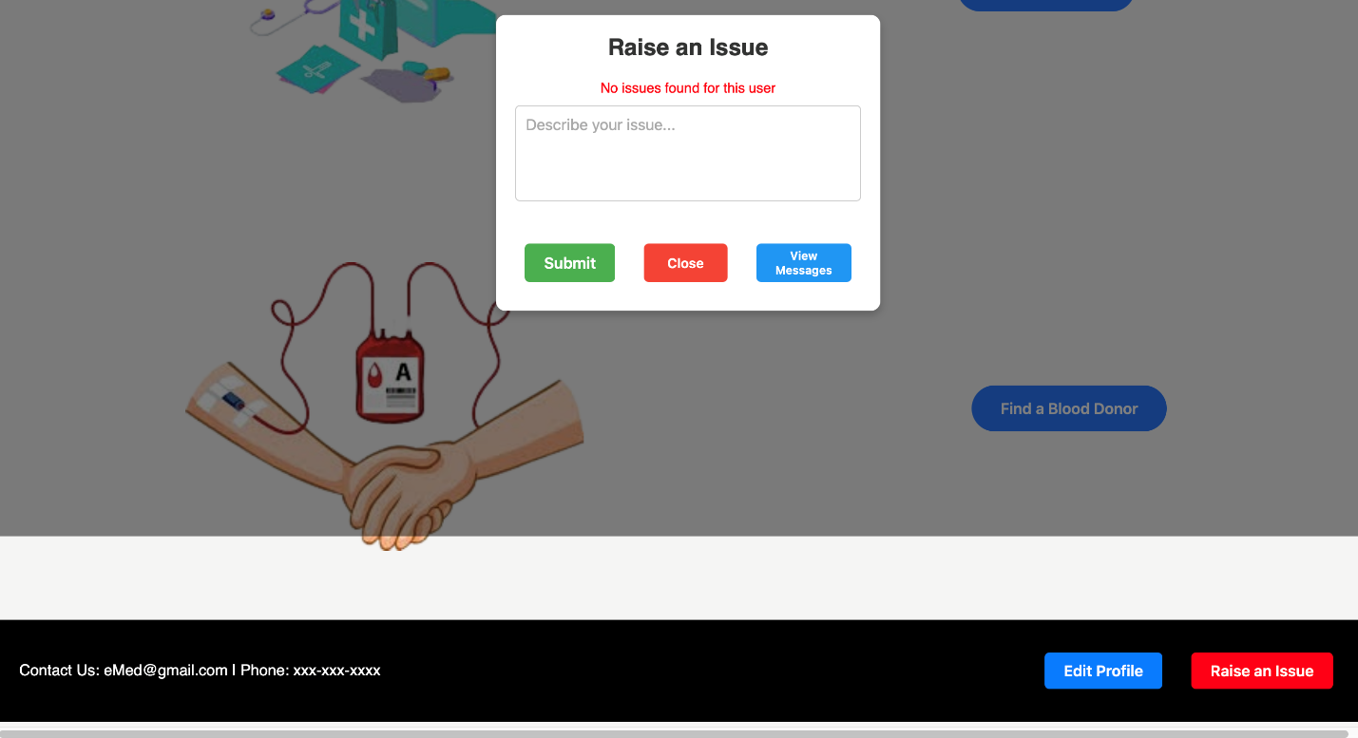

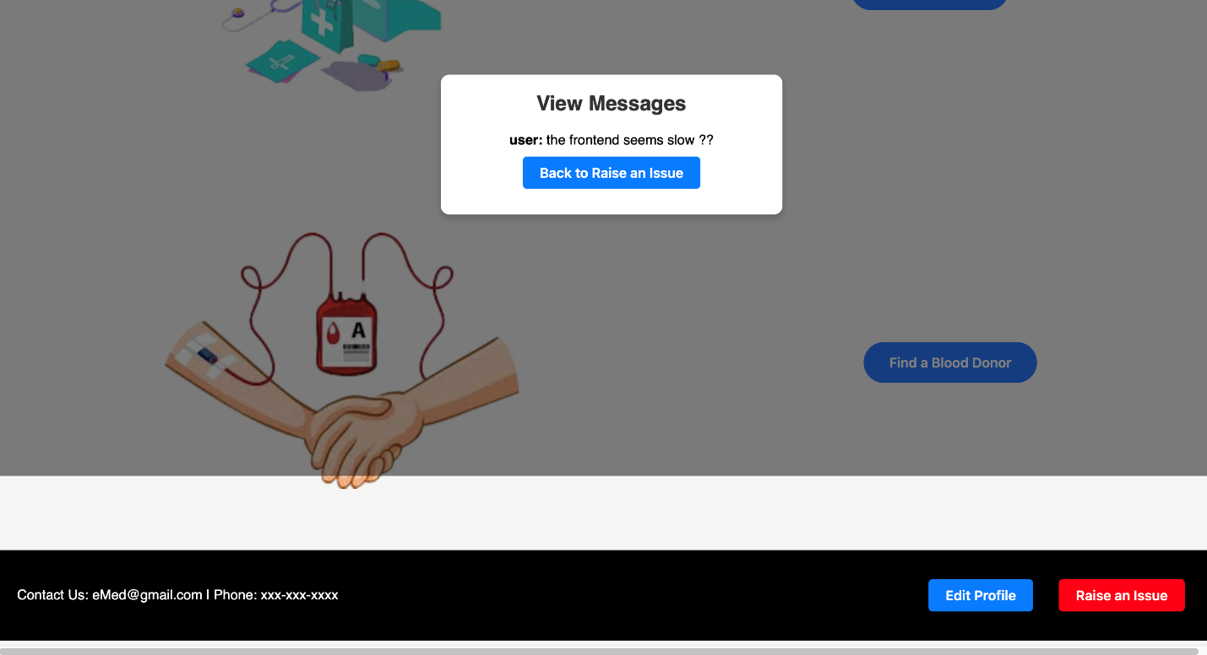

Added functionality : edit our profile :

1. Once the user or doctor is logged in , he / she can now edit their profile by clicking on to the edit profile button and making necessary changes.
2. These changes are being updated in the backend too.

