**Deliverable-2**

**Project Title: eMed-a complete pharmacy cart at your doorstep.**

**Group Name: Team Delta**

**Group Members:**

|  |  |  |  |
| --- | --- | --- | --- |
| **S. No** | **Full Name** | **Student ID** | **Email** |
| **1.** | Shabana Syed | 11723237 | [ShabanSyed2@my.unt.edu](mailto:ShabanSyed2@my.unt.edu) |
| **2.** | Ganesh Gundekarla | 11700551 | [ganeshgundekarla@my.unt.edu](mailto:ganeshgundekarla@my.unt.edu) |
| **3.** | Rishika Kandrigal | 11699010 | [rishikakandrigal@my.unt.edu](mailto:rishikakandrigal@my.unt.edu) |
| **4.** | Md Ariful Hasan | 11428575 | [MdArifulHasan@my.unt.edu](mailto:MdArifulHasan@my.unt.edu) |
| **5.** | Vishnu Priya Vulichi | 11727751 | [vishnupriyavulichi@my.unt.edu](mailto:vishnupriyavulichi@my.unt.edu) |
| **6.** | Vivek Nelluri | 11691249 | [Viveknelluri@my.unt.edu](mailto:Viveknelluri@my.unt.edu) |
| **7.** | Pranav Chalasani | 11712496 | [PranavChalasani@my.unt.edu](mailto:PranavChalasani@my.unt.edu) |
| **8.** | Ajay Kumar Reddy Sammeta | 11646754 | [Ajaykumarreddysammeta@my.unt.edu](mailto:Ajaykumarreddysammeta@my.unt.edu) |

**SYSTEM STRUCTURE**

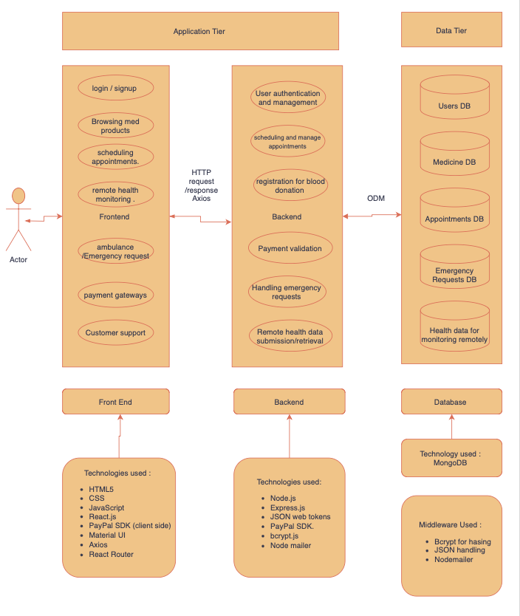

**Data flow:**

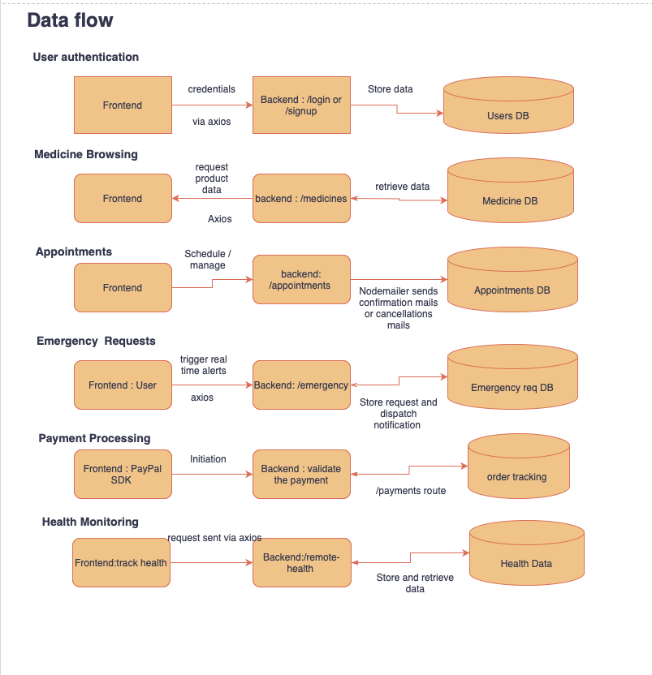

**REQUIREMENT SPECIFICATION**

**FUNCTIONAL REQUIREMENTS:**

* **User Authentication & Registration:** The user should be able to create an account with personal details. Users should have data privacy and be able to change their credentials through an email ID verification.
* **Searching for Medication:** The user should be able to access the medicines list and choose the desired medication and should be able to purchase the medication.
* **Doctor Profiles and Appointment Scheduling:** The interface should have a detailed page that displays doctor profile and appointment scheduling information.
* **Blood Donation and Emergency needs:** The user should be able to access the blood donor's details. In case of an emergency, the user should be able to make an emergency blood request.
* **Admin Control Center:** The admin should be able to manage the user information and appointments and have overall control over the application.
* **User-Admin Communication:** The user should be able to access the live chat to resolve the queries, updates regarding scheduling the appointments medicine purchased.
* **Ambulance Services and Emergency Assistance:** The user should be able to make a request for an ambulance service in an emergency.
* **Payment Gateway and Checkout Options**: The payment gateway should be provided to pay the bill for a medicine purchase and provide the shipping details.
* **Category Pages with SEO Optimization: The platform should be integrated with the SEO to enhance the user experience where patients can easily fetch the medication history, patient details.**
* **Remote Wellness Monitoring: The application should have feature to give the summary of the patient details, medication and health conditions.**

**NON- FUNCTIONAL REQUIREMENTS:**

* **Performance**:
* The e-health system shall serve each page to the user within 3 seconds of initiation under normal load conditions.
* The platform will support up to 10,000 concurrent users without performance degradation.
* **Scalability**:
* The system can scale horizontally to accommodate growing user numbers, especially during peak times like health emergencies.
* **Security**:
* Sensitive data, such as patient information and payment details, will be encrypted both in transit and at rest.
* The system will use multi-factor authentication (MFA) for user login, especially for administrative users.
* **Reliability**:
* The website will ensure continuous availability for users to book appointments and request emergency services.
* **Usability**:
* The website will provide a user-friendly interface accessible to users with minimal technical skills.
* **Maintainability**:
* The website will have a modular architecture, making it easy to update individual components without affecting the entire system.
* **Backup and Recovery**:
* In case of a system failure, a backup system will restore data within an hour to prevent data loss and minimize downtime.

**USER INTERFACES:**

**Interfaces:**

Readability should be good with all the devices.

**Breaking main components of UI for our website:**

1. Logo page with the title of our project.
2. Sign up and sign in options. Redirecting to forgot password if clicked on.
3. Medicine information page with a bar where we have options like:

Medicine

Doctor

Blood

Contact Us

Sign in

1. In that page of medicine, pictures of medicines along with some information to understand.
2. When clicked on a specific medicine we get a add to cart option with a reviews section
3. Shopping cart to check price and then shipping info, payment method
4. When selected doctor, doctors' information will get displayed
5. Booking an appointment page
6. Blood donors page with requesting blood
7. Admin pages for orders, appointments and blood requests.

**Phase 1 of the Implementation Plan Development Process:**

**Fundamental Features Priority of Implementation: High**

**Time frame:** 1 weeks

* **User Authentication & Registration:**
  + This feature enables users to register
  + Users can login once registered.
  + User can see his/her orders, appointments and other information by logging in.
* **Medicine Browsing & Purchase:**
  + Users can search and browse medicines that are available to purchase.
  + This feature enables customers to check their required medicines, add medications to a cart and proceed further for checkout.
* **Doctor Profiles and Appointment Scheduling:**
  + This feature shows detailed doctor profiles with information about the specialties, qualifications, and availability of each doctor.
  + Allows customers to book doctor appointments according to their preferences and availability.
* **Fundamental UI/UX:** Simple and appealing visuals are being used to make the website look good.

### **Phase 2 - Improved Functionality and Medium Polish**

#### **Time Frame:** 1 week

#### **Key Enhancements:**

* **Product Management Improvements:**
* Allow admin users to edit or remove products.
* Display additional product details like descriptions, available colors, sizes, and usage instructions.
* Implement search functionality for users to find products by name or category.
* **Checkout Process:**
* Enable users to proceed through checkout using their shopping cart.
* Prompt users to provide payment and shipping information.
* Upon successful checkout, send confirmation emails with order details.
* **User Experience Improvements:**
* Implement mobile responsiveness to ensure smooth use on all devices.
* Add accessibility features like alt text for images and keyboard navigation, ensuring WCAG compliance.
* Performance optimization to reduce load times, targeting a sub-3 second response time for page loads.

**Phase Three of Development:**

**Conditions:**

* **User Profile Enhancement:**
* Improve the user profile system to deliver customized services and a better overall user experience.
* Enable users to check their order history and appointment history easily.
* Set up user preferences for notifications like e-mail, messages.
* **Enhanced Search and Smart Filter System:**
* Implement advanced search and filtering for finding medicines, doctors, and blood donors.
* Create text search in MongoDB to find drugs by name, category, and symptoms.
* Add options for doctors based on specialization and availability.
* **Real Time Features:**
* Add real-time notifications for order updates, reminders, blood requests.
* Make sure that real-time communication channels are secure and handle high traffic smoothly.
* **User Feedback and Review System:**
* Improve the feedback mechanism to provide better service and quality control.
* Allow users to leave detailed reviews and feedback on their experience.
* Add a rating system for doctors, medicines, and services provided by the platform.

**Roles Assignment:**

|  |  |
| --- | --- |
| **Task** | **Top preference** |
| **Project Management Lead** | Rishika Kandrigal |
| **Requirements Lead** | Ganesh Gundekarla |
| **Design Lead** | Vivek Nelluri |
| **Implementation Lead for front-end** | Ganesh Gundekarla |
| **Implementation Lead for back-end** | Vishnu Priya Vulichi |
| **Configuration Management Lead** | Vivek Nelluri |
| **Testing Lead** | Shabana Syed |
| **Documentation Lead** | Ajay Kumar Reddy Sammeta |
| **Demo and Presentation Lead** | Pranav Chalasani |
| **System Administrator Lead** | Md Ariful Hasan |

**SKILLS ASSIGNMENT:**

|  |  |
| --- | --- |
| **Language/Technology** | **Assigned to:** |
| **Node.js with Express.js** | Ganesh Gundekarla, Pranav Chalasani |
| **MongoDB (via Mongoose)** | Vishnu Priya Vulichi, Shabana Syed |
| **React.js** | Ganesh Gundekarla, Rishika Kandrigal, Pranav Chalasani |
| **Axios for API requests** | Vishnu Priya Vulichi, Ajay Kumar Reddy Sammeta |
| **PayPal SDK (client-side)** | Ajay Kumar Reddy Sammeta, Ganesh Gundekarla |
| **JavaScript Object Notation** | Md Ariful Hasan, Vivek Nelluri |
| **JavaScript** | Vivek Nelluri, Md Ariful Hasan |
| **HTML5, CSS** | Shabana Syed, Rishika Kandrigal |

**Team members Description:**

|  |  |  |  |
| --- | --- | --- | --- |
| **Member name** | **Contribution description** | **Overall Contribution (%)** | **Note**  **(if applicable)** |
| Shabana Syed | Worked on functional requirements, and specified key features like medicine browsing, order processing workflows, and user authentication. | 12.5% |  |
| Ganesh Gundekarla | Worked on designing and developing the system structure and data flow of the system. | 12.5% | This is a planning and development phase, and it could be changed in the future. |
| Rishika Kandrigal | Worked on User Interfaces by researching and collecting data for improving user experience and functionality. | 12.5% |  |
| Md Ariful Hasan | Worked on Nonfunctional requirements. | 12.5% |  |
| Vishnu Priya Vulichi | Worked on phase one of development in developing the fundamental features of the project | 12.5% |  |
| Vivek Nelluri | Worked on Phase three of development to design features | 12.5% |  |
| Pranav Chalasani | Worked on Phase 2, the focus is on the project management improvements and enhancing the overall user experience | 12.5% |  |
| Ajay Kumar Reddy Sammeta | Helped in developing and designing system structure and gathering information related to system requirements. | 12.5% |  |