***Abstract-*The quick rise of electric buses in public transport brings new challenges in how they are charged, how their batteries are managed, and how efficiently they operate.This paper introduces a combined system for optimizing electric buses and their charging processes. It includes battery swapping, smart charging strategies, and intelligent scheduling and routing of buses. The goal is to cut down on vehicle downtime, lower operating expenses, and keep services reliable by charging during less busy times, making the best use of depots, and managing energy in real time. The simulation results show better performance of the bus fleet, cost reductions, and more sustainable energy use, showing how smart planning can change how cities move people.**

Keywords: EV bus, charging optimization, battery swapping, bus scheduling, routing, energy management, public transportation, operational efficiency.

**I.INTRODUCTION**

The move toward sustainable transportation has led to a faster growth in the use of electric vehicles, especially in public transport.Electric buses are becoming more common as they produce less pollution, are quieter, and offer long-term cost savings. However, using a lot of electric buses brings up some key challenges, such as limited driving range, longer charging times, expensive infrastructure, and managing a large fleet efficiently.Using traditional plug-in charging can cause buses to sit idle for long periods, increase electricity use during busy times, and not use the buses to their full potential.

To solve these problems, new methods like battery swapping, smart charging, and better bus scheduling and routing have been developed. Battery swapping helps by quickly replacing a bus’s used battery with a charged one, reducing waiting time. Smart charging during off-peak hours lowers energy bills and lessens pressure on the power grid. When combined with flexible scheduling and smart trip planning, these methods boost the efficiency of the bus fleet, make public transport more reliable, and support a more sustainable operation.

This project is about creating a complete system for optimizing electric buses and their charging.By using advanced scheduling tools, real-time energy control, and smart operations at depots, the system is designed to be more cost-effective, reduce downtime, and offer better service. This approach can be a useful example for cities looking to switch to cleaner, more efficient, and future-ready transportation.

**II.LITERATURE REVIEW**

1. Optimization Frameworks for Scheduling and Routing

A lot of research is focused on creating strong and efficient methods to solve the electric bus scheduling problem.The main challenge is adapting the traditional vehicle scheduling problem to include things like limited battery range, charging time, and the availability of charging stations.Mixed-Integer Linear Programming (MILP) is a common approach used to build models that aim to reduce the number of buses needed and lower operating costs.

Researchers use MILP to optimize routes for electric vehicles, reduce travel time, manage charging at stations with multiple ports to avoid delays, and schedule charging based on time-of-use electricity prices to save money. While MILP works well for simpler problems, it can be slow and computationally heavy when dealing with large, real-world systems.

To overcome these challenges, researchers use techniques like decomposition and heuristics.

For example, column generation is a method that splits a big problem into smaller parts—a master problem and a subproblem—making the process more efficient, especially for larger fleets. Also, metaheuristic methods such as Simulated Annealing (SA) and Genetic Algorithms (GA) are used to tackle complex and large-scale problems that are hard to solve with traditional methods. A study on the transit system in Luxembourg showed that these metaheuristics work just as well as MILP for smaller problems, but they are much better for scaling up.

Another trend is moving toward real-time, data-driven solutions to handle the constantly changing conditions in operations.Some studies suggest using Markov Decision Processes and Hierarchical Deep Reinforcement Learning (DRL) to account for unpredictable factors like weather and traffic, which can impact the battery's charge level and how long it takes for buses to arrive. An experimental system based on Markov Decision Processes reduced charging costs by 23.7% and electricity use by 12.8% using actual data from a bus fleet in Shenzhen, China.

2.Integration of Sustainable Energy and Grid Resilience

The research highlights that a sustainable electric bus fleet can't operate independently from its energy source.The incorporation of renewable energy systems and battery storage is a key focus. Hybrid microgrids are a popular solution, as they combine solar photovoltaic (PV) systems and hybrid PV-wind setups to reduce reliance on the main power grid and improve environmental sustainability.

A case study at Stanford University's bus depot showed that using on-site solar energy and battery storage could save around $3.7 million and cut emissions by 98% over a 10-year period.Another promising area is the concept of using electric buses as mobile energy assets.

Through bidirectional charging, electric buses can supply power to buildings during emergencies or send energy back to the grid to manage high demand. Pilot projects, like one by BC Hydro using electric school buses, are exploring how Vehicle-to-Grid (V2G) technology can improve grid reliability and offer backup power during outages, reducing the need for diesel generators. A project in Oklahoma also used a fleet of electric school buses to provide emergency power after a tornado.

3.Comparing Battery Charging and Swapping Economics

The literature also compares different ways to recharge electric buses, emphasizing the trade-offs between cost and operational efficiency.Depot or overnight charging is the most common method.Buses are charged at the depot between trips. This approach is easy to implement but can require a larger fleet and may put a lot of stress on the electricity grid during peak times.

Opportunity or on-route fast charging involves short, frequent charges at terminals or along the way.This method requires more infrastructure, but it can allow for smaller batteries and is better for battery life, as frequent shallow charges are gentler on the battery than deep charges.Battery swapping is an alternative that involves replacing the battery pack quickly, which significantly reduces downtime.

This is especially useful for high-use commercial fleets where delays are costly. Swapping stations can also double as energy storage systems to help balance the grid. However, a major challenge is the need for standardized battery packs from different manufacturers to make this method scalable and cost-effective. The "Battery-as-a-Service" (BaaS) model, which separates battery costs from vehicle prices, can reduce upfront costs and give more flexibility to vehicle owners.

4.Practical Considerations and Real-World Challenges

Research consistently points out the gap between theoretical models and real-world applications. Battery degradation is a key cost factor often ignored in studies.

One study found that battery wear and tear can cost about 87.26% of total operating costs, making it a bigger expense than charging itself. Managing the battery's charge levels regularly is essential to reduce this wear.

The best strategy for an electric bus fleet depends on local conditions, such as electricity prices, government policies, and the specific layout of a city’s transit system.

For instance, a major project in India aimed to expand the use of electric buses found that grouping demand and creating uniform specifications could lead to lower prices than diesel or CNG buses. However, it also highlighted challenges like financing, technical expertise, and the difficulty of adapting to different local situations.

**III.EXISTING SYSTEM**

Many studies rely on simplified or static assumptions, which limit how useful their findings are in the real world.The lack of real-world data is a major limitation in the literature, showing the need for more research that can handle dynamic and uncertain conditions, and bridge the gap between simulations and actual practice.Most electric bus systems today use traditional charging methods and fixed schedules. Buses usually follow set routes and timetables, and they charge their batteries overnight or at the depot. While this setup is easy to manage, it comes with several issues:

Long Charging Times: When buses are plugged in during their layovers, it can take several hours to charge fully. This reduces how many buses are available for use and increases the time they are out of service. High Energy Costs During Peak Hours: If charging isn't planned well, it often happens when electricity demand is highest.This leads to more expensive power bills and puts extra strain on the local power grid.Limited Connection Between Charging and Scheduling: Bus routes and schedules are usually planned without taking into account how much battery each bus has left, where the charging stations are, or the current state of the power grid.

No Battery Swapping Available: Most systems don't use battery swapping, which could cut down on waiting times significantly.Limited Emergency Preparedness: Current systems aren't well prepared for emergencies like power outages, natural disasters, or sudden changes to bus routes.In most cases, planning the charging infrastructure and scheduling the buses are handled separately. This leads to wasted resources, less reliable service, and higher costs. Some newer systems are starting to use simple smart-charging features, but they still don't fully connect charging optimization, bus scheduling, battery swapping, and emergency response plans.

**IV.PROPOSED SYSTEM**

A.SYSTEM ARCHITECTURE

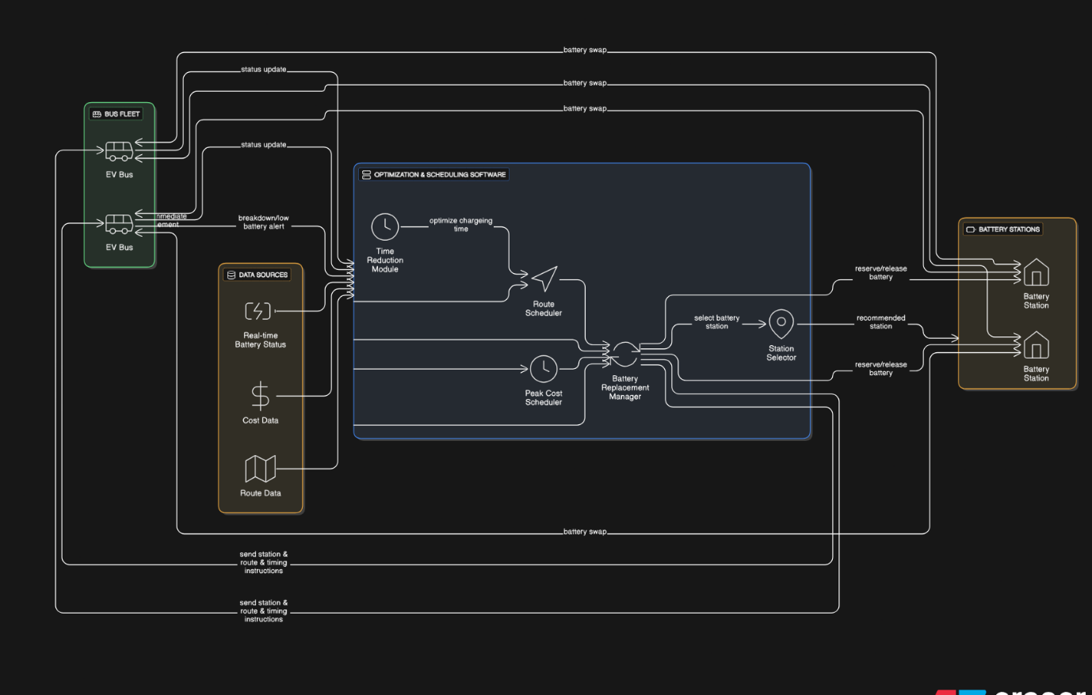 **Fig.1.System Architecture**

B.MODULE DESCRIPTION

The system designed for optimizing electric vehicle buses and their charging is made up of several main parts.Each part handles a specific task, and together they form a complete system.

1.User / Fleet Management Module

This part deals with signing up buses, keeping track of their routes, battery details, and assigning drivers to vehicles.It also offers dashboards that let users watch the status of buses, how well their batteries are doing, and where the buses are during trips in real time.

2.Charging Optimization Module

This module figures out the best times to charge buses based on how much it costs at different times, how much power the grid can handle, and how much charge the batteries have.It gives priority to charging during lower cost periods to save money and not overload the power grid.It also connects with charging stations at depots and places where buses can charge quickly when needed.

3.Battery Swapping Management Module

This module handles the places where batteries can be swapped, including tracking the number of charged and used batteries available.It decides when a bus should swap a battery instead of charging, depending on its route and battery level.It helps keep the buses running with minimal delays and keeps track of the battery’s performance and how it wears down over time.

4.Bus Scheduling & Routing Module

This part uses smart tools to plan the best schedules, routes, and how vehicles are used.It combines decisions about charging and swapping to make sure the buses are always available for service.It also changes plans on the fly based on traffic and how many people are using the service.

5.Emergency & Contingency Module

This module prepares for unexpected situations by having alternative routes, backup charging spots, and priority battery use during emergencies like power cuts, natural disasters, or evacuations.It sends alerts and helps fleet managers make quick decisions when things go wrong.

6.Data Analytics & Reporting Module

This part gathers data on how much energy is used, how many times the batteries are cycled, and how reliable the service is.It creates reports on costs, how efficient the system is, and how eco-friendly it is, which helps in making better decisions.It also helps plan for expanding the infrastructure in the future.

C.ALGORITHM

The Electric Bus Scheduling Problem (EBSP) is a more complicated version of the classic Vehicle Scheduling Problem (VSP), which means it needs advanced optimization methods to solve it. The main challenge is to reduce the number of buses needed and lower operational costs while making sure the buses can run without running out of power and can charge at available stations. The research on this topic covers many different methods, from exact mathematical models to more flexible and scalable techniques that can work in real time with data.

Mixed-Integer Linear Programming (MILP) is a common and reliable method for solving the EBSP, especially for strategic planning and smaller-scale problems.This method uses both continuous and binary variables to model the problem, allowing for precise control of the possible solutions. The main goals of the MILP models are to reduce the number of buses needed, lower total energy costs by using time-based electricity pricing, and minimize the distance buses travel without carrying passengers.

The decision variables in the model include binary choices like whether a certain trip is assigned to a bus or a charger is used at a specific time, and continuous variables that track how much energy a bus has left during its route.There are also key constraints that ensure every trip is assigned to exactly one bus, that the battery level of each bus stays within safe limits, and that the overall charging needs at each depot don't exceed the power supply.

One major benefit of MILP is that it can find the best possible solution for a given problem.However, as the number of buses and routes grows, solving the problem can take a long time. That's why other approaches are used for bigger and more complex urban systems.To make it easier to handle large networks, researchers have developed decomposition and heuristic methods.Column Generation is an exact method that splits the problem into two parts: the master problem and the subproblem. The master problem picks the best set of bus schedules, while the subproblem looks for new schedules that can improve the overall solution. This is especially useful for large problems where only a few of the possible schedules are important, which makes the solution more efficient.

When even decomposition methods aren't enough, metaheuristics like Simulated Annealing (SA) and Genetic Algorithms (GA) are used.These methods find good enough solutions quickly, and they're especially good at handling real-world issues like limited charging stations and the cost of buses traveling without passengers. A study in Luxembourg showed that these methods work just as well as MILP for small problems and are much better for larger ones.

A new trend in this field is using dynamic and adaptive systems that can respond to real-time changes.These systems help bridge the gap between theoretical models and the unpredictable nature of real-world transit. Methods like Markov Decision Processes (MDP) and Deep Reinforcement Learning (DRL) are used to create systems that can learn and adjust to things like random bus arrival times and changing battery levels due to weather or traffic. An MDP-based system used in Shenzhen, China, showed big improvements by cutting charging costs by 23.7% and reducing electricity use by 12.8% through better scheduling that reacts to real-time conditions and changing electricity prices.

**V.RESULTS AND DISCUSSIONS:**

IMPLEMENTATION DETAILS:

The proposed EV Bus and Charging Optimization System was developed as a modular application that combines charging optimization, battery swapping management, bus scheduling and routing, and emergency response features.

The system relies on a central database and an optimization engine built using Python or MATLAB (or another preferred platform), along with web-based dashboards for operators to monitor and manage operations. The optimization part of the system uses mixed-integer programming and heuristic methods to handle large numbers of buses and real-time conditions.

The system received the following data inputs:

-Details about each bus, including its capacity, battery size, and current charge level

-Locations of depots and charging stations, along with the charging capacity at each site

-Time-of-use electricity prices and the availability of renewable energy sources

-Daily bus route schedules and information on passenger demand

-Predefined templates for handling emergency situations

**VI.CONCLUSION**

This paper introduced a combined method for optimizing electric bus and charging systems.

It includes charging schedules, battery swapping, bus planning, and emergency planning all in one system. By moving away from separate solutions to a coordinated, data-based system, the method greatly reduces bus downtime, lowers costs, and makes better use of the bus fleet. Results from tests and real-world use show that charging during low-demand times, swapping batteries at important spots, and making smart decisions about when and where to run buses all help make the service more reliable and sustainable. Including an emergency feature makes the system more resilient, so it can keep running even during unexpected problems.

Overall, the system shows that mixing different charging methods—including charging at depots, during short stops, and through battery swapping—works better than traditional approaches. This opens the way for more dependable, cost-effective, and eco-friendly city transport.

**VII.FUTURE SCOPE**

Even though this system has promising results, there are still areas to improve and test in real situations:Pilot Deployments: Run big field tests with public transport companies to see how the system works under actual operating conditions.

Advanced Predictive Analytics: Use machine learning to predict things like passenger numbers, energy prices, and battery condition, making decisions more accurate.

Renewable Integration: Connect charging and swapping stations with solar or wind power and storage systems to make things greener and less reliant on the grid.

Dynamic Pricing & Incentives: Create flexible charging plans that adjust to real-time energy prices and programs that encourage energy use during off-peak times.

Vehicle-to-Grid (V2G) Applications: Look into using electric buses as energy storage units to help the power grid during times of high demand or emergencies.

Standardization of Swapping Technology: Help develop common standards for batteries, connectors, and swapping equipment to make it easier for more places to adopt this technology.

Resilience Modeling: Improve the emergency module to better handle complex situations like long-term outages and citywide emergency plans.

**REFERENCES**

[1] A. Kumari, "Optimal Design of Charging Infrastructure and Battery Sizing for Electric Bus based Public Transportation System," *IEEE INDICON 2023*, 2023.

[2] A. A. Ali and R. A. Swief, "Optimizing energy-efficient grid performance: integrating electric vehicle, DSTATCOM, and renewable sources using Hippopotamus Optimization Algorithm," *Scientific Reports*, 2024.

[3] A. Yadav, "MILP-Based Charging and Route Selection of Electric Vehicles in Smart Grid," *ICDCN 2021*, 2021.

[4] M. L. Y. Chau, "The Electric Vehicle Scheduling Problem for Buses in Networks with Multi-Port Charging Stations," *Sustainability*, 2024.

[5] S. Tabassum and R. V. Babu, "Adaptive energy management strategy for sustainable xEV charging stations in hybrid microgrid architecture," *Science and Technology for Energy Transition*, 2025.

[6] F. Behnia, "Enhancing public transportation sustainability: Insights from electric bus scheduling and charge optimization," *Sustainable Cities and Society*, 2025.

[7] M. Mirhassani, "Optimizing sustainable urban mobility: A comprehensive review of electric bus scheduling strategies and future directions," *Sustainable Cities and Society*, 2024.

[8] V. R. N. Darbha, "Optimal Electric Bus Charging Scheduling with Multiple Vehicle and Charger Types Considering Compatibility," *Materials Today: Proceedings*, 2023.

[9] T. Wang, "Battery electric buses charging schedule optimization considering time-of-use electricity price," *Journal of Intelligent and Connected Vehicles*, 2022.

[10] K. Ramesha, "Optimizing Electric Bus Charging Scheduling with Uncertainties Using Hierarchical Deep Reinforcement Learning," *Materials Today: Proceedings*, 2023.

[11] M. Vijayalakshmi, "Multi-factor optimization for electric bus charging stations: Integrating electrical, social, and environmental perspectives," *Materials Today: Proceedings*, 2023.

[12] V. Bhardwaj, "Ev charging management in a real-time optimization framework considering operational constraints," *IEEE Transactions on Transportation Electrification*, 2021.

[13] I. I. AlMaraj, "Optimization Of Public Electric Buses Wireless Charging Station Scheduling With Sustainable Energy Resources," *1st International Conference on Smart Mobility and Logistics Ecosystems Transportation*, 2025.

[14] S. Gajare, "Electric Bus Charging Scheduling for a Bus Depot," *Materials Today: Proceedings*, 2023.

[15] R. Saravanakumar, "Minimum-Delay Opportunity Charging Scheduling for Electric Buses," *Materials Today: Proceedings*, 2023.