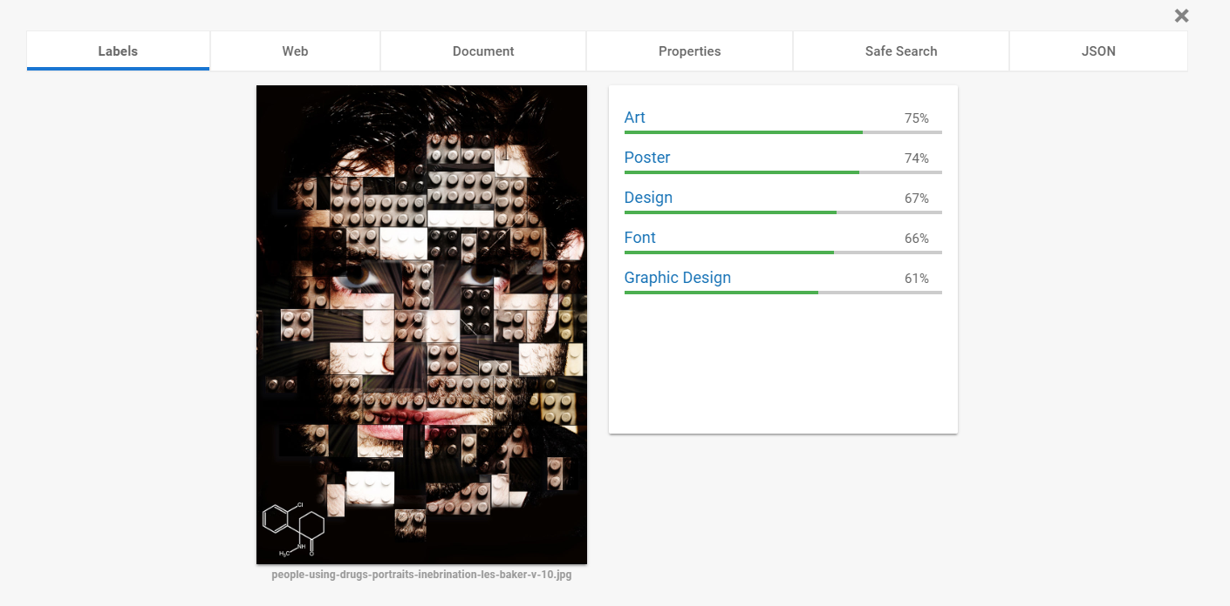1751023 – Nguyễn Anh Thư (Assignment 2)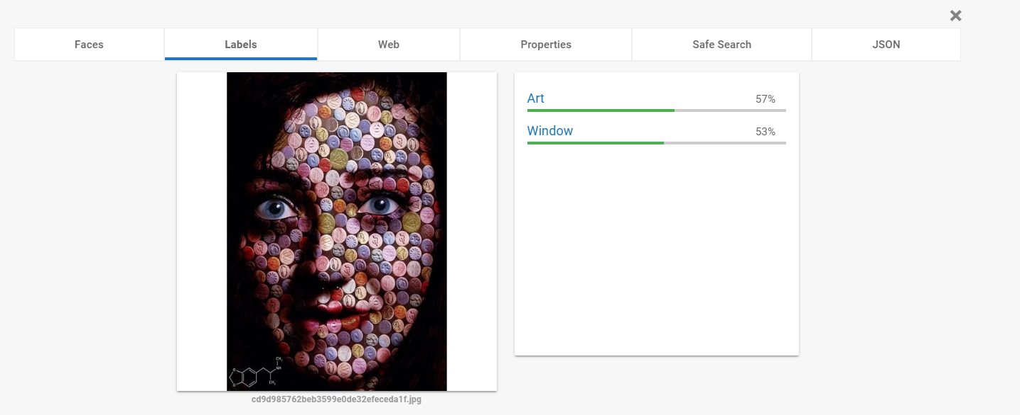

- Photos combined with many pieces, Google API cannot recognize the face.

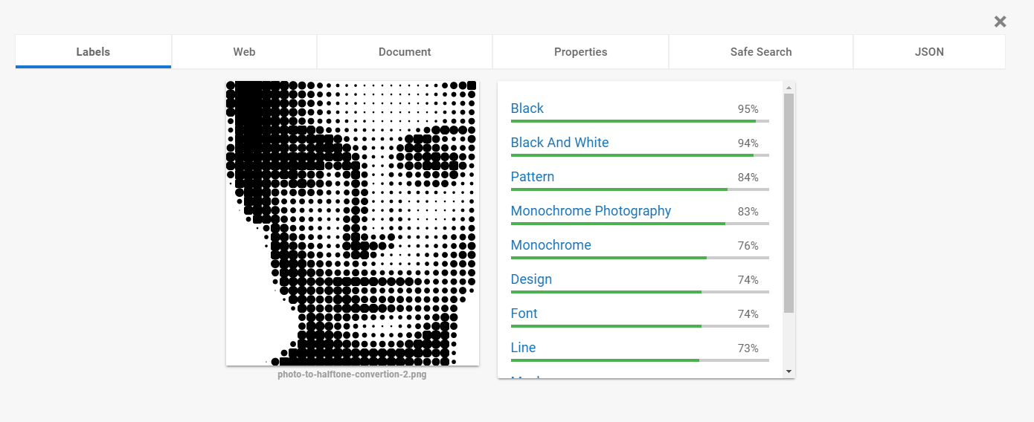- Halftone photo effects, cannot fine the face.

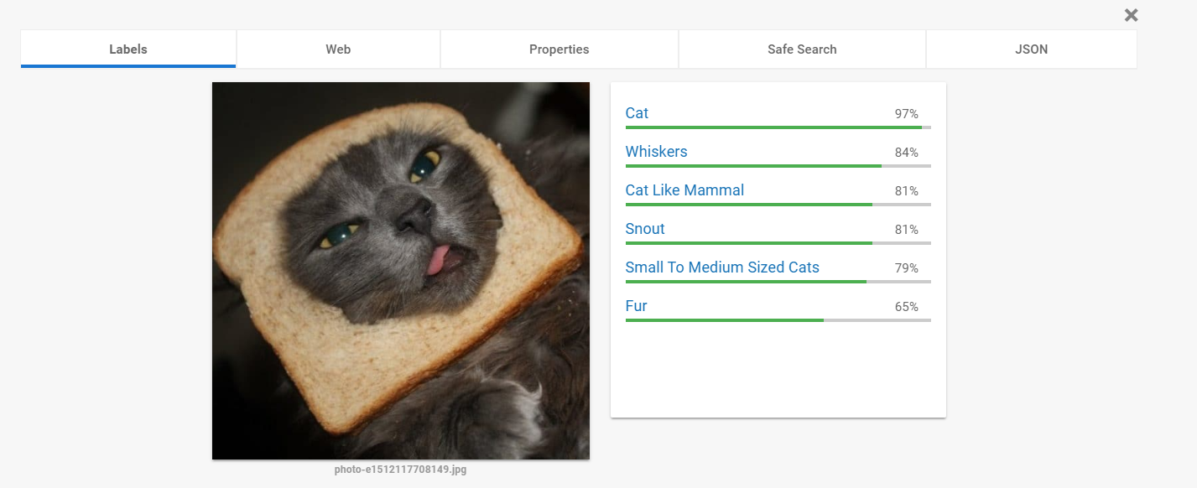

- Cannot find the bread, focus on the cat.

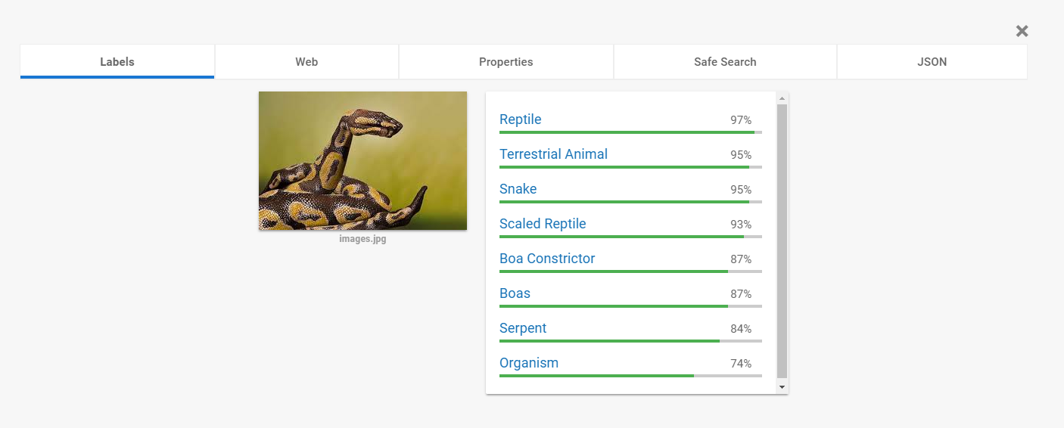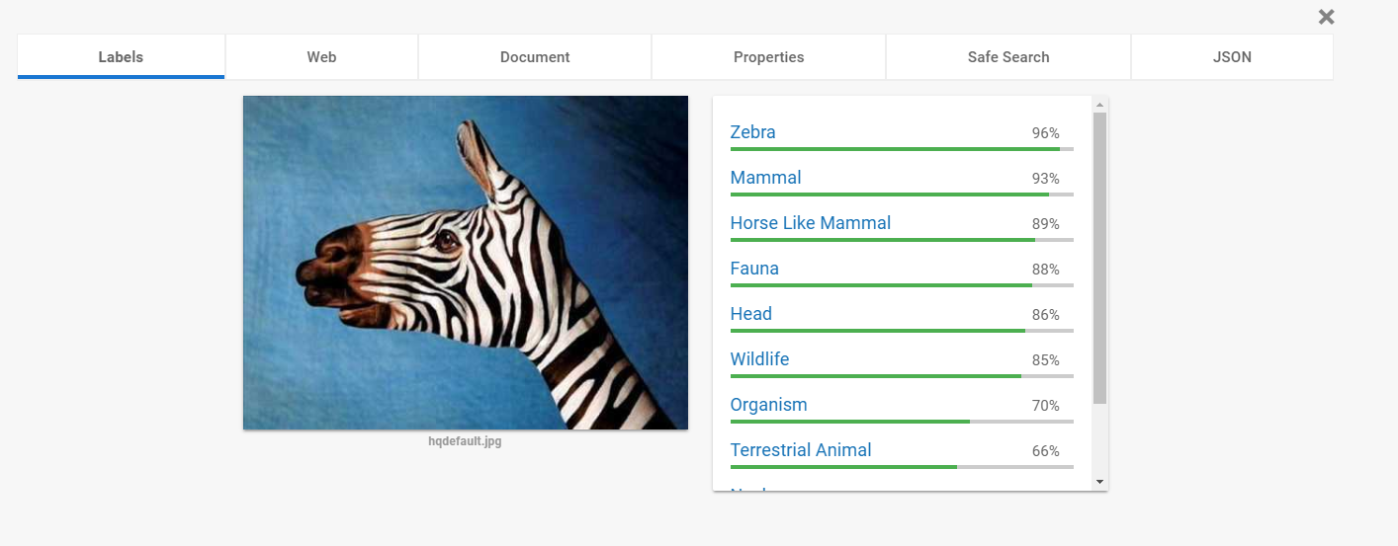

- Body art photos.

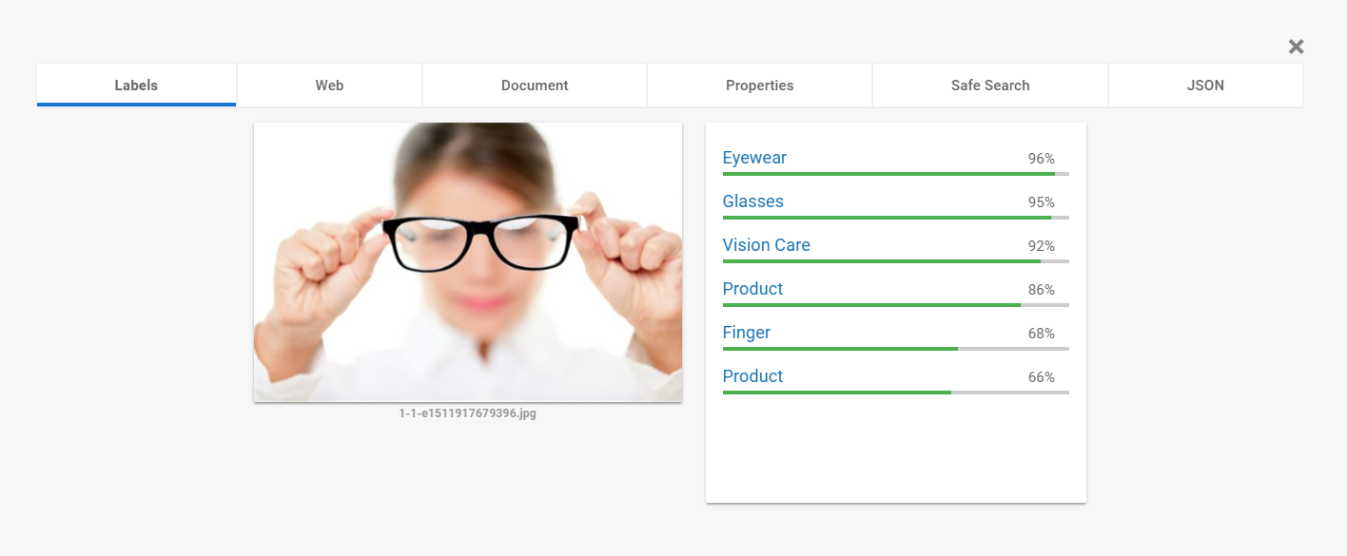

- Photos that are faded, cannot recognize the girl.

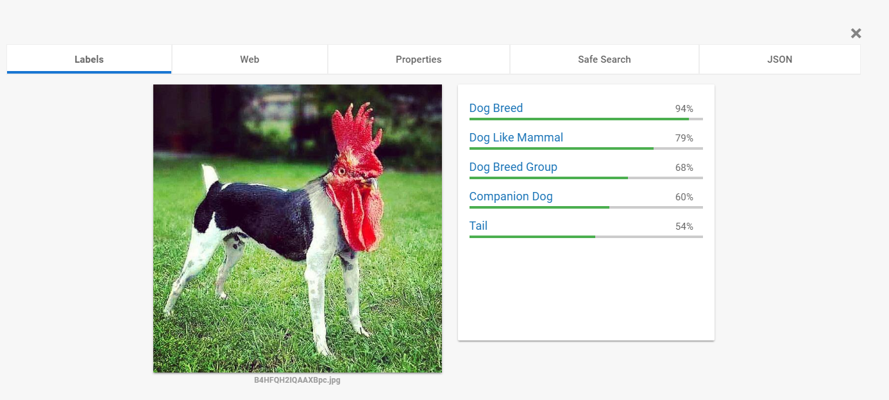

- Weird animals, recognize the dog’s body, pass the chicken’s head.

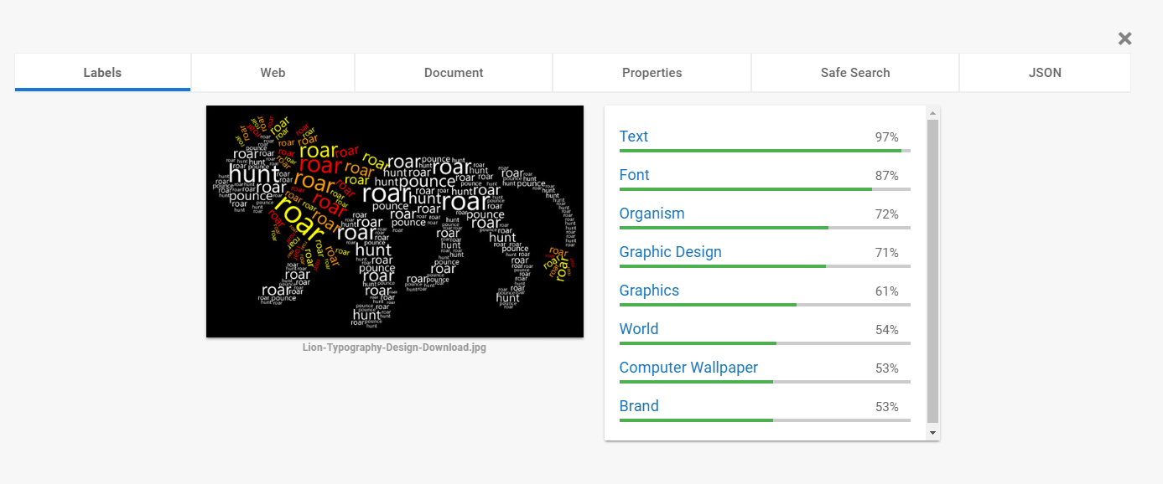

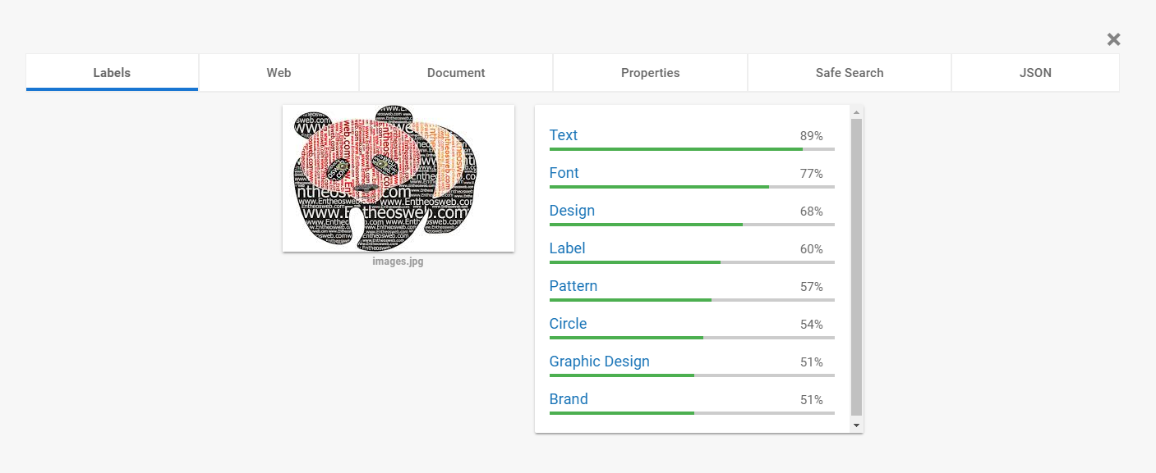

- Text that is arranged to particular shape, but google API cannot realize the shape.