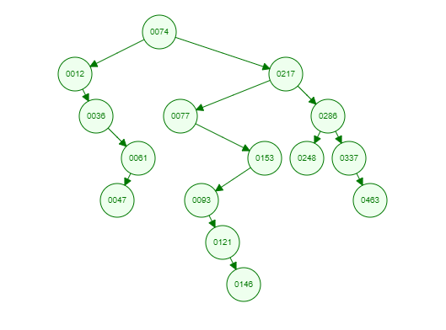**1/** BST:

**2/** Height of the tree is 7.

**3/**

a/ Pre-order: 74, 12, 36, 61, 47, 217, 77, 153, 93, 121, 146, 286, 248, 337, 463.

b/ In-order: 12, 36, 47, 61, 74, 77, 93, 121, 146, 153, 217, 248, 286, 337, 463.

c/ Post-order: 47, 61, 36, 12, 146, 121, 93, 153, 77, 248, 463, 337, 286, 217, 74.

4/

- Use pre-order to make a complete duplication.

- Use in-order to sort and print ascending.

- Use post-order to delete entire tree.

**5/** Successor (146) = 153.

**6/** Predecessor (146) = 121.

**7/**

- To find 337 we need to traverse: 74, 217, 286, 337.

- To find 47 we need to traverse: 74, 12, 36, 61, 47.

**8/** After remove node 146

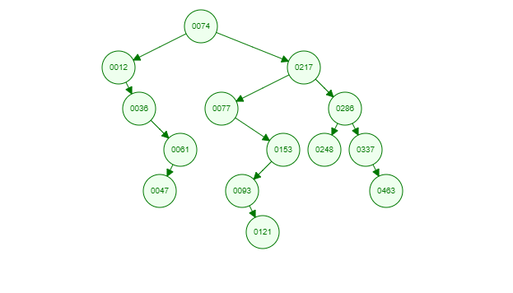

**9/**

Orders of numbers:

121, 61, 36, 77, 12, 47, 74, 93, 248, 153, 337, 146, 217, 286, 463.

Balance BST tree

