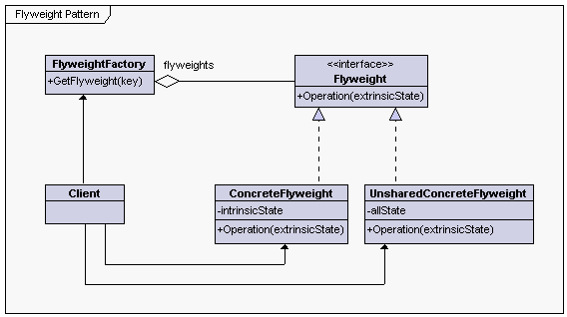

**Flyweight** - declares an interface through which flyweights can receive and act on extrinsic state

**ConcreteFlyweight** - implements the Flyweight interface and adds storage for intrinsic state, if any. A ConcreteFlyweight object must be sharable. Any state it stores must be intrinsic; that is, it must be independent of the ConcreteFlyweight object's context

**UnsharedConcreteFlyweight** - not all Flyweight subclasses need to be shared. The Flyweight interface enables sharing; it does not enforce it.

**FlyweightFactory** - creates and manages flyweight objects

- ensures that flyweights are shared properly. When a client requests a flyweight, the FlyweightFactory object supplies an existing instance or creates one, if none exists.

**Client** - maintains a reference to flyweight(s)

- computes or stores the extrinsic state of flyweight(s)