CSC 206 Algorithms and Paradigms
CSC 140 Advanced Algorithm Design and Analysis
Spring 2023
Assignment 2: Recurrences
Solutions

Solve all the following recurrences using the Master Method (if possible) and the first five of them using the recursion tree method:

- 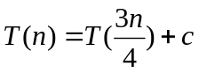
# of leaves = n^{log1} (base 4/3, but the base does not matter here)
= n⁰ = 1 (same order as c) → Case 2
T(n) = θ(logn)
- 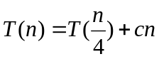
# of leaves = n^{log1} (base 4, but the base does not matter here)
= n⁰ = 1
cn has a higher order than the number of leaves → Case 3
Regularity condition: af(n/b) ≤ k f(n)
cn/4 ≤ k cn
Satisfied for k = ¼ < 1
T(n) = θ(n)
- 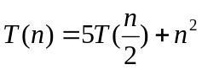
# of leaves = 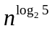> 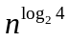= 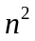 (for large n) → Case 1
T(n) = θ()

- 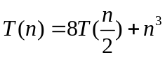
# of leaves = 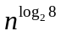 = 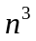 (same order as f(n)) → Case 2
T(n) = θ(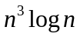)

- 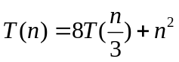
# of leaves = 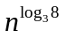< 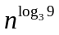= (for large n) → Case 3
Regularity condition: af(n/b) ≤ k f(n)
8 (n/3)² ≤ k n²
8 n² / 9 ≤ k n²
Satisfied for k = 8/9 < 1
T(n) = θ()

- 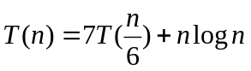
# of leaves = 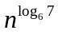> 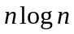(for large n)
The number of leaves is polynomially larger than nlogn, because has a polynomial degree greater than 1, while nlogn has a polynomial degree of 1. As proved in class, even the smallest polynomial is larger than logn.
T(n) = θ()
- 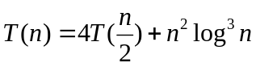
# of leaves = = < 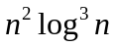(for large n)
However, they are both of the same polynomial degree of 2. So, we cannot apply the Master Theorem to this case.

- 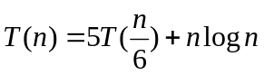
# of leaves = 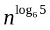< n¹ <(for large n)
nlogn is polynomially larger than the number of leaves, because it has a polynomial degree of 1, while has a polynomial degree less than1.
T(n) = θ(nlogn)

