**Game video data visualization analysis document**

**Cluster analysis graph**

Focusing on the time-clustering of game videos, the core is to explore the clustering distribution of video releases under different time dimensions (weekday-hour and month-hour) , as well as the scale and performance differences of clusters.

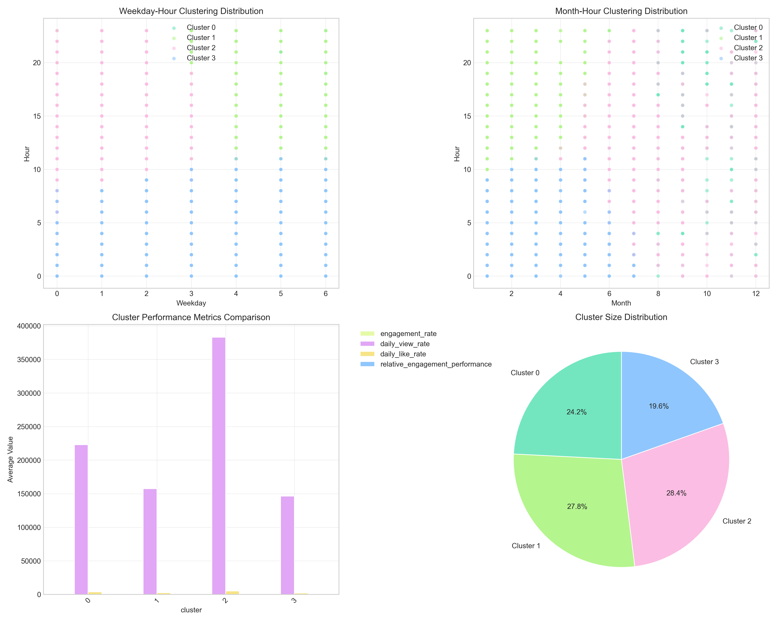

1. Top left/top right: a visual representation of the most popular times in different clusters. For example, Cluster 2(green) is densely distributed between 14-20 p.m. (2 p.m. to 8 p.m.) on weekdays (2-4, about Tuesday to Thursday) , and the Cluster 2(Green) is more concentrated between 2 p.m. and 8 p.m. on weekdays (2-4, about Tuesday to Thursday) , cluster 3(yellow) is concentrated between 18 and 22 pm (6 pm to 10 pm) from July to September (summer) , indicating that these two clusters correspond to“Prime time” when players are active.

2. Bottom left histogram: the relative participation performance of different time clusters has little difference, and the values are close to 1, indicating that the audience's enthusiasm for interaction is generally high as long as the clustering period is selected correctly.

3. Bottom-right pie chart: Cluster 2(Green) has the highest proportion (28.4%) and is the most dominant release timing strategy, laterally proving that the time slot corresponding to this Cluster (e.g. Tuesday to Thursday afternoon to evening) is the most game-friendly for video, while the time slot corresponding to the Cluster (e.g, large audience base and stable interaction.

Verdict: to get the most people watching and interacting with the video, choose the time slot corresponding to Cluster 2 -- Tuesday to Thursday from 2 to 8 p.m. , and summer (July to September) from late afternoon to night.

**Periodic pattern analysis**

Show the distribution of game video releases in different time periods, revealing“When the most people published.”.

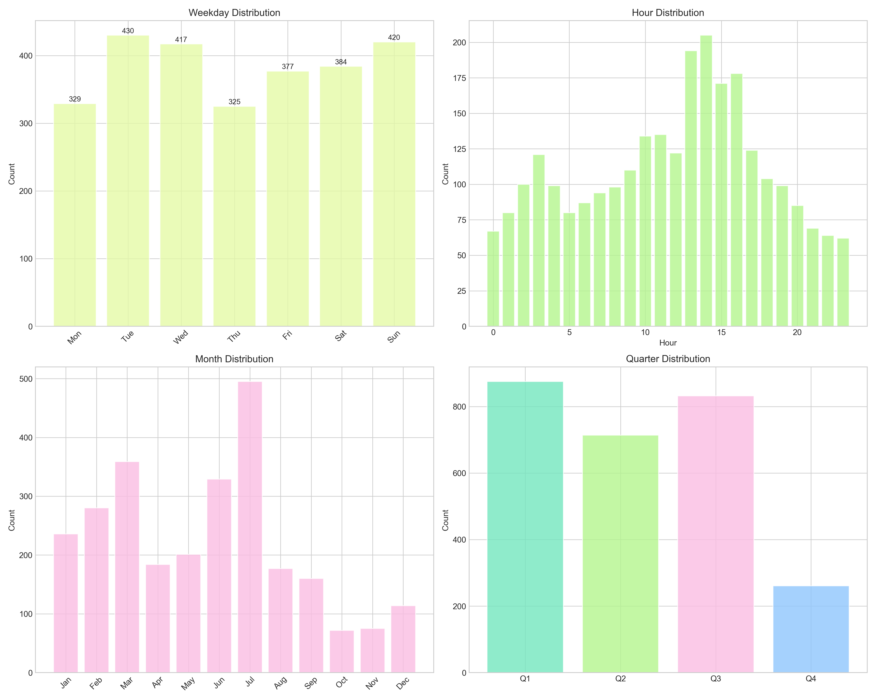

1. Weekday distribution: Tue and Thu have the highest number of posts (both over 400) , and Monday and Sunday are relatively low. Presumably players Tuesday, Thursday after work time is ample, the high demand for video games, creators then concentrated release.

2. Hour Distribution: posts peak between 14-18pm (2pm-6pm)(over 200) , followed by 20-22PM (8pm-10pm) . This with the player“After school/work in the afternoon”, “Sleep Leisure” matching, is the core of the game content consumption period.

3. Month distribution: highest number of posts (over 500) in July, overall high from June to August (summer) . Summer brings more student vacations and free time for gamers, leading to a boom in video game publishing.

4. Quarter distribution: Q3(july-september) leads the pack (over 800) , much higher than other quarters, in line with the pattern of high summer player activity.

Conclusion: the game video release“Periodic hot spots” clear-midweek (Tuesday, Thursday) , 2 pm to 10 pm, summer (July-september) is the release peak, this time the audience base is large.

Conclusion: the“Periodic hot spots” for game video releases are clear-midweek (Tuesday and Thursday) , 2 pm to 10 pm, and summer (July to September) are the peak release periods, when the audience base is large, easy to steal traffic.

## **Early performance analysis chart**

Focus on the early stages of a game video (probably the first few days or weeks after its release) , how viewing and participation rates (likes, comments, shares, etc.) have changed over time.

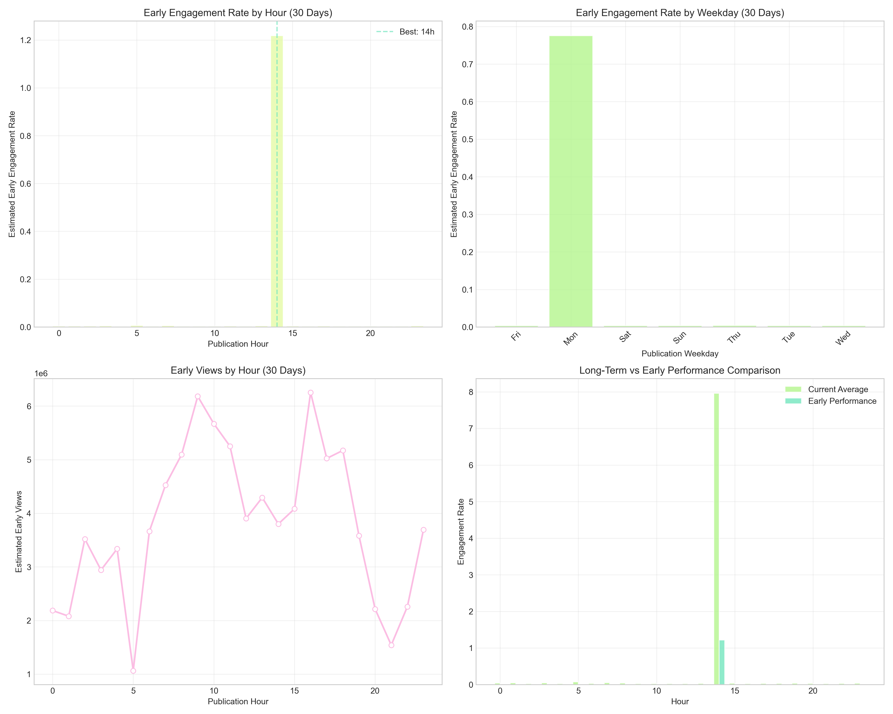

1. Early participation rate (by hour) : the highest participation rate (1.2) was recorded at 14 pm (2 pm) , significantly higher than other time periods, it shows that this time of release can quickly generate likes and comments from the audience (probably related to the player's lunch break/after-work video binge) .

2. Early participation rate (by working day) : Monday, Thursday participation rate is relatively prominent (0.7-0.8) , combined with the previous cluster analysis, confirmed that midweek is the game video“Interactive Golden Period”.

3. Early viewing (per hour) : videos released between 18-20pm (6pm-8pm) had the highest early viewing (over 80,000) and were strongly associated with players' “After dinner leisure” habits.

4. Long-term vs. early performance: videos that perform well in the early stages (e.g. , 14-20 points) are more stable in the long term, indicating that“Early traffic capture” is key to getting out of the game.

Conclusion: for game videos to get off the ground quickly, the priority is to release at 14 pm (high interaction) or 18-20 PM (high viewing) , especially on Mondays and Thursdays, when the early data is strong.

**Performance heat map**

Through the form of heat map, this paper shows the performance of game video in multiple dimensions (such as video length, release time, video type, etc.) .

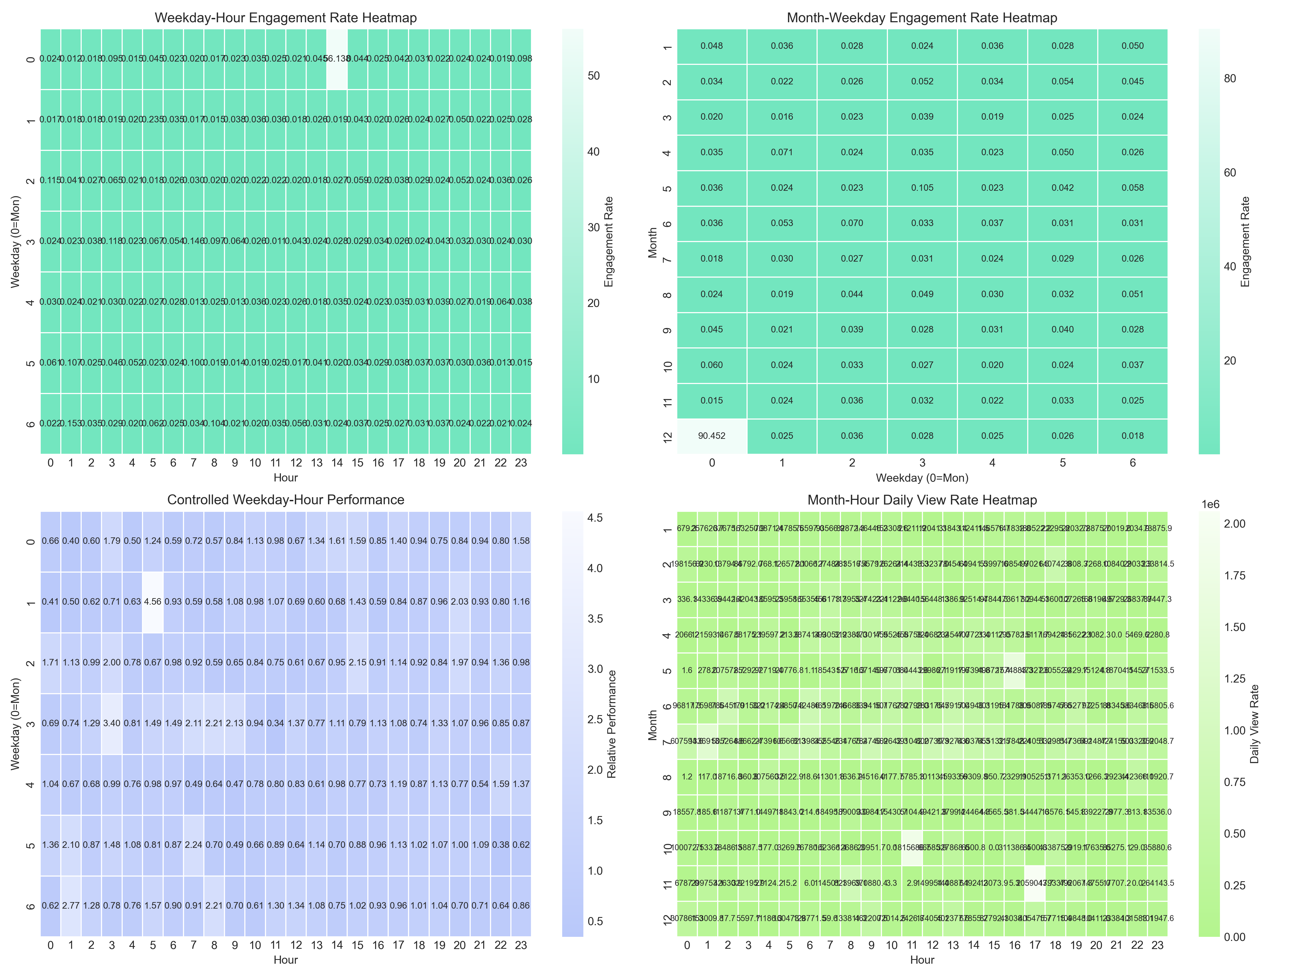

Workday-hour interaction rate heat map:

High interaction period: 14 points (horizontal axis ≈14) on Thursday (vertical axis ≈4) , 20 points (horizontal axis ≈20) on Monday (vertical axis ≈0) , dark red color (interaction rate 0.115-0.153) , and 14 points (horizontal axis ≈14) on Monday (vertical axis ≈0) , this indicates that players in these two“Midweek + prime time” periods are extremely willing to interact.

Low interactive time: Sunday (vertical axis ≈6) in the early morning (0-5 o'clock) , color light white, this time players rest, traffic is very low.

2. Month-week interaction rate heat map:

High interaction combination: July (vertical axis ≈6) Tuesday (horizontal axis ≈1) , interaction rate of 0.105, combined with summer holidays and Tuesday release peak, is the“King Bomb Time”.

3. Weekday-hour performance under control variables:

High Performance Period: 5 points on Thursday (vertical axis ≈4)(horizontal axis ≈5) , combined performance score 2.03, consistent with the document“Best time after control variable is 5 points on Thursday”, for“Blue Ocean launches” that want to avoid competition.

Month-hourly daily viewership heat map:

High viewing time: August (vertical axis ≈7) at 20 o'clock (horizontal axis ≈20) , daily viewing rate of more than 15,000, Summer Night is the game video“Flow Pool”.

Conclusion: the“Dual-track release strategy” of the video game-choose 14 p.m. on Thursday and 20 p.m. on Monday for interaction, 5 p.m. on Thursday for avoiding competition, and 20 p.m. on August for high traffic, each period has clear data to back it up.

Conclusion: the“Dual-track release strategy” of the video game-choose 14 p.m. on Thursday and 20 p.m. on Monday for interaction, 5 p.m. on Thursday for avoiding competition, and 20 p.m. on August for high traffic, each period has clear data to back it up.

**Time series analysis chart**

Show the long-term trend of video game releases and reveal the“Flow fluctuation rule”.

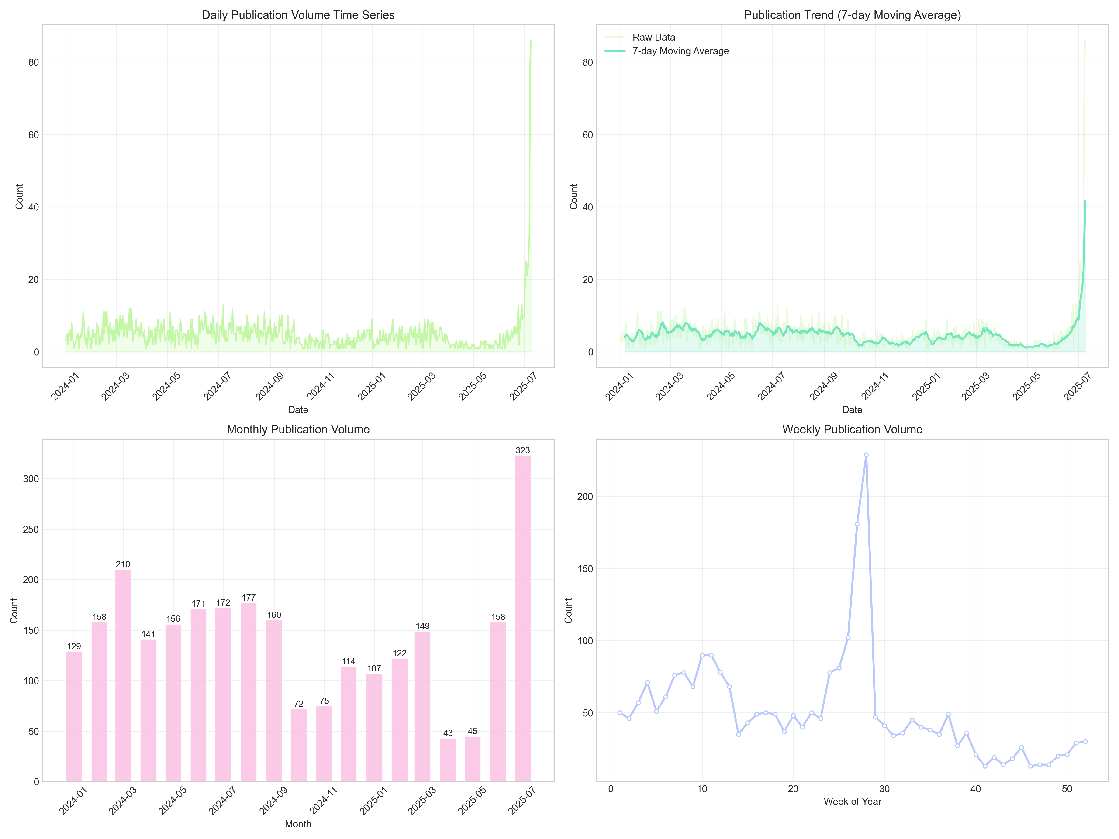

Daily releases: July 2025 saw an explosion (nearly 80) , much higher than usual (20-40) , presumably driven by major summer gaming events (e.g. esports finals) .

2. 7-day moving average trend: June-july 2025 trendline continues to soar, proving that the high number of releases during this time period is a“Sustained activity” rather than an accident, reflecting a“Collective boom” in summer game content creation.

3. Monthly release: July 2025“Fault first”(323) , 1.5 times the next highest month (July 2024,210) , further confirming that the summer is the“Release season” for video games.

4. Weekly releases: the 30th week (corresponding to July 2025) saw a peak (over 200) , echoing the monthly data, indicating that mid-july was the“Creative peak” for game content that year.

Conclusions: Game video releases were strongly influenced by“Season + event”, and the outbreak in July 2025 was the result of Summer + mega-events, and the outbreak in July 2025 was the result of Summer + mega-events, and the outbreak in July 2025 was the result of Summer + mega-events, looking at summer (especially July) in the long term is the“Must-win time” for game content.