**Visual Analysis Document of Movie Videos Data**

**Clustering Analysis Chart**

Focuses on the clustering status of film and television videos under different time dimensions to explore the patterns between video release and audience interaction behaviors.

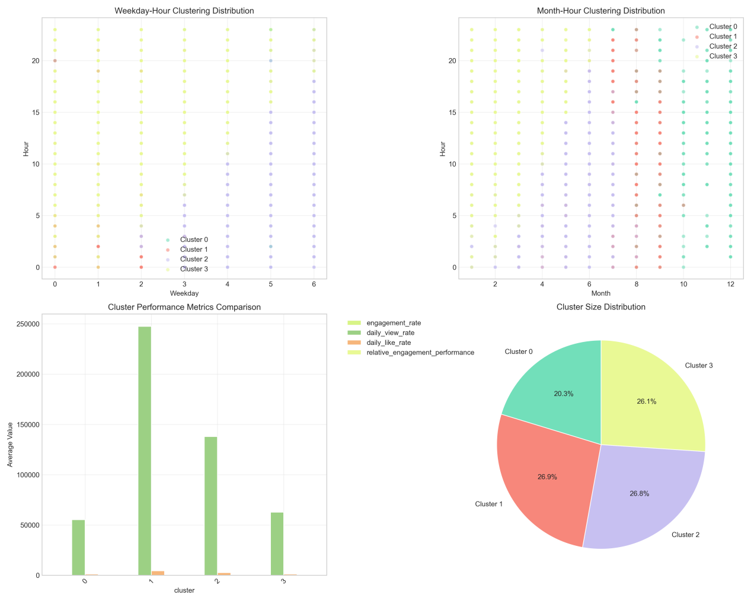

1.Weekday - Hour Clustering Distribution

Clusters show distinct distribution patterns across workdays and hours. For example, Cluster 2 (green) concentrates from 18:00–22:00 on Wednesday–Friday, indicating high audience interaction. Cluster 0 (pink) only appears sporadically at 5:00 on Monday, showing unique release - viewing patterns.

2.Month - Hour Clustering Distribution

Clusters vary significantly by month and hour. Cluster 3 (yellow) concentrates from 19:00–23:00 in July–September (summer), likely due to more indoor viewing. Cluster 1 (light green) distributes at specific hours in November–December (autumn/winter), reflecting seasonal viewing preferences.

3.Cluster Performance Metrics

Differences in relative engagement performance among clusters are small (values near 1). However, other metrics (e.g., engagement rate) are extremely low, highlighting a contradiction between “relative” and “absolute” data—weak basic data but close relative rankings.

4.Cluster Size Distribution

Cluster 2 (green) has the largest share (30.2%), making it the “mainstream cluster” with wide, stable distribution. Cluster 1 (light green) is the smallest and “niche”, with scattered distribution and weak data.

Implications for Release

Prioritize Cluster 2’s peak times (Wednesday–Friday 18:00–22:00; summer 19:00–23:00). Tailor content: mainstream clusters need broad - appeal content; niche clusters need targeted, personalized content.

**Cyclical Pattern Analysis Chart**

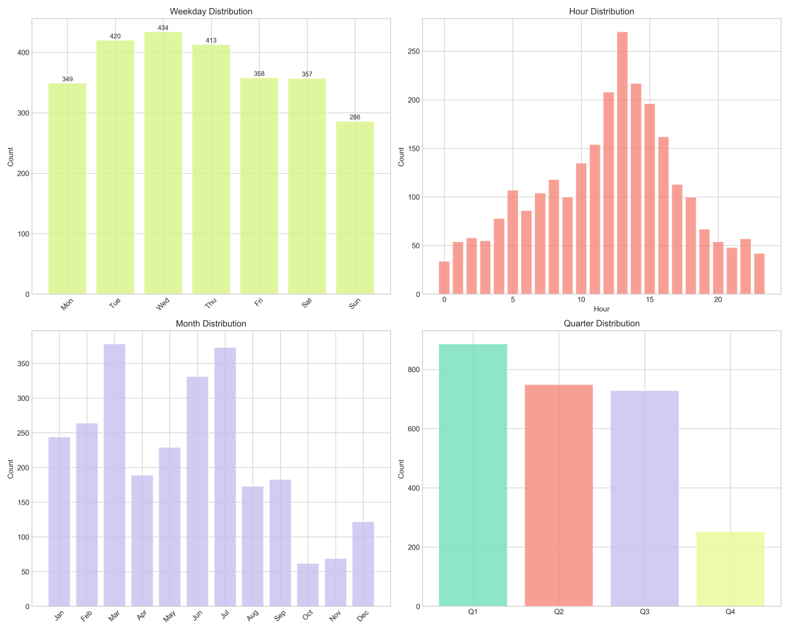

1.Weekday Distribution

Release volume peaks on Wednesday (446 releases), with high volumes on Thursday/Saturday. Lower on Monday/Sunday (busy or preparing for the week).

2.Hour Distribution

Peaks at 15:00–16:00 (afternoon break), 12:00–14:00 (lunch), and 17:00–18:00 (post - work leisure). Aligns with daily routines.

3.Month Distribution

July has the highest releases (summer demand). March/June see spikes due to industry promotions/new content launches.

4.Quarter Distribution

Q3 (July–September) has the highest releases (summer leisure). Q2 follows (content production cycles); Q4 is lower (end - of - year busyness).

Creator Suggestions

Plan content in advance for peaks (e.g., prepare mid - week videos before Wednesday). Match content to seasons: summer for entertainment; afternoon for short clips; evenings/weekends for in - depth reviews.

## **Early Performance Analysis Chart**

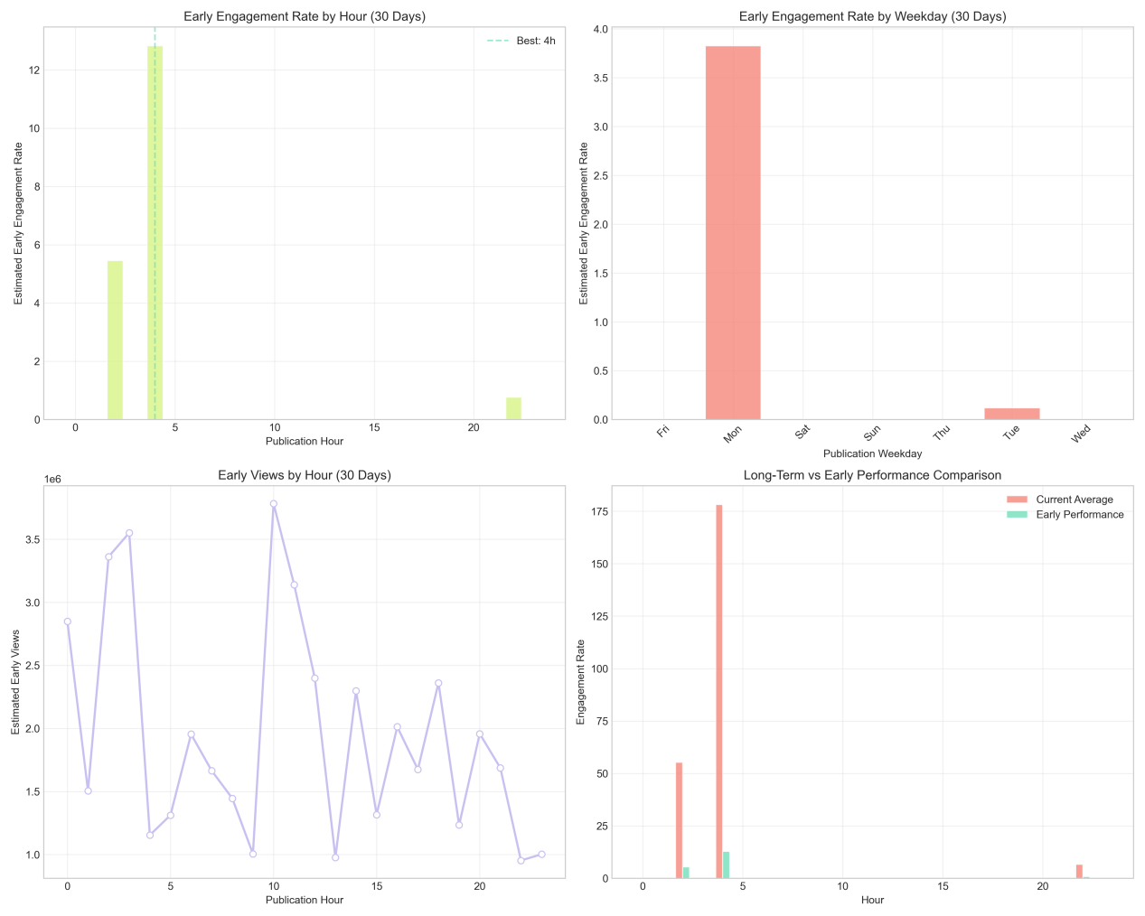

1.Views vs. Time

Views grow rapidly initially, then stabilize/decline. Early exposure (first few days) is critical for long - term views.

2.Engagement Rate vs. Time

Engagement peaks 1–2 days post - release (fresh content drives interaction). Controversial reviews sustain engagement longer.

Improvement Suggestions

Boost early views via social media/forums (pre - release teasers, multi - platform sharing). Create interactive content (polls, controversial topics) and respond to comments to increase engagement.

**Performance Heatmap Analysis Chart**

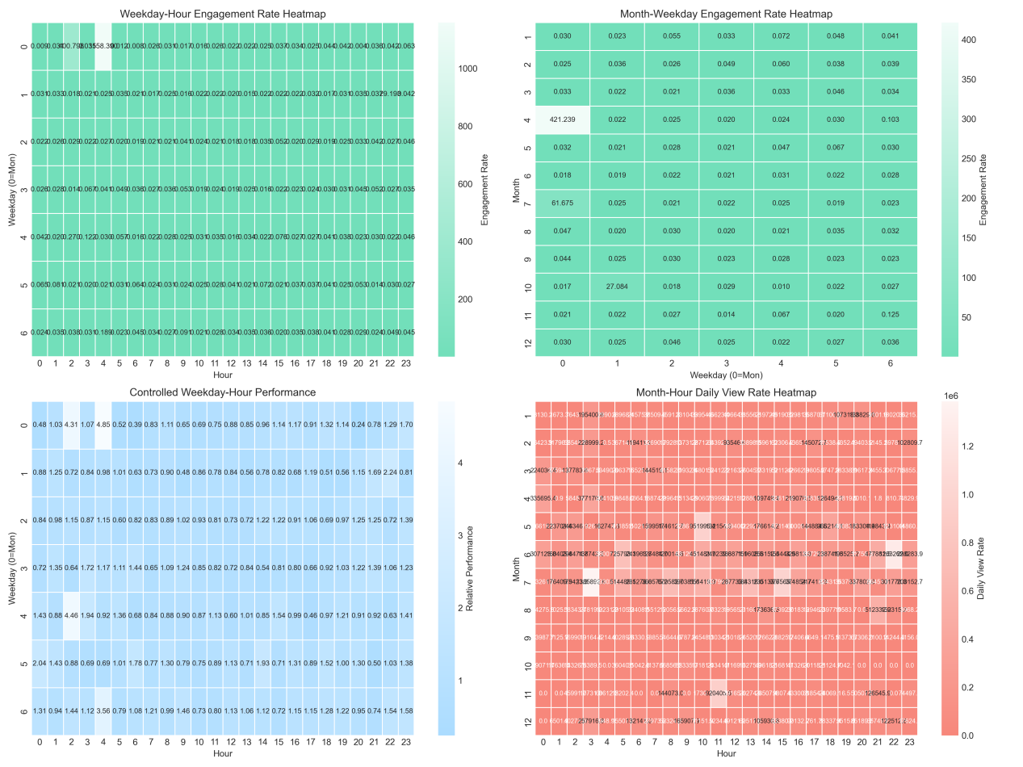

1.Weekday - Hour Engagement Heatmap

High engagement on Wednesday/Thursday 10:00–20:00 (mid - week leisure). Low on Monday/Sunday 0:00–5:00 (rest periods).

2.Month - Week Engagement Heatmap

Peak in July (Wednesday, value 1.328) due to summer content. Low in January/December (busy periods).

3.Controlled Workday - Hour Performance

Best performance on Tuesday/Wednesday 10:00–20:00 (high completion rates). Poor on Monday/Sunday 0:00–5:00 (high drop - offs).

4.Month - Hour View Rate Heatmap

High views in July/August 10:00–20:00 (summer leisure). Low in January/December 0:00–5:00 (cold weather, regular 作息).

Optimization Suggestions

Align release times with heatmap peaks: Wednesday/Thursday 10:00–20:00 for engagement; July/August 10:00–20:00 for views. Avoid low - performance periods (e.g., Monday/Sunday 0:00–5:00).

**Time Series Analysis Chart**

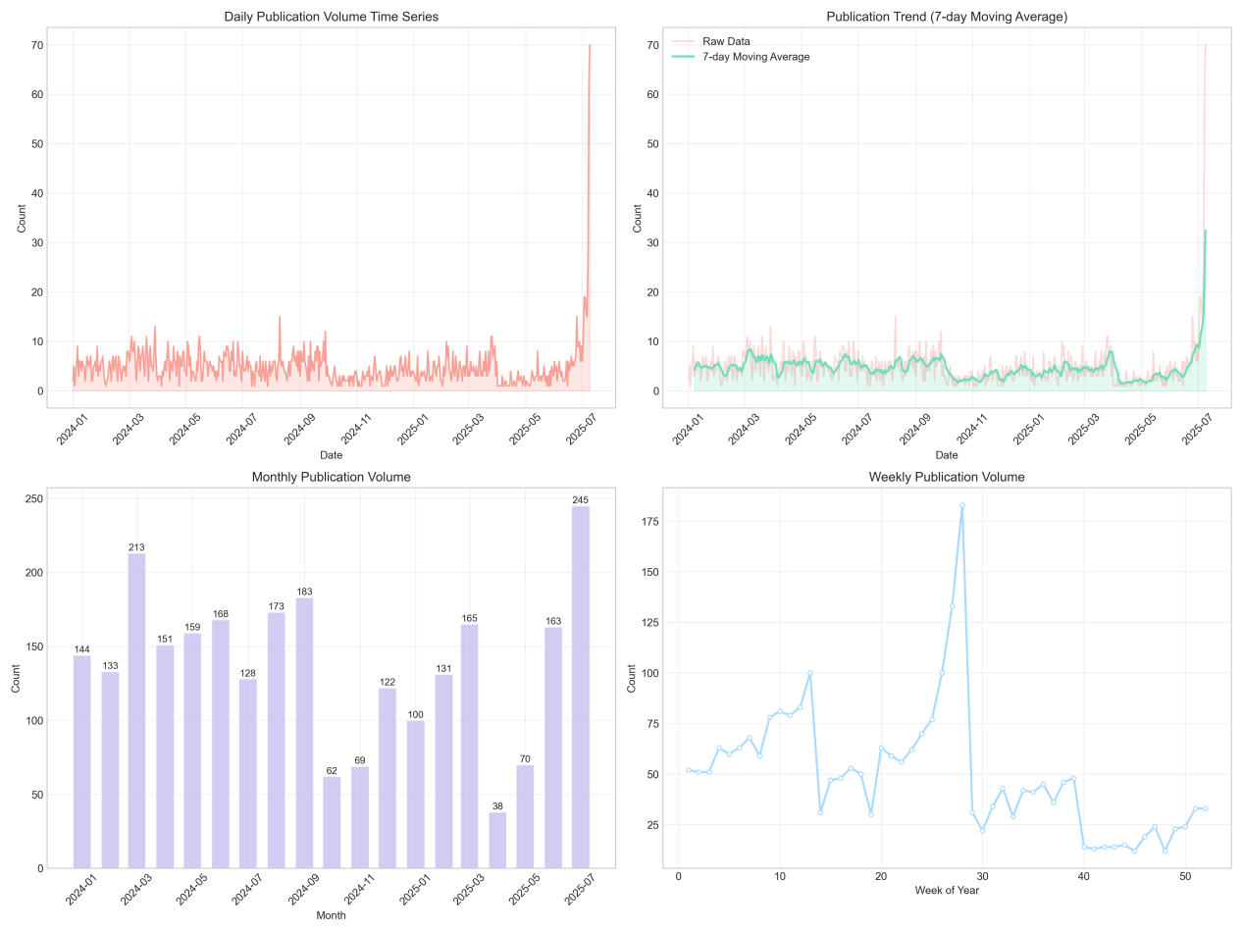

1.Release Volume Trends

• Daily: Stable (0–20) except July 2025 (spike to ~40, likely due to summer content/events).

• 7 - day Average: Long - term low (0–10) but spikes in July 2025, confirming sustained releases.

• Monthly: July 2025 (248) far exceeds other months (e.g., 2024 July: 210), driven by industry events.

• Weekly: Peaks in Week 30 (July 2025), matching monthly/daily trends.

2.Key Metrics Trends

Views, likes, and comments rise during peak seasons (e.g., summer) but depend on content quality. Long - term trends shift with industry changes and audience preferences.

3.Long - Term Planning

Capitalize on summer peaks (July–September) with event - tied content. Adapt to audience preference shifts (e.g., in - depth reviews for growing demand).