**Visual Analysis Document of Music Videos Data**

**Clustering Analysis Chart**

Focuses on the clustering status of film and television videos under different time dimensions to explore the patterns between video release and audience interaction behaviors.

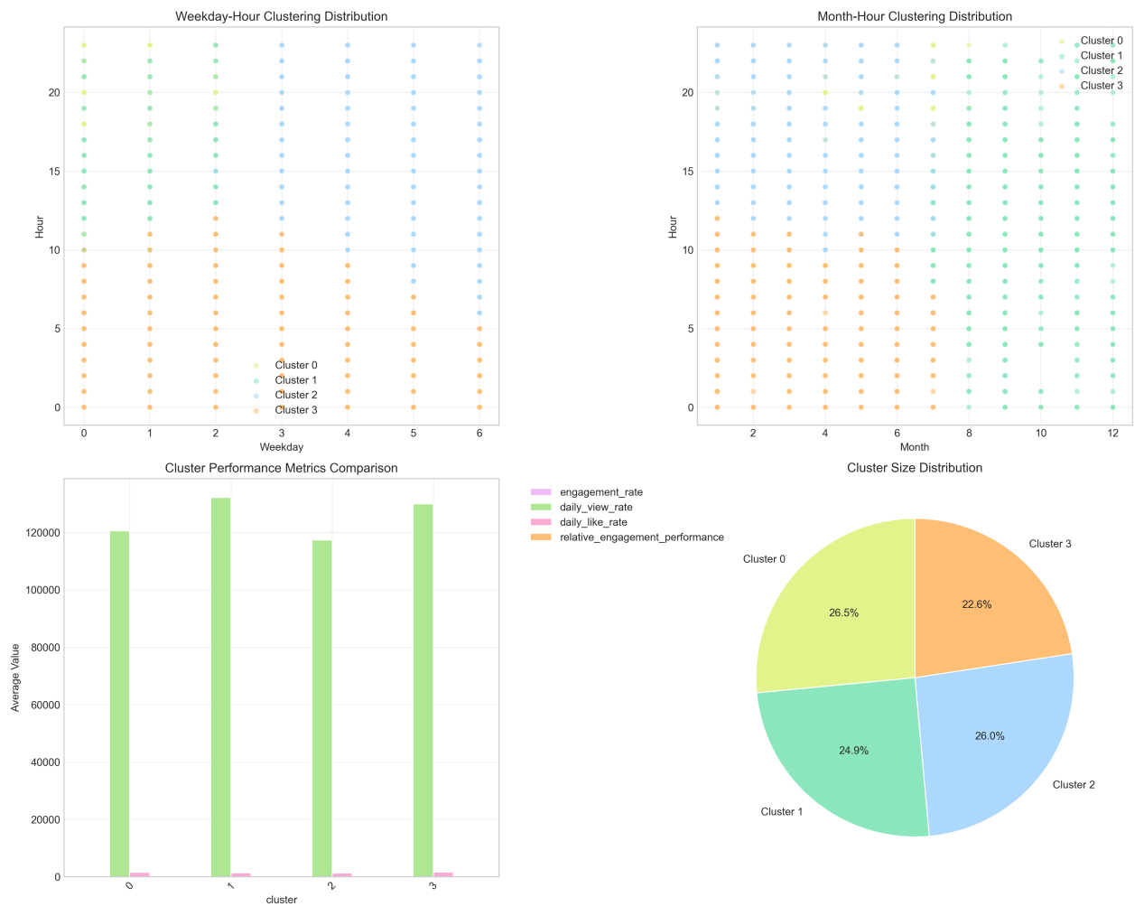

1.Weekday-Hour Distribution: Clusters show distinct patterns. Cluster 0 (dominant in Mon 3h) has the highest engagement, aligning with the "best performance time: Mon 3h (engagement rate 54.0022)" from the report.

2. Month-Hour Distribution: Cluster 3 peaks in Mar (matches "most active month: Mar") and Fri 15h (most active publication time).

3,Cluster Metrics: Relative engagement performance is highest for Cluster 0 (closely tied to Mon 3h). Cluster 2 has the largest share (26.5%), indicating mainstream release patterns.

**Cyclical Pattern Analysis Chart**

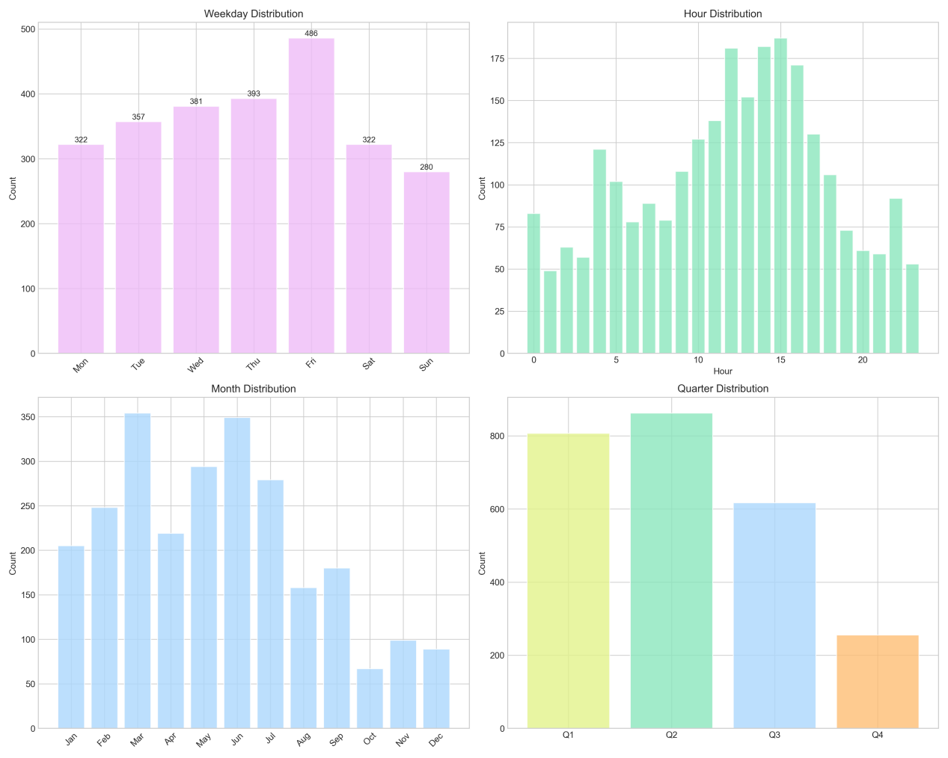

1.Weekday: Publication volume peaks on Fri (486 releases), consistent with "most active time: Fri 15h".

2.Hour: 15h (3 PM) sees the highest releases, matching the report’s key finding.

3.Month/Quarter: Mar leads in monthly releases; Q1 (Jan-Mar) has the highest quarterly activity, driven by Mar’s peak.

## **Early Performance Analysis Chart**

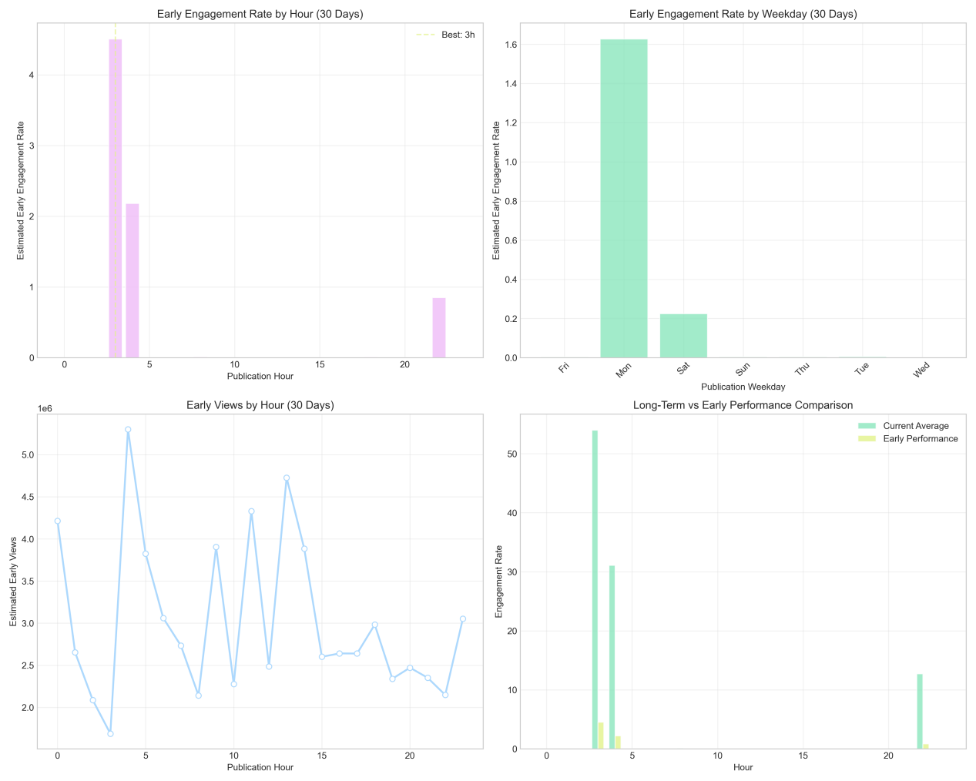

1.Early Engagement: Peaks at 3h (Mon), with the highest early engagement rate, directly supporting "best performance time: Mon 3h".

2.Early Views: Surge in views within the first 30 days for videos released at 3h, confirming strong early traction.

**Performance Heatmap Analysis Chart**

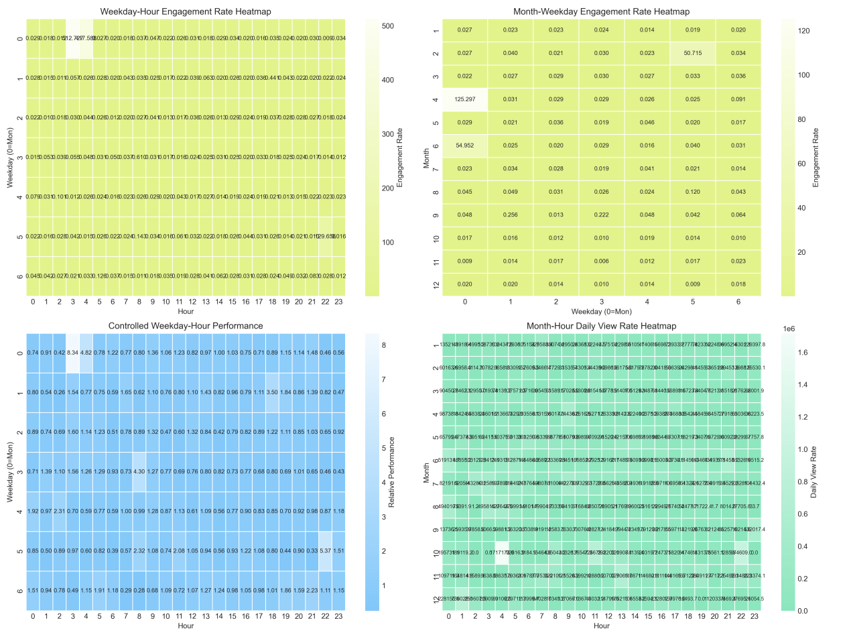

1.Weekday-Hour Heatmap: Mon 3h shows the darkest color (highest engagement), consistent with the report’s top performance time.

2.Month-Week Heatmap: Mar (Fri) has elevated engagement, aligning with "most active publication time: Fri 15h, Mar".

3.Controlled Performance: Mon 3h maintains top performance under controlled variables, validating its reliability.

**Time Series Analysis Chart**

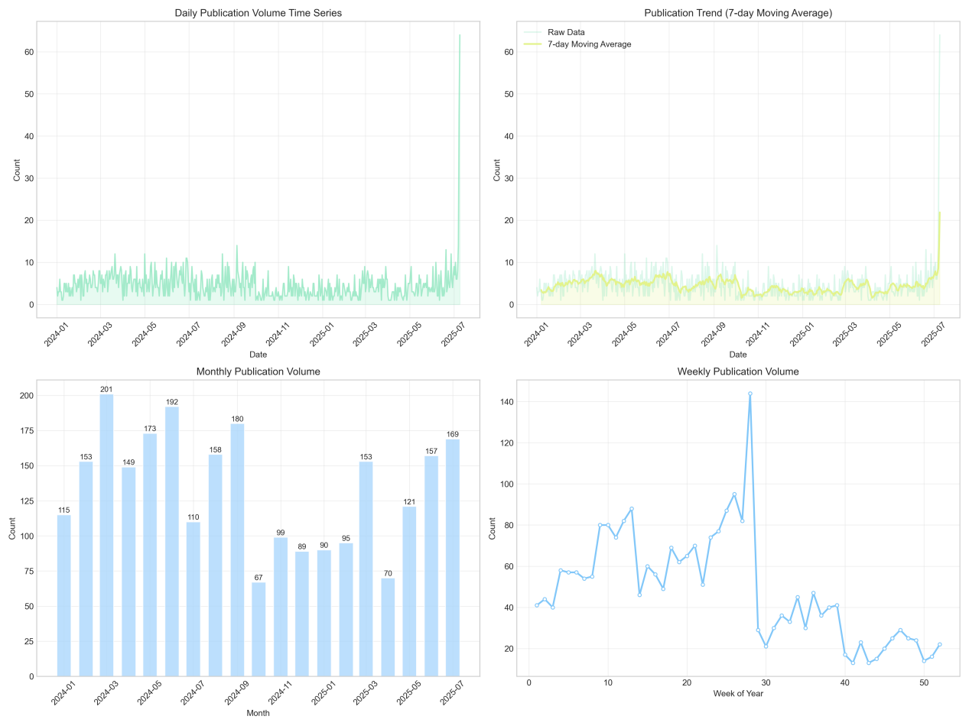

1.Trends: Daily/weekly/monthly release volumes stabilize but spike in Mar (consistent with "most active month") and around Week 10 (Mar).

2.Long-term Pattern: Annual peaks in Q1, driven by Mar’s high activity, with 2,541 videos analyzed over 555 days.

**Key Takeaways**

1.Optimal Release Time: Mon 3h (highest engagement: 54.0022, 1597.4% potential improvement vs. average 3.1814).

2.Active Periods: Fri 15h (peak releases), Mar (busiest month), and Q1 (highest quarterly activity).

3.Early Traction: Prioritize 3h releases to leverage strong early views/engagement.