**Sports video data visualization analysis document**

**Cluster Analysis Chart**

This paper focuses on the time-clustering analysis of sports videos. The core is to explore the clustering distribution of video releases under different time dimensions (weekday-hour and month-hour) , as well as the scale and performance differences of clustering.

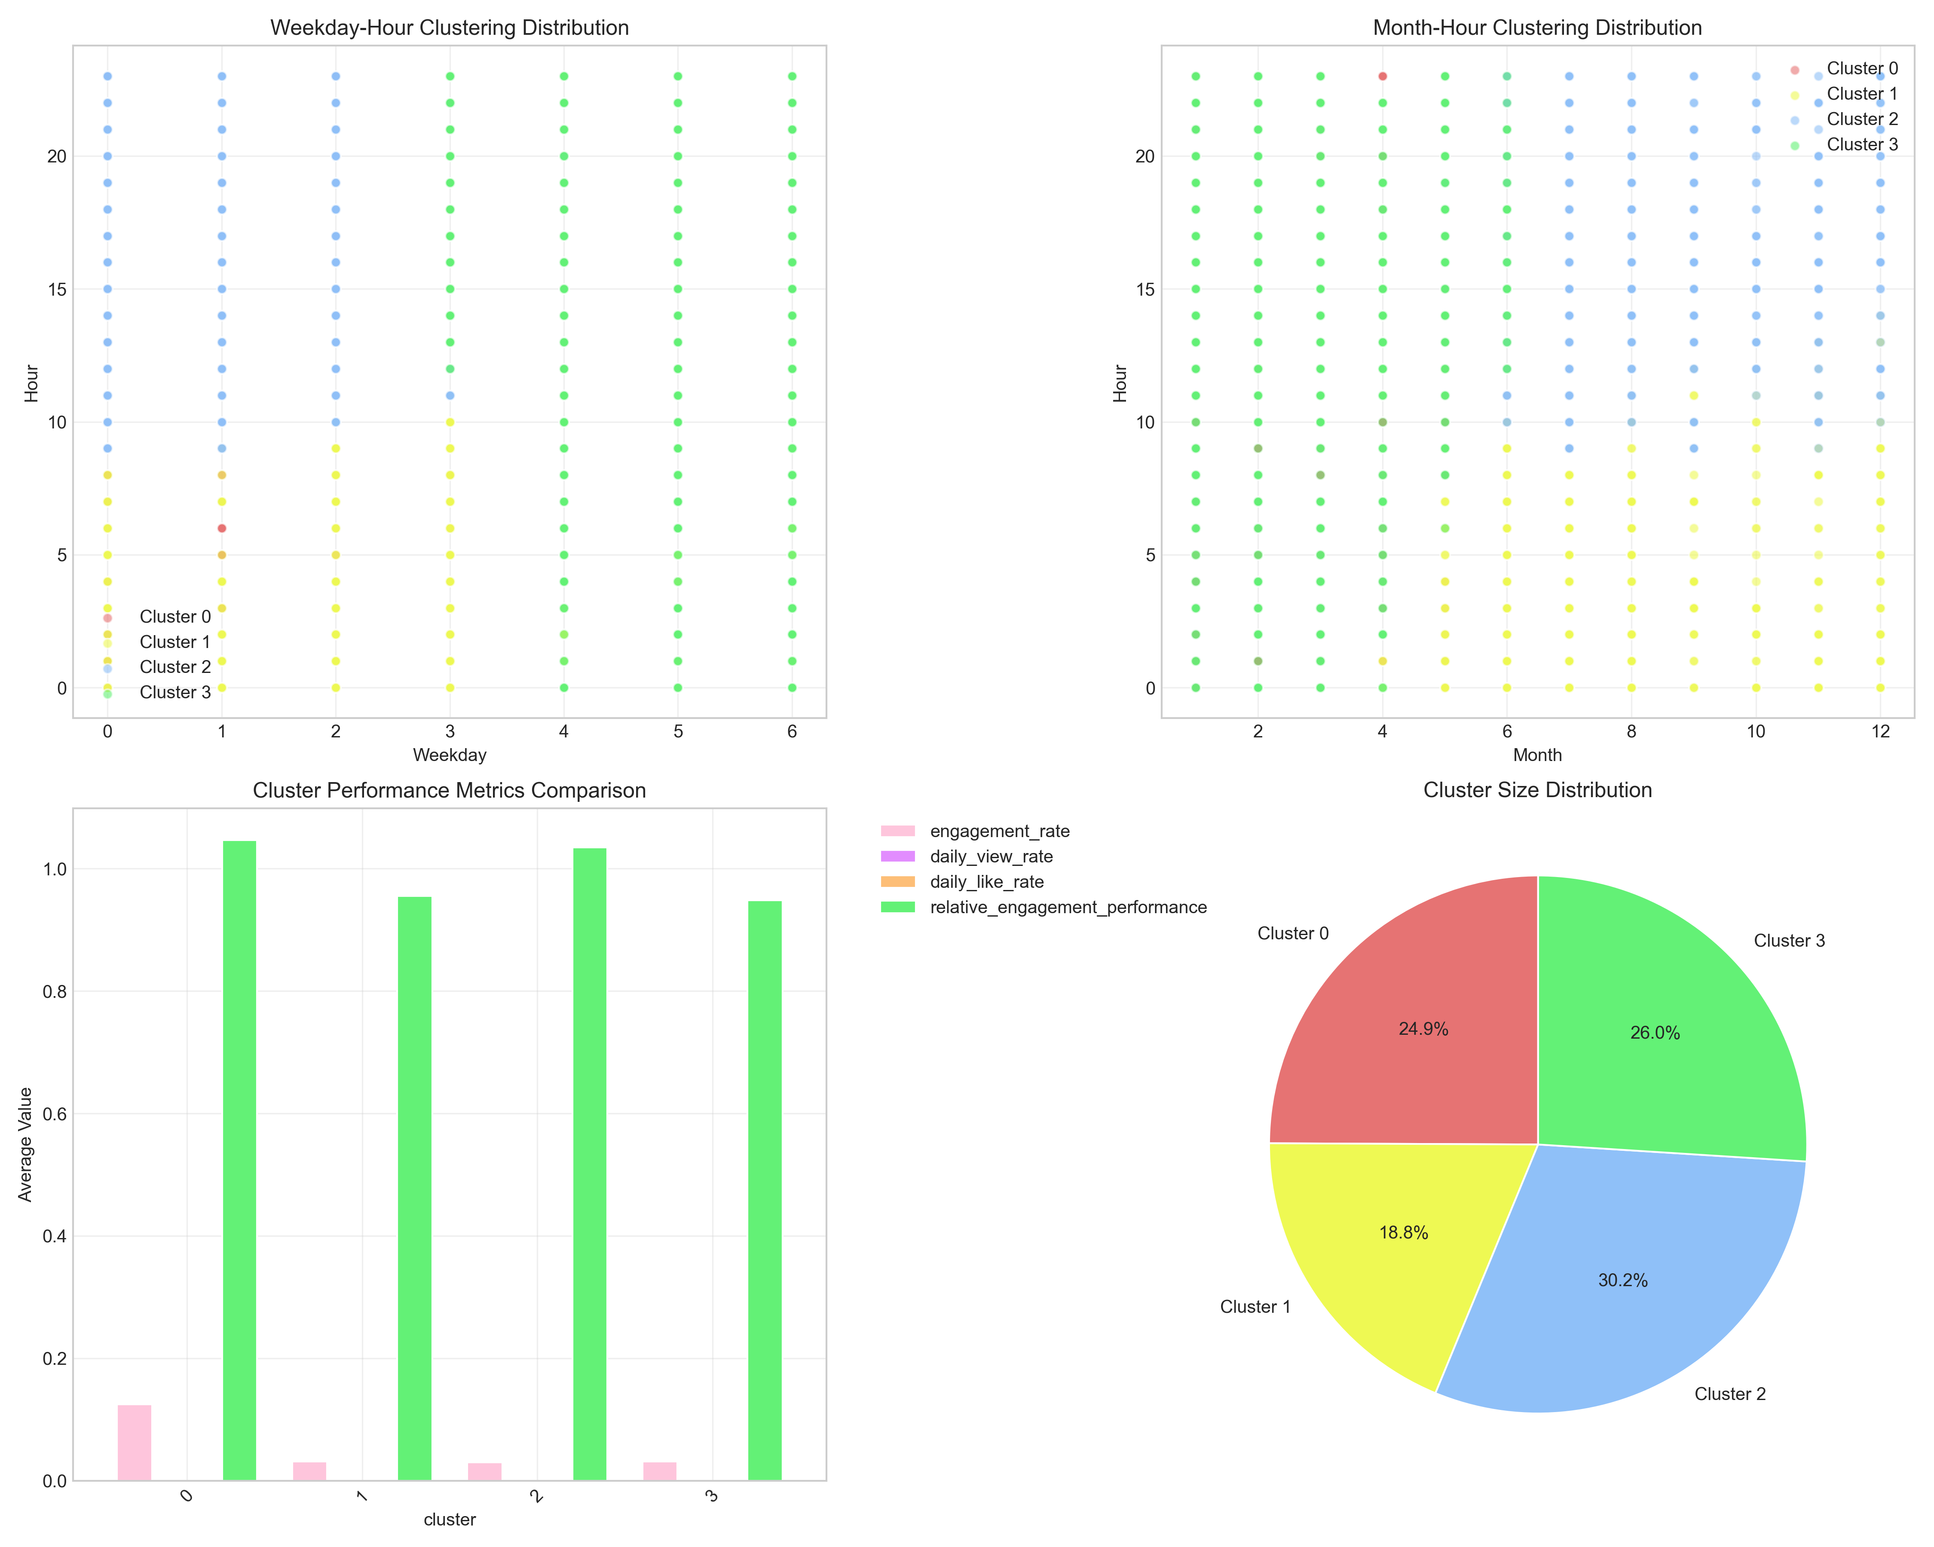

1. Top left and top right: you can see exactly where the clusters are located.

2. Lower left bar chart: although different“Time clustering” video posted by more or less people, but the interactive effect points are not much difference.

3. Bottom-right pie chart: Cluster 2(Green) has the highest percentage (30.2%) , indicating that this is the most popular type of“Temporal clustering” for videos, proving that it really works and has a large audience.

To get more people watching and interacting with sports videos, prioritize the first two charts to focus on clusters, especially Cluster 2, from Monday to Wednesday, and from afternoon to evening in summer and fall.

**Periodic pattern analysis chart**

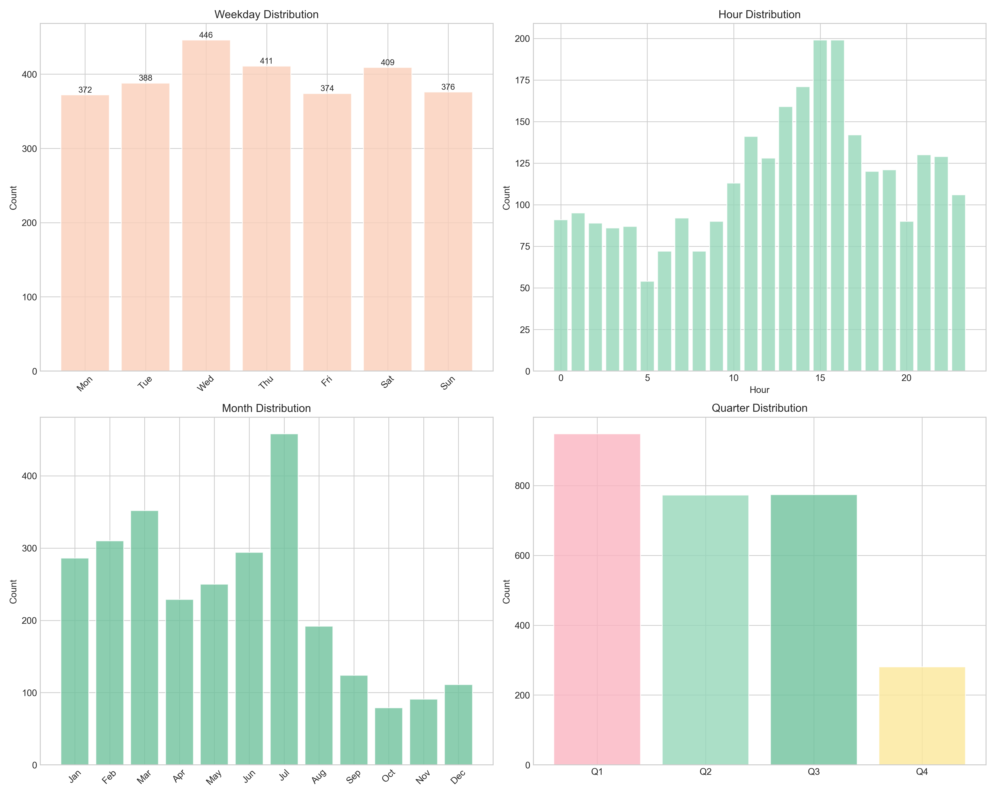

Week: Wednesday, Thursday, the most popular weekend;

In a day: Afternoon to evening (12-18 o'clock) send the most people;

Within a year: July (summer) and the third quarter (july-september) are peak release seasons

Weekday distribution: looking at the number of Weekday releases, you may find that the number of midweek (Tuesday-thursday) releases is relatively stable, while the number of Friday and Saturday releases is up, and the number of Sunday releases may be down slightly.

Hour distribution: at different hours of the day, the number of posts shows a clear periodicity. The number of posts usually reaches a peak between 6 pm and 10 pm, which is consistent with people's daily schedule. Evening is the main time period for people to relax and entertainment, and people pay more attention to sports videos. In the early morning, the number of posts is very small.

Month distribution: in the dimension of Month, the number of releases in some months is larger, which may be related to the arrangement of sports events and seasonal characteristics in that Month.

Quarter Distribution: on a quarterly basis, you may find a relatively high number of releases in Q2 and Q4.

## **Early performance analysis chart**

Focus on the early stages of a sports video (probably the first few days or weeks after it's released) , how viewing and participation rates (likes, comments, shares, etc.) have changed over time.

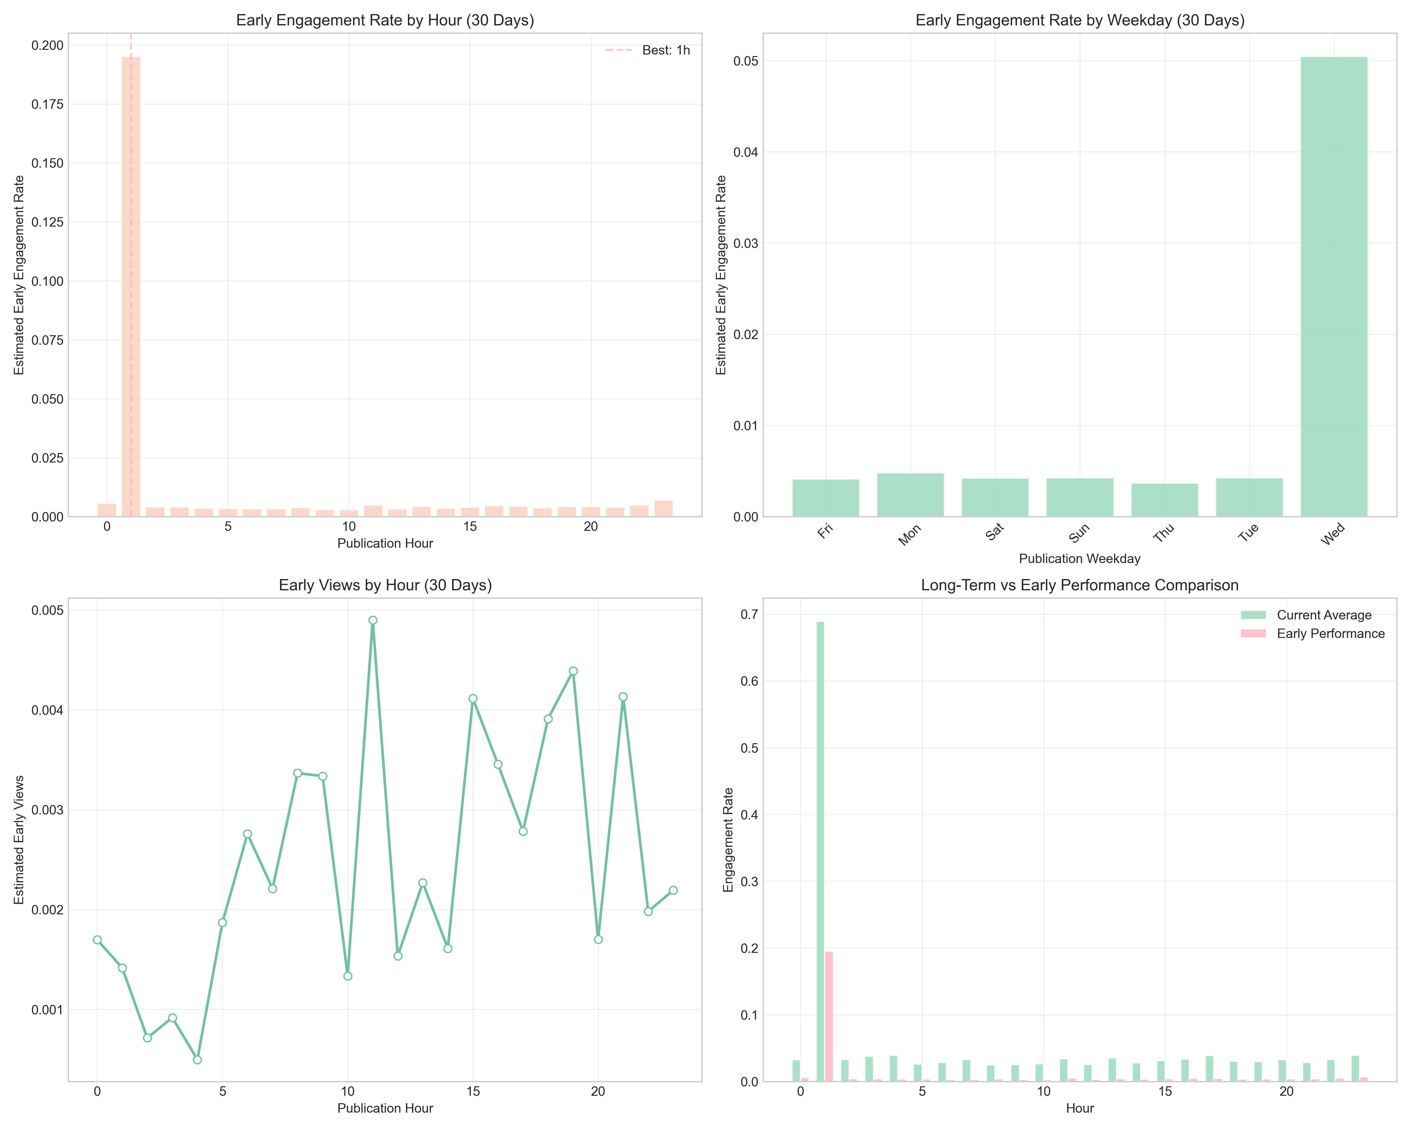

Viewing over time: as you can see from the graph, after the release of the video, the amount of viewing may show a rapid upward trend at the beginning, and then gradually flatten out or decline.

The relationship between participation rate and time: the change of participation rate (such as likes rate, comments rate) has a certain correlation with the number of views, but also has its own characteristics.

**Performance Heat diagram analysis chart**

Through the form of heat map, the performance of sports videos in multiple dimensions (such as video length, release time, video type, etc.) is shown.

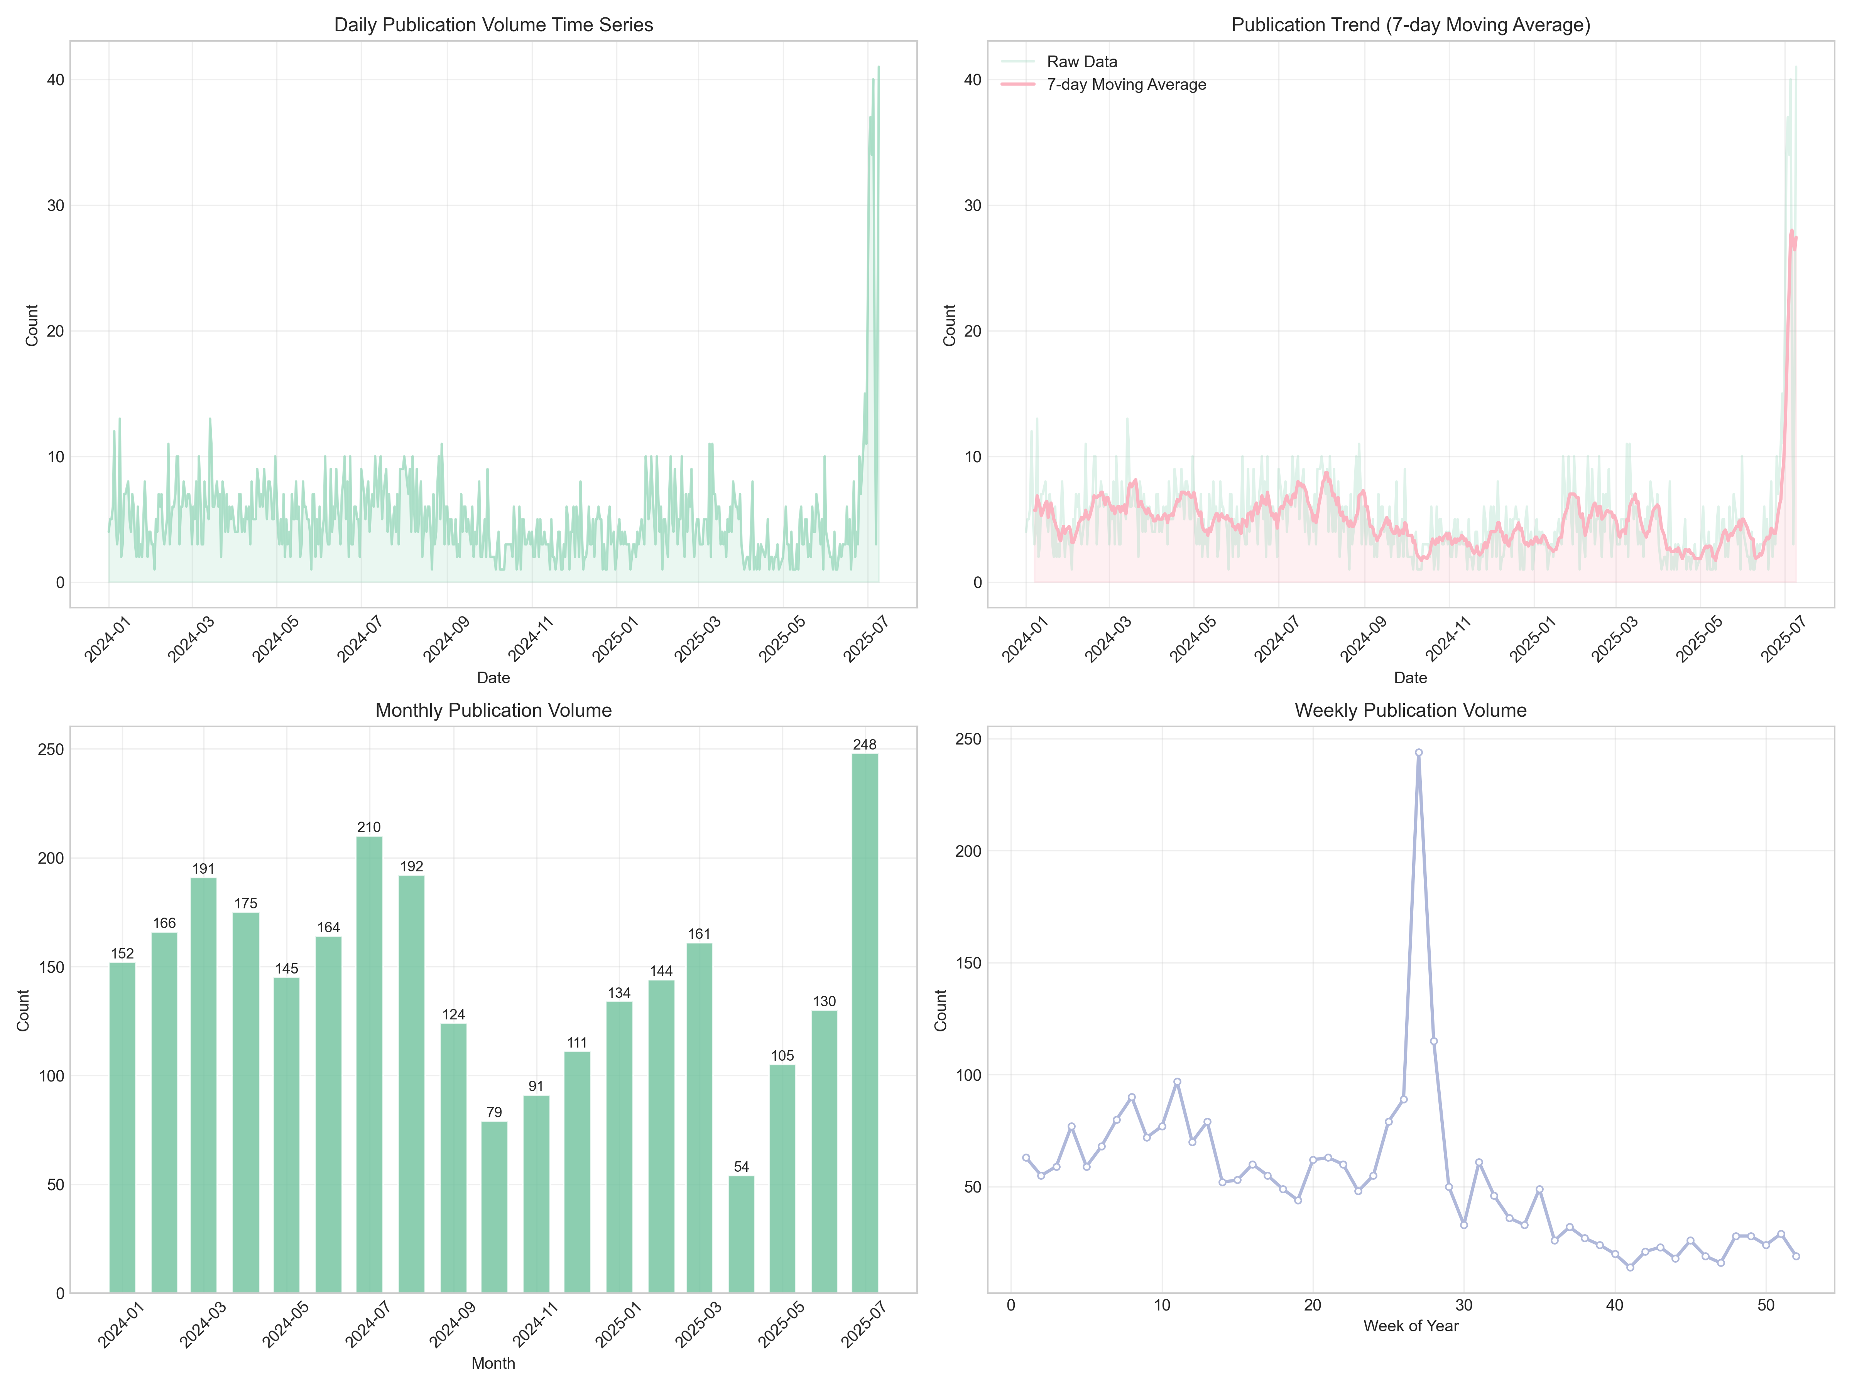

1. Top left: Weekday-Hour Engagement Rate Heatmap

High Interaction Time: weekdays, Wednesday (≈2 on the vertical axis) , Thursday (≈3 on the vertical axis) at 10-20 p.m. (10-20 on the horizontal axis) , color dark red: day to night for both days, audience interaction (likes, comments, shares) is most active.

Low interaction time: Monday (vertical axis ≈0) , Sunday (vertical axis ≈6) in the early hours of the morning (horizontal axis 0-5) , color light white: these two times the video, audience interaction is less.

2. Top Right: Month-weekday Engagement Rate Heatmap

High Interaction Month + week: Wednesday in July (vertical axis ≈6)(horizontal axis ≈2) , color dark red -LRB-value 1.3WednesdaysdayJulyjuly, audience interaction is extremely high.

Low Interaction Month + week: Monday in January (vertical axis ≈0) , Monday in December (vertical axis ≈11)(horizontal axis ≈0) , light pink color, Mondays at the beginning and end of the year, low audience interaction intention.

3. Bottom left: Controlled Weekday-Hour Performance heat map

High Performance: Tuesday (vertical axis ≈1) , Wednesday (vertical axis ≈2)10-20 points (horizontal axis 10-20) , color deep purple: these two days of day to night, the video overall performance is the best.

Low-performance hours: Monday (vertical axis ≈0) , Sunday (vertical axis ≈6) in the early hours of the morning (horizontal axis 0-5-RRB- , color light blue: these two hours to send video, even if there is a stream, the audience may be half-way to watch and leave, poor distribution of content.

4. Bottom right: Month-hour Daily View Rate Heatmap

High-day viewing times: 10-20 p.m. (X-axis 10-20) in July (y-axis ≈6) , August (y-axis ≈7) , dark green: daytime to evening in summer (July-august) , highest daily video viewing.

Low-day viewing times: early morning in January (vertical axis ≈0) , December (vertical axis ≈11)(horizontal axis 0-5) , light green: Early and late morning, almost no viewing.

Overall conclusion (clear pattern) :

1. The more time in between, the better:

Midweek (Tuesday-thursday) > weekend/Monday, PM to PM (10-20 pm) > early morning;

Summer (June-august) > early/late of the year, Wednesday in July is the“King of bombs”(interaction rate, viewing rate is both high) .

2. Content strategy recommendations:

Likes, comments high: preferred July Wednesday, mid-week (Tuesday-thursday)10-20 points to send video;

High broadcast volume: Priority Selection of 7-8 months, mid-week (Tuesday-thursday)10-20 points to send video;

Avoid early Monday/Sunday, early year/late year, low traffic.

Time series analysis chart

Taking time as the sequence, this paper shows the change trend of the release amount of sports videos in different time spans (such as day, month and week) , and some key indicators (such as viewing, likes, comments, etc.) time series changes.

1. Daily Publication Volume Time Series

Overall: most days are between 0 and 20, with July 2025(far right) seeing an explosion (close to 40) , indicating a recent concentration of video releases.

2. Publication Trend -7-day Moving Average

The Red Line (7-day average) : a long period of stable low levels (0-10) , followed by a sudden spike in July 2025, corresponding to a burst of daily postings that proved to be consistent and concentrated (rather than a one-day blip) .

3. Monthly Publication Volume

Month comparison: July 2025“Fault first”(248) , much higher than other months (followed by July 2024,210) ;

The Pattern: previous releases peaked in July (July 2024) , but“Skyrocketed” in July 2025, possibly driven by special events (e.g. major sports events, platform events) .

4. Weekly Publication Volume

Weekly comparison: around the 30th week (corresponding to July 2025) release volume“Peak”, other weeks stable at a low level;

Related: consistent with the monthly and daily data, there was a large number of videos released in a single week in July 2025.

The number of sports video releases has been stable for a long time, and it increased suddenly in July 2025, presumably driven by special events (events/events) , and a large amount of content was released centrally.