# Plan Scores based on People Spatial Distribution

The purpose of this experiment is to figure out how much the people spatial distribution affects the scores of the zoning plan. First, I randomly generate a zoning plan, spatially distribute people, and compute the scores. Then, by repeating this step for 10000 times, I got the best plan and worst plan. Finally, for these two extreme plans, I spatially distribute people for 1000 times and compute the scores at each time. The resulting score distribution is shown in Figure 1. This result shows that the variance in the scores by the zoning plan is significantly larger than the one by the people spatial distribution. This indicates that we can do a hierarchical two-steps search for the good zoning plans: 1) first, search for good zoning plans with random spatial distribution of people, 2) second, for each zoning plan, find the best spatial distribution of people and jobs. Since the search for the best spatial distribution of people is more expensive because of the significantly larger dimensionality, we can increase the performance of the search by this hierarchical approach.

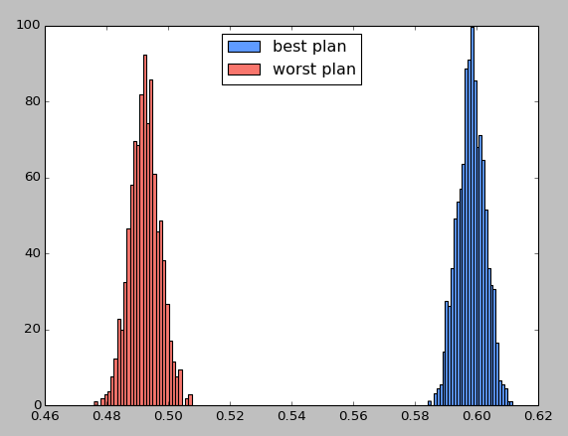

Figure 1. The difference in the score distribution between two zoning plans, the best one and the worst one.