SOFTWARE ORIENTED PROJECT TRAINING REPORT

SELL YOUR FURNITURE – AN E-COMMERCE WEBSITE
SUBMITTED IN PARTIAL FULFILMENT OF THE
REQUIREMENTS FOR THE AWARD OF

Degree of Bachelor of Technology in Computer Science & Engineering


SUBMITTED BY
Name: Nitin Garg
University Roll No.1628144
SUBMITTED TO:-Mr. Tejpal.

Department of Computer Science & Technology
CGC COLLEGE OF ENGINEERING, LANDRAN

CERTIFICATE

This is to certify that the declaration statement made by the student is correct to the best of my knowledge and belief. He has completed his internship under my guidance and supervision. The present work is the result of his original investigation, effort and study. No part of the work has ever been submitted for any other degree at any University. The internship is fit for the submission and partial fulfilment of the conditions for the award of B.Tech. degree in Computer Science and Engineering from CGC College Of Engineering, Punjab.

(Signature of student)

Nitin Garg
1628144
Date: ____________________

Certified that the above statement made by the student is correct to the best of our knowledge and belief.

Signatures

Examined by:

Head of Department

(Signature and Seal)

ACKNOWLEDGEMENT

The internship opportunity I had with MINDTREE LTD. was a great chance for learning and professional growth. Therefore, I consider myself as a very fortuitous individual to be a part of such reputed organization. I am also grateful for having a chance to meet so many wonderful people and professionals who led me though this internship period.

I am also thankful to all the staff members of our department, who helped us directly or indirectly in our endeavour and shown keen interest in our project by providing their encouragement.

I would like to thank Mr. Amarendra Gopalakrishna , Mr. Deepak Nagaraj and the management of Mindtree ltd for their opportunity and enlightening us with other aspects of project.

I perceive this opportunity as a big milestone in my career development. I will strive to use gained skills and knowledge in the best possible way, and I will continue to work on their improvement, in order to attain desired career objectives.

I want to give my thanks to my COMPUTER SCIENCE DEPARTMENT of CGC College of engineering for always supporting me. The knowledge which they have imparted in me allowed me to perform the actions in a smooth and efficient manner. Along with that their contribution towards self-development skills helped me a lot.

PREFACE

A student gets theoretical knowledge from classroom and gets practical knowledge from industrial training. When these two aspects of theoretical knowledge and practical experience are together then a student is fully equipped to secure his best.

In conducting the project study in an industry, students get exposed and have knowledge of real situation in the work field and gains experience from them. The objective of the Industrial Training is to provide an opportunity to experience the practical aspect of the technology in an organization. It provides a chance to get the feel of the organization and its function.

CONTENTS

Title Page No.
- Introduction
  - Mindtree Private Limited 6-8
- Project 8
- Technology 9-26
  - Overview 9
  - Snapshots and code 10-26
III.3 Unit testing 26-27
- Conclusion 27
- Bibliography 28

INTRODUCTION

I.1. Mindtree Private Limited:

Mindtree is a global technology services company with a mission to engineer meaningful technology solutions to help businesses and societies flourish. Our culture is about collaboration, education and opportunity, and we are proud to be recognized as a great place to work. Mindtree is acquired on the 7th position in the list of top IT companies in India.



Mindtree deals in e-commerce, mobile applications, cloud computing, digital transformation, data analytics, enterprise application integration and enterprise resource planning, with more than 339 active clients and 43 offices in over 18 countries.
The works in Application Development and Maintenance, Data Analytics, Digital Services, Enterprise Application Integration and Business Process Management, Engineering R&D, Enterprise Application Services, Testing, and Infrastructure Management Services.

MindTree Limited (MindTree), a global IT and R&D Services Company co-headquartered in India and the U.S was incorporated on 5th August 1999 as MindTree Consulting Private Limited. It was promoted by 10 industry professionals who came from Cambridge Technology Partners, Lucent Technologies and Wipro. The Company's activity is structured into two business units that focus on software development - IT Services and R&D Services, in which MindTree offers different IT Services to Capital Markets, Insurance, Manufacturing, Retail and Travel & Transportation Industries. Under which R&D, the company provides its bailout to Automotive, Communication Systems, Consumer Appliances and Computer Peripherals, Industrial Systems and Storage and Computing Systems. MindTree have offices across India, USA, United Kingdom, Germany, Switzerland, United Arab Emirates, Singapore, Australia and Japan. In January of the year 2000, an investment of Rs. 169 million was made by way of subscription to Equity Shares of the company in first round of funding by LSO Investment (P) Limited, a Promoter company promoted by three of the Promoters, and Walden Software Investments Limited (managed by Walden International), Amalgamated Holdings Limited and Vaitarna Holdings Private Limited. After a year, in August 2001, investment by Global Technology Ventures Limited, Walden Software Investments Limited and Capital International Global Emerging Markets Private Equity Fund LP in second round of funding. In December of the same year 2001, the company had commenced IT outsourcing partnership with Volvo Information Technology. MindTree assessed as a People Capability Maturity Model (P-CMM) Level 5 company in year of 2003 and following year, in 2004, the company assessed as a CMMi Level 5 company. MindTree had executed a contract with AIG Offshore Systems Service Inc in January of the year 2004 for supply of IT Services. During September of the identical year 2004, the company had acquired the software division of ASAP Solutions Private Limited and Arachno Solutions Private Limited (ARPSL). West Campus development center of the company was opened in February of the year 2005 at Bangalore. In June of the same year 2005, MindTree had acquired 100% share capital of Linc Software Services Private Limited, which engaged in the business of application development and maintenance, Enterprise Resource Planning (ERP) product support and web development. During the year 2006, in July, the development centre of the company was launched in Chennai. The Company's status was changed from private limited to a public limited in September of the year 2006. The Company obtained fresh certificate of incorporation consequent on change of name as MindTree Consulting Limited in November 2006. In December of the same year 2006, the company had signed a Memorandum of Understanding (MoU) for expansion of facilities in the Special Economic Zone (SEZ) at Chennai. In February 2007, the company came out with Initial Public Offerings with 5,593,300 Equity Shares. MindTree was declared the Number 1 Most Admired Knowledge Enterprise in India during the same year 2007 by Teleos, in association with the KNOW Network. The Company made its strategic alliance with Borland Software India Private Limited in June 2007 to launch state-of-the-art Centre of Excellence (CoE) in India and in November of the same year signed a definitive agreement to acquire 100% of the equity in TES-PV Electronic Solutions Private Limited ('Purple Vision'), the India-based, fully-owned subsidiary of TES Electronic Solutions SA. MindTree received the BML Munjal Award, adjudged the best Indian private sector company in the area of Learning and Development, in February of the year 2008. The Company's name was changed from MindTree Consulting Ltd to MindTree Ltd in April of the year 2008; consequently, the company also made changes to its visual identity. The Company had opened its own development center, MindTree Coromandel at Chennai in June of the year 2008. In September of the same year 2008, the company established a Testing Center of Excellence (CoE) in partnership with Hewlett Packard (HP), for HP's quality and performance testing tools.

We Deliver Value to our Clients in Many Ways:
- Our experienced consultants understand current business challenges and how they manifest in a rapidly changing environment
- We put our clients’ interests first and do not hesitate to offer candid opinions about solution designs or implementations
- Our proprietary process accelerators are born out of our diverse experience in implementing and integrating enterprise systems; these tools help compress the time required for our clients to realize tangible benefits
- We serve our smaller clients with the same dedication as our multi-billion dollar clients

- We are flexible about how we engage- we do not lock our clients into expensive, multi-year contracts

How We Are Different (and our clients agree!):

- Certainty of Outcome
- Better Anticipation, Better Implementation
- Trusted Advisors
- Cost-Effectiveness & Flexibility
- Knowledge Assets

Website: https://www.mindtree.com
Industries: Information Technology and Services
Company size: 20000-25000 employees
Headquarters: Bengaluru, India
Type: Privately Held
Founded: 1999
Revenue: US$980 million

PROJECT

Project named as SELL YOUR FURNITURE is a web based project. Through this website user can sell or buy furniture. For the server side coding I have used spring boot and for the client side I have used angular 8.For storing the data in the database I have used MySQL.

In this application user can post the furniture details which the want to sell and the buyer can buy that furniture by choosing payment through two modes. These two modes are payment through card and payment on delivery. In this application we have authenticate users because I have enable login and signup through Facebook and Google. It will help the buyer who are looking for varieties by sitting at home and will also help the seller to sell the furniture without any hesitation.

Spring Boot- Spring Boot is an open source Java-based framework used to create a micro Service. It is developed by Pivotal Team and is used to build stand-alone and production ready spring applications.
Angular 8- It is used to create a single page application .In this I have also used the HTML, CSS and bootstrap. It works on Typescript language.

Bootstrap-I have used it to make by application attractive.

MySQL- I have used it as a local database for storing the data in the local database.

TECHNOLOGY

III.1. OVERVIEW

With the help of Spring Boot framework of java I have completed the backend (server side) of my project and created some API”s which has to hit by the user Interface.

With the help of angular 8 using html,css,typescript and bootstrap I have completed the frontend(client side) part of my project and have made it responsive using some media query. To make my website attractive I have also used some courosels and the sliders using bootstrap. To store the data in the local database I have used MySQL.

It is website named as SELL YOUR FURNITURE through which its user can sell or buy any kind of furniture. For selling or buying furniture user should signup first in our website. User can also signup through Facebook or Google

Here I have used the social login user for login through Facebook and google. Reactive forms from reactiveformsmodule is also used for the validations of the various fields.

SNAPSHOTS AND CODE

Some of the snapshot of the websites are as follows:

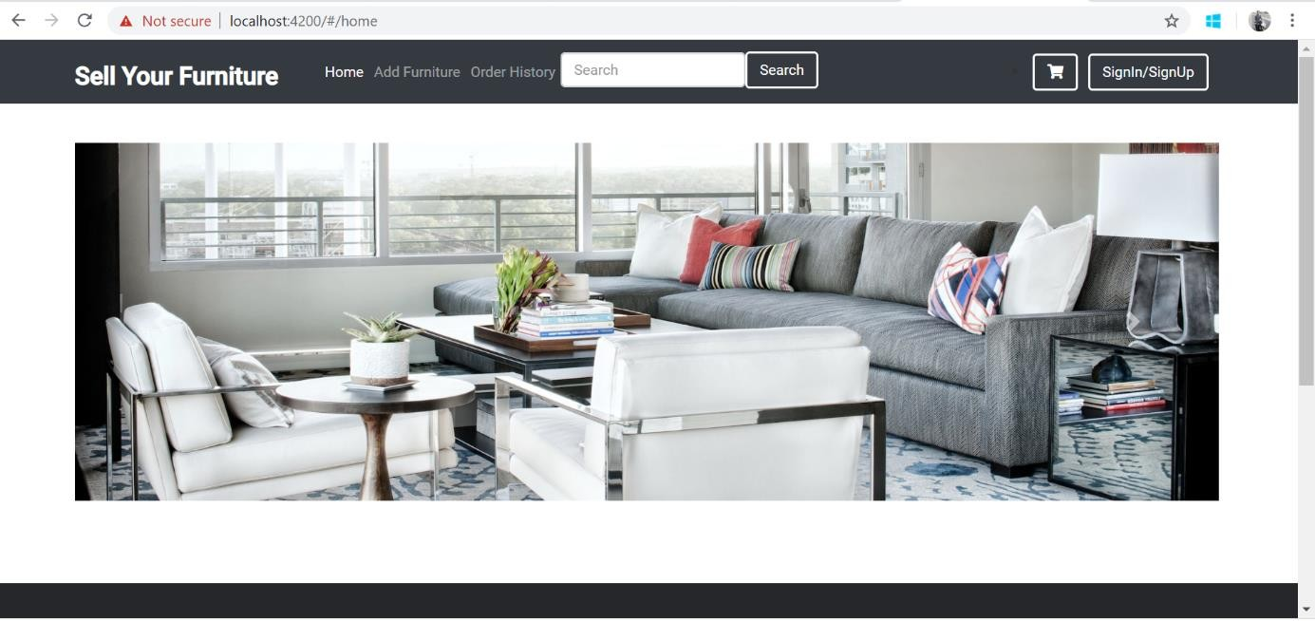
Fig:3.1
This is the home view of the application user should not be logined for accessing the home page of the application but for the further selection user should be logined.

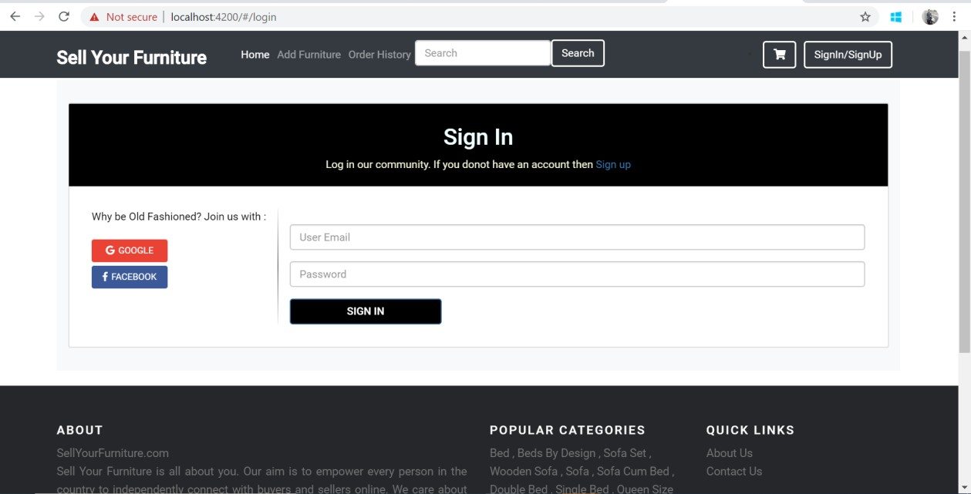
Fig: 3.2

This is the view of the login page where user should enter their credentials or can login through Facebook or Google.

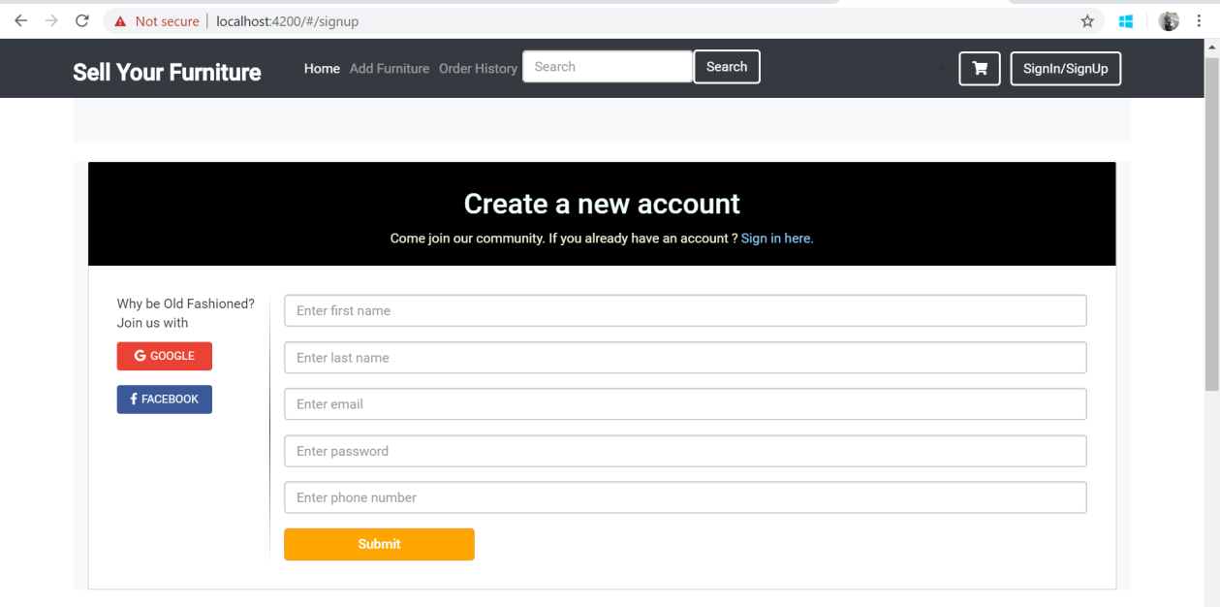
Fig: 3.3

This is the view of the signup page. If the user is not signed up before so he/she have to sign up before login. User can sign up through google or Facebook as well. Here every field is validated.

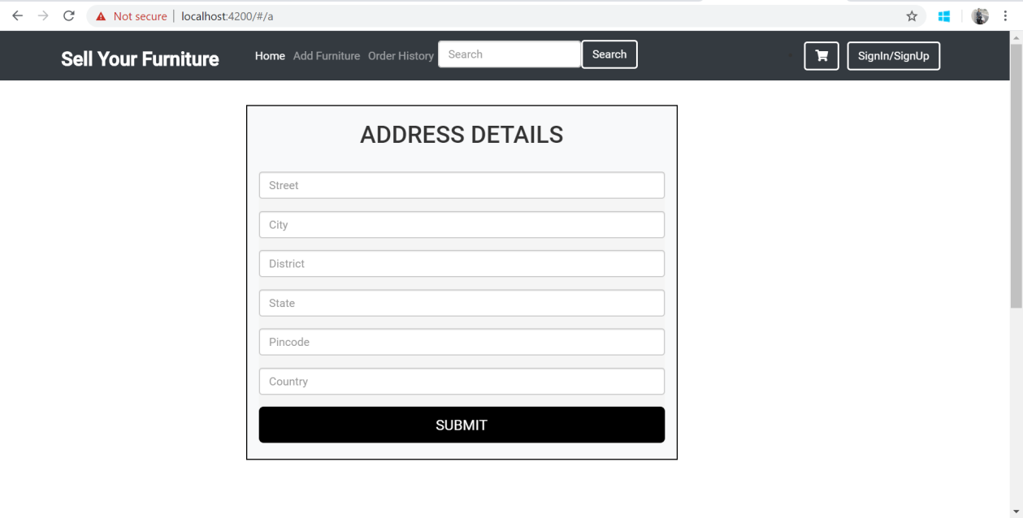
Fig: 3.4

This is address page where user should add the address for the delivery of the product.

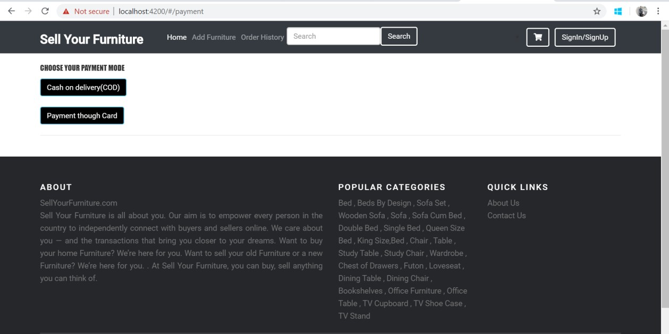
Fig: 3.5

This is the payment page where user can choose payment modes.

And some of the database images as are as follow:-

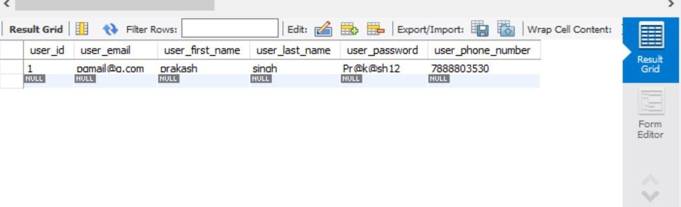
Fig: 3.6

This is the image of the user table which is present in the local database.

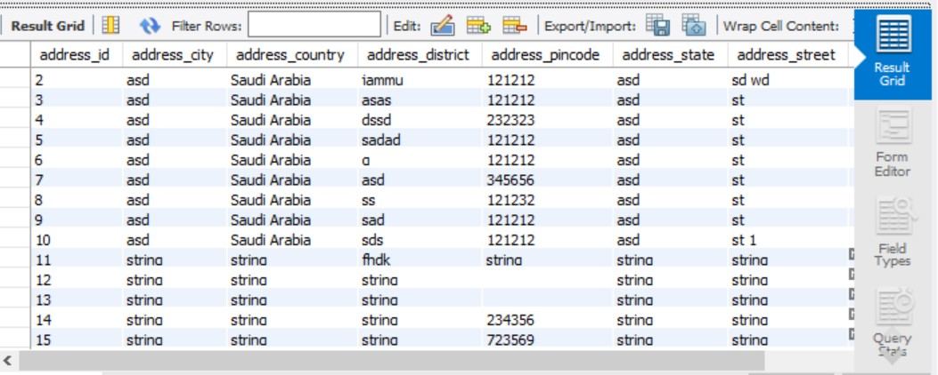

Fig: 3.7
This the address table where address of every user is stored.

Some snapshot of the spring boot packages:

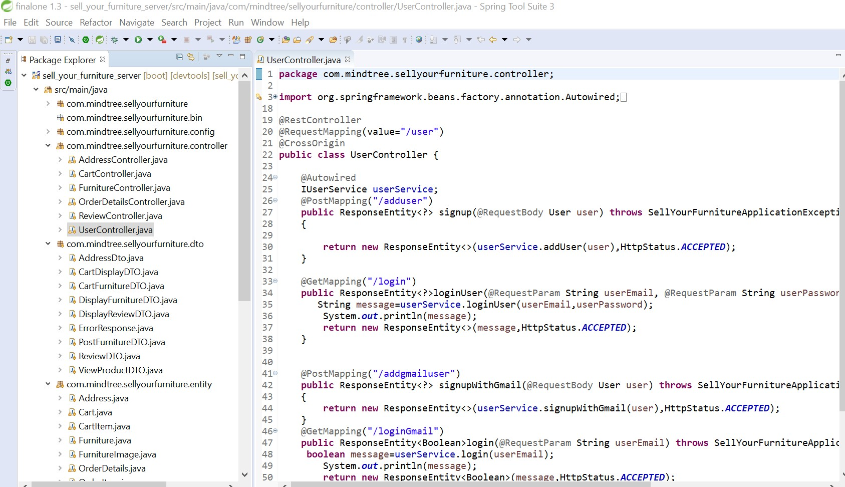
Fig: 3.8

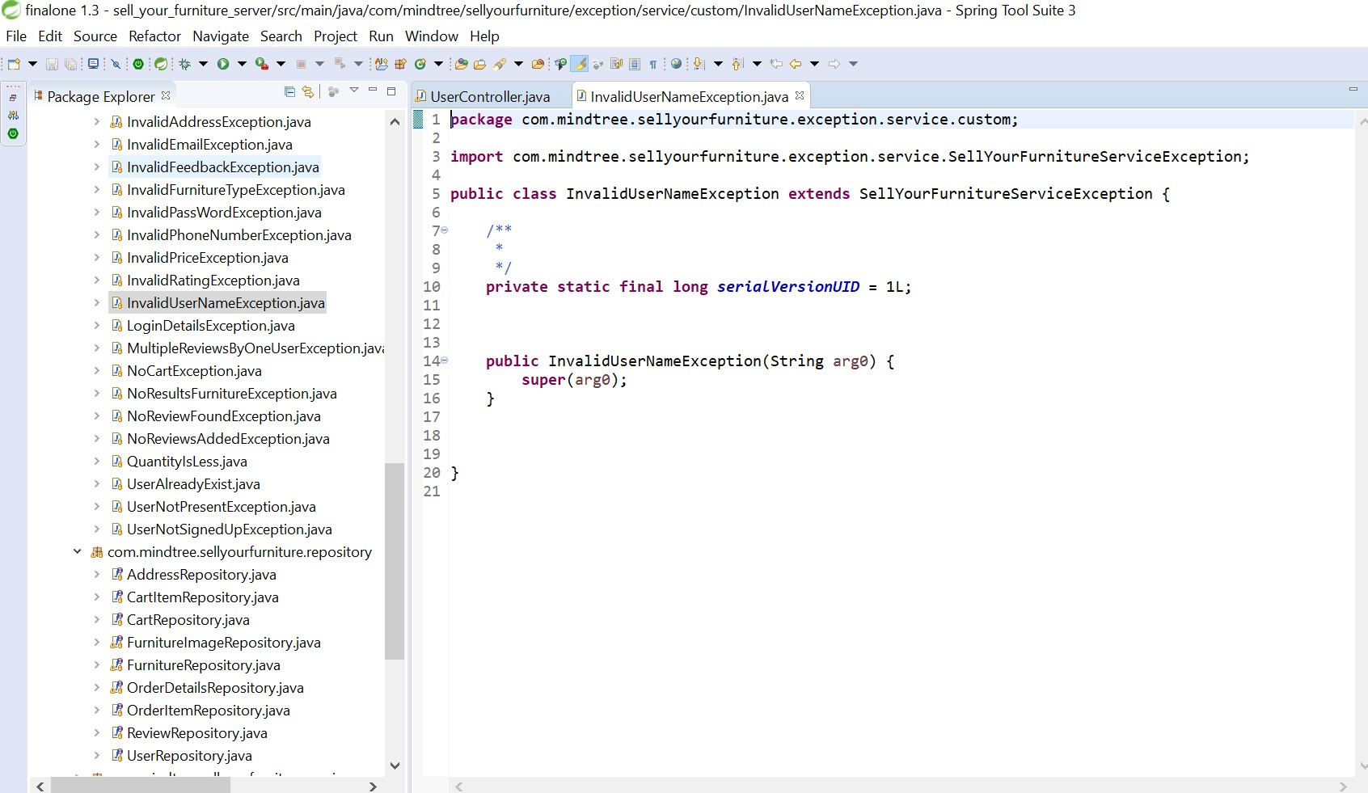

Fig: 3.9

Some snapshots of the angular component:

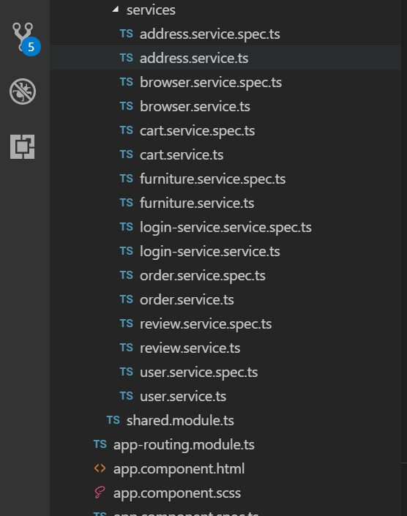
Fig 3.10

Fig: 3.11

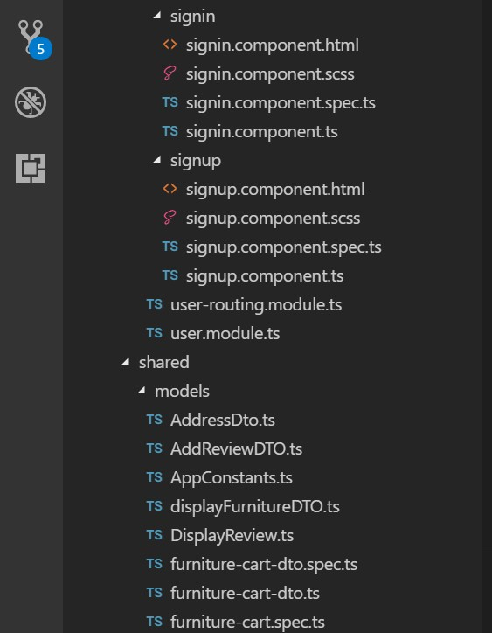

Fig: 3.12

Fig: 3.13

RESPONSE ENTITY:-

In this application I have also used the response entity for the desired output. Some of the examples of the usages of response entity is as in following code: package com.mindtree.sellyourfurniture.controller;
import org.springframework.beans.factory.annotation.Autowired; import org.springframework.http.HttpStatus;
import org.springframework.http.ResponseEntity;

import org.springframework.web.bind.annotation.CrossOrigin; import org.springframework.web.bind.annotation.GetMapping; import org.springframework.web.bind.annotation.ModelAttribute; import org.springframework.web.bind.annotation.PostMapping; import org.springframework.web.bind.annotation.RequestBody; import org.springframework.web.bind.annotation.RequestMapping; import org.springframework.web.bind.annotation.RequestParam; import org.springframework.web.bind.annotation.RestController;

import com.mindtree.sellyourfurniture.entity.User;

import com.mindtree.sellyourfurniture.exception.SellYourFurnitureApplicationException;

import com.mindtree.sellyourfurniture.service.IUserService;

@RestController @RequestMapping(value="/user") @CrossOrigin
public class UserController { @Autowired IUserService userService;
@PostMapping("/adduser")

public ResponseEntity<?> signup(@RequestBody User user) throws SellYourFurnitureApplicationException

{

return new ResponseEntity<>(userService.addUser(user),HttpStatus.ACCEPTED);

}

@GetMapping("/login")

public ResponseEntity<?>loginUser(@RequestParam String userEmail, @RequestParam String userPassword) throws SellYourFurnitureApplicationException {

String message=userService.loginUser(userEmail,userPassword); System.out.println(message);

return new ResponseEntity<>(message,HttpStatus.ACCEPTED);

}

@PostMapping("/addgmailuser")

public ResponseEntity<?> signupWithGmail(@RequestBody User user) throws SellYourFurnitureApplicationException

{

Return new ResponseEntity<>(userService.signupWithGmail(user),HttpStatus.ACCEPTED);

}

@GetMapping("/loginGmail")

public ResponseEntity<Boolean>login(@RequestParam String userEmail) throws SellYourFurnitureApplicationException {

Boolean message=userService.login(userEmail); System.out.println (message);
return new ResponseEntity<Boolean>(message,HttpStatus.ACCEPTED);

}

}

As the above code is of the controller package where I have used response entity. Like this only , I have use the response entity in every controller.

package com.mindtree.sellyourfurniture.controller;

import org.springframework.beans.factory.annotation.Autowired; import org.springframework.http.HttpStatus;
import org.springframework.http.ResponseEntity;

import org.springframework.web.bind.annotation.CrossOrigin; import org.springframework.web.bind.annotation.GetMapping; import org.springframework.web.bind.annotation.PostMapping; import org.springframework.web.bind.annotation.RequestBody; import org.springframework.web.bind.annotation.RequestMapping; import org.springframework.web.bind.annotation.RequestParam; import org.springframework.web.bind.annotation.RestController;

import com.mindtree.sellyourfurniture.dto.CartFurnitureDTO; import com.mindtree.sellyourfurniture.service.ICartService;

@RestController @RequestMapping("/cart")

@CrossOrigin(origins = "*") public class CartController {

@Autowired

private ICartService cartService;

@PostMapping("/addfurniture")

public ResponseEntity<?> addFurnitureToCart(@RequestBody CartFurnitureDTO cartFurniture){

return new ResponseEntity<>(cartService.addToCart(cartFurniture),HttpStatus.OK);

}

@PostMapping("/changequantity")

public ResponseEntity<?> changeQuantityOfCart(@RequestBody CartFurnitureDTO cartFurniture){

return new ResponseEntity<>(cartService.addToCart(cartFurniture),HttpStatus.OK);

}

@GetMapping("/getfurniture")

public ResponseEntity<?> getFurnituresOfCart(@RequestParam("email") String email){

return new ResponseEntity<>(cartService.getCartDetails(email),HttpStatus.OK);

}

@PostMapping("/removecart")

public ResponseEntity<?> deleteFurnitureOfCart(@RequestBody CartFurnitureDTO cartFurniture){

return new ResponseEntity<>(cartService.deleteFurnitureFromCart(cartFurniture),HttpStatus.OK
);

}

@GetMapping("/getfurnitureids")

public ResponseEntity<?> allFunitureIdOfCart(@RequestParam("email") String email){

return new ResponseEntity<>(cartService.getFurnitureIdsOfCart(email),HttpStatus.OK);

}

}

This is of the cart controller.

UNIT TESTING:

As I have also done the joint testing for the server side code and unit testing using jasmine and karma for the client side code.

From this testing I got the following output:

Frontend code coverage :

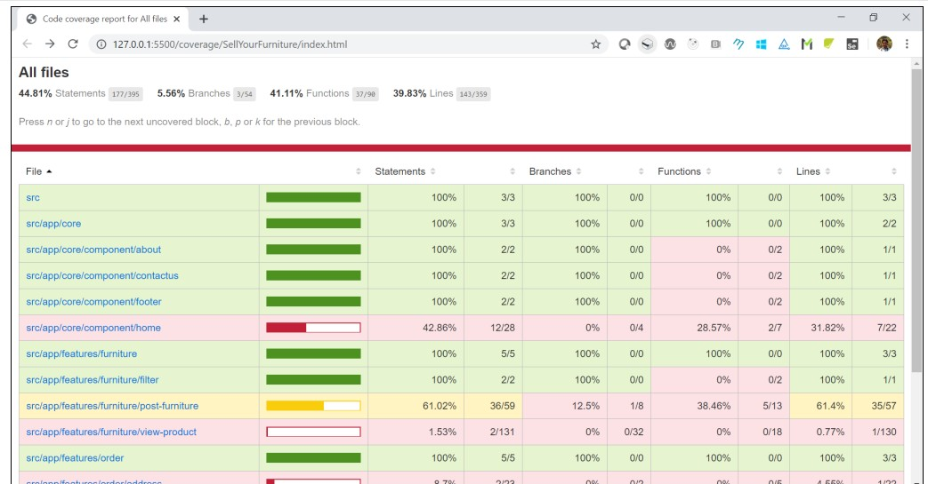

Fig: 3.14

As the required code coverage must be above 30%.so mine was 44.8%.

Backend Code Coverage:

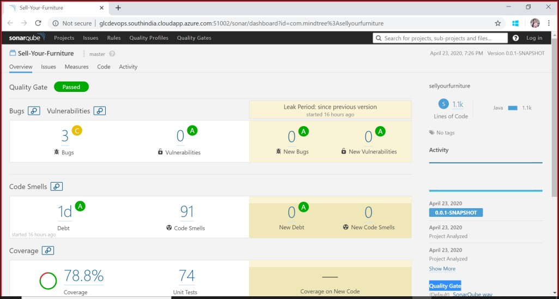

Fig: 3.15

As the backend code coverage must ne 70 %.Mine was 78.8%.

CONCLUSION

    - As a person who want to sell his/her furniture can sell in on this website without roaming and searching for the buyer.
    - So it will save the time for both of the seller as well as for the buyer.
    - Buyer can also give reviews.
    - Authenticated users.
    - Time Saving

BIBLOGRAPHY

- https://angular.io/
- https://www.tutorialspoint.com/spring_boot/spring_boot_introduction.htm
- https://en.wikipedia.org/wiki/Mindtree

