数控车加工工艺品经典资料（附FANUC系统程序）

1、奖杯

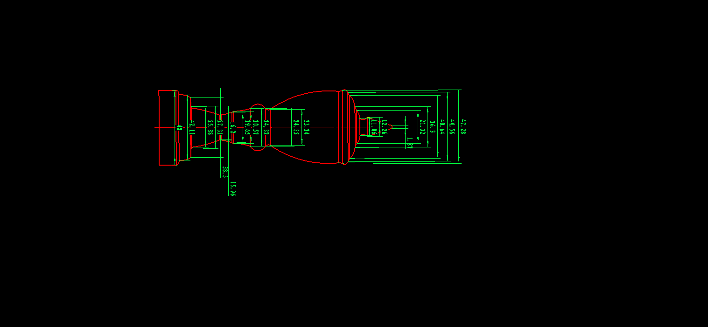
程序：
O0001;
G99G97G40;
T0101;
M03S800;
G00Z2.0;
X38.0;
G73U17R8;
G73P1Q2U0.5W0.0F0.3;
N1G01X1.32F0.1;
Z0.0;
X8.64Z-10.99;
G02X7.91Z-14.39R2.35F0.1;
G03X18.53Z-16.58R5.06F0.1;
X30.98Z-19.95R8.04;
X33.31Z-22.23R1.62;
G02X32.41Z-24.11R2.96;
G03X16.37Z-54.96R46.42;
G02X17.29Z-57.44R1.55;
G03X17.13Z-64.32R4;
G02X14.49Z-71.95R29.59;
X11.24Z-77.9R18.02;
G03X19.24Z-91.06R72.07;
G01X27.09;
G03X29.67Z-96.78R7.19;
X33.81Z-97.61R1.27;
G01X33.81Z-105.36;
N2X38.0;
G70P1Q2;
G00X100.0;
Z100.0;
M05;
M30;
2、葫芦
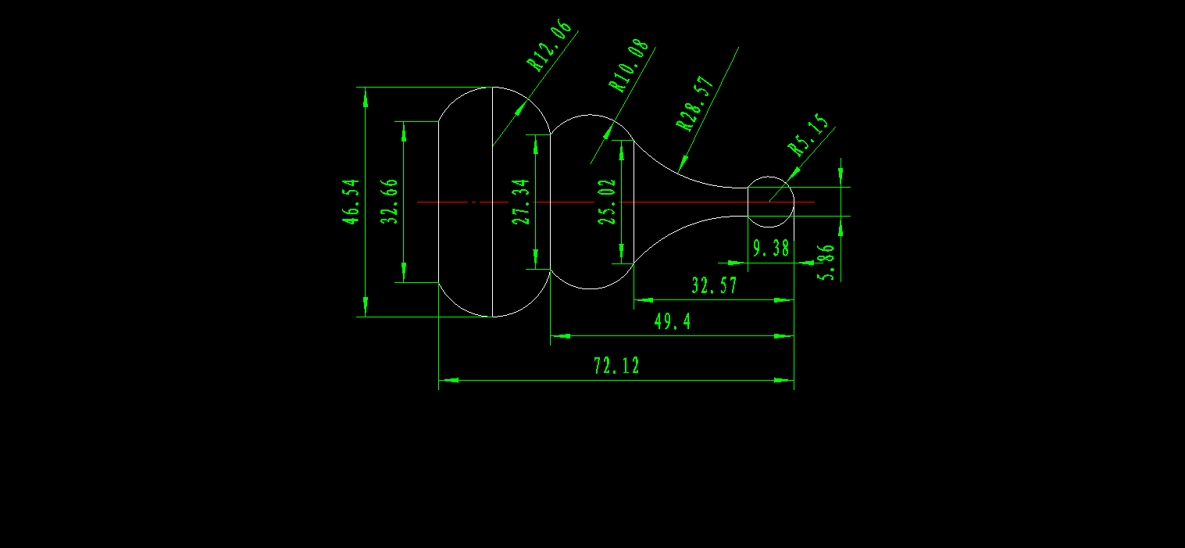
程序:
O0001
G99G97G40
M03S500
T0101
G00 Z2.0
X52.0
G73 U25 R12
G73 P1 Q2 U1.5 W0.5 F0.3
N1 G01 X0.0 F0.1
Z0.0
G03 X5.86 Z-9.38 R5.15 F0.1
G02 X25.02 Z-32.57 R28.57
G03 X27.34Z-49.4 R10.08
G03 X32.66 Z-72.12R12.06
N2 G01 X52.0
G70 P1 Q2
G00 X100.0
Z100.0
M05
M30
3、椭圆（宏程序）
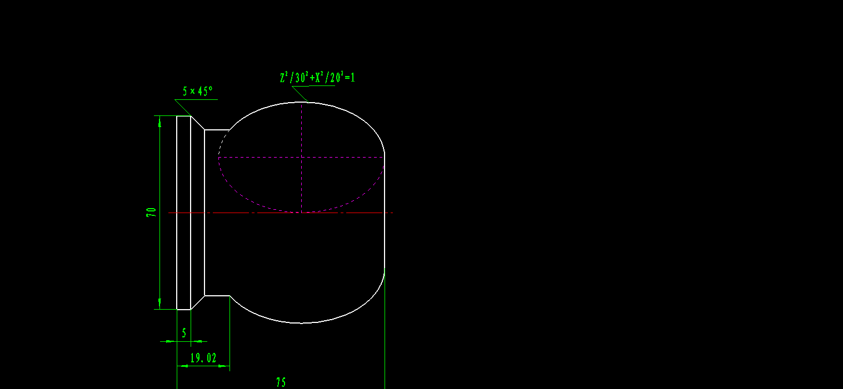
程序:
O0001
G99G97G40
T0101
M03S500
G00Z2.0
X52.0
G01X0.0 F0.1
#1=30
#2=20
#3=30
#4=-24
N10 #5=#2*SQRT[1-#3*#3/900]
G01 X[2*#5+40] Z[#3-30]
#3=#3-0.1
IF[#3 GE #4] GOTO10
G01 Z-60.0
X38.0
X42.0 Z-62.0
X52.0
G00 X100.0
Z100.0
m05
m30
4、子弹
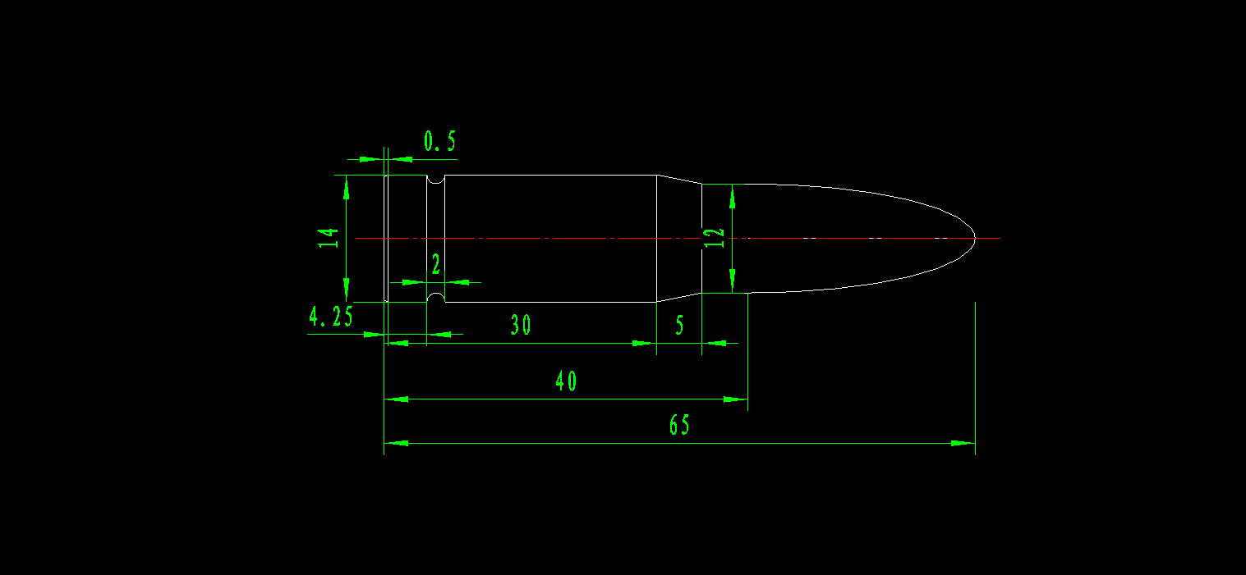
程序:
O0002
G99G97G40
T0101
M03S500
G00 Z2.0
X52.0
G71 U2.0 W0.5
G71 P1 Q2 U1.0 W0.0 F0.3
N1 G01 X0.0 F0.1
Z0.0
G03 X7.87 Z-17.3 R40.0
G01 X8.57
Z-23.0
G01 X10.07 Z-25.5
X11.35 Z-52.8
G02 X11.35 Z-54.5 R1.5
G01 Z-56.0
N2 X52.0
G70 P1 Q2
G00 X100.0
Z100.0
M05
M30
5、锤头
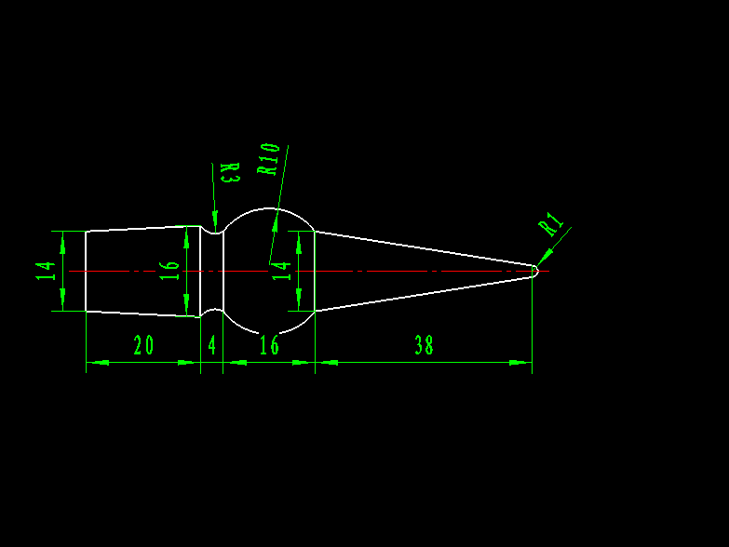
程序：
O0001
G99G97G40
T0101
M03S500
G00Z2.0
X22.0
G73U18R17
G73P1Q2U0.5W0.0F0.1
N1G01X0.0F0.1
Z0.0
G03X2.0Z-1.0R1.0F0.3
G01X14.0Z-39.0F0.1
G03X14.0Z-54.0R10.0F0.3
G02X16.0Z-58.0R3.0F0.3
G01X14.0Z-78.0
N2X22.0
M00
T0101
M03S800
G00Z2.0
X22.0
G70P1Q2
G00X100.0
Z100.0
M05
N30
6、酒杯
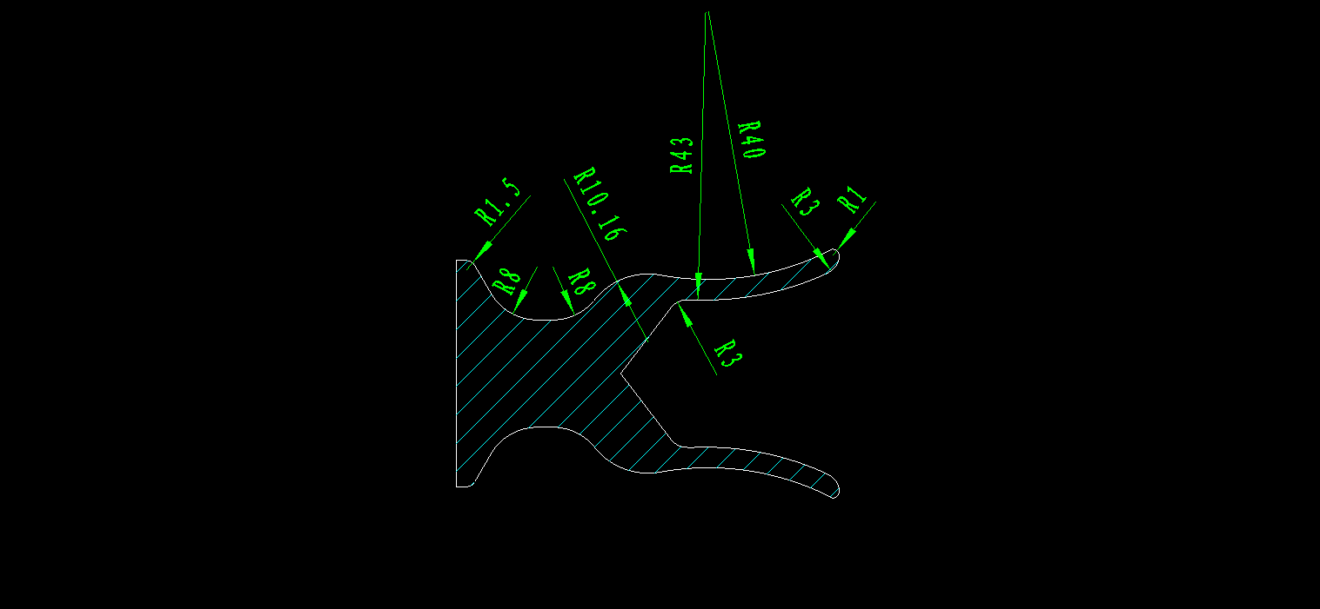
程序：
酒杯外圆：
O0001
G99G97G40
M03S500
T0101
G00Z2.0
X52.0
G73U17R16
G73P1Q2U0.5W0.0F0.3
N1G01X34.498F0.1
Z0.0
G03X37.183Z-0.738R1
G02X29.472Z-26.951R43
G03X21.821Z-36.625R10.16
G02X16.0Z-42.797R8
G01Z-45.0
G02X24.Z-51.928R8
G01X32.304Z-54.325
G03X33.804Z-55.624R1.5
G01Z-57.124
N2X52.0
M00
M03S800
T0101
G00Z2.0
X52.0
G70P1Q2
G00X100.0
Z100.0
M05
M30
酒杯内轮廓：
O0001
G99G97G40
M03S500
T0404
G00Z2.0
X18.0
G71U1.0R0.5
G71P1Q2U-0.5W0.0F0.3
N1G01X34.498F0.1
Z0.0
G02X29.472Z-1.744R3
G02X22.034Z-24.182R43
G03X19.066Z-27.090R3
N2G01X18.0
M00
M03S800
T0404
G00Z2.0
X18.0
G70P1Q2
Z100.0
M05
M30
宇龙仿真效果演示：
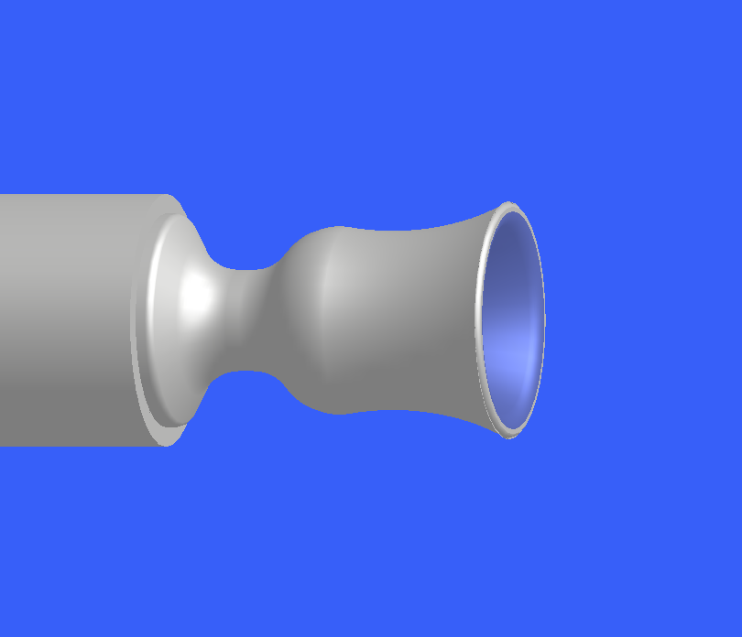

7、国际象棋

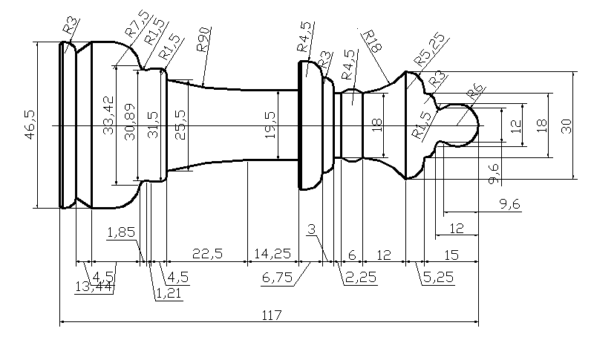
程序：
建议用CAXA生成
实物展示

8、保龄球

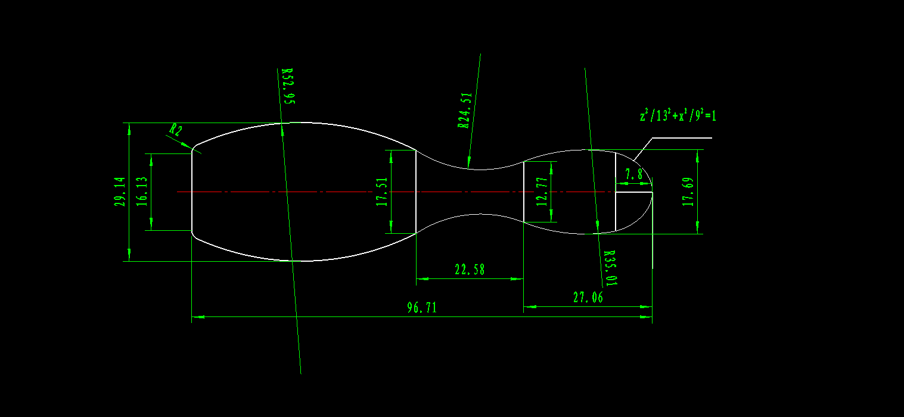
程序
O0001
G99G97G40
T0101
M03S500
G00Z2.0
X38.0
G01X0.0F0.1
Z0.0
#1=13
#2=9
#3=13
#4=7.8
N3 #5=#2*SQRT[1-#3*#3/#1/#1]
G01 X[2*#5] Z[#3-13]
#3=#3-0.1
IF[#3 GE #4] GOTO3
G03X12.77Z-27.06R35.01F0.3
G02X17.51Z-49.67R24.51F0.3
G03X20.13Z-94.71R52.95F0.3
G03X16.13Z-96.71R2F0.3
G00X100.0
Z100.0
M05
M30
仿真效果演示

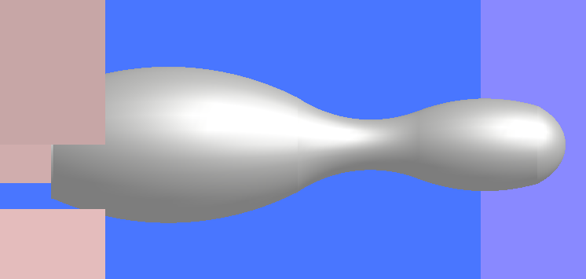
9、花瓶

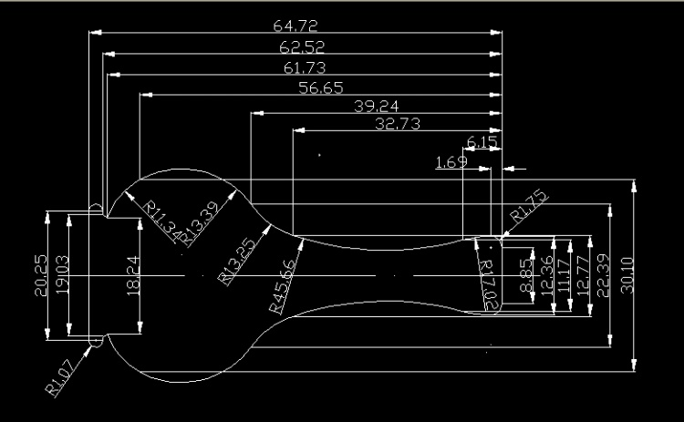
程序
O0001
T0101
M03 S650;
G00Z2.0;
X38;
G73 U12 R10;
G73 P1 Q2 U1.0 W0.0F0.2;
N1G01X8.85F0.1;
Z0.0;
G03 X12.36 Z-1.69 R1.75F0.3;
G03 X11.17 Z-6.15 R17.02F0.3;
G02 X12.77 Z-32.73 R45.66F0.3;
G02 X22.39 Z-39.24 R13.25F0.3;
G03 X30.1 Z-56.56 R13.39F0.3;
G03 X18.24 Z-61.73 R11.34F0.3;
G01 X19.03 Z-62.52F0.1;
X22.5;
G03X23.0Z-64.0R1.07;
G01W-5.0
N2G01X40.0F0.1
G70 P1 Q2;
G00X100.0;
Z100.0;
M05;
M30;
仿真效果演示
