Chess Board Assignment
Modifying the in-class HTML/CSS chess board
This document records my progress through the five tasks of the assignment. For each step I describe the change I made to the HTML/CSS, show a screenshot of the rendered result, and answer the questions that were asked. The final code is delivered separately as the file chess-board.html, which contains all changes up to and including Step 5.

Step 1 — The .left-offset class
I created a new CSS class called .left-offset that applies a left margin of 25px, and added it to the first cell of every row that starts with a dark cell (rows 2, 4, 6 and 8). Because each of those rows is pushed 25px to the right, the row now needs 8 × 50px + 25px = 425px of horizontal space. I therefore increased the width of the #chess-board container from 400px to 425px so that each shifted row still fits on a single line and does not wrap incorrectly.

CSS added
.left-offset {
margin-left: 25px;
}
/* #chess-board width changed from 400px to 425px */

Result
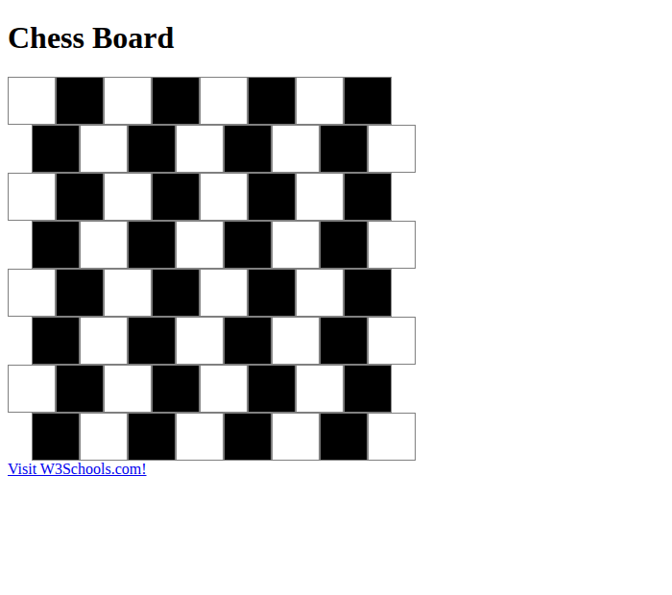
Figure 1 — Dark-starting rows shifted right by 25px.

Observation
The board is no longer a perfect square grid. The four dark-starting rows are shifted 25px to the right, while the light-starting rows stay in their original position. This produces a staggered, zig-zag pattern: the rows alternate between two horizontal positions, much like the offset rows of a brick wall. Because I widened the container to 425px, every row still keeps all eight of its cells on one line — nothing wraps to the next line, and the structure fits the container perfectly.

Step 2 — Changing .dark to yellow
For this step I changed only the background-color of the .dark class from black to yellow. Every other property was left exactly as it was in Step 1, including the .left-offset shift.

CSS changed
.dark {
background-color: yellow; /* was: black */
}

Result
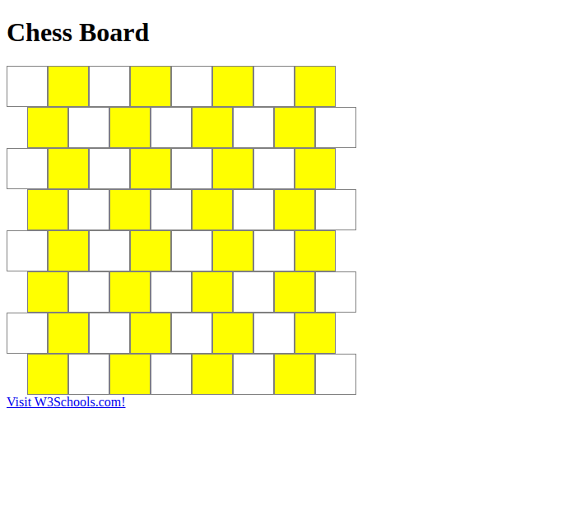
Figure 2 — The .dark cells are now yellow.

Observation
All the cells that use the .dark class are now filled with yellow instead of black. Something does feel strange, though: the class is still called ".dark", yet yellow is one of the brightest, lightest colours possible. The name of the class no longer matches what it actually does. This is a good reminder that a CSS class name is just a label chosen by the developer — the browser does not care about the meaning of the word "dark"; it only applies whatever rules are written inside the class. For readable, maintainable code the class would be better renamed (for example ".square-b") so the name describes its role rather than a colour that might change.

Step 3 — Using red colours from the video
This step asked me to watch a linked video about colours and use the red shown at timestamp 10:00 for the .light class and the dark red shown 20 seconds later for the .dark class.
Note: the video itself was not included with the assignment text I received — only the words "Play Video" appeared, with no playable link. Because I could not watch it, I could not read the exact colour values from timestamps 10:00 and 10:20. I have therefore used standard, clearly-named red values as a placeholder: a medium red for .light and a darker red for .dark. The exact hex codes can be swapped in after watching the video — only the two values below need to change.

CSS changed
.light {
background-color: #e63946; /* medium red */
}
.dark {
background-color: #7d1620; /* dark red */
}

Result
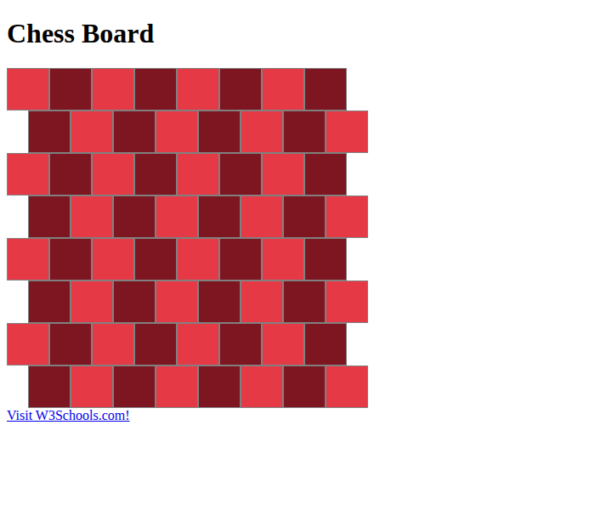
Figure 3 — Light cells in medium red, dark cells in dark red.

Observation
With both classes set to shades of red, the board reads as a two-tone red pattern. The lighter red and darker red still give enough contrast to tell the two types of cell apart, so the checkerboard structure is still visible. Combined with the staggered .left-offset rows from Step 1, the board already starts to resemble a red-brick wall.

Step 4 — Removing .left-offset and adding .half-width
I removed the .left-offset class completely (both the CSS rule and the class on the rows). In its place I created a .half-width class that sets a cell's width to 25px — exactly half of a normal 50px cell.
I then added a "light half-width" cell as instructed. A row that starts with a dark cell gets a half-width light cell added at its beginning, and a row that ends with a dark cell gets a half-width light cell added at its end. In the original board the dark-starting rows (2, 4, 6, 8) end with a light cell, and the light-starting rows (1, 3, 5, 7) end with a dark cell. So in practice a half-width light cell is added at the start of rows 2, 4, 6, 8 and at the end of rows 1, 3, 5, 7.

CSS changed
/* .left-offset rule deleted */
.half-width {
width: 25px;
}

Result
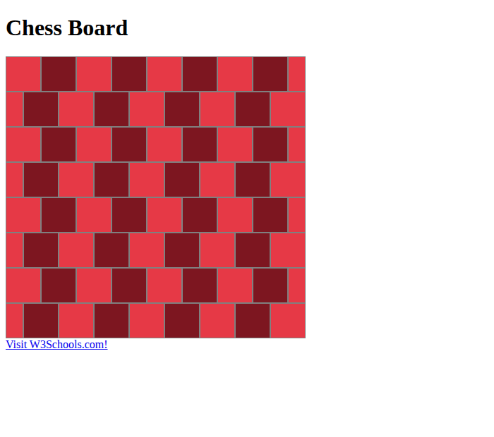
Figure 4 — Half-width cells fill the staggered ends; every row is a full 425px rectangle.

Observation
Instead of shifting whole rows with a margin, each row now produces the offset by itself: a half-width cell at one end means the full-size cells inside the row land in a staggered position relative to the row above and below. Because 25px + 8 × 50px + 25px is not needed — each row has exactly one extra 25px cell, so every row is 8 × 50px + 25px = 425px wide and fills the container with a clean straight edge on both sides. The result is the same brick-style stagger as Step 1, but now the board has neat rectangular borders instead of a ragged zig-zag outline.

Step 5 — Turning the board into a brick wall
For the final step I adjusted the .cell class so the board looks like a brick wall, while keeping every other property (width, the commented-out styling, box-sizing) unchanged. I made three changes: I reduced the cell height so the cells become short rectangles like real bricks, I added a small border-radius so the corners are slightly rounded, and I increased the border thickness so the gaps between cells read as the mortar lines of the wall.

CSS changed
.cell {
height: 28px; /* was 50px - shorter, brick-shaped */
width: 50px; /* unchanged */
border: 3px solid gray; /* was 1px - thicker 'mortar' */
border-radius: 4px; /* new - softly rounded corners */
box-sizing: border-box; /* unchanged */
}

Result
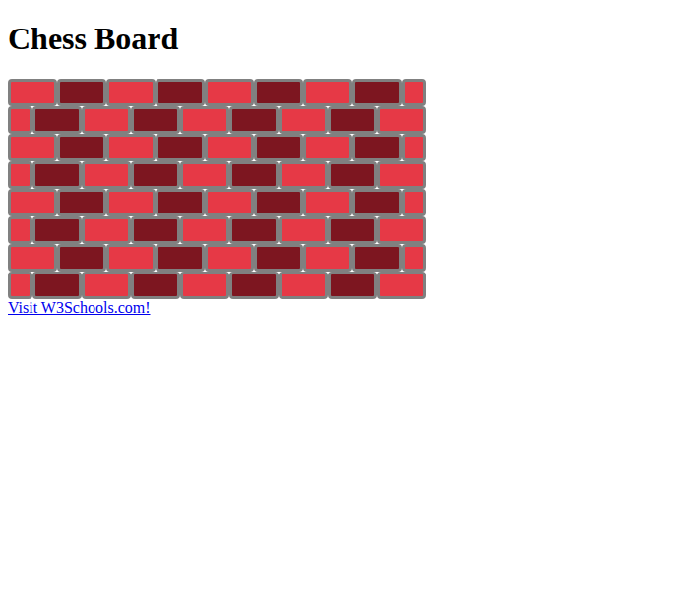
Figure 5 — The finished brick wall.

Observation
Lowering the height to 28px turns each square cell into a wide, short rectangle, which is the natural shape of a brick. The 3px gray border, sitting between every cell, looks like the mortar holding the bricks together, and the 4px border-radius softens the corners just enough so the bricks look slightly worn rather than perfectly sharp. Together with the staggered half-width cells from Step 4, the rows are offset like a real running-bond brick pattern, and the two shades of red give a convincing brick-and-mortar appearance. These were the values that looked best to me; the height, radius and border thickness can easily be tweaked further to taste.

Files delivered
Alongside this document I am attaching chess-board.html, which is the final state of the code after all five steps (it includes the Step 5 brick-wall styling, the .half-width cells, and the red colours; the .left-offset class has been removed as required by Step 4).
Reference used in class: W3Schools.com

