1. 按照下面的方法，写到Main里面

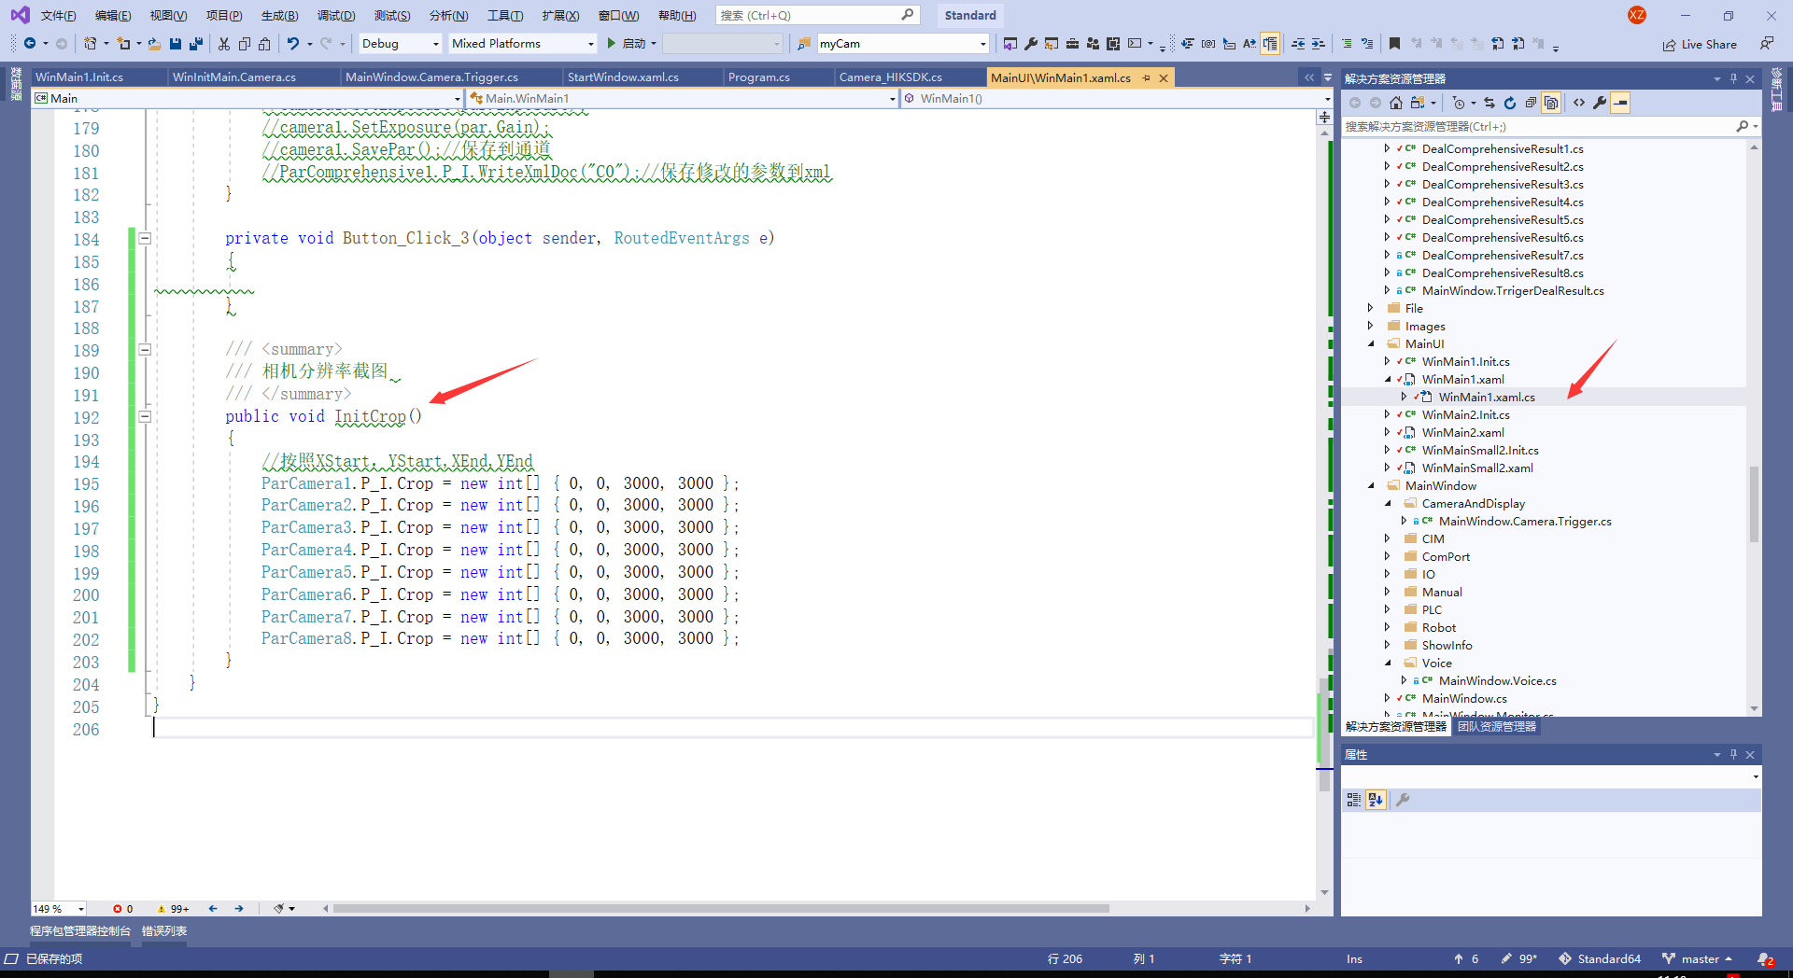

/// <summary>

/// 相机分辨率截图

/// </summary>

public void InitCrop()

{

//按照XStart，YStart,XEnd,YEnd

ParCamera1.P_I.Crop = new int[] { 0, 0, 3000, 3000 };

ParCamera2.P_I.Crop = new int[] { 0, 0, 3000, 3000 };

ParCamera3.P_I.Crop = new int[] { 0, 0, 3000, 3000 };

ParCamera4.P_I.Crop = new int[] { 0, 0, 3000, 3000 };

ParCamera5.P_I.Crop = new int[] { 0, 0, 3000, 3000 };

ParCamera6.P_I.Crop = new int[] { 0, 0, 3000, 3000 };

ParCamera7.P_I.Crop = new int[] { 0, 0, 3000, 3000 };

ParCamera8.P_I.Crop = new int[] { 0, 0, 3000, 3000 };

}

2.在采图之前设置一下，就会按照设置的分辨率进行处理，做ROI的部分还没弄好，正在处理

