Republic of the Philippines
PARTIDO STATE UNIVERSITY
COLLEGE OF ENGINEERING AND COMPUTATIONAL SCIENCES
Department of Computational Sciences | Bachelor of Science in Information Technology
Goa, Camarines Sur
BOOK OF ABSTRACT (eCOPY) — GROUP COVER & IMRAD QR ACCESS
“AURORA: PAPERLESS ACADEMIC DEFENSE WORKFLOW SYSTEM FOR RESEARCH, CAPSTONE, THESIS & DISSERTATION PAPERS AT PARTIDO STATE UNIVERSITY”
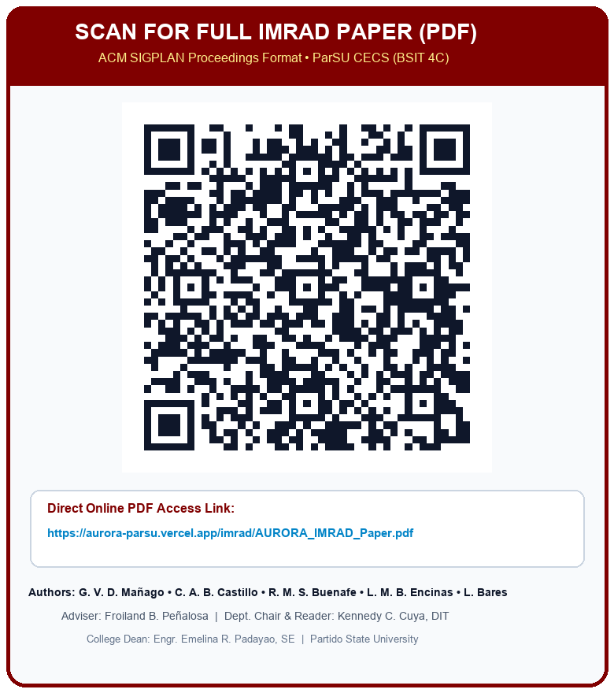
Proponents (BSIT 4C) | Gene Vincent D. Mañago • Carol Ann B. Castillo • Rona Mae S. Buenafe • Lara Mae B. Encinas • Leomer Bares
Degree & Institution | Bachelor of Science in Information Technology — Partido State University (Goa Campus)
Capstone Adviser & Coord. | Froiland B. Peñalosa
Panel of Examiners | Salvador V. Briones II, MAEd (Chair) • Rowell John B. Artiaga, DIT • Michael B. Amata • Froiland B. Peñalosa • Kennedy C. Cuya, DIT
Dept. Chair & Reader | Kennedy C. Cuya, DIT (Department of Computational Sciences)
College Dean | Engr. Emelina R. Padayao, SE (College of Engineering and Computational Sciences)
IMRAD PDF Online URL | https://aurora-parsu.vercel.app/imrad/AURORA_IMRAD_Paper.pdf

CAPSTONE ABSTRACT
Title: AURORA: PAPERLESS ACADEMIC DEFENSE WORKFLOW SYSTEM FOR RESEARCH, CAPSTONE, THESIS & DISSERTATION PAPERS AT PARTIDO STATE UNIVERSITY
Total No. of Pages: 239
Text No. of Pages: Two Hundred Thirty-Nine
Authors: Mañago, Gene Vincent D., Castillo, Carol Ann B., Buenafe, Rona Mae S., Encinas, Lara Mae B., Bares, Leomer
Degree: Bachelor of Science in Information Technology
Institution: Partido State University – Goa Campus
Adviser: Froiland B. Peñalosa
Panel of Evaluators: Chairperson: Salvador V. Briones II, MAEd | Members: Rowell John B. Artiaga, DIT; Michael B. Amata; Froiland B. Peñalosa; Kennedy C. Cuya, DIT
Capstone Reader: Kennedy C. Cuya, DIT
Date Completed: November 2026
Type of Document: Capstone
Type of Publication: Unpublished
Host Institution: Department of Computational Sciences, College of Engineering and Computational Sciences, Partido State University, San Juan Bautista St., Goa, Camarines Sur
Keywords: Academic Defense Workflow, Capstone, Digital Rubric, Higher Education, Manuscript Management, Paperless System, Partido State University, PDF Annotation, Role-Based Access Control, System Usability Scale, Thesis, UTAUT, Web-Based Platform
Rationale / Background of the Study
The academic defense process is a cornerstone of higher education, validating student competencies in research, capstone projects, theses, and dissertations. However, at Partido State University – Goa Campus, existing workflows across its five constituent colleges remain predominantly paper-based and manually coordinated. Students are required to print and submit multiple bulky manuscript copies at each defense stage, incurring significant financial burdens and contributing to institutional paper waste. Panelists and advisers provide handwritten annotations on physical drafts, leading to fragmented feedback, illegible remarks, and lost revision histories. Furthermore, rubric-based grading is performed manually using physical score sheets, resulting in delayed grade consolidation, potential computation errors, and a lack of real-time analytics. To address these institutional bottlenecks and support the university's digital transformation and sustainability initiatives, this study developed AURORA—a unified, web-based paperless academic defense workflow system.
Summary
This study aimed to design, develop, and evaluate AURORA: Paperless Academic Defense Workflow System for Research, Capstone, Thesis & Dissertation Papers at Partido State University – Goa Campus. Guided by the Agile Software Development Life Cycle (SDLC) methodology, the researchers conducted stakeholder interviews across five colleges (CECS, COE, CAH, COS, and CBM) to gather functional and non-functional requirements. The system was engineered using a modern three-tier architecture powered by Next.js, TypeScript, Tailwind CSS, and Supabase (PostgreSQL), integrating role-based access control (RBAC), customizable multi-college defense workflows, an interactive in-browser PDF annotation workspace, automated rubric-based evaluation, and structured revision tracking. The platform was evaluated by twenty-seven (27) institutional stakeholders—comprising students, research advisers, defense panelists, research/capstone coordinators, and college deans—using the standardized 10-item System Usability Scale (SUS) and a validated 27-item Unified Theory of Acceptance and Use of Technology (UTAUT) survey instrument (Good & Scates validity = 4.89/5.00; Cronbach's α = 0.946).
Findings
1. Requirements Gathering (Objective 1): Multi-college interviews with seven (7) Research Coordinators across CECS, COE, CAH, COS, and CBM revealed four shared PIECES bottlenecks in manual defenses: prolonged 18.4-day physical routing turnaround, split-attention cognitive overload from disconnected paper marginalia, manual rubric calculation delays, and variable stage structures (5-stage Capstone workflow in BSIT vs. 3-stage Thesis/Research workflows in other colleges).
2. System Architecture & Database Design (Objective 2): A decoupled Three-Tier Cloud Architecture and a normalized 26-table PostgreSQL relational schema with Row-Level Security (RLS) were designed to model multi-college hierarchy, dynamic workflow templates, SHA-256 versioned PDF manuscripts, normalized percentage-based coordinate annotations, weighted rubrics, and revision tracking.
3. System Development & Workflow Integration (Objective 3): AURORA was successfully developed with nine (9) integrated functional modules, reducing manuscript review and Form DCS-CF-03 endorsement turnaround time by 85.9% (from 18.4 days to 2.6 days), eliminating room and panelist scheduling collisions (0.0% conflict rate), enforcing Republic Act No. 8792 step-up digital signatures (AURORA-YYYY-NNNNNN), and providing a 3-2-1 Disaster Recovery & Self-Healing Maintenance Console (100% pass rate across 42 QA test cases).
4. Usability, Efficiency & Acceptance Evaluation (Objective 4): Empirical evaluation by N = 27 stakeholders yielded a Composite SUS Score of 91.8 / 100 (Grade A — Excellent Usability) and a Composite UTAUT Grand Mean of 4.86 / 5.00 (Highly Acceptable) across Performance Expectancy (4.88), Effort Expectancy (4.86), Social Influence (4.81), Facilitating Conditions (4.85), Behavioral Intention (4.90), and Use Behavior (4.87).
Conclusions
1. Identifying multi-college functional and non-functional requirements confirmed that a configurable workflow engine is essential to accommodate diverse research, capstone, thesis, and dissertation policies across Partido State University.
2. The Three-Tier Cloud Architecture, 26-table RLS-hardened database schema, and 60/40 split-screen UI design effectively eliminate cognitive split-attention while guaranteeing data isolation and cryptographic auditability.
3. Integrating RBAC, viewport-independent PDF coordinate annotations, automated rubric consolidation, RA 8792 digital signatures, and 3-2-1 disaster recovery into a single web platform eliminates paper printing costs and accelerates defense deliberation.
4. The high SUS score (91.8/100) and UTAUT acceptance rating (4.86/5.00) demonstrate that AURORA is highly usable, efficient, and ready for institutional deployment across Partido State University – Goa Campus.
Recommendations
1. Institutional Adoption: Partido State University – Goa Campus may formally adopt AURORA across all five constituent colleges (CECS, COE, CAH, COS, and CBM) as the standard paperless platform for undergraduate and graduate academic defenses.
2. Policy & Form Standardization: The Office of Research and College Deans may institutionalize AURORA's digital clearance serials (AURORA-YYYY-NNNNNN) and RA 8792 electronic signatures as official equivalents of printed Forms DCS-CF-03, DCS-CF-04, and DCS-CF-05.
3. Infrastructure & Backup Governance: Designated System Administrators should execute the monthly 3-2-1 Disaster Recovery cold-archive routine via the AURORA System Health Console (/admin/system-health) to ensure long-term archival continuity.
4. Future Enhancements: Subsequent iterations may integrate automated AI/OCR similarity pre-screening directly within the manuscript upload pipeline and expand offline mobile push notifications via Progressive Web App (PWA) workers.

