Republic of the Philippines
PARTIDO STATE UNIVERSITY
COLLEGE OF ENGINEERING AND COMPUTATIONAL SCIENCES
Department of Computational Sciences | Goa, Camarines Sur
COMPREHENSIVE OPERATIONAL, SYSTEM ADMINISTRATOR,
MAINTENANCE & DISASTER RECOVERY MANUAL
“AURORA: Paperless Academic Defense Workflow System for Research, Capstone, Thesis & Dissertation Papers at Partido State University”
Proponents (BSIT 4C) | Gene Vincent D. Mañago • Carol Ann B. Castillo • Rona Mae S. Buenafe • Lara Mae B. Encinas • Leomer Bares
Capstone Adviser & Coord. | Froiland B. Peñalosa
Dept. Chair & Capstone Reader | Kennedy C. Cuya, DIT
Panel of Examiners | Salvador V. Briones II, MAEd (Chair) • Rowell John B. Artiaga, DIT • Michael B. Amata • Froiland B. Peñalosa • Kennedy C. Cuya, DIT
College Dean | Engr. Emelina R. Padayao, SE (College of Engineering and Computational Sciences)
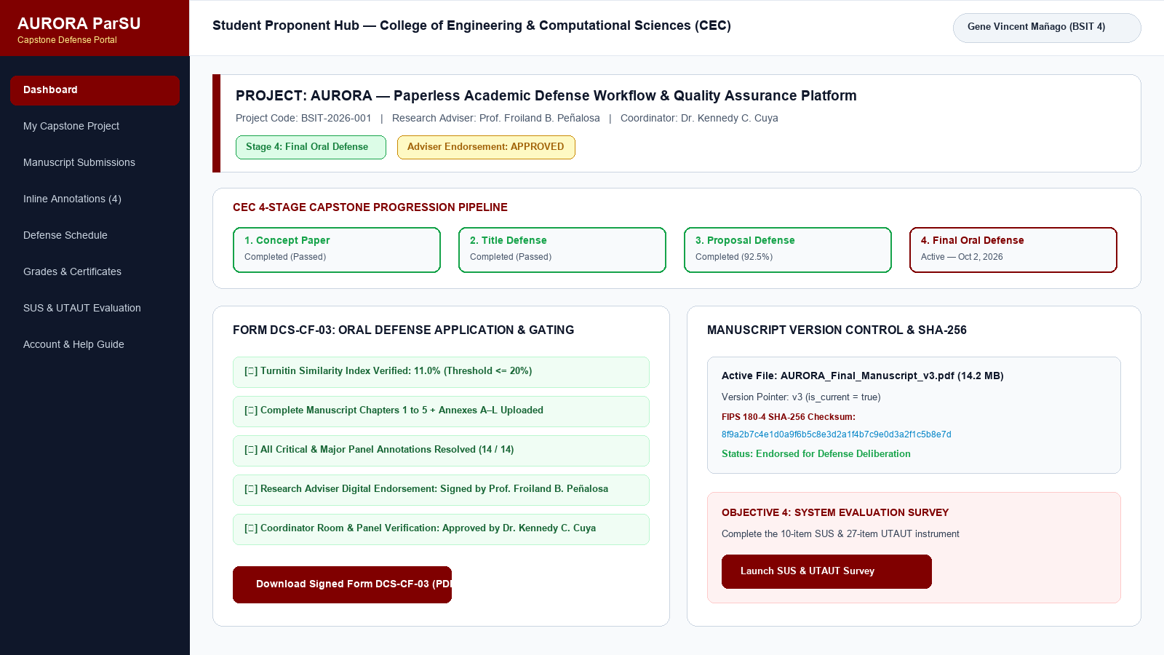
Figure 1. Student Proponent Hub & Multi-Stage Defense Stepper
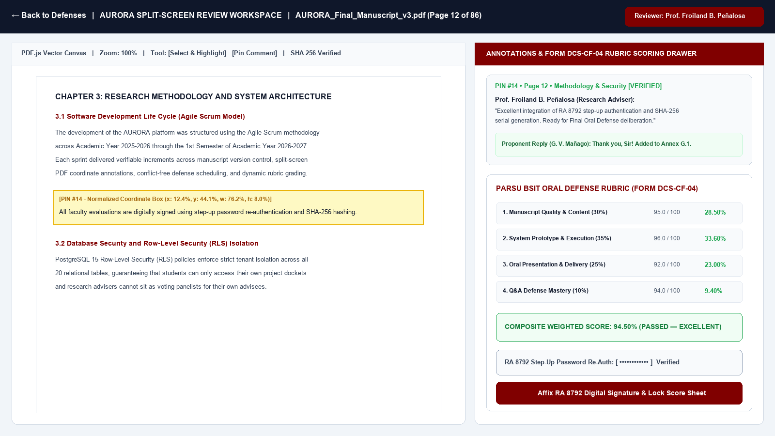
Figure 2. Split-Screen PDF.js Coordinate Annotation & Rubric Workspace
J.1 USER'S GUIDE / ROLE MANUALS
AURORA provides dedicated operational guides for each institutional stakeholder group:
J.1.1 Student Proponent Guide
1. Accessing the Portal: Visit https://aurora-parsu.vercel.app/login and log in using your institutional email.
2. Team Formation: The lead proponent clicks Create Project, inputs the approved title, and shares the generated 8-character Join Code with teammates.
3. Manuscript Submission: Navigate to Submissions or My Project, drag-and-drop your latest PDF manuscript, and select the target defense stage from your college's customized workflow (5 stages for BSIT: Concept Defense, Title Defense, Progress Report 1, Progress Report 2, Final Defense; 3 customizable stages for other colleges). The system computes its FIPS 180-4 SHA-256 fingerprint and sets status to under_review (pending adviser endorsement).
4. Filing Defense Application (Form DCS-CF-01 for BSIT / U-CF-03 for Other Colleges): Fill in the requirements checklist (Turnitin score, adviser clearance, preferred defense dates). For BSIT Title Defense, complete the official Application for Oral Defense (DCS-CF-01) listing the three proposed project concepts, which upon adviser recommendation endorses the group to proceed to the Progress Report defense stages.
5. Viewing Feedback & Remarks: Open the Annotations view or Review Workspace to view adviser and panelist comments. Click on any annotation to jump to the highlighted page segment and reply to notes.
6. Accessing Defense Outcomes: Check the Grades tab to review composite panel evaluations, download Form DCS-CF-04, and view your verifiable clearance certificate serial number (AURORA-YYYY-XXXX).
J.1.2 Research Adviser Guide (e.g., Prof. Froiland B. Peñalosa)
1. Advisee Directory: Click Dashboard or Submissions to view all capstone groups under your supervision.
2. Dual-Pane Annotation: Open the project in the Review Workspace (/workspace). Select text or draw freehand / bounding-box annotations directly on the manuscript PDF. Categorize comments by severity (Critical, Major, Minor) and tag rubric criteria.
3. Endorsing for Defense: When satisfied with revisions, click Approve & Endorse for Defense (or Request Revisions) on the manuscript card. Endorsement automatically unlocks the project for defense scheduling by the Coordinator.
J.1.3 Faculty Panel Evaluator Guide
1. Defense Calendar: View your assigned deliberation schedule under Defenses.
2. Live Evaluation Workspace: During the oral defense, launch the split-screen Review Workspace (/workspace/[projectId]/[stageId]) to view the PDF manuscript on the left and the interactive rubric scoring drawer on the right.
3. Scoring Criteria (DCS-CF-04): Score each dynamic rubric criterion (weights normalized to 100%).
4. Digital Signature (RA 8792): Ensure your official signature baseline is registered in Settings (/dashboard/settings) or draw/upload your signature directly in the signing modal, then click Finalize & Lock Evaluation.
J.2 SYSTEM ADMINISTRATOR MANUAL
J.2.1 Defense Coordinator Command Hub
1. Application & Endorsement Vetting: Review adviser-endorsed manuscripts and DCS-CF-03 applications.
2. Defense Scheduling (`/dashboard/defenses/schedule`):
- Single Schedule: Select room, start time, duration, and panel committee. The system automatically blocks room collisions, panelist time clashes, or adviser conflict-of-interest violations.
- Batch Auto-Scheduler: Automatically distribute multiple eligible projects across conflict-free time windows and rooms.
3. Customizable Defense Stages (`/admin/stages`) & Rubrics (`/admin/rubrics`):
- BSIT in the Department of Computational Sciences (CECS) utilizes the dedicated 5-stage progression (Concept Defense, Title Defense, Progress Report 1, Progress Report 2, and Final Defense), while other academic colleges default to the 3 main defense stages (Title Defense, Proposal Defense, and Final Oral Defense) with full administrative stage and rubric customization.
J.2.2 College Dean & System Administrator Operations
1. Executive Analytics (`/dashboard/analytics`): Monitor college-wide throughput, pass/fail ratios, Objective 2 latency benchmarks, and Objective 4 (SUS & UTAUT) acceptability survey statistics.
2. User Management & Security (`/admin/users`): Approve pending registrations, onboard faculty accounts, and manage role assignments (student, adviser, panelist, coordinator, college_dean, sys_admin).
3. Maintenance, Troubleshooting & Disaster Recovery Console (`/admin/system-health`): Run live subsystem diagnostics, trigger one-click self-healing maintenance, and export/verify SHA-256 signed institutional database backups.
4. Audit Ledger (`/admin/audit`): Inspect the immutable audit trail recording actor email, role, action type, IP address, and state diffs.
J.3 MAINTENANCE & TROUBLESHOOTING GUIDE
J.3.1 Preventive System Maintenance Schedule (SOP)
Frequency | Responsible Role | Target Subsystem | Preventive Maintenance Procedure | Verification Metric
Daily | System Admin / Automated Probes | PostgreSQL 15 Pool, RLS & Realtime WSS | Verify database connection pool health, Row-Level Security (RLS) enforcement, automated daily WAL backup completion, and WebSocket latency. | Status = Healthy; Latency < 200 ms; 0 RLS errors.
Weekly (Fridays) | System Admin / Coordinator | Disaster Recovery Vault & Self-Healing Engine | Click Export DR Backup Snapshot in /admin/system-health; click Run Self-Healing Maintenance; inspect /admin/audit. | Signed .json backup archived offsite; 100% active pointers.
Monthly | System Administrator | S3 Storage Buckets & SHA-256 Verifier | Audit manuscripts, signatures, and certificates bucket utilization; verify latest backup archive in the SHA-256 Integrity Verifier. | Storage < 80% quota; 100% SHA-256 checksum match.
Semestral Rollover | Coordinator, College Dean & Admin | Workflow Stages, Rubrics & User Directory | Archive completed capstone dockets; review college Defense Stages (/admin/stages) and Rubric Templates (/admin/rubrics); onboard new faculty. | All college workflows active; rubric weights sum to 100%.

J.3.2 Automated Subsystem Integrity Probes & Self-Healing Maintenance
Accessible via /admin/system-health (Tab 1: Maintenance & Live Diagnostics), AURORA provides six automated probes and a Run Self-Healing Maintenance utility:
1. PostgreSQL Relational Engine & RLS (`postgres_engine`): Verifies active connection pooling and Row-Level Security enforcement.
2. Manuscript Storage & SHA-256 Version Pointers (`manuscript_versions`): Detects any document where versions exist without an active is_current = true flag and automatically promotes the latest version pointer.
3. RA 8792 Cryptographic Digital Signatures (`digital_signatures`): Audits all faculty profiles against user_signatures and automatically provisions a verifiable SHA-256 baseline signature for any approved faculty account missing one.
4. College Workflow Templates & Defense Stages (`workflow_stages`): Verifies ordered defense stages across all university colleges.
5. Dynamic Rubric Scoring & Consensus Engine (`rubric_engine`): Confirms active rubric templates have criterion weights summing to 100%.
6. Security Audit Trail & Non-Repudiation Ledger (`audit_ledger`): Confirms append-only audit logging across all system modules.
J.3.3 Comprehensive Module Troubleshooting Matrix
Code & Priority | Module | Observed Symptom / Issue | Root Cause | Step-by-Step Resolution
TS-AUTH-01 (Medium) | Authentication & RBAC | User logs in but sees Pending Approval or restricted navigation. | Account status is pending or active role in header Role Switcher is set to another role. | 1. Approve the user in /admin/users. 2. Use the top header Role Switcher pill to switch active role context.
TS-PDF-01 (High) | Manuscript PDF & Storage | Uploaded PDF does not appear in Adviser Queue or shows older version. | Upload was interrupted before is_current version pointer completed. | 1. Open /admin/system-health and click Run Self-Healing Maintenance. 2. Confirm manuscript status in /dashboard/submissions is under_review.
TS-WS-01 (Low) | Split-Screen Workspace | Realtime annotations do not sync immediately across panelists. | Transient WebSocket (WSS) disconnect or network sleep. | 1. Reselect the stage in the workspace header or refresh the page to re-subscribe to the Supabase WAL channel.
TS-SCHED-01 (Medium) | Defense Scheduling | Room Conflict, Panelist Clash, or Conflict of Interest error. | Overlapping non-cancelled schedule or adviser selected as voting panelist. | 1. Cancel/reschedule postponed sessions in /dashboard/defenses first. 2. Select an independent panelist or use Batch Auto-Schedule.
TS-RUBRIC-01 (Medium) | Rubric Management | Rubric template cannot be saved in /admin/rubrics. | Sum of criterion weights does not equal 100%. | 1. Adjust criterion weights in the Rubric Builder until total equals 100%, then save.
TS-SIG-01 (High) | Digital Signatures & Certificates | Panelist cannot lock evaluation or /verify/[serial] fails. | Missing active electronic signature baseline or mistyped certificate serial. | 1. Save an Electronic Signature Baseline in /dashboard/settings (or run Self-Healing Maintenance). 2. Copy exact serial (AURORA-YYYY-XXXX) into /verify.

J.4 DISASTER RECOVERY & DATA BACKUP PLAN (DRP / BCP)
To guarantee institutional business continuity and satisfy ISO/IEC 25010 Recoverability and NPC Circular No. 16-01 (Data Privacy Act of 2012), AURORA enforces a formal Disaster Recovery and Data Backup Plan accessible at /admin/system-health (Tab 2: Disaster Recovery & Data Backup Plan).
J.4.1 Service Level Objectives & 3-2-1 Backup Architecture
- Recovery Time Objective (RTO): ≤ 4 Hours for full relational database and object storage restoration (≤ 15 minutes for cloud application failover).
- Recovery Point Objective (RPO): ≤ 24 Hours via automated daily snapshots and on-demand pre-defense JSON exports (near-zero data loss via continuous Write-Ahead Logging PITR).
- 3-2-1 Backup Rule:
1. Tier 1 (Primary Live Cluster): Managed PostgreSQL 15 cluster with RLS and S3 object storage (manuscripts, signatures, certificates).
2. Tier 2 (Automated Cloud Daily Snapshots & WAL PITR): Daily physical snapshots retained for 30 days plus continuous WAL archiving for point-in-time recovery.
3. Tier 3 (Offsite Cryptographically Signed JSON Cold Archives): Weekly and pre-defense on-demand snapshots generated via Export DR Backup Snapshot (exportInstitutionalBackupAction), exporting all 20 relational tables into AURORA_DR_Backup_YYYY-MM-DD_<sha256>.json with a verifiable FIPS 180-4 SHA-256 digest.
J.4.2 Catastrophic Disaster Recovery Playbooks
Scenario | Target RTO / RPO | Step-by-Step Recovery & Restoration Procedure
Scenario A: Relational Database Corruption or Accidental Deletion | RTO ≤ 2h / RPO ≤ 24h | 1. Restrict writes or enable maintenance mode. 2. Trigger Supabase Point-in-Time Recovery (PITR) for cluster rollback, or validate the latest AURORA_DR_Backup_*.json in the SHA-256 Integrity Verifier (/admin/system-health) and restore affected tables. 3. Click Run Self-Healing Maintenance to verify foreign-key pointers.
Scenario B: Manuscript PDF Storage Outage or File Tampering | RTO ≤ 3h / RPO 0h | 1. Compare document_versions.checksum_sha256 against binary file hashes in the manuscripts bucket. 2. Restore missing/altered PDFs from the replicated institutional S3 archive. 3. Re-verify SHA-256 digests before re-opening the workspace.
Scenario C: Compromised Credentials or Auth Lockout | RTO ≤ 30m / RPO 0h | 1. Set compromised profile status to suspended in /admin/users (Edge Middleware revokes active sessions immediately). 2. Rotate SUPABASE_SERVICE_ROLE_KEY if administrative keys were exposed. 3. Audit /admin/audit by user_email and ip_address.
Scenario D: Cloud Application Host Failover | RTO ≤ 15m / RPO 0h | 1. Promote the last known-good immutable production deployment in Vercel. 2. Confirm environment variables (NEXT_PUBLIC_SUPABASE_URL, NEXT_PUBLIC_SUPABASE_ANON_KEY, SUPABASE_SERVICE_ROLE_KEY). 3. Click Re-Run Diagnostics in /admin/system-health.

Compliance Verification: All preventive maintenance procedures, self-healing probes, troubleshooting playbooks, and 3-2-1 disaster recovery workflows are live and operational in /admin/system-health.

