AURORA: PAPERLESS ACADEMIC DEFENSE WORKFLOW SYSTEM FOR RESEARCH, CAPSTONE, THESIS & DISSERTATION PAPERS AT PARTIDO STATE UNIVERSITY
Department of Computational Sciences • College of Engineering and Computational Sciences • Partido State University
Unifying Research, Capstone, Thesis & Dissertation Defenses Across All 5 Colleges of Partido State University – Goa Campus
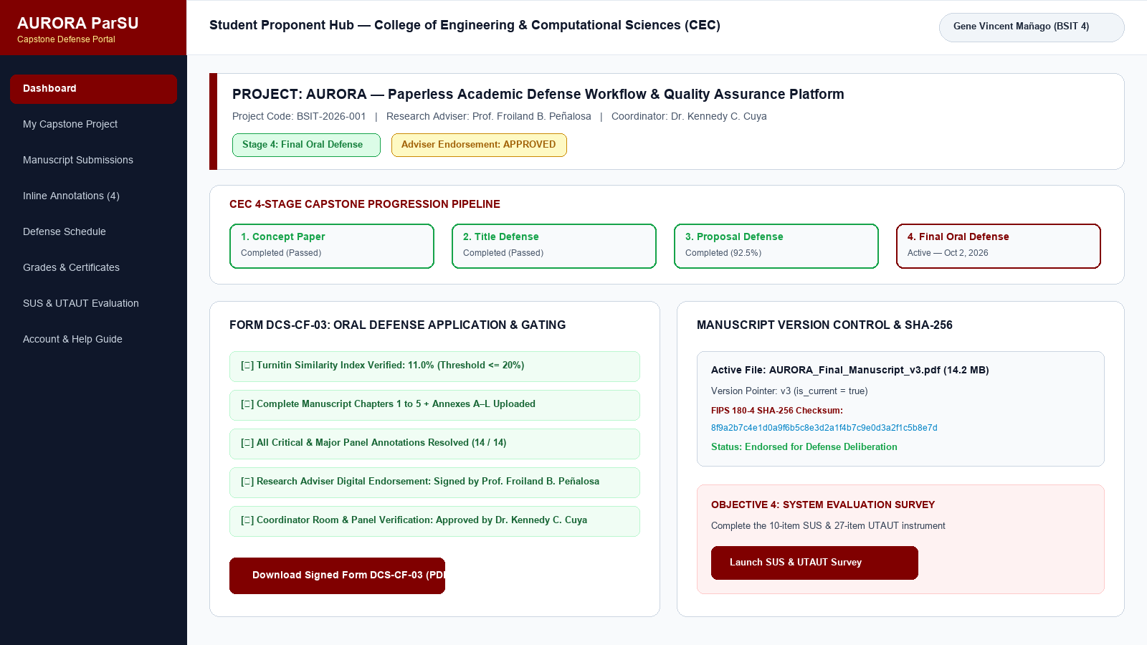  Multi-College Defense Stepper & Proponent Hub | 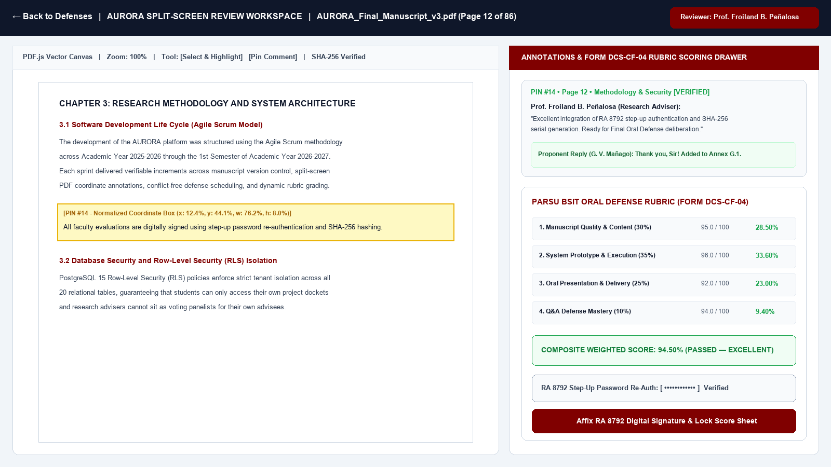  Dual-Pane Split-Screen PDF.js & Rubric Workspace

1. Dual-Pane PDF.js & Coordinate Annotations  Eliminates cognitive split-attention by anchoring normalized bounding-box highlights (x%, y%, w%, h%), severity tags, and revision threads directly onto the PDF viewport. | 2. Multi-College Workflows & Conflict Firewall  Supports customizable 5-stage (BSIT Capstone) and 3-stage (COE, CAH, COS, CBM Thesis) pipelines with automatic room-clash and adviser conflict-of-interest isolation.
3. Automated Rubric & RA 8792 Digital Signatures  Automates weighted rubric computations with step-up password re-authentication and tamper-evident clearance serials (AURORA-YYYY-NNNNNN). | 4. Self-Healing Maintenance & 3-2-1 DR Vault  Built-in administrative console (/admin/system-health) with 6 live diagnostic probes, one-click self-healing repair, and SHA-256 signed JSON cold backups.

EMPIRICAL IMPACT & PROJECT TEAM (BSIT 4C)  • SUS Usability Score: 91.8 / 100 (Grade A — Excellent)  • UTAUT Acceptability Mean: 4.86 / 5.00 (Highly Acceptable)  • Turnaround Reduction: 18.4 days → 2.6 days (−85.9%)  • Authors: G. V. D. Mañago, C. A. B. Castillo, R. M. S. Buenafe, L. M. B. Encinas, L. Bares  • Adviser: Froiland B. Peñalosa | Chair & Reader: Kennedy C. Cuya, DIT |   Scan for Live Portal  aurora-parsu.vercel.app | 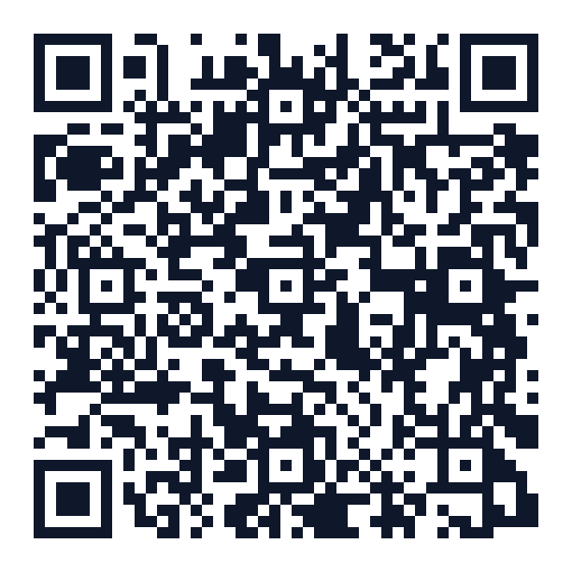  Scan for IMRAD Paper  (ACM SIGPLAN PDF)

