SYSTEM DESIGN AND FUNCTIONAL ARCHITECTURE
Functional Diagram
The functional diagram visually represents the structural flow of the system and its major operational components, illustrating how institutional academic stakeholders interact with the platform and how research data transitions across modules. In AURORA (Automated Unified Review and Operations for Research Archival), the functional decomposition model establishes a cohesive, loosely-coupled architecture that bridges the gap between student research proponents, faculty mentors, examination panelists, and academic administrators. Figure 2 illustrates the functional decomposition diagram of the platform, partitioning the system into nine core operational modules.
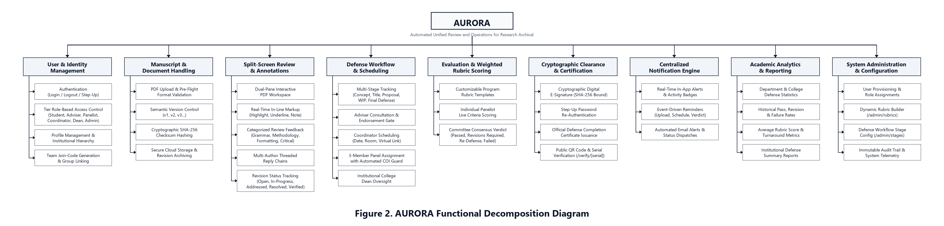
Figure 2. AURORA Functional Decomposition Diagram
In Figure 2, Functional Decomposition Diagram, the AURORA platform breaks down into nine interconnected functional modules:
1. User & Identity Management. This module facilitates secure user registration, session authentication, and account recovery. It enforces strict Tier Role-Based Access Control (RBAC) across six primary institutional roles: Student, Adviser, Panelist, Research Coordinator, College Dean, and System Administrator. It maintains institutional scoping across Campuses, Colleges, Departments, and Academic Programs, and provides team join-code generation to enable multi-author student proponent group linking.
2. Manuscript & Document Handling. Responsible for the full lifecycle of capstone and thesis manuscripts, this module manages client- and server-side PDF pre-flight validation, sanitization, and automated semantic version control (v1, v2, v3...). Every document iteration is bound to a cryptographic SHA-256 checksum hash to ensure tamper resistance. Digital files are securely stored in encrypted cloud storage buckets with pre-signed access tokens, providing a permanent non-destructive audit trail of manuscript progression.
3. Split-Screen Review & Annotations. This module provides a dual-pane interactive PDF review workspace designed for concurrent manuscript reading and qualitative evaluation. It supports real-time, coordinate-anchored in-line annotations including text highlights, strikethroughs, and sticky notes. Reviewers classify feedback into standardized categories (Methodology, Research Concern, Grammar, Formatting) with assigned severity levels (Info, Minor, Major, Critical). Students engage through multi-author threaded reply chains to document specific revisions, while the system monitors progress across discrete lifecycle statuses (Open, In-Progress, Addressed, Resolved, Verified).
4. Defense Workflow & Scheduling. Orchestrating the institutional defense progression, this module tracks research projects across five key milestones: Concept Paper, Title Defense, Proposal Defense, Work-in-Progress (WIP), and Final Defense. It enforces the Adviser Consultation Gate, requiring formal adviser endorsement remarks before a defense hearing can be scheduled. Coordinators utilize an integrated calendar engine to set defense schedules, venues, and virtual meeting links, while an automated Conflict of Interest (COI) guard algorithmically prevents assigned thesis advisers from sitting on their advisees' examination panels.
5. Evaluation & Weighted Rubric Scoring. This module manages academic assessment through program-specific, configurable rubric templates. During defense proceedings, panelists conduct independent, live criterion scoring with automated weighted average computations. Upon defense conclusion, individual evaluations are aggregated into an official committee consensus verdict (Passed, Passed with Revisions, Re-Defense, or Failed) in strict compliance with university grading standards.
6. Cryptographic Clearance & Certification. Governing academic integrity and legal non-repudiation in accordance with the Philippine Electronic Commerce Act of 2000 (Republic Act No. 8792), this module captures vector digital signatures backed by Step-Up Password Re-Authentication. Digital signatures are cryptographically bound to an immutable SHA-256 payload digest. The module issues official Defense Completion Certificates bearing automated sequential serial numbers (e.g., AURORA-2026-000054) and embedded QR codes for zero-login public authenticity verification (/verify/[serial]).
7. Centralized Notification Engine. This module serves as the real-time communications backbone of the platform. Operating via an event-driven publish-subscribe architecture, it dispatches instant in-app alerts, unread activity badges, and automated email notifications. System triggers include manuscript upload announcements, revision requests, defense scheduling notifications, grade releases, and adviser endorsement updates, ensuring seamless coordination among all research participants.
8. Academic Analytics & Reporting. Designed for institutional decision-making and accreditation compliance, this module compiles comprehensive defense statistics at both departmental and college levels. It tracks historical pass, revision, and failure rates, measures average rubric score distributions, and analyzes revision turnaround velocity. Executive summary reports provide College Deans and department chairs with empirical data to evaluate academic research productivity.
9. System Administration & Configuration. This module provides IT administrators with master data management tools. It governs faculty and coordinator account verifications, workflow stage configurations, dynamic rubric template weighting, and storage bucket quotas. Furthermore, it maintains an append-only, tamper-evident audit log that records all critical system operations alongside actor email, IP address, and telemetry metadata for institutional compliance audits.
Table 1. Institutional Role-to-Module Access Matrix
Functional Module | Student | Adviser | Panelist | Coordinator | College Dean | Sys Admin
User & Identity Management | Self | Self | Self | Dept | College | Full
Manuscript & Document Handling | Upload / View | Review / Endorse | Examine | Audit | Oversight | Storage Admin
Split-Screen Review & Annotations | Reply / Address | Annotate / Resolve | Annotate / Grade | Audit | View Only | Full
Defense Workflow & Scheduling | View Schedule | Consultation Gate | Defense Hearing | Manage / Schedule | Oversight | Stage Config
Evaluation & Rubric Scoring | View Grades | View Endorsement | Live Scoring / Sign | Consolidate Verdict | View Reports | Template Config
Cryptographic Clearance & Cert. | Download Cert | Sign Endorsement | Sign Evaluation | Release Cert | Executive Sign | Audit Log
Centralized Notification Engine | Active Alerts | Active Alerts | Active Alerts | Active Alerts | Active Alerts | System Broadcast
Academic Analytics & Reporting | Personal Stats | Advisee KPIs | Panel Records | Dept KPIs | College Analytics | Full Telemetry
System Administration & Config. | None | None | None | Dept Setup | College Setup | Full Admin

