Chapter 3
TECHNICAL BACKGROUND
System Architecture
AURORA (Automated Unified Review and Operations for Research Archival) follows a robust, cloud-native Three-Tier System Architecture designed specifically to modernize, automate, and secure the academic defense and manuscript review lifecycles at Partido State University. The three-tier model structurally separates user presentation, application logic, and persistent data storage into distinct, loosely-coupled layers: the Presentation Tier, the Application/Logic Tier, and the Data Tier. This separation enforces strict modularity, high horizontal scalability, maintainability, and least-privilege access control across all defense operations, ensuring that client-side interactions cannot compromise underlying academic records or bypass institutional evaluation rules.
In accordance with modern software engineering paradigms and the institutional workflow requirements of Partido State University, the system eliminates traditional monolithic client-server dependencies. All user operations—spanning manuscript submission, pre-defense adviser endorsement, live split-screen review, freehand vector pen markup, conflict-of-interest-guarded scheduling, weighted rubric computation, consensus verdict generation, and cryptographic digital certification—are processed through a serverless full-stack orchestration core that communicates with an enterprise-grade cloud database infrastructure. Figure 1 illustrates the comprehensive Three-Tier System Architecture of AURORA.
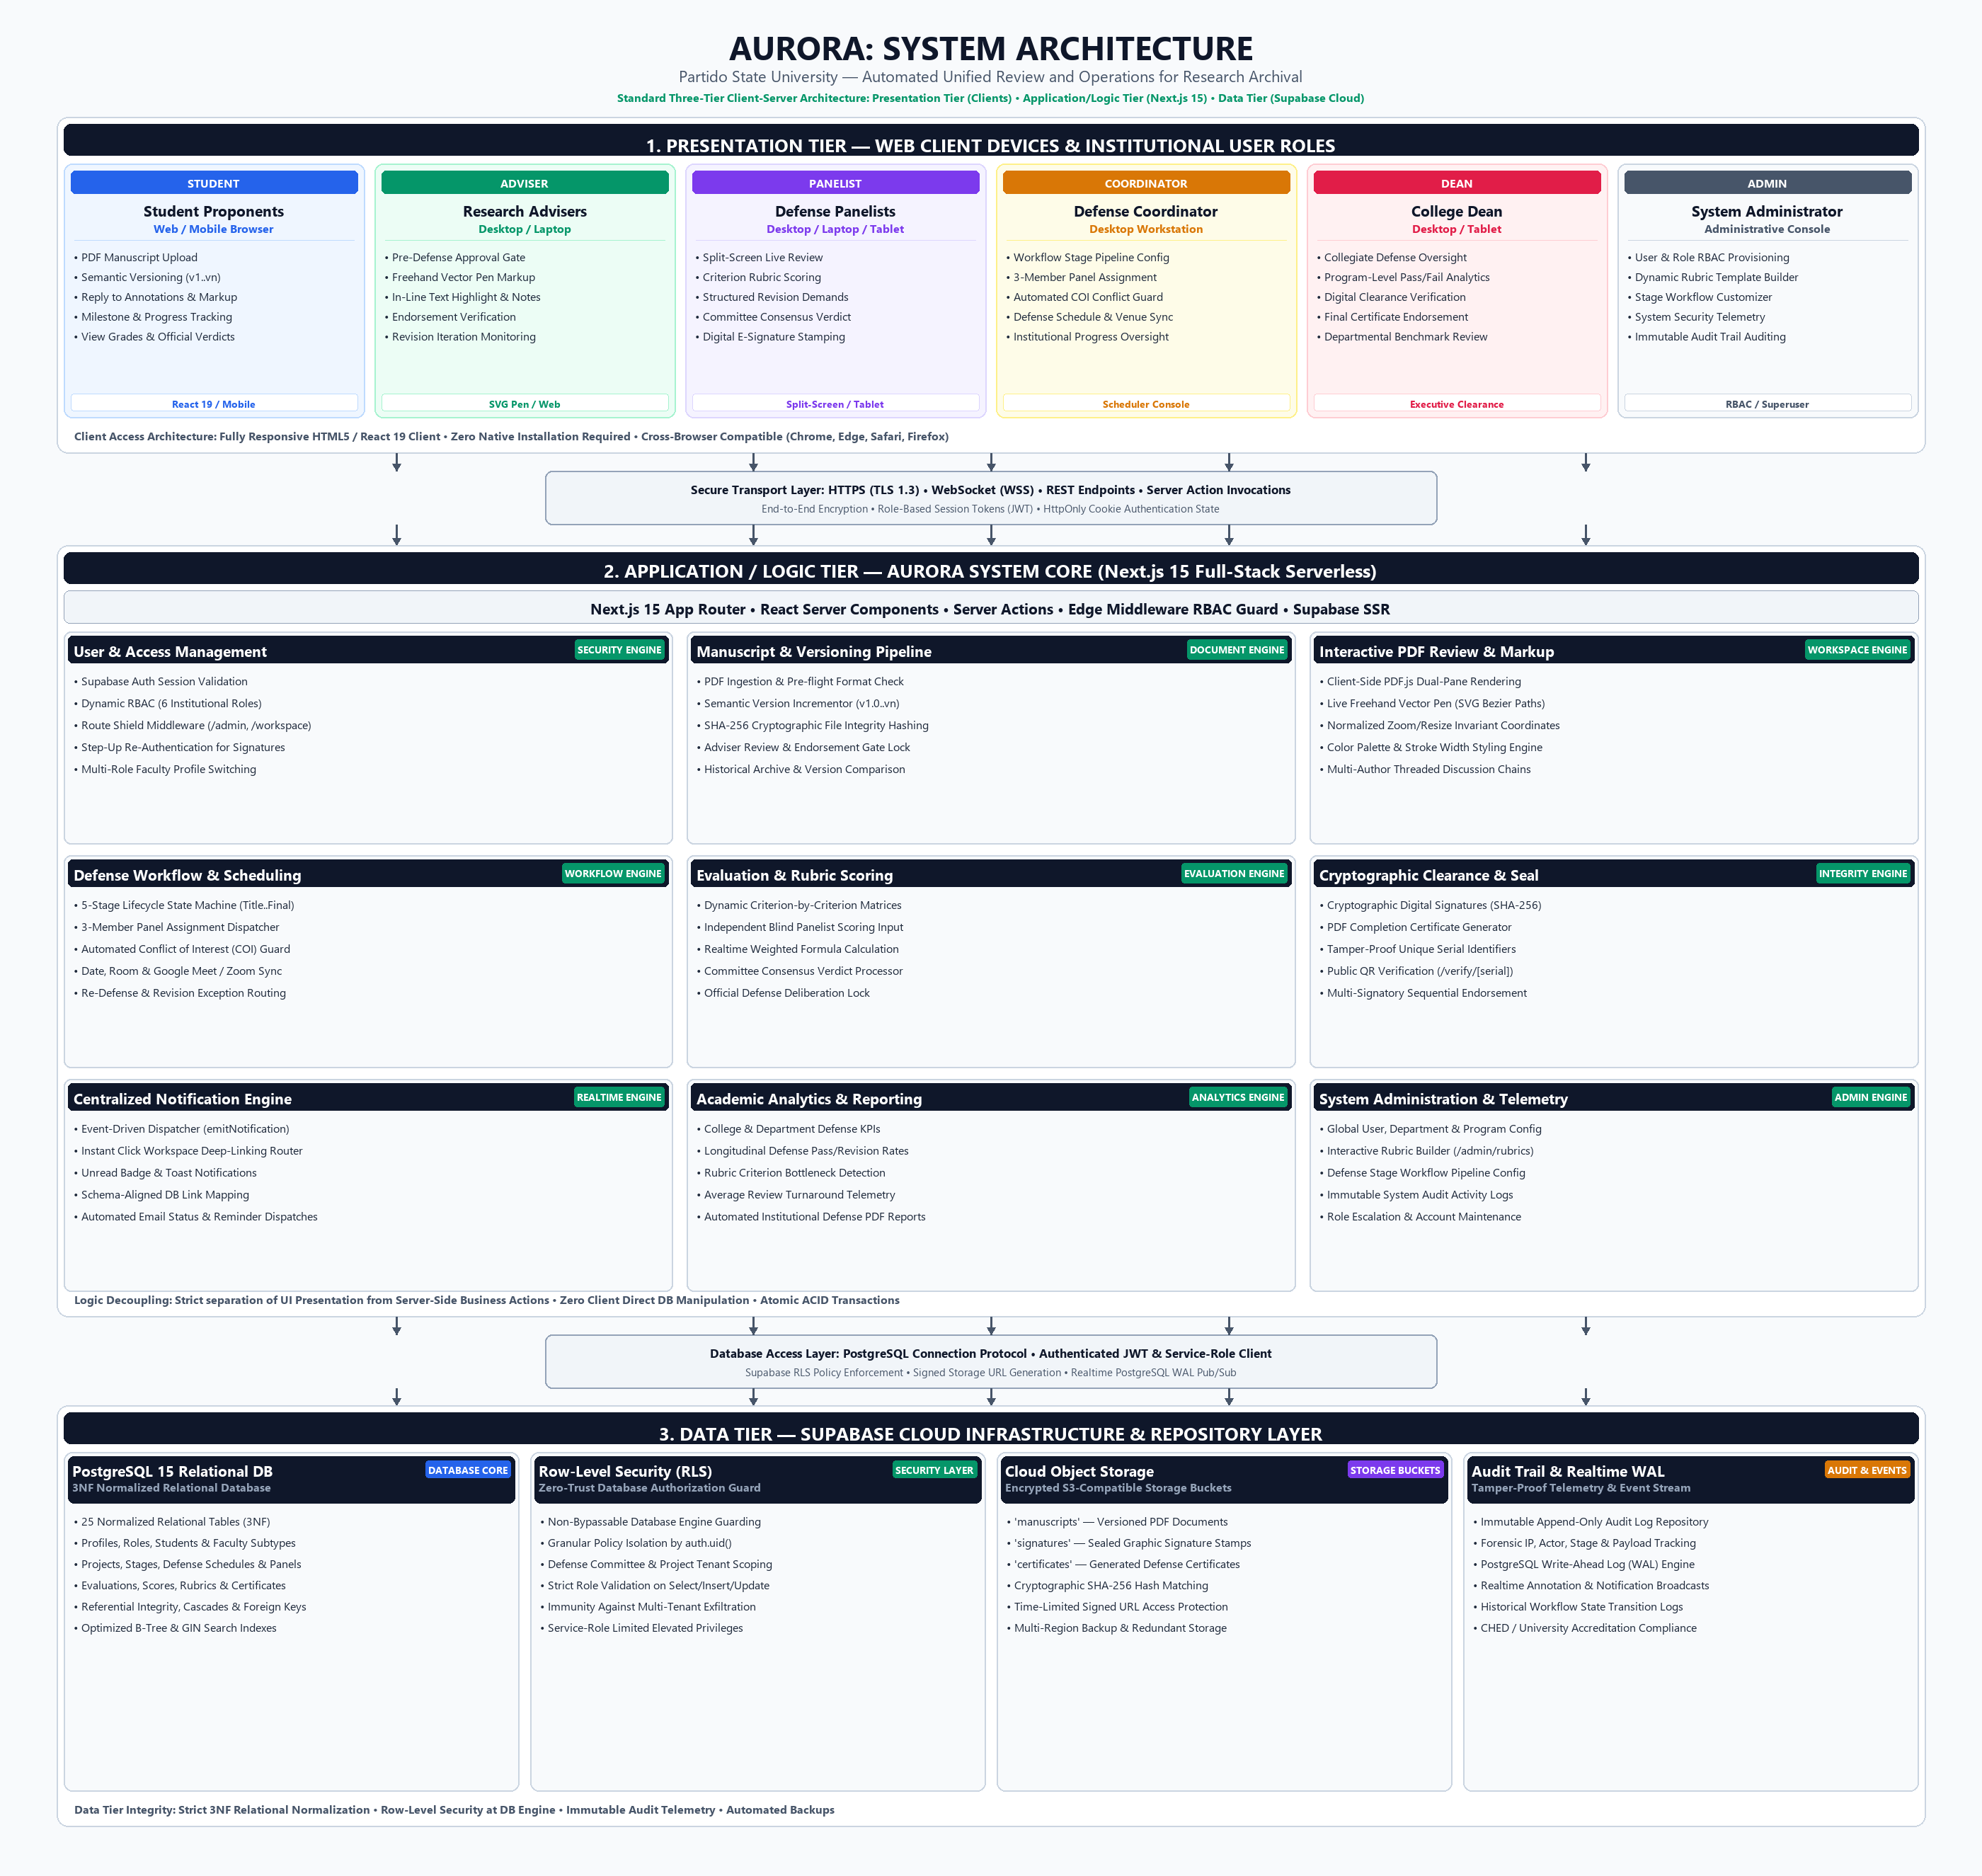
Figure 1
AURORA System Architecture Diagram
1. Presentation Tier (Client Devices & Institutional User Roles)
The Presentation Tier serves as the user-facing interface of the AURORA platform, facilitating ubiquitous, zero-install accessibility across diverse client hardware environments, including desktop workstations, laptops, tablets, and mobile smartphones. Built upon React 19 and Next.js 15 client-side component architecture, the interface is fully responsive, WCAG 2.1 accessible, and cross-browser compliant with modern web engines (Google Chrome, Microsoft Edge, Mozilla Firefox, and Apple Safari). The tier strictly enforces a dynamic Role-Based Access Control (RBAC) model tailored to six institutional academic roles within Partido State University:
a. Student Proponents: Students access a dedicated research project portal allowing them to register capstone teams via cryptographically generated join-codes, upload PDF manuscripts across sequential defense milestones, monitor semantic version histories (v1.0 through vn), view adviser and panelist annotations in-line, reply to threaded review comments, track stage progress, and view officially released defense grades and consensus verdicts.
b. Research Advisers: Faculty advisers utilize a specialized guidance dashboard providing pre-defense manuscript review tools. Advisers act as institutional quality gates; only manuscripts formally endorsed by the adviser can transition to the scheduling and panel review phases. Advisers are equipped with live freehand vector pen markup tools, categorized text-highlighting capabilities, and revision requirement composers to guide student revisions prior to defense deliberation.
c. Defense Panelists: Panel members operate an interactive split-screen evaluation workspace during oral defense proceedings. The left pane presents the synchronized PDF manuscript complete with page navigation and zoom controls, while the right pane displays the live rubric evaluation matrix. Panelists record criterion-by-criterion scores, log mandatory revision notes, and submit individual verdicts that contribute to the committee's aggregate decision.
d. Defense Coordinators: Departmental coordinators oversee academic defense schedules and committee logistics. Coordinators configure defense stages, assign three-member evaluation panels enforced by an automated Conflict of Interest (COI) detector that prevents advisers from sitting on their own advisees' panels, assign physical defense venues or video conference rooms (Google Meet / Zoom), and monitor department-wide defense throughput.
e. College Deans: The Dean exercises executive collegiate oversight over all departmental capstone programs within the College of Engineering and Computational Sciences. The Dean's dashboard surfaces high-level longitudinal defense statistics, pass/revision rates, and turnaround benchmarks. Furthermore, the Dean executes digital cryptographic signature clearance to seal final defense completion certificates and academic clearances.
f. System Administrators: IT Administrators manage system-level configurations, institutional hierarchy (colleges, departments, and degree programs), account provisioning, dynamic rubric template creation, workflow pipeline definitions, and tamper-proof security audit telemetry.
2. Application / Logic Tier (AURORA System Core)
The Application/Logic Tier constitutes the computational and operational core of the AURORA platform. Hosted on a high-performance serverless execution framework powered by Next.js 15, React Server Components (RSC), and Edge Middleware, this tier encapsulates all business logic, workflow state transitions, document processing, and validation rules. The presentation layer never interacts directly with the database; instead, all client mutations are mediated through secure Server Actions and REST API routes that execute with strict session verification and input sanitation. The application tier decomposes into nine interconnected engines:
a. User & Access Management Engine: Orchestrates user authentication, session state management via HttpOnly cookies, dynamic RBAC enforcement, and route-level protection guards. Implements step-up re-authentication requiring faculty to confirm credentials immediately before applying cryptographic digital signatures to official evaluation documents.
b. Manuscript & Versioning Pipeline: Handles multi-part PDF file ingestion, pre-flight MIME and size validation, semantic version incrementation (v1.0, v1.1, v2.0), and cryptographic SHA-256 file hashing. By computing the SHA-256 digest upon upload, AURORA guarantees manuscript integrity, ensuring that documents examined during defense deliberations remain strictly identical to those archived upon completion.
c. Interactive PDF Review & Vector Markup Engine: Integrates client-side PDF.js rendering with a normalized SVG vector canvas. Reviewers can sketch freehand vector marks (circles, underlines, margin callouts) and highlight text sections. Coordinates are stored as percentage-based normalized vectors (0% to 100%), rendering markups invariant to viewport resizing, responsive column collapse, or zoom levels (75% to 200%). Threaded replies allow bidirectional discourse between reviewers and students.
d. Defense Workflow & Scheduling Engine: Implements a deterministic finite state machine (FSM) governing academic defense lifecycles (Concept, Title Defense, Proposal Defense, Work-in-Progress, and Final Defense). The engine enforces sequential stage gates, coordinates three-member panel dispatching, executes automated COI conflict checks, and manages calendar, room, and video link synchronization.
e. Evaluation & Rubric Scoring Engine: Translates dynamic institutional rubric matrices into live digital scorecards. The engine supports blind, independent scoring by each committee member, executes weighted percentage aggregation in real time, and computes the official committee consensus verdict (Passed, Revisions Required, Re-Defense, or Failed) based on institutional grade thresholds.
f. Cryptographic Clearance & E-Signature Engine: Manages the digital sealing of official academic records. Panelists, advisers, and deans affix digital signatures bound to their authenticated identities and the manuscript's SHA-256 hash. The engine dynamically synthesizes official Certificate of Completion PDF documents embedded with anti-tamper serial numbers and QR verification codes accessible via public verification routes (/verify/[serial]).
g. Centralized Notification Engine: Employs an event-driven dispatcher (emitNotification) that dispatches in-app badge alerts, toast notifications, and email dispatches upon critical milestone triggers (e.g., manuscript uploaded, revisions demanded, defense scheduled, verdict released). All notifications include direct workspace deep-links, immediately routing recipients to the exact manuscript stage or annotation thread requiring attention.
h. Academic Analytics & Reporting Engine: Aggregates institutional evaluation metrics across semesters and academic years. Produces real-time analytical dashboards illustrating department pass/revision distributions, rubric criterion turnaround times, and panelist review bottlenecks to support continuous curriculum enhancement.
i. System Administration & Telemetry Engine: Provides administrative facilities for dynamic rubric configuration, workflow pipeline customization, role provisioning, and immutable activity auditing. Captures structured audit telemetry for every security-sensitive action.
3. Data Tier (Supabase Cloud Infrastructure & Distributed Persistence)
The Data Tier manages secure, fault-tolerant persistence across structured relational data, binary document storage, and system audit trails. Implemented via Supabase Cloud infrastructure, the persistence layer combines an enterprise PostgreSQL 15 database engine with S3-compatible cloud object storage and real-time event streaming. The tier is architected around four foundational components:
a. PostgreSQL 15 Relational Database: The relational database schema is normalized to Third Normal Form (3NF), comprising 25 interconnected tables (including PROFILES, USER_ROLES, STUDENTS, FACULTY, PROJECTS, DEFENSE_STAGES, DEFENSE_SCHEDULES, DEFENSE_PANELS, DOCUMENTS, ANNOTATIONS, EVALUATIONS, GRADING_TEMPLATES, DIGITAL_SIGNATURES, and NOTIFICATIONS). Referential integrity is maintained via foreign key constraints and cascading rules, eliminating data redundancy and orphaned records.
b. Row-Level Security (RLS) Policy Layer: To enforce zero-trust data protection at the database level, PostgreSQL Row-Level Security policies are activated across all tables. RLS ensures that access permissions are evaluated directly by the PostgreSQL engine based on the authenticated user's JWT identity (auth.uid()). Proponents can only access manuscripts within their registered capstone group; faculty can only score projects to which they are officially assigned; and administrative tables are strictly shielded from non-administrative queries.
c. Supabase Cloud Object Storage: Encrypted storage buckets host binary assets, categorized into 'manuscripts' (versioned student PDF submissions), 'signatures' (biometric and sealed graphic signature stamps), and 'certificates' (generated completion credentials). All file access is mediated via signed, time-limited URLs, preventing direct unauthorized URL enumeration.
d. Immutable Audit Trail & Realtime WAL Engine: System activities—such as document uploads, endorsement decisions, score submissions, and verdict releases—are permanently recorded in an append-only audit repository. The database utilizes PostgreSQL Write-Ahead Logging (WAL) and WebSockets to broadcast instant annotation updates and notifications to connected clients.

Chapter 5
RESULTS AND DISCUSSIONS
Design of System Architecture
The second major objective of this capstone study was to design and implement a scalable, highly secure system architecture capable of supporting end-to-end paperless capstone defense workflows at Partido State University. Architectural evaluation during development demonstrated that the three-tier client-server paradigm successfully resolved the operational bottlenecks, security vulnerabilities, and communication breakdowns inherent in conventional paper-based and fragmented email-driven defense procedures.
Table 1 outlines the architectural decomposition of AURORA, summarizing the distribution of functional responsibilities, underlying technologies, communication protocols, and security enforcement mechanisms across the three tiers.
Table 1
Architectural Decomposition and Functional Allocation Across AURORA Tiers
Tier | Subsystem / Layer | Core Technologies | Key Operational Responsibilities | Security Protocol
Presentation Tier | Client Layer & Role Portals | Next.js 15, React 19, Tailwind CSS, PDF.js | Responsive dashboards for 6 roles; manuscript upload; live split-screen review; normalized vector pen markup; grade tracking. | HTTPS (TLS 1.3), HttpOnly JWT Cookies, Role-Based Route Shielding
Application Tier | AURORA System Core (Serverless) | Next.js 15 App Router, React Server Actions, Edge Middleware | Authentication & RBAC; manuscript versioning; SHA-256 hashing; stage state machine; dynamic rubric scoring; notification dispatch; QR certification. | Server-Side Input Validation, Step-Up Re-Auth, Least-Privilege Execution
Data Tier | Persistence & Storage Layer | Supabase PaaS, PostgreSQL 15, S3 Cloud Storage, WAL Engine | 3NF relational persistence (25 tables); encrypted PDF & signature storage; real-time event streaming; immutable audit telemetry. | PostgreSQL Row-Level Security (RLS), Signed Storage URLs, ACID Transactions

Data Integrity and Non-Repudiation: By integrating SHA-256 cryptographic hashing at the manuscript pipeline and digital signature layers, AURORA ensures absolute non-repudiation. Once an oral defense concludes and the committee releases its official verdict, the submitted rubric scores and the finalized manuscript are immutably tied to the signatories' digital signature profiles. Any post-defense tampering with manuscript PDF content immediately invalidates the computed checksum, alerting institutional evaluators during public QR code certificate verification.
Zero-Trust Database Security via Row-Level Security (RLS): Unlike conventional web applications that rely solely on application-level access checks, AURORA activates PostgreSQL Row-Level Security policies across all 25 tables. This architecture establishes a zero-trust security posture where even if an attacker attempts parameter tampering or client-side script manipulation, the database engine itself rejects unauthorized read or write operations. Consequently, confidential rubric deliberations, student revision feedback, and pre-release grades remain completely isolated and tamper-proof.

