Software Development Life Cycle (SDLC)
The development of the Academic Defense Workflow System (AURORA) followed the System Development Life Cycle (SDLC), specifically adopting a combination of prototyping and Agile methodology. The Agile methodology, in particular, was instrumental in enabling iterative refinement—an essential component when designing a workflow system with multiple user roles, including Students, Research Advisers, Defense Panelists, Research Coordinators, College Deans, and System Administrators across the five colleges of Partido State University – Goa Campus.
Figure 1
Agile SDLC Model for AURORA
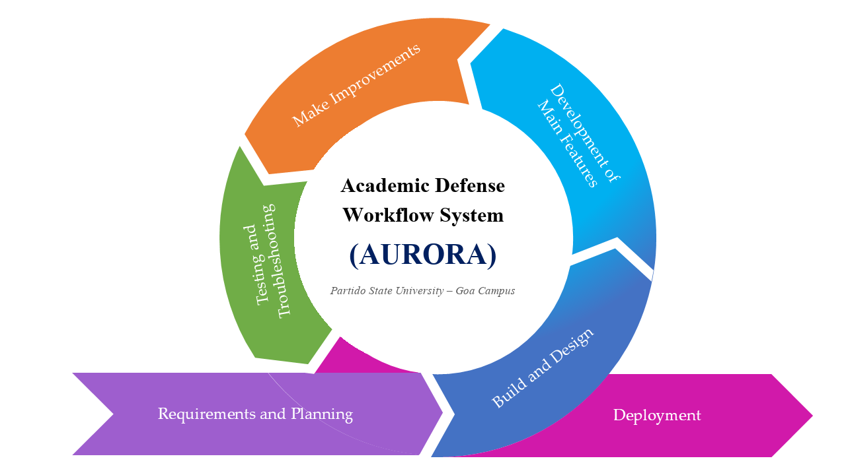
Figure 1 illustrated the System Development Life Cycle (SDLC) model used in developing AURORA, which integrates elements of both the prototyping and Agile methodologies. The model emphasizes iterative development, continuous stakeholder engagement, and progressive refinement of system features. Beginning with requirements gathering and planning, the process proceeds through prototyping, development, testing, iteration, and final deployment. Each phase feeds into the next while allowing feedback loops, ensuring that the system evolves based on user input, testing results, and institutional needs. This hybrid SDLC approach supports the creation of a user-centered, role-based workflow system aligned with the university’s academic defense process.
Requirements and Planning. This initial phase involves close collaboration with key stakeholders including the Capstone Research Coordinators, College Deans, Research Advisers, Panelists, and Students to define the functional and non-functional requirements of AURORA. Through semi-structured interviews, document analysis of existing defense rubrics, and collaborative workshops, the researchers identify existing challenges in the manual submission, delayed grading tallying, and scheduling conflicts. The phase clarifies hierarchical approval structures and outlines essential features such as the split-screen annotation workspace, dynamic rubric-based scoring, Conflict of Interest (COI) panel allocation, and cryptographic signing mechanisms. This ensures alignment between the system objectives and the actual operational needs of users across all five colleges.
Build and Design. Guided by the gathered requirements, the researchers develop the preliminary system architecture, database schema, and interface prototypes. High-fidelity UI/UX wireframes and mockups of the split-screen workspace, role-based dashboards, and defense scheduling calendars were constructed to visualize the user experience. These prototypes were presented to target faculty and student researchers for early feedback, allowing refinement of the visual layout, interaction paradigms, and workflow gating logic before core development began.
Development of Main Features. In this phase, the main functionalities of AURORA were implemented through incremental, sprint-based development. This includes user authentication with institutional credentials, manuscript PDF uploading with SHA-256 checksums, coordinate-based canvas annotations, dynamic rubric scoring with automated composite calculations, and cryptographic digital signatures conforming to Republic Act No. 8792. Modular programming techniques utilizing Next.js, React, TypeScript, and Supabase PostgreSQL were employed to ensure scalability and maintainability, allowing each subsystem—manuscript submission, review, scheduling, evaluation, and audit logging—to be developed and enhanced independently.
Testing and Troubleshooting. The system undergone comprehensive evaluation, including functional unit testing, integration testing, and scenario-based simulations using actual capstone manuscripts. Testers validated whether key features (e.g., manuscript upload, split-screen review, rubric grading, e-signature verification, and audit logging) perform reliably without errors. Usability assessments examined navigation clarity, task efficiency, and cognitive load reduction, employing standardized evaluation metrics such as the System Usability Scale (SUS) targeting a benchmark score of ≥ 68 and the ISO/IEC 25010 software quality model.
Make Improvements. Based on findings from testing and stakeholder feedback, iterative refinements were implemented to enhance system performance, interface usability, and workflow accuracy. The Agile model supports continuous refinement—allowing interface adjustments, rubric weight recalculations, adviser gating rules, and mobile responsive optimizations to be integrated promptly without disrupting overall development progress.
Deployment. After all core modules have been validated, AURORA was prepared for deployment at Partido State University – Goa Campus. Final debugging, performance checking, database indexing, and interface polishing were conducted. User manuals and administrative documentation were produced to support training and institutional adoption. The fully developed and tested system was then presented during the capstone defense, marking its formal completion.

