**Exercise 1: Simple Listing**

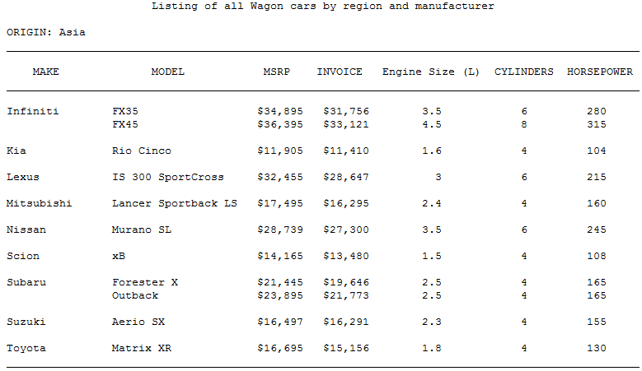

Program using proc report

data cars1;

set sashelp.cars;

RUN;

title"listing of all Wagon cars by region and manufacturer";

proc report data=cars1;

by origin notsorted;

COLUMN ORIGIN MAKE MODEL MSRP INVOICE ENGINESIZE CYLINDERS HORSEPOWER ;

define ORIGIN/ display group noprint ;

define MAKE/display;

define MSRP/display;

define INVOICE/display;

define ENGINESIZE/display;

define CYLINDERS/display;

define HORSEPOWER/display;

compute before_page_ origin;

break after origin/ page;

RUN;

For Macumba using datalist macro

The below program

%iniprog(

name = excercise1

, log2file =

, print2file = Y

, createRTF =

, cleanWork = Y

, cleanTitlesFoot = Y

, addTS2Log = N

, verbose = Y

);

%initsystems(initstudy = 4, mosto = 7, spro = 3, adamap = 1, definexml = 1, p21e = 1, gral = 4, eva = 1, dtools = 2, cars = 1, woops = 1, poster=1, valir=1)

%initstudy(

iniProgram =

, iniAreaSubDir = /var/swan/root/bhc/general/playground/training/12345/stat/main17/dev/analysis

, includeADSFrom = main01/dev

, iniDrive =/* &drive.*/ /var/swan/root/bhc/general/playground

, display_formats = N

, inimode = ANALYSIS

);

data cars (KEEP= Origin Make Model MSRP Invoice EngineSize Cylinders HorsePower);

set sashelp.cars;

where type= "Wagon";

run;

%set_titles_footnotes(

tit1 = "Listing of all Wagon Cars by region and manufacturer"

)

%datalist(

data = cars

, page = Origin

, by = Make

, sidebyside =

, var = Model MSRP Invoice EngineSize Cylinders HorsePower

, postvar =

, contby =

, order =

, order_var =

, tablesby =

, collate_seq = NO

, ncolumn1 =

, transpose =

, freeline =

, together =

, optimal = NO

, maxlen = 20

, repby = NO

, space = 5

, splitby = YES

, split = '/ *'

, hsplit =

, label = YES

, layout = STANDARD

, bylen =

, vertical_header =

, ignore_prespace = NO

, print_empty = YES

, hb_align = CENTER

, hv_align = CENTER

, hc_align =

, hn_align =

, outdat_meta_lib =

, store_fmt_cat = NO

, shells = NO

, shell_maxobs =

, shell_replace_by = NO

);

%endprog;

**Exercise-2 Descriptive Statistics:**

**Please produce the following table from SASHELP.CARS using an appropriate MoSTO macro:**

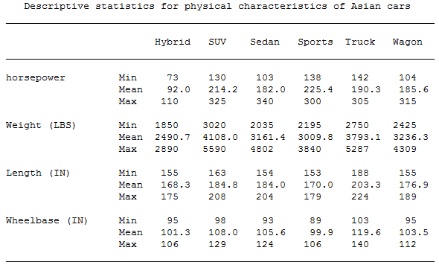

%iniprog(

name = excericse2

, log2file =

, print2file = Y

, createRTF =

, cleanWork = Y

, cleanTitlesFoot = Y

, addTS2Log = N

, verbose = Y

);

/*

DATA cars;

SET sashelp.cars;

where Origin="Asia";

RUN;

%set_titles_footnotes(

tit1 = "Descriptive statistics for physical characteristics of Asian cars"

)

%desc_tab(

data = cars

, data_n =

, var = Horsepower Weight Length Wheelbase

, stat = MIN MEAN MAX

, alpha_ci = 0.5

, by =

, inby =

, page =

, sidebyside =

, data_n_ignore =

, order =

, class = Type

, class_order =

, total = NO

, round_factor = 1

, round_limit = 1

, round_type = DECIMAL

, completevar =

, code99x = NO

, print = PORTRAIT

, vlabel = YES

, out = DESC_TAB

, baseline =

, baseline_var =

, compare_var =

, baseline_pre =

, absbase =

, time =

, visittext = Visit

, baselinetext = Baseline

, subject =

, p_method =

, p_method_var =

, p_method_foot = NO

, samecont = YES

, stratum =

, outdat =

, harmonized_outdat = Yes

, tablesby =

, layout = STANDARD

, arithm_label = NO

, optimal = YES

, maxlen = 34

, space = 2

, split =

, hsplit =

, vertical_header =

, ignore_prespace = YES

, hb_align = CENTER

, hv_align = CENTER

, hc_align =

, hn_align =

, freeline = <default>

, together = <default>

, print_empty = YES

, order_var =

, repby = NO

, splitby = YES

, label = NO

, bylen =

, contby =

);

%endprog;

**Exercise-3 Frequency Analysis: Please produce the following table from SASHELP.CARS using an appropriate MoSTO macro:**

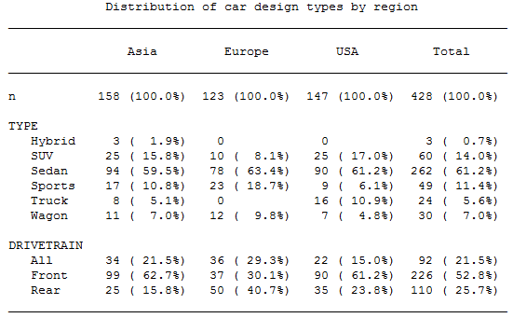

%iniprog(

name = excericse3

, log2file =

, print2file = Y

, createRTF =

, cleanWork = Y

, cleanTitlesFoot = Y

, addTS2Log = N

, verbose = Y

);

/*

data cars (KEEP=Origin Type DriveTrain);

set sashelp.cars;

RUN;

%set_titles_footnotes(

tit1 = "Distribution of car design types of region "

)

%freq_tab(

data = cars

, data_n =

, var = Type DriveTrain

, subject =

, page =

, by =

, sidebyside =

, inby =

, data_n_ignore =

, total = Yes

, totalby =

, totaltxt = Total

, order =

, class = Origin

, class_order =

, zeropct = NO

, percentage_decimals = 1

, freqoption = ALL

, basepct = N

, hlabel = NO

, levlabel = NO

, dintable = NO

, incln = NO

, desc = NO

, header_bign = YES

, misstext = missing

, subjectlabel = n

, p_method =

, p_method_var =

, p_method_foot = NO

, samecat = YES

, stratum =

, outdat =

, harmonized_outdat = NO

, missing = YES

, complete = NONE

, print = PORTRAIT

, code99x = NO

, completeclass = NO

, tablesby =

, layout = STANDARD

, optimal = NO

, maxlen = 20

, space = 2

, split = '/ *'

, hsplit =

, vertical_header =

, ignore_prespace = NO

, hb_align = CENTER

, hv_align = CENTER

, hc_align =

, hn_align =

, freeline = <default>

, together = <default>

, print_empty = YES

, order_var =

, repby = NO

, splitby = NO

, label = NO

, bylen =

, contby =

);

%endprog;

**Exercise-4 Incidence Report: Please produce the following table from SASHELP.CARS using an appropriate MoSTO macro:**

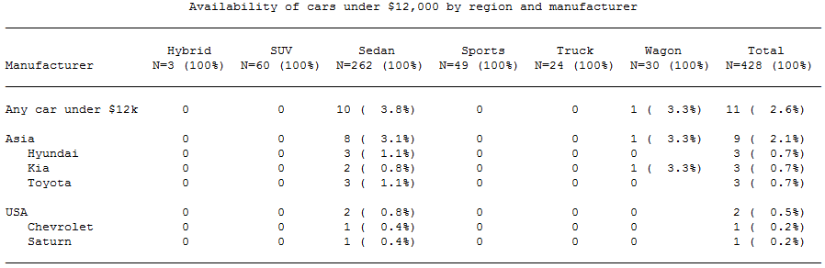

**WARNING: For this table, rename variable TYPE to any other name. It is a known bug; the macro uses this specific variable name internally.**

**WARNING: Choose your SUBJECT= variable(s) carefully, it must be unique.**

%iniprog(

name = excericse4

, log2file =

, print2file = Y

, createRTF =

, cleanWork = Y

, cleanTitlesFoot = Y

, addTS2Log = N

, verbose = Y

);

data cars (Keep=Make Origin MSRP Manufacturer Model DriveTrain Comb);

set sashelp.cars;

Comb=Model||"-"||DriveTrain;

Rename Type=Manufacturer;

RUN;

%set_titles_footnotes(

tit1 = "Availability of cars under $12,000 by region and manufacturer"

)

%incidence_print(

data = cars

, data_n = cars

, subject = Comb

, page =

, by =

, sidebyside =

, var = Origin Make

, inby =

, data_n_ignore =

, categor =

, class = Manufacturer

, class_order =

, outpat =

, harmonized_outdat = Yes

, triggercond = MSRP<12000

, contind =

, sortid =

, p_method =

, p_ignore_missing = NO

, p_method_foot = NO

, total = Yes

, zeropct = NO

, percentage_decimals = 1

, sumcount = YES

, events = NO

, totalcat = YES

, misstext = missing

, complete = NO

, completeclass = NO

, completevar =

, code99xhandling = DEFAULT

, code99x = NO

, transcat = NO

, threshold = 0

, threshold_class_value =

, percentage_range =

, sortorder = CODE

, sortseq = DESCENDING

, frqclass =

, frqsidebyside = SIDEBYSIDE

, frqvar =

, evlabel = Manufacturer

, anytxt =

, uncodedtxt = Any Car under $12K

, uncodedwarn = YES

, eventstxt =

, maxcattxt = Maximum

, order =

, outdat =

, tablesby =

, layout = STANDARD

, optimal = NO

, maxlen = 80

, space = 2

, split = '/ *'

, hsplit = <default>

, vertical_header =

, ignore_prespace = NO

, hb_align = LEFT

, hv_align = CENTER

, hc_align =

, hn_align =

, freeline = <default>

, together = <default>

, print_empty = YES

, order_var =

, repby = NO

, splitby = YES

, label = YES

, bylen =

, contby = <default>

)

%endprog;

**Exercise 5: Special Inquiries Please produce the following table from SASHELP.CARS using an appropriate MoSTO macro:**

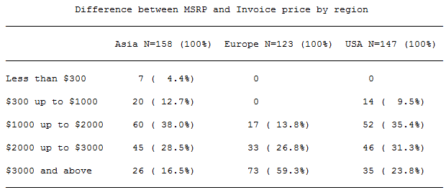

**WARNING: Choose your SUBJECT= variable(s) carefully, it must be unique.**

%iniprog(

name = excericse5

, log2file =

, print2file = Y

, createRTF =

, cleanWork = Y

, cleanTitlesFoot = Y

, addTS2Log = N

, verbose = Y

);

data cars (Keep=Origin Comb MSRP Invoice Diff);

set sashelp.cars;

Length Price $ 24;

Comb=Model||"-"||DriveTrain;

Diff= MSRP-Invoice;

RUN;

%set_titles_footnotes(

tit1 = "Difference Between MSRP and Invoice price by region "

)

%overview_tab(

data = cars(where=(not missing(Diff)))

, data_n =

, class = Origin

, class_order =

, by =

, sidebyside =

, page =

, order =

, transpose = NO

, missing = YES

, misstext = missing

, subject = Comb

, total = NO

, groups = "Diff <300" *"less than $300"

"Diff>300 and Diff<1000" *"$300 upto $1000"

"Diff ge 1000 and Diff<2000" *"$1000 upto $2000"

"Diff ge 2000 and Diff<3000 " *"$2000 upto $3000"

"Diff ge 3000" *"$3000 and above"

, groupstxt =

, code99xhandling = DEFAULT

, n_group = 0

, complete = NONE

, freqoption = ALL

, zeropct = NO

, percentage_decimals = 1

, code99x = NO

, outdat =

, harmonized_outdat = NO

, tablesby =

, optimal = NO

, maxlen = 50

, space = 2

, split = '/ *'

, hsplit =

, layout = STANDARD

, vertical_header =

, ignore_prespace = NO

, hb_align = CENTER

, hv_align = CENTER

, hc_align =

, hn_align =

, freeline =

, together = fline

, print_empty = YES

, order_var =

, repby = NO

, splitby = YES

, label = NO

, bylen =

, contby =

);

%endprog;

**Exercise 6: %DATALIST Magic : Please produce the following table from SASHELP.CARS using an appropriate MoSTO macro:**

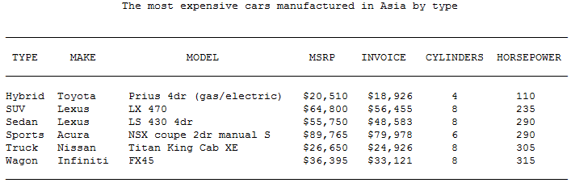

**WARNING: A page for each region must have a different title. No macro code!**

%iniprog(

name = excericse6

, log2file =

, print2file = Y

, createRTF =

, cleanWork = Y

, cleanTitlesFoot = Y

, addTS2Log = N

, verbose = Y

);

data cars (KEEP=Origin Type Make Model MSRP Invoice Cylinders HorsePower);

set sashelp.cars;

run;

proc sort data=cars out=cars1;

by Type Origin descending MSRP ;

RUN;

data cars2;

set cars1;

by Type Origin descending MSRP ;

if first.Type then output;

if first.Origin then output;

RUN;

proc sort data = cars2 out=cars3 nodupkey;

by Type Origin;

RUN;

proc sort data = cars3 out=cars4 ;

by Origin;

RUN;

data ca(KEEP=Origin);

set sashelp.cars;

run;

proc sort data=ca nodupkey;

by Origin;

RUN;

%set_titles_footnotes(

tit1 = "The most expensive cars manufactured in $Origin$ by Type"

)

%datalist(

data = cars4

, page = Origin

, by =

, sidebyside =

, var = Type Make Model MSRP Invoice Cylinders HorsePower

, postvar =

, contby =

, order =Origin

, order_var =

, tablesby =ca

, collate_seq = NO

, ncolumn1 =

, transpose =

, freeline =

, together =

, optimal = NO

, maxlen = 20

, repby = NO

, space = 5

, splitby = YES

, split = '/ *'

, hsplit =

, label = YES

, layout = STANDARD

, bylen =

, vertical_header =

, ignore_prespace = NO

, print_empty = YES

, hb_align = CENTER

, hv_align = CENTER

, hc_align =

, hn_align =

, outdat_meta_lib =

, store_fmt_cat = NO

, shells = NO

, shell_maxobs =

, shell_replace_by = NO

);

%endprog;

**Exercise 7: Heavy Lifting Please produce the following RTF table from SASHELP.CARS using an appropriate MoSTO macro:**

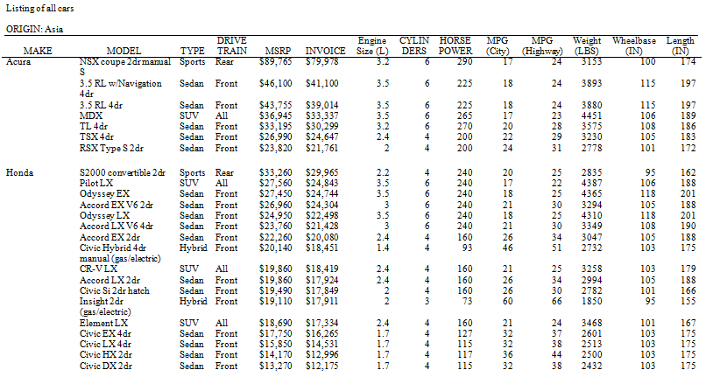

**WARNING: Every variable must be included – with as few line breaks as possible!**

%iniprog(

name = excericse7

, log2file =

, print2file = Y

, createRTF =

, cleanWork = Y

, cleanTitlesFoot = Y

, addTS2Log = N

, verbose = Y

);

data cars ;

set sashelp.cars;

run;

%set_titles_footnotes(

tit1 = "Listing of all Cars"

)

%GLOBAL MostoCalcPercWidth ;

%LET MostoCalcPercWidth = NO;

%insertOptionRTF(namevar= Make,width =13mm, keep = n, overwrite = n,align=l);

%insertOptionRTF(namevar= Model,width =20mm, keep = n, overwrite = n);

%insertOptionRTF(namevar= Type,width =10mm, keep = n, overwrite = n,align=l);

%insertOptionRTF(namevar= Drivetrain,width =12mm, keep = n, overwrite = n,align=l);

%insertOptionRTF(namevar= MSRP,width =12mm, keep = n, overwrite = n,align=l);

%insertOptionRTF(namevar= Cylinders,width =12mm, keep = n, overwrite = n,align=l);

%insertOptionRTF(namevar= HorsePower,width =13mm, keep = n, overwrite = n,align=l);

%LET _tmp_MostoCalcPercWidth = &MostoCalcPercWidth;

%LET MostoCalcPercWidth = NO;

%datalist(

data = cars

, page = Origin

, by = Make

, sidebyside =

, var = Model Type Drivetrain MSRP Invoice EngineSize Cylinders HorsePower MPG_City MPG_Highway weight Wheelbase Length

, postvar =

, contby =

, order =

, order_var =

, tablesby =

, collate_seq = NO

, ncolumn1 =

, transpose =

, freeline = Make

, together = Make

, optimal = NO

, maxlen = 20

, repby = NO

, space = 15

, splitby = YES

, split = '/ *'

, hsplit =

, label = YES

, layout = STANDARD

, bylen =

, vertical_header =

, ignore_prespace = NO

, print_empty = YES

, hb_align = CENTER

, hv_align = CENTER

, hc_align =

, hn_align =

, outdat_meta_lib =

, store_fmt_cat = NO

, shells = NO

, shell_maxobs =

, shell_replace_by = NO

);

%endprog();