Setup
If “element could not be shown” appears click “Yes” to removed the “Referenced Libraries” filter, since it’s not needed anymore.
Delete the v0.1.x Mylar plugin and place the two v0.1.2 plugins into your <eclipse-dir>/plugins directory. Start Eclipse and switch to the Mylar perspective (Window -> Open Perspective -> Other).
Make the extended Mylar Java editor the default for “.java” and “.class” files by selecting them in the “Associated editors” lists and clicking “Default” (Window -> Preferences -> Workbench -> File Associations). Close all files to reset existing editors.

Documentation
Mylar colors Java elements according to their degree-of-interest (DOI). The DOI is determined by the number of times that you select and edit the element, and decays over time so that rarely used elements fade from view. The DOI is visualized with at “hot-cold” coloring of elements in the following extended Eclipse views. The Mylar views and editors do not take away any existing functionality from those that they extend.
1. Mylar Perspective: contains the Mylar views. Note that Mylar views appear with little solar eclipse viewing Mylar glasses on the icon. If you work in other perspectives you can add the Mylar views manually.
2. Mylar Outline: shows DOI coloring and provides an additional filter for hiding all elements of low interest. Note that in the filtered mode members won’t show until they become interesting (e.g. by getting selected or edited).
3 & 4. Mylar Package Explorer: in addition to Outline functionality this view provides the “Auto Expand” action, which causes all high interest elements to be automatically expanded and visible in the tree, and all low interest elements to be filtered. Filtered elements can be temporarily shown using the “Raise children” action in the popup menu (4). The “Erase model” action will cause the DOI for all elements to be reset, useful if you move on to an entirely different task.
5: Mylar Problems: identical to the regular Problems view, but for each problem lists the Java element instead of resource and line number.
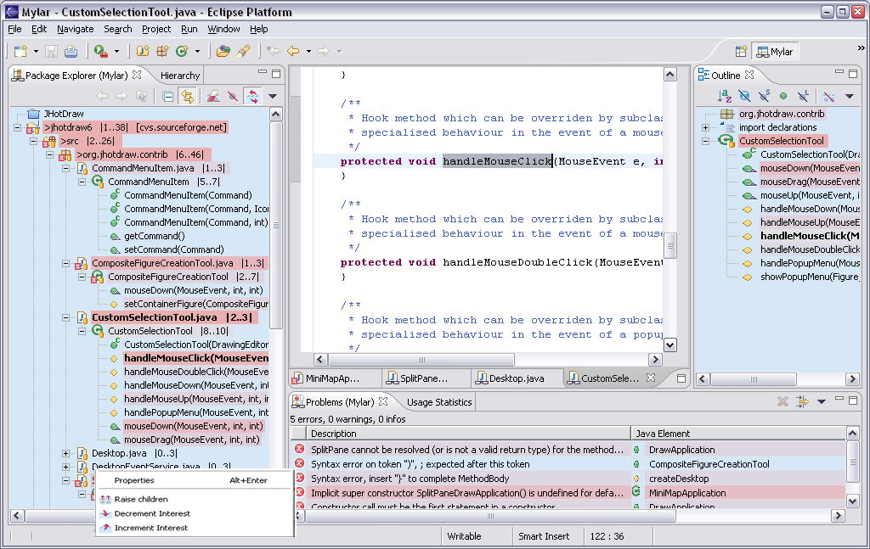

Known Limitations
Java element icons in the Outline and Problems views are slightly distorted.
When using AJDT in conjunction with Mylar the “AspectJ Editor” needs to be set as default for “.java” files, so the Mylar Outline can not be used.

