Single Neuron ANN Model
Author: Hong Jeong
Date: 2025-01-20
This presentation explains a single neuron ANN model including its mathematical formulation, a diagrammatic representation, and an implementation in PyTorch.

Outline
- Mathematical Model
- Diagram & Conceptual Figures
- PyTorch Implementation
- Testing the Model

Mathematical Model
We consider a single neuron described by an ANN model. In our context, the neuron computes a weighted sum of its input and then applies a nonlinear activation function.

Notation:
- x: Input vector
- W: Weight vector (parameters of the neuron)
- b: Bias term
- f: Activation function
- y: Output of the neuron

Mathematical Expression
$$y=f\left(W⋅x+b\right)$$
For example, if we use a sigmoid activation:
$$f\left(z\right)=\frac{1}{1+e^{−z}}$$
This model is fundamental in neural network theory and forms the basis of many more complex architectures.

Single Neuron
Below is a Mermaid representation of a single neuron:
graph TD
x1[x1] --> neuron[Neuron]
x2[x2] --> neuron[Neuron]
dots[...] --> neuron[Neuron]
xn[xn] --> neuron[Neuron]
neuron[Neuron] --> y[y]
b[b] --> neuron[Neuron]

PyTorch Implementation: Single Neuron ANN Model
We can implement the single neuron using PyTorch’s nn.Module.
import torch
import torch.nn as nn
import torch.nn.functional as F
import matplotlib.pyplot as plt
class SingleNeuron(nn.Module):
def __init__(self, input_dim):
super(SingleNeuron, self).__init__()
# Define a linear transformation: y = Wx + b
self.linear = nn.Linear(input_dim, 1)
def forward(self, x):
# Compute the weighted sum plus bias
z = self.linear(x)
# Apply a sigmoid activation function
y = torch.sigmoid(z)
return y
# Test the model with dummy data
if __name__ == '__main__':
# Set random seed for reproducibility
torch.manual_seed(0)
# Define input dimension
input_dim = 3
# Create the model
model = SingleNeuron(input_dim=input_dim)
# Create dummy input data: a batch of 10 samples
X = torch.randn(10, input_dim)
# Forward pass
outputs = model(X)
print('Input data:\n', X)
print('Output predictions:\n', outputs)
# Plot a histogram of the output activations
plt.hist(outputs.detach().numpy(), bins=10, edgecolor='k')
plt.title('Histogram of Neuron Output Activations')
plt.xlabel('Activation')
plt.ylabel('Frequency')
plt.show()
Input data:
tensor([[ 0.8487, 0.6920, -0.3160],
[-2.1152, -0.3561, 0.4372],
[ 0.4913, -0.2041, 0.1198],
[ 1.2377, 1.1168, -0.2473],
[-1.0438, -1.3453, -0.4927],
[ 0.2484, 0.4397, 0.1124],
[ 0.6408, 0.4412, -0.2159],
[-0.7425, -0.2897, 0.0525],
[ 0.5229, 2.3022, -1.4689],
[-1.5867, 1.2032, 0.0845]])
Output predictions:
tensor([[0.4840],
[0.3244],
[0.3665],
[0.5083],
[0.3537],
[0.4150],
[0.4530],
[0.3690],
[0.7279],
[0.4786]], grad_fn=<SigmoidBackward0>)
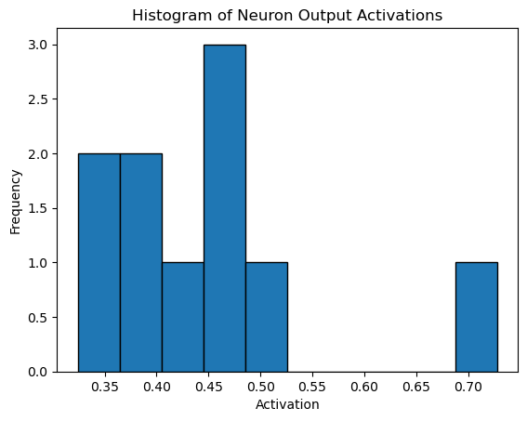

Summary
- We defined a single neuron as a model performing a linear transformation followed by a non-linear activation.
  - Mathematically: ( y = f(Wx + b) )
- The diagram illustrates the data flow through the neuron.
- PyTorch makes it easy to implement, test, and visualize such models.
Thank you for your attention!
Questions?

