Student Name: _____SL20________

Weather History File

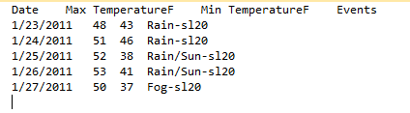

Event Table

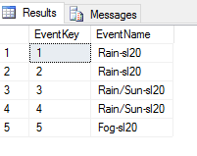

Event Dimension

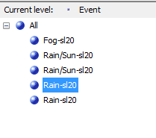

Weather Report

