Student Name: _____CMR92 ________

Weather History File

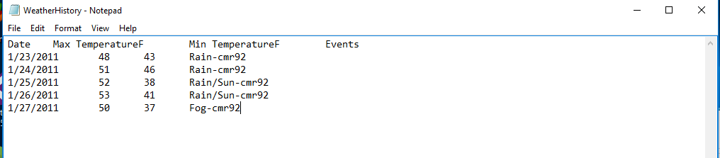

Event Table

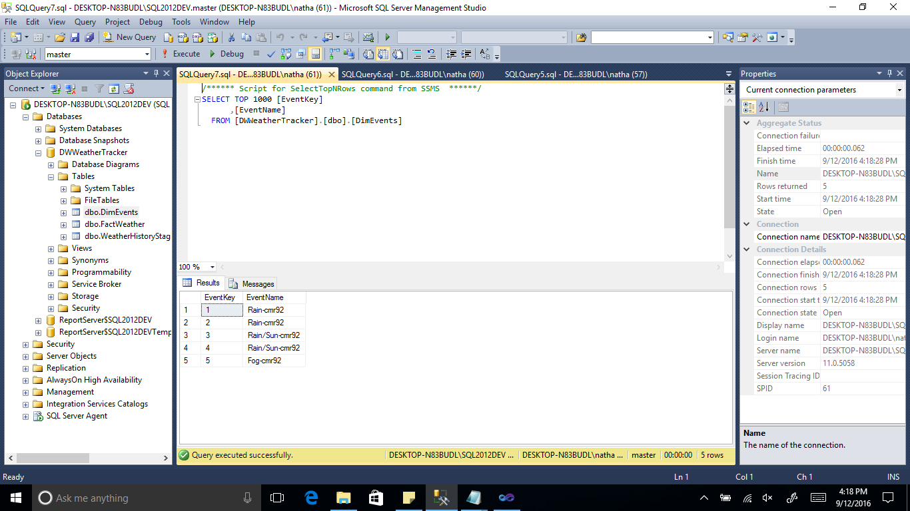

Event Dimension

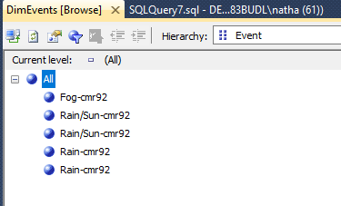

Weather Report

