CIS 4349, Fall 2016 – HW3

Due Date: Nov 1, 2016

1. Create a script (.sql file) to create the data warehouse specified in the diagram given below. **Note that your script must be able to drop the data warehouse if it already exits.**
2. Create a script (.sql file) that include statements to **backup or restore** the data warehouse.

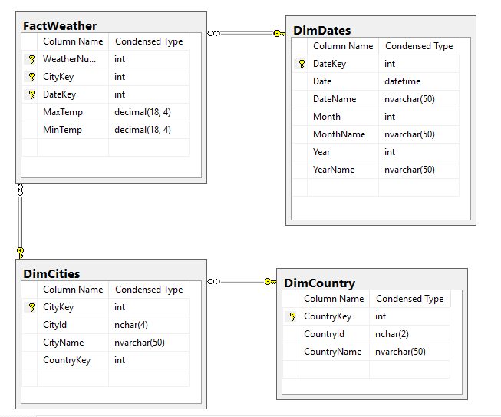

**You must create the scripts using SQL Server Management Studio and save your scripts as .sql files.**

***Turn in your scripts (.sql files) using the Assignments tool (HW3) on TRACS.***