**Devops evaluation Scenario**

Fork the below repository in your GitHub account – use the public GitHub.

<https://github.com/anuu1989/sample-node-app>

Task which needs to be completed:

1. Create a Docker file for the above application.
2. Setup a Minikube/Docker for desktop cluster in your local system.
3. Do a deployment of the above application in the cluster you have setup.

You can use all the resources available in the internet. You need to push all the changes done by you in your forked repo including the screenshots of the deployment and the cluster setup.

Once completed please share your GitHub repo.

**Screenshots:**

Forked the sample-node-app to my public github. Created a Dockerfile and updated the same in github.

https://github.com/gnprabhu27/sample-node-app

DockerFile :

FROM artifactory.service.anz:8118/node:9-slim

WORKDIR /app

COPY package.json /app

COPY index.js /app

RUN npm config set proxy "http://gblproxyinch.service.anz:80"

RUN npm config set strict-ssl false

RUN npm install

EXPOSE 3000

CMD ["npm", "start"]

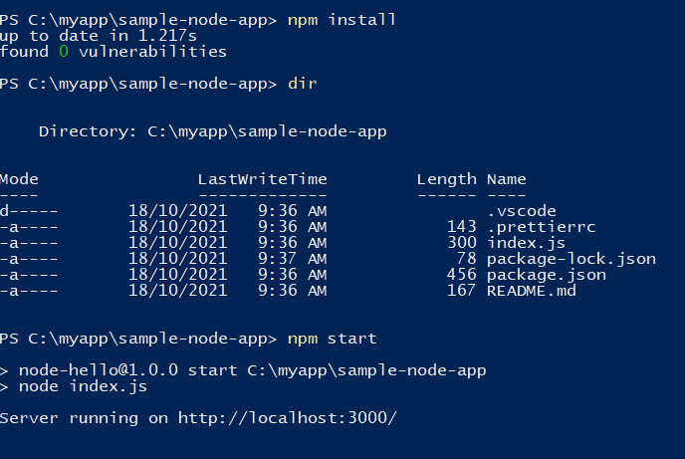

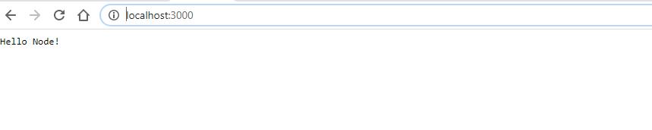

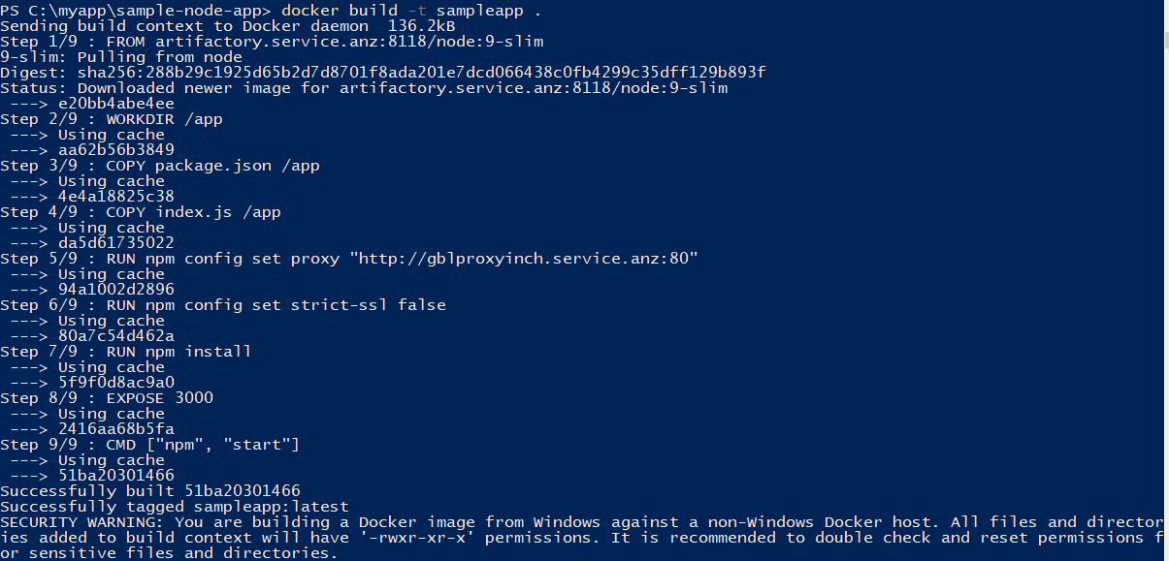

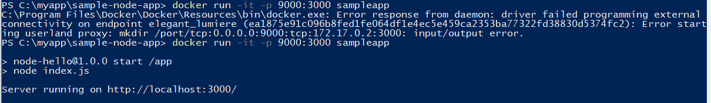

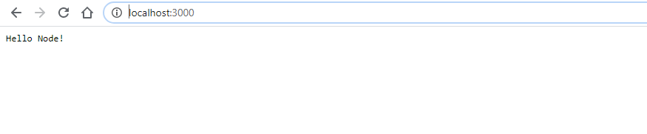

Enable Kubernetes

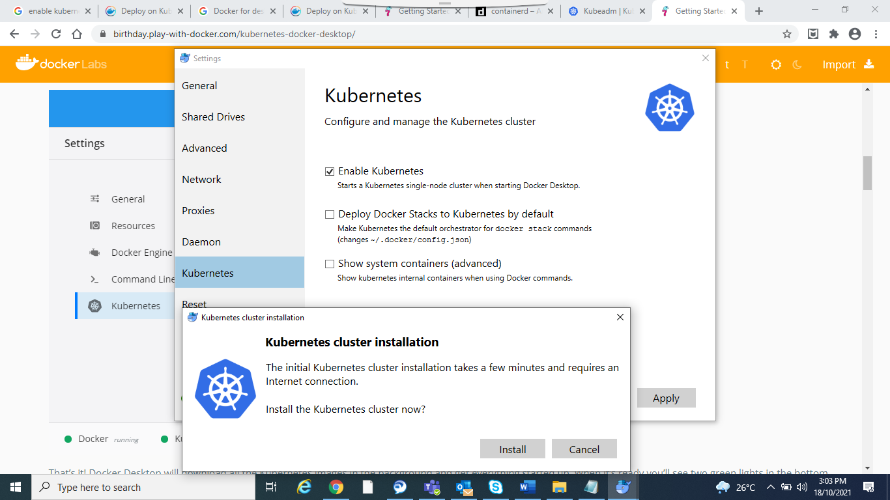

**Check the state of your Docker Desktop cluster:**

kubectl get nodes

**Run a familiar application:**

kubectl apply -f ./deployment.yaml

**Check the app components**

kubectl -n deployment get pods

**To see the ReplicaSet (rs) created by the Deployment,**

kubectl get rs