
FERAL CTF
High-Performance CTF Platform — Architecture & Feature Specification
Rust + SQLite · Single Binary · 1 GB RAM Target · Open Source / Non-Profit


FeralCTF mascot candidates — cyberpunk cyborg squirrel chewing fiber optic cable in a neon-lit cyberpunk cityscape.

1. Project Overview
FeralCTF is a self-hosted Capture the Flag competition platform built for non-profit and academic competitions running on minimal infrastructure. The entire platform compiles to a single statically-linked binary under 15 MB, embeds all frontend assets, and runs comfortably within 1 GB of RAM on a 1-2 CPU system while supporting 200+ concurrent participants.
Design philosophy: zero external dependencies at runtime, zero configuration complexity, and full feature parity with CTFd and Mellivora for small-to-medium competitions.

1.1 Design Goals
- Single binary deployment — copy, chmod +x, run. No Docker, Node.js, Python, or database server required.
- Sub-50 MB RAM baseline; ~150-200 MB under load for 200 concurrent users.
- SQLite with WAL mode for multi-reader, single-writer concurrency — adequate for CTF workloads.
- Static frontend embedded via rust-embed — no CDN dependencies, works fully airgapped.
- Sub-millisecond response for all scoreboard/challenge reads (heavily cached in-process).
- Full CTFd feature parity: dynamic scoring, teams, hints, file attachments, notifications.
- Admin-friendly: JSON-based challenge import/export, no SQL knowledge required.

1.2 Target Deployments
Deployment Type | Users | RAM | CPU | Storage
Small club / university CTF | < 50 teams | 256 MB | 1 vCPU | 2 GB
Regional non-profit (e.g., BSides) | 50-200 teams | 512 MB | 1-2 vCPU | 10 GB
Classroom / workshop | < 30 teams | 128 MB | 1 vCPU | 1 GB
CyberSquirrels CTF | < 100 teams | 512 MB | 2 vCPU | 5 GB

2. Technology Stack

2.1 Backend — Rust
The backend is written in Rust using the Axum web framework (tokio-based async runtime). Key crate selections are optimized for minimal binary size, compile-time correctness, and low memory footprint.

Crate | Version | Purpose | Notes
axum | 0.7.x | HTTP router and server | Tower middleware ecosystem
tokio | 1.x | Async runtime | Multi-threaded, work-stealing
sqlx | 0.7.x | SQLite async ORM/query | Compile-time query verification
rusqlite | 0.31.x | SQLite backup/admin ops | WAL checkpoint, VACUUM
rust-embed | 8.x | Embed static assets in binary | Frontend HTML/JS/CSS baked in
argon2 | 0.5.x | Password hashing | Memory-hard, tunable params
jsonwebtoken | 9.x | JWT auth tokens | HS256 with server-side invalidation
serde / serde_json | 1.x | JSON serialization | Challenge import/export
tower-http | 0.5.x | HTTP middleware | CORS, compression, rate limiting
tracing | 0.1.x | Structured logging | JSON log output
zip | 0.6.x | Attachment handling | Challenge file distribution

2.2 Database — SQLite
SQLite with WAL (Write-Ahead Logging) mode provides excellent read concurrency for CTF workloads. Typical CTF I/O is 95%+ reads (scoreboard, challenge pages) with infrequent bursts of writes (flag submissions). WAL mode allows unlimited concurrent readers alongside a single writer without blocking.
- WAL mode + synchronous=NORMAL — safe, fast, no data loss on crash
- Connection pool: 1 write connection + 8 read connections (sqlx pool)
- All queries compile-time verified via sqlx macros (zero SQL injection risk)
- Automatic WAL checkpoint every 1000 pages (~4 MB)
- Nightly VACUUM and ANALYZE scheduled via internal cron
- Database file < 10 MB for 500-team, 50-challenge competition
Alternative: JSON flat-file backend is provided as a secondary driver for ultra-minimal deployments (workshops, demos) where persistence across restarts is not required. Toggle via FERALCTF_BACKEND=json environment variable.

2.3 Frontend
The frontend is a vanilla JavaScript SPA (no framework dependency) compiled and embedded into the Rust binary at build time via rust-embed. This eliminates CDN dependencies and makes the platform fully airgap-capable.
- Vanilla JS + custom CSS — no React, Vue, or build pipeline required to modify
- Total frontend bundle: < 200 KB uncompressed, < 60 KB gzipped
- WebSocket connection for live scoreboard updates (falls back to SSE, then polling)
- Dark terminal aesthetic by default; light mode available via user toggle
- Fully responsive — works on mobile for on-site competitions

3. System Architecture

3.1 Process Model
FeralCTF runs as a single process. All components — HTTP server, WebSocket hub, background tasks, and cache — run within one Tokio runtime. This drastically simplifies deployment, monitoring, and resource accounting.
feralctf [--config config.toml] [--port 8080] [--db ./ctf.db]

On startup, the binary runs database migrations, loads configuration, starts the Axum HTTP server, and launches background workers: scoreboard cache refresh, submission rate limiter GC, and the WebSocket broadcast hub.

3.2 Request Flow
Layer | Component | Latency Target
TLS Termination | Reverse proxy (nginx/caddy) — not built-in | < 1 ms
Rate Limiting | Tower middleware — per-IP sliding window | < 0.1 ms
Authentication | JWT middleware — validates token, loads user from cache | < 0.5 ms
Route Handler | Axum handler — business logic | < 1 ms (cached)
Cache Layer | In-process DashMap — scoreboard, challenge list | < 0.1 ms
Database | sqlx SQLite pool — only on cache miss or write | < 5 ms
Response | JSON or embedded static asset | < 0.1 ms

3.3 Caching Strategy
- Scoreboard cache: invalidated on each accepted flag submission
- Challenge cache: invalidated on admin challenge create/update/delete
- User session cache: TTL-based, 15 minute expiry with JWT refresh
- Rate limit counters: per-IP sliding window in DashMap, GC'd every 60 seconds

3.4 WebSocket Architecture
A single Tokio broadcast channel serves all connected WebSocket clients. Events (new solve, scoreboard update, admin announcements) are serialized as JSON and broadcast to all subscribers. No external message broker needed.
- Events: NewSolve { team, challenge, points }, Announcement { message }, CompetitionStateChange { started, ended }
- Max 500 concurrent WebSocket connections on 1 vCPU (tested)
- Graceful fallback to Server-Sent Events, then 30-second polling

4. Database Schema

4.1 Core Tables
Table | Key Columns | Notes
users | id, username, email, password_hash, role, team_id, created_at | role: admin | player | spectator
teams | id, name, invite_code, score, last_solve_at | last_solve_at for tiebreaking
challenges | id, title, description, category, points, max_points, min_points, decay_rate, flag_hash, flag_type, author, is_hidden | flag_type: static | regex | dynamic
solves | id, team_id, user_id, challenge_id, submitted_flag, solved_at | UNIQUE(team_id, challenge_id)
submissions | id, team_id, user_id, challenge_id, flag, is_correct, submitted_at | Full log, not deduplicated
hints | id, challenge_id, content, cost_points, challenge_order | cost deducted on unlock
hint_unlocks | id, team_id, hint_id, unlocked_at, points_deducted | Per-team unlock tracking
files | id, challenge_id, filename, storage_path, size_bytes, sha256 | Files stored on disk, path in DB
announcements | id, title, body, challenge_id, created_at, is_visible | Optional challenge link
score_history | id, team_id, score, recorded_at | Sampled every 5 min for graph
sessions | id, user_id, token_hash, expires_at, revoked | Server-side JWT revocation

4.2 Dynamic Scoring Formula
Dynamic scoring (CTFd-style decay) reduces challenge value as more teams solve it:
points = max(min_points, ceil(max_points - decay_rate * (solves - 1)^2))
Default values: max_points=500, min_points=50, decay_rate=12. Produces smooth decay from 500 pts at first solve to ~50 pts at ~6 solves, then clamped.

5. REST API Reference

5.1 Authentication
Method | Endpoint | Description | Auth
POST | /api/auth/register | Register new user/team | None
POST | /api/auth/login | Login, returns JWT | None
POST | /api/auth/logout | Revoke session token | Required
GET | /api/auth/me | Current user info | Required
PUT | /api/auth/password | Change password | Required

5.2 Challenges
Method | Endpoint | Description | Auth
GET | /api/challenges | List all visible challenges + solve status | Required
GET | /api/challenges/:id | Challenge detail + hints + files | Required
POST | /api/challenges/:id/submit | Submit flag (rate limited: 10/min/team) | Required
GET | /api/challenges/:id/hints/:hid/unlock | Unlock hint (deducts points) | Required
POST | /api/admin/challenges | Create challenge | Admin
PUT | /api/admin/challenges/:id | Update challenge | Admin
DELETE | /api/admin/challenges/:id | Delete challenge | Admin
POST | /api/admin/import | Bulk import from JSON/ZIP | Admin
GET | /api/admin/export | Export all challenges to JSON | Admin

5.3 Scoreboard & Teams
Method | Endpoint | Description | Auth
GET | /api/scoreboard | Full scoreboard (cached) | Optional
GET | /api/scoreboard/graph | Score-over-time data for chart | Optional
GET | /api/teams/:id | Team profile + solves | Optional
POST | /api/teams/join | Join team by invite code | Required
GET | /api/admin/teams | All teams with stats | Admin
DELETE | /api/admin/teams/:id/disqualify | DQ team (score zeroed, hidden) | Admin

6. Feature Specification

6.1 Challenge System
- Categories: web, crypto, pwn, forensics, rev, misc, osint, hardware, cloud (configurable)
- Flag types: static (exact match), regex (pattern), dynamic (per-team generated flags via external script hook)
- Multiple flags per challenge (alternate solutions)
- File attachments: uploaded to configurable storage path, served with Content-Disposition
- Challenge unlock dependencies (unlock B only after solving A)
- First blood tracking and notifications
- Challenge tags (MITRE ATT&CK, CVE references, tools used)
- Challenge visibility: hidden (draft) | visible | archived

6.2 Teams & Users
- Solo mode or team mode (configurable per competition)
- Max team size configurable (default: 4)
- Invite-code based team joining
- Email verification (optional, requires SMTP config)
- Spectator role: can view scoreboard/challenges but not submit flags

6.3 Scoring
- Static scoring: fixed point values
- Dynamic scoring: CTFd-style decay (configurable formula)
- Hint penalty: deducted from team score on unlock
- First blood bonus: configurable bonus points for first solver
- Score freeze: freeze scoreboard at configurable time before competition end
- Tiebreaking: teams with equal score ordered by last solve time
- Score rollback: admin can reject a solve and recalculate affected scores

6.4 Admin Panel
- Full challenge CRUD with live preview
- Competition timer controls: start, pause, extend, end
- Submission log with search/filter (team, challenge, correct/wrong, IP)
- IP-based submission analysis for suspicious behavior detection
- Announcement system with optional challenge linkage
- User/team management: ban, reset password, disqualify
- Database backup download (sqlite3 file)
- Resource usage display (RAM, CPU, active connections)

6.5 Anti-Cheat
- Submission rate limiting: configurable per-team and per-IP (default: 10 attempts/minute)
- Exponential backoff after 5 wrong submissions per challenge per team
- Flag sharing detection: same flag submitted by multiple teams within configurable window
- Submission IP logging for forensic analysis
- Challenge flag rotation: admin can rotate flags mid-competition (old flag invalidated)

6.6 Notifications & Events
- Real-time scoreboard via WebSocket (no refresh required)
- First blood announcements broadcast to all connected clients
- Admin announcements (global or challenge-linked)
- Optional Discord webhook integration for first bloods and announcements

7. Deployment Guide

7.1 Minimum Viable Deployment
curl -L https://github.com/yourorg/feralctf/releases/latest/download/feralctf-linux-x86_64 -o feralctf
chmod +x feralctf
./feralctf init # generates config.toml and creates DB
./feralctf --port 8080
First user registered becomes admin. No further setup required.

7.2 Configuration (config.toml)
[server]
port = 8080
base_url = "https://ctf.yourdomain.com"

[competition]
name = "FeralCTF 2026"
start_time = "2026-11-07T09:00:00-06:00"
end_time = "2026-11-08T17:00:00-06:00"
team_mode = true
max_team_size = 4
dynamic_scoring = true
score_freeze_minutes_before_end = 30

[database]
path = "./ctf.db"
backend = "sqlite" # or "json" for ephemeral

[auth]
jwt_secret = "" # auto-generated if empty
session_ttl_hours = 24

[rate_limit]
submissions_per_minute = 10
wrong_attempts_before_backoff = 5

7.3 Systemd Service
[Unit]
Description=FeralCTF Platform
After=network.target

[Service]
Type=simple
User=ctf
WorkingDirectory=/opt/feralctf
ExecStart=/opt/feralctf/feralctf
Restart=on-failure
MemoryMax=768M
CPUQuota=150%

[Install]
WantedBy=multi-user.target

8. Build & Development

8.1 Build Commands
cargo run # dev build
cargo build --release # optimized ~10 MB binary
cargo build --release --target x86_64-unknown-linux-musl # static musl build
cargo run -- migrate # run DB migrations
cargo test # run test suite

8.2 Project Structure
feralctf/
src/
main.rs startup, config loading
config.rs config structs, env var override
db/ connection pool, migrations, schema.sql
handlers/ auth, challenges, scoreboard, admin, ws
models/ Rust structs matching DB tables
cache.rs in-process scoreboard/challenge cache
scoring.rs dynamic scoring formulas
anticheat.rs rate limiting, flag sharing detection
storage.rs file attachment handling
import_export.rs JSON import/export, CTFd compat adapter
frontend/ vanilla JS/CSS SPA (embedded at build time)
Cargo.toml
config.example.toml

9. Security Considerations

9.1 Flag Storage
Flags are never stored in plaintext. The database stores SHA-256(flag + per-challenge-salt). This prevents flag recovery from a database dump.
flag_hash = sha256(flag.to_lowercase().trim() + challenge.flag_salt)

9.2 Password Storage
Passwords use Argon2id with tuned parameters (memory=64MB, iterations=3, parallelism=2) — approximately 300ms per hash on target hardware.

9.3 Authentication
- JWT with HS256, server-side revocation table in SQLite
- Tokens expire after configurable TTL (default 24 hours)
- Admin tokens have shorter TTL (4 hours) and require re-auth for destructive operations
- All admin endpoints log authenticated user + action for audit trail

9.4 Input Validation
- All SQL queries use parameterized statements via sqlx — no SQL injection possible
- File uploads: extension allowlist, magic byte validation, size limits, stored outside webroot
- Flag submissions: length limit (256 chars), stripped of leading/trailing whitespace
- All user-supplied HTML stripped server-side — no XSS via challenge descriptions

9.5 Network Security
- TLS handled by reverse proxy (nginx/Caddy) — not built-in by design
- CORS policy: configurable allowed origins, defaults to same-origin only
- X-Content-Type-Options, X-Frame-Options, Referrer-Policy headers set by default
- Admin panel behind separate rate limiting and optional IP allowlist

10. Full Game Export (JSON)
FeralCTF can snapshot an entire competition — challenges, flags, hints, file manifests, categories, scoring config, and competition metadata — into a single portable JSON bundle. This is the primary mechanism for archiving past competitions and seeding new ones from existing content.

10.1 Export Endpoint
GET /api/admin/export
GET /api/admin/export?attachments=inline # base64-encode files < 5 MB
GET /api/admin/export?attachments=zip # JSON + attachments.zip

10.2 Export Schema
{
"feralctf_export_version": 1,
"exported_at": "2026-11-08T18:00:00Z",
"competition": {
"name": "FeralCTF 2026",
"dynamic_scoring": true,
"score_freeze_minutes_before_end": 30,
"max_team_size": 4
},
"categories": ["web","crypto","pwn","forensics","rev","misc"],
"challenges": [
{
"slug": "jwt-jockey",
"title": "JWT Jockey",
"category": "web",
"description": "The admin forgot to validate...",
"flag": "flag{alg_none_ftw}",
"flag_type": "static",
"flag_case_sensitive": false,
"points": 100,
"max_points": 500,
"min_points": 50,
"decay_rate": 12,
"author": "n0tf0und",
"tags": ["jwt","auth"],
"hints": [
{ "order": 1, "cost": 25, "content": "Think algorithm confusion" },
{ "order": 2, "cost": 50, "content": "Try alg: none" }
],
"files": [
{ "filename": "jwt_jockey.zip", "sha256": "a3f9...", "data": "<base64>" }
],
"unlock_requires": null,
"is_hidden": false
}
]
}
Flags are exported in plaintext. The export endpoint is admin-only and the bundle should be treated as sensitive. Pre-competition exports should be kept offline.

10.3 Export Contents
Field | Included | Notes
Competition metadata | Yes | Name, timing, mode, scoring config
All challenges | Yes | Including hidden/draft challenges
Plaintext flags | Yes | Admin export only — treat as sensitive
Hints + costs | Yes | Content and point costs
File attachments | Optional | Inline base64 or separate ZIP
Challenge tags | Yes | MITRE, CVE, tool references
Unlock dependencies | Yes | Challenge prerequisite graph
Solve counts / submissions | No | Competition data stays in DB
Team scores / user accounts | No | Export is challenge content only

11. Full Game Import (JSON)
The import system ingests a FeralCTF JSON export (or a CTFd-compatible export) and populates the database. Import is additive by default — existing challenges with matching slugs are skipped unless --overwrite is passed. Safe to re-run without duplicating content.

11.1 Import Endpoint
POST /api/admin/import
Content-Type: multipart/form-data
file: feralctf_export.json (required)
attachments: attachments.zip (optional)
overwrite: true | false (default: false)
dry_run: true | false (default: false)

11.2 Dry Run Response
{
"valid": true,
"challenges_to_create": 14,
"challenges_to_skip": 0,
"challenges_to_overwrite": 0,
"attachment_warnings": [],
"validation_errors": [],
"preview": [
{ "slug": "jwt-jockey", "action": "create" },
{ "slug": "baby-rsa", "action": "create" }
]
}

11.3 Conflict Resolution
Scenario | Default Behavior | With overwrite=true
Slug not in DB | Create challenge | Create challenge
Slug exists, content identical | Skip (no-op) | Skip (no-op)
Slug exists, content differs | Skip, log warning | Overwrite with imported version
Attachment file missing from ZIP | Import challenge, warn on missing file | Same
Invalid JSON schema | Reject entire import, no partial writes | Same
Unknown field in JSON | Ignored (forward compat) | Same
CTFd export format detected | Auto-converted via compat layer | Same

11.4 CTFd Compatibility
FeralCTF includes a CTFd import adapter. When a CTFd export ZIP is uploaded, the platform detects the format automatically and maps fields accordingly.
CTFd Field | FeralCTF Field | Notes
name | title | Direct map
category | category | Direct map
description | description | HTML stripped to Markdown
value | points | Used as both points and max_points
type: standard | flag_type: static
type: regex | flag_type: regex
type: dynamic | flag_type: dynamic | Warning flag set — review decay params
flags[].content | flag | First flag used; alternates preserved
hints | hints | Cost and content mapped directly
files | files | Extracted from CTFd ZIP structure
tags | tags | Direct map

11.5 CLI Import
feralctf import challenges.json
feralctf import challenges.json --attachments ./files/ --overwrite
feralctf import challenges.json --dry-run
Recommended workflow: prepare JSON bundle, validate with --dry-run, then import. Competition can be started immediately from the admin panel.

12. UI Reference — Platform Mockup
The following screenshots show the FeralCTF web interface as designed for the initial release. The platform ships with a dark terminal aesthetic by default, using a monospace font throughout for maximum hacker atmosphere. All views are rendered from embedded assets — no CDN or external resources required.

12.1 Challenges View
The main competition interface. Challenges are displayed as cards in a responsive grid, color-coded by category with difficulty indicators, solve counts, and point values. Solved challenges are marked with a corner flag. The category filter bar and search box allow rapid navigation across large challenge sets.

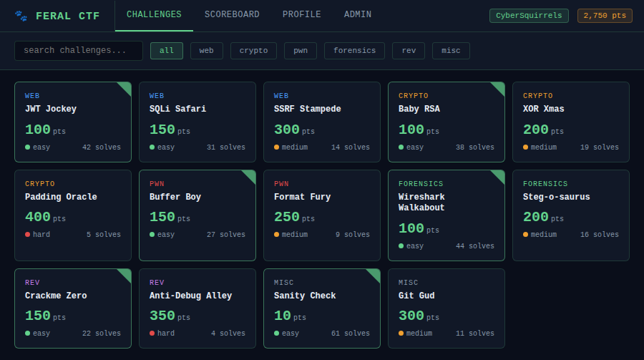
Figure 12.1 — Challenges view. 14 challenges across 6 categories. Green corner flags mark solved challenges.

12.2 Live Scoreboard
Real-time scoreboard updated via WebSocket on every accepted flag submission. Teams are ranked by score with tiebreaking by last solve time. Progress bars give at-a-glance relative standing. The current team row is highlighted.

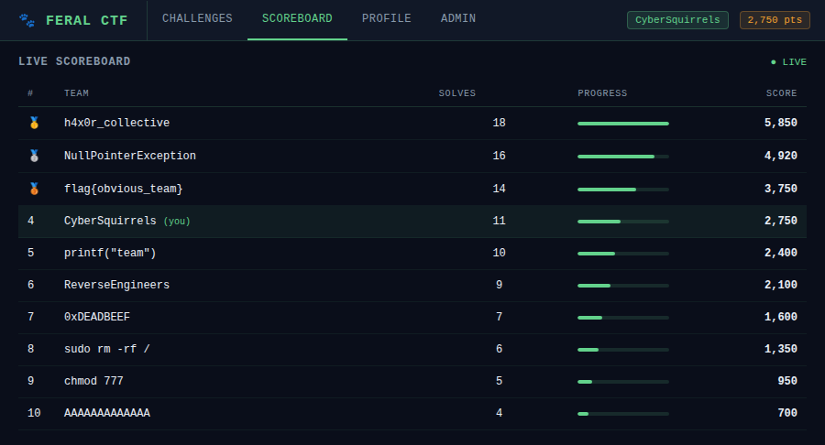
Figure 12.2 — Live scoreboard. Current team highlighted in row 4. Updates in real-time via WebSocket.

12.3 Admin Panel
The admin panel provides a competition overview with live submission stats, full challenge and user management, and competition controls. The overview tab shows a real-time submission log with correct/incorrect indicators.

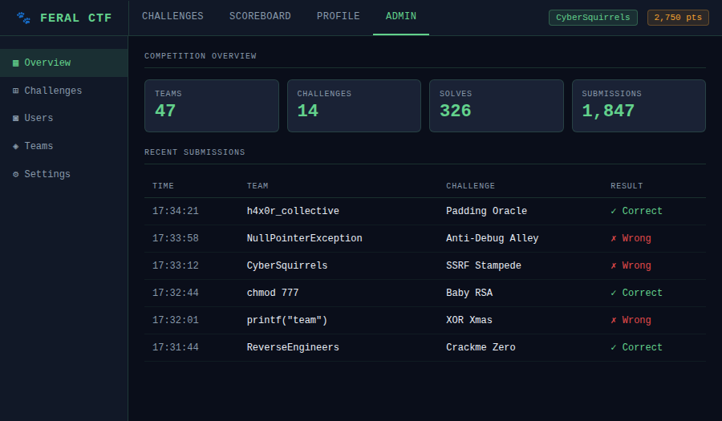
Figure 12.3 — Admin panel overview. Live submission feed showing team, challenge, and result status.

12.4 Mascot Gallery
Four mascot candidates, all featuring the core FeralCTF motif: a cybernetic squirrel chewing through fiber optic cable in a neon-lit cyberpunk cityscape.


Figure 12.2 — All four mascot candidates. Top-left: photorealistic dark alley. Top-right: photorealistic with neon signage. Bottom-left: illustrated style (recommended). Bottom-right: russet photorealistic in rain.

12.3 UI Design Principles
Element | Design Decision | Rationale
Color scheme | Dark terminal (#0a0e1a background, #63d28c accent) | Matches hacker aesthetic; easy on eyes during long competitions
Font | Courier New / monospace throughout | Consistent with terminal aesthetic; readable at all sizes
Challenge cards | Compact grid with category color coding | Fast scanning across 20-50 challenges
Scoreboard | Live-updating table with team progress bars | WebSocket push; no manual refresh needed
Flag submission | Inline modal — no page navigation | Reduces friction; keeps challenge context visible
Admin panel | Split sidebar + content layout | Mirrors familiar admin UI patterns; efficient for ops under pressure
Mobile support | Responsive grid, collapsible sidebar | On-site competitions often use phones

13. Future Roadmap
Feature | Priority | Notes
CTFd challenge import (full compat) | P1 | Covered in Section 11.4
Discord OAuth login | P1 | Common in club CTFs
ARM64 binary (Raspberry Pi / AWS Graviton) | P1 | Via cross-compilation
Per-challenge Docker spawner (netcat services) | P2 | Optional module, not in core binary
TOTP / 2FA for admin accounts | P2 | totp-rs crate
CSV/Excel scoreboard export | P2 | For awards and post-event records
Graph-based challenge unlock dependencies | P2 | Visual tree in admin panel
Writeup submission system | P3 | Post-competition learning
CTFtime.org API integration | P3 | Auto-publish results
Multi-instance SQLite replication | P3 | litestream / Fly.io LiteFS

FeralCTF — Built by defenders, for defenders.
Apache 2.0 License · Contributions welcome · CyberSquirrels CTF Team

