**5C#W**

**SESSION 12 – Searching & Sorting**

**Test Document**

**Author:** Alessandro Ferro

1. Ten student have been created and inserted in an array:

|  |  |  |  |  |  |  |  |  |  |
| --- | --- | --- | --- | --- | --- | --- | --- | --- | --- |
| Ivan | Alex | Giorgio | Bobby | Jayjay | Ector | Donald | Frederick | Carl | Holly |

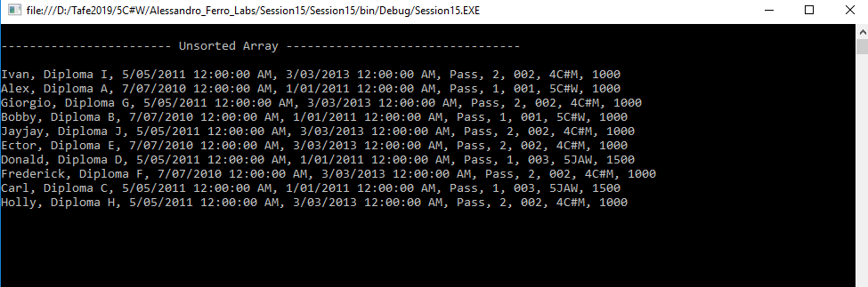

Figure : The array viewed in the Console. Not sorted yet.

1. The program will search for student3 (Giorgio). It is expected to be found at index 2 in the unsorted array.

|  |  |  |  |  |  |  |  |  |  |
| --- | --- | --- | --- | --- | --- | --- | --- | --- | --- |
| Ivan | Alex | Giorgio | Bobby | Jayjay | Ector | Donald | Frederick | Carl | Holly |

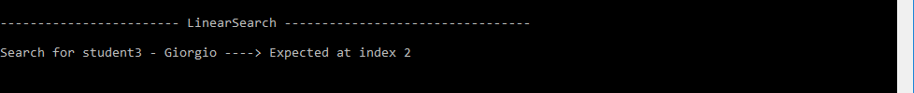

Figure : The program will look for Giorgio

1. Giorgio found at index 2 as expected

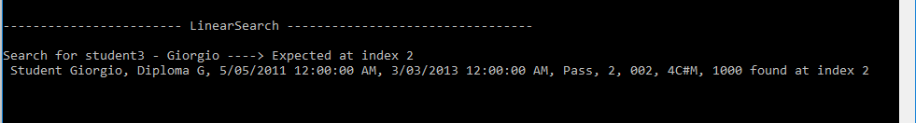

Figure : Giorgio found at index 2



1. The program sort the student in the array by their name using a bubble sort algorithm.

The new array contains the same students, but in ascending order according to their name.

|  |  |  |  |  |  |  |  |  |  |
| --- | --- | --- | --- | --- | --- | --- | --- | --- | --- |
| Alex | Bobby | Carl | Donald | Ector | Frederick | Giorgio | Holly | Ivan | Jayjay |

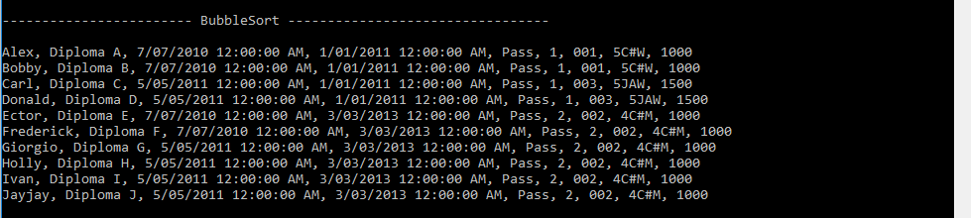

Figure : The array has been sorted.

1. The program will search for Giorgio again, but this time will use a Binary Search. After the array has been sorted, the new index for Giorgio is expected to be 6

|  |  |  |  |  |  |  |  |  |  |
| --- | --- | --- | --- | --- | --- | --- | --- | --- | --- |
| Alex | Bobby | Carl | Donald | Ector | Frederick | Giorgio | Holly | Ivan | Jayjay |

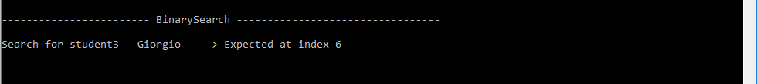

Figure : In search of Giorgio… Again!.

1. Giorgio has been found at the expected index

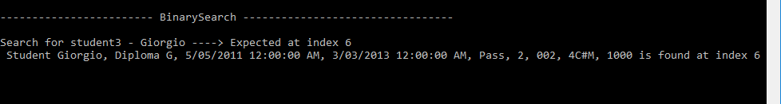

Figure : The Binary Search successfully found Giorgio at the expected index.

1. **Conclusion:** The three methods requested for the assessable lab work as expected and have been successfully tested.