**To connect the SQL Server database you need the SQL Server to recognise your database files.**

1. Install the SQL Server Express 2012 with SP1 **only if** it is not installed in your computer. **Your campus computer should have installed the SQL Server already.**

<https://www.microsoft.com/en-au/download/details.aspx?id=29062>

However, the file is too big for uploading to Moodle. You can download it from Microsoft Website if needed.

1. Install the **SQL Server Management Studio 2012**, **only** **if** it is not installed in your computer. **Your campus computer should have installed the SQL Server already.**

<https://www.microsoft.com/en-au/download/confirmation.aspx?id=29062>

1. In DOS command prompt, run the script (**addselftosqlsysadmin.cmd**) as administrator (i.e. in Window Explorer, right click the .cmd file and choose **Run as Administrator**).
2. Copy the database files (**.mdf** and .**ldf**) into the DATA folder of the SQL Server installation folder.

For 64 bit Windows, the DATA folder is in:

e.g. C:\Program Files\Microsoft SQL Server\MSSQL11.SQLEXPRESS\MSSQL

For 32 bit Windows , the DATA folder is in:

C:\Program Files (x86)\Microsoft SQL Server\MSSQL11.SQLEXPRESS\MSSQL

1. Use Management Studio to attach the database files (.mdf and ldf) into the DATA folder. This is shown as the following:

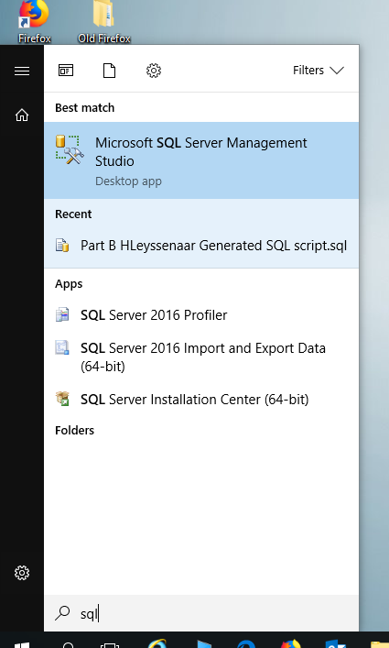

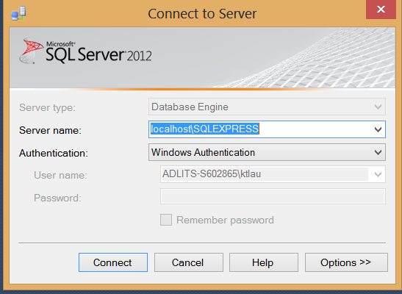

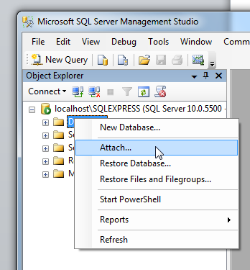

Click **Add, localhost\Express**, database to connect as **Payables** you should be able to see your tables.

Lecturer explains the codes of LINQ. With Open source codes students may have skill gaps, but with the explanation of using example codes, students are expected to come up with similar codes on different forms.