**View Items Page:**

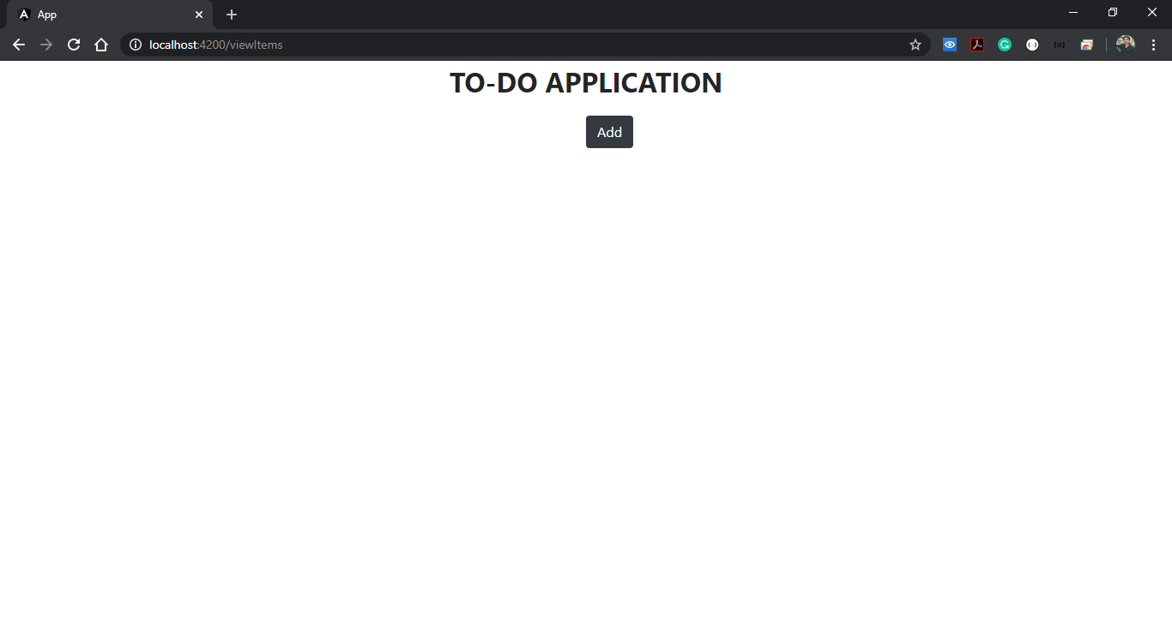

On click of add button a new screen will be shown where user can enter the tile and description.

**Add Item Page:**

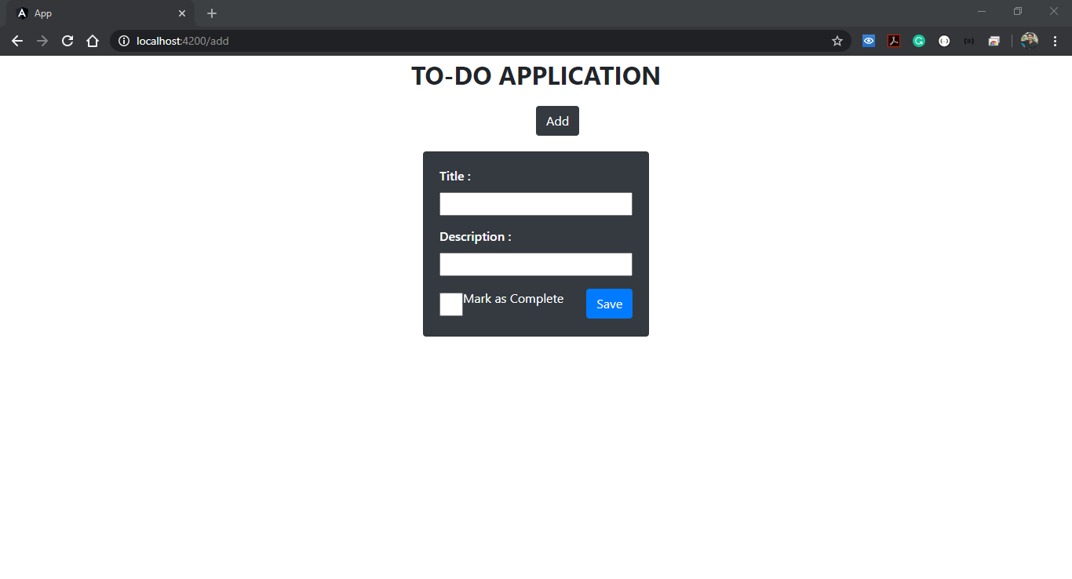

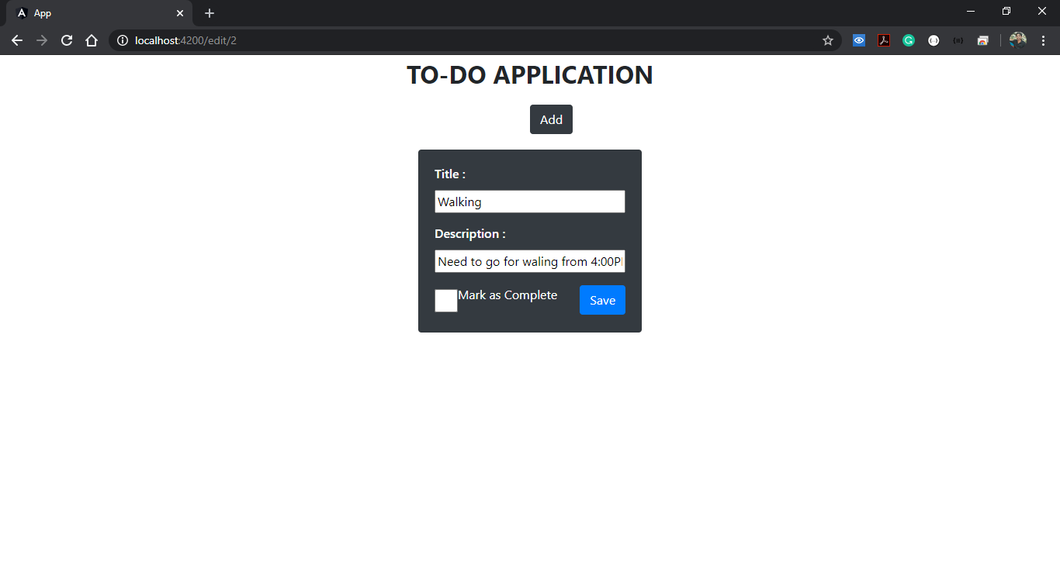

On click of save button user will be redirected to view items page where he can either edit the task or delete the task.

**View Items Page After Adding Tasks:**

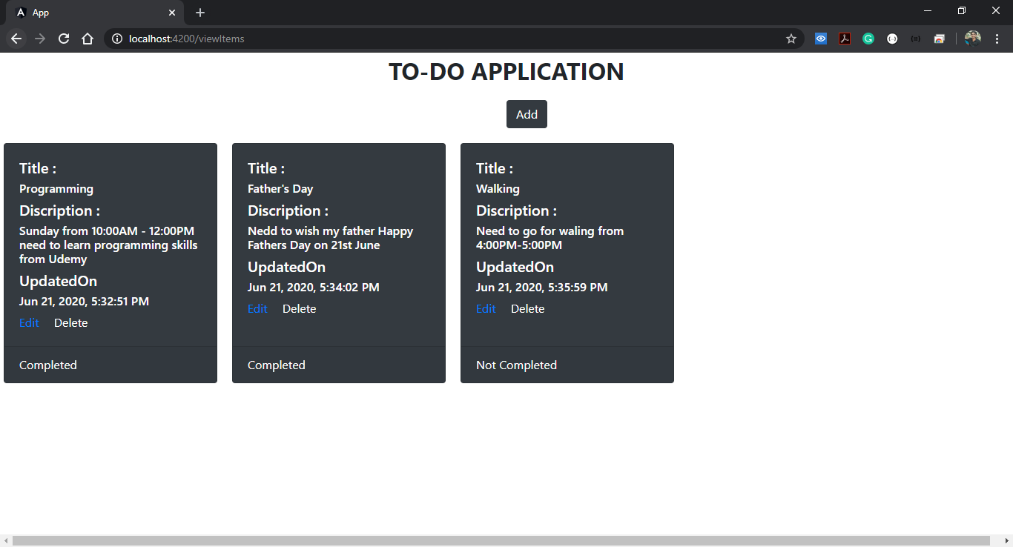

On click of edit button the user will be again redirected to edit page in this case i am editing 2nd task.

**Edit Item Page:**

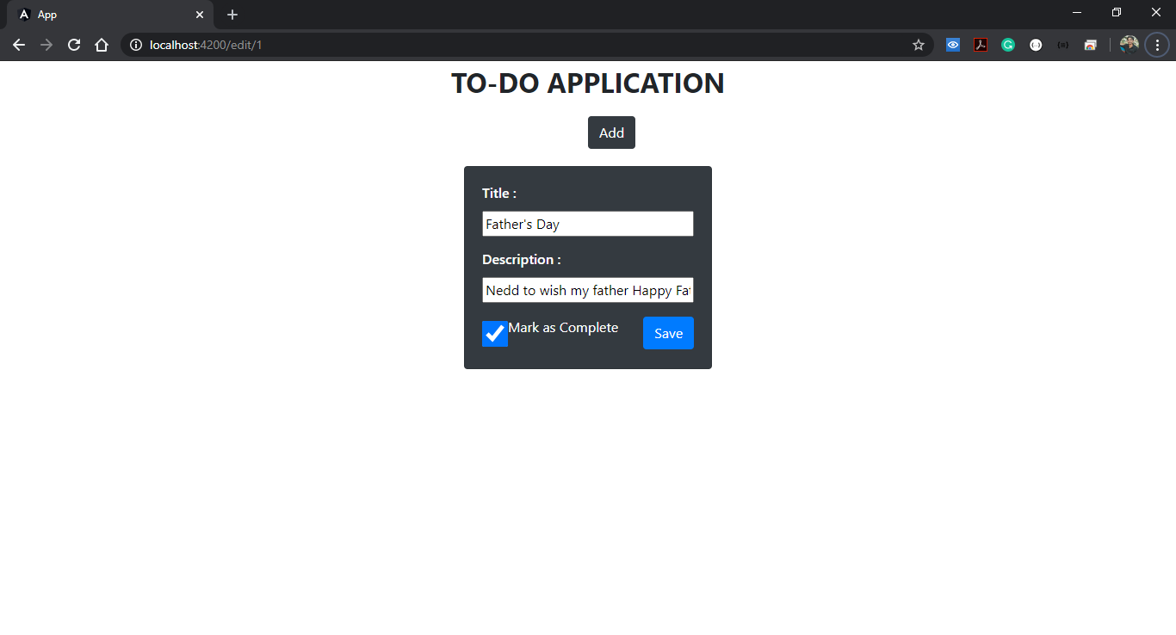

On clicking of save again user will be redirected to view items page.

Now if I try to delete any item from the list I can use delate button. In this case I have delated the last task from the list.

