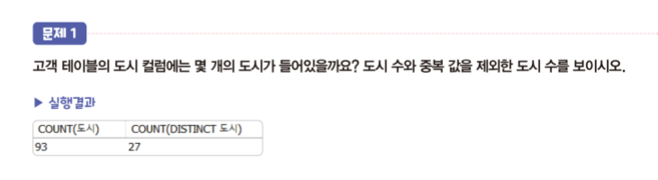



SELECT COUNT(도시)

, count(distinct 도시)

FROM 고객;

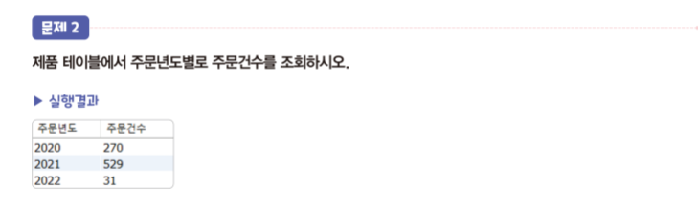



SELECT YEAR(주문일) AS 주문년도

,COUNT(주문일) AS 주문건수

FROM 주문

group by YEAR(주문일);

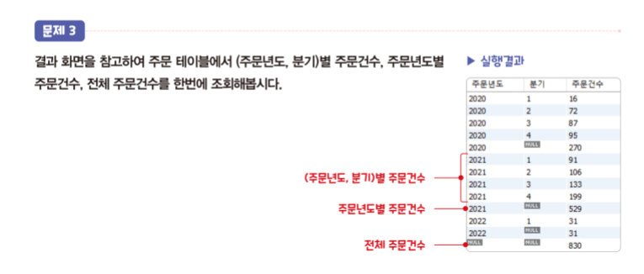

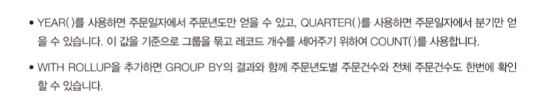

SELECT YEAR(주문일) AS 주문년도

,QUARTER(주문일) AS 분기

,COUNT(주문일) AS 주문건수

FROM 주문

group BY 1, 2

WITH ROLLUP;

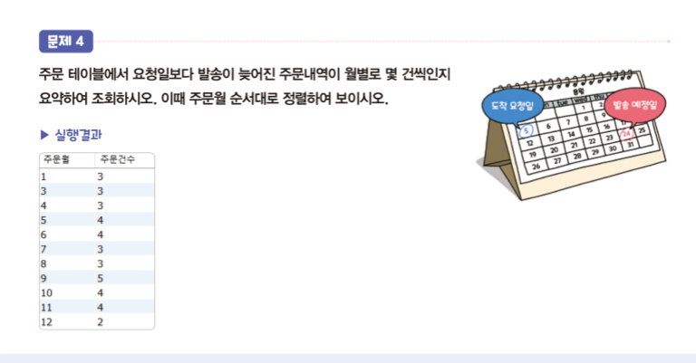

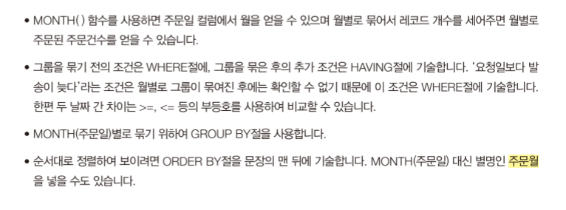

SELECT MONTH(주문일) AS 주문월,

COUNT(\*) AS 주문건수

FROM 주문

WHERE DATEDIFF(발송일, 요청일) >= 0

GROUP BY MONTH(주문일)

ORDER BY MONTH(주문일);

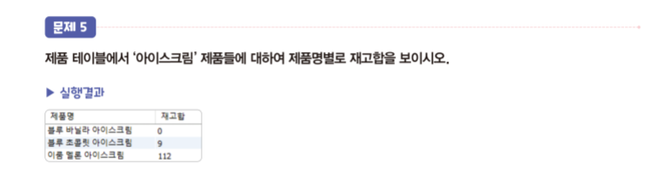

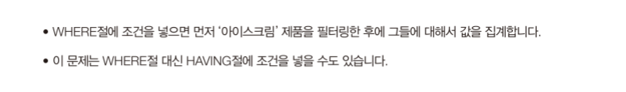

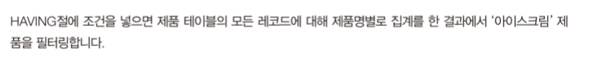

SELECT 제품명, SUM(재고) AS 재고합

FROM 제품

group by 1 HAVING 제품명 LIKE "%아이스크림%";

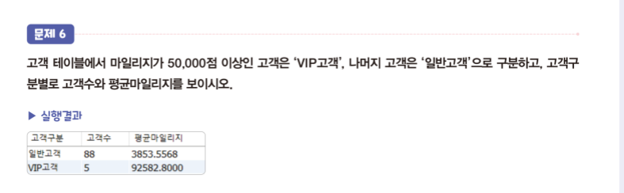

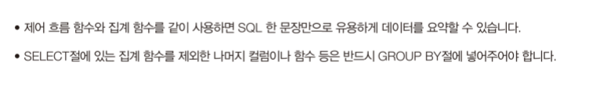

SELECT

CASE WHEN 마일리지 >= 50000 THEN 'VVIP고객'

ELSE "일반고객"

END AS 고객구분

,COUNT(\*) AS 고객수

,AVG(마일리지) AS 평균마일리지

FROM 고객

group by 1;