**Asp.Net-Core-Inventory-Order-Management-System**

Project example Asp.Net Core Mvc implementation of inventory order management system. warehouse, product, vendor, customer, purchase order, sales order, shipment, goods receive and more.[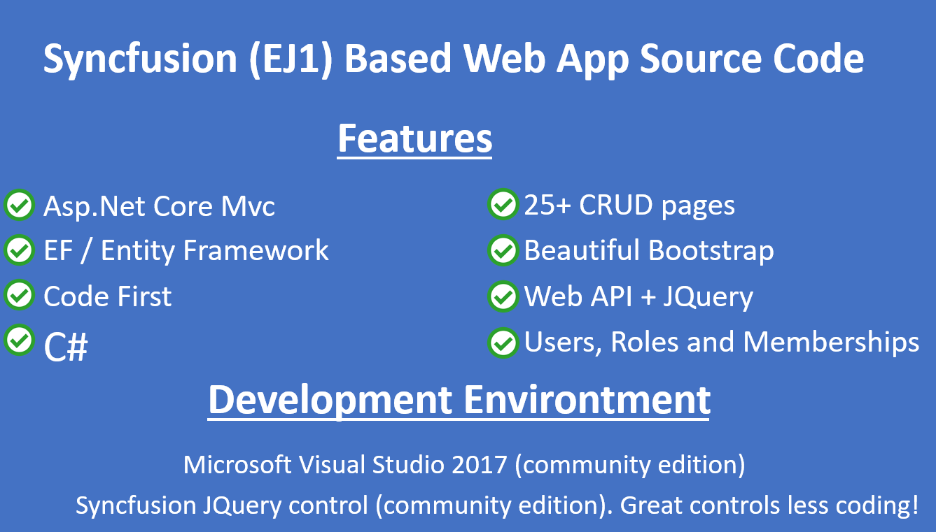](https://github.com/go2ismail/Asp.Net-Core-Inventory-Order-Management-System/blob/master/coderush/wwwroot/images/scm6.png) [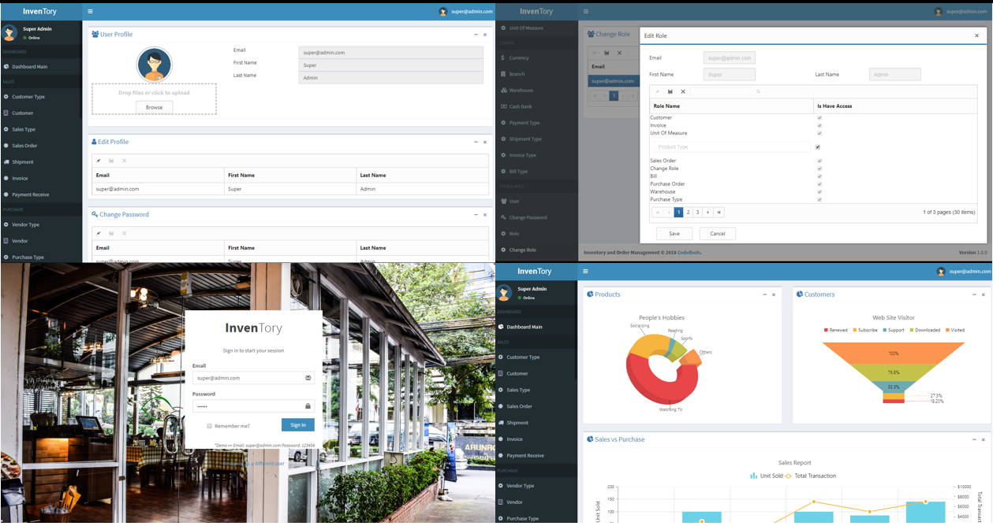](https://github.com/go2ismail/Asp.Net-Core-Inventory-Order-Management-System/blob/master/coderush/wwwroot/images/scm7.png)

**Features**

* Asp.Net Core Mvc
* EF / Entity Framework
* Code First
* C#
* Beautiful Bootstrap
* Web API + JQuery
* SendGrid
* Upload Profile Picture
* Edit Profile
* Change Password
* Users, Roles and Memberships
* 25+ CRUD Forms

**Functional Features**

* Dashboard / Chart Example
* Sales
  + Customer Type
  + Customer
  + Sales Type
  + Sales Order
  + Shipment
  + Invoice
  + Payment Receive
* Purchase
  + Vendor Type
  + Vendor
  + Purchase Type
  + Purchase Order
  + Goods Received Note
  + Bill
  + Payment Voucher
* Inventory
  + Product
  + Product Type
  + Unit of Measure
* Config
  + Currency
  + Branch
  + Warehouse
  + Cash Bank
  + Payment Type
  + Shipment Type
  + Invoice Type
  + Bill Type
* User & Role
  + User
  + Change Password
  + Role
  + Change Role

**Development Tools & Environment**

* **Visual Studio 2017 (Community Edition)**. (<https://visualstudio.microsoft.com/>)
* **Syncfusion JQuery Controls EJ1 (Community Edition)**. (<https://www.syncfusion.com/products/communitylicense>)

**Supported by CodeRush.Co**

[CodeRush.CO] source code collections ([https://coderush.co](https://coderush.co/)). 50% Off All Products, Use Discount Code **GITHUB50**