COCOMEM Jr.

Memory expansion and MMU for the TANDY Color Computer™ 1 and 2 and Dragon Data™ 32/64 and TANO Dragon

# Features

* 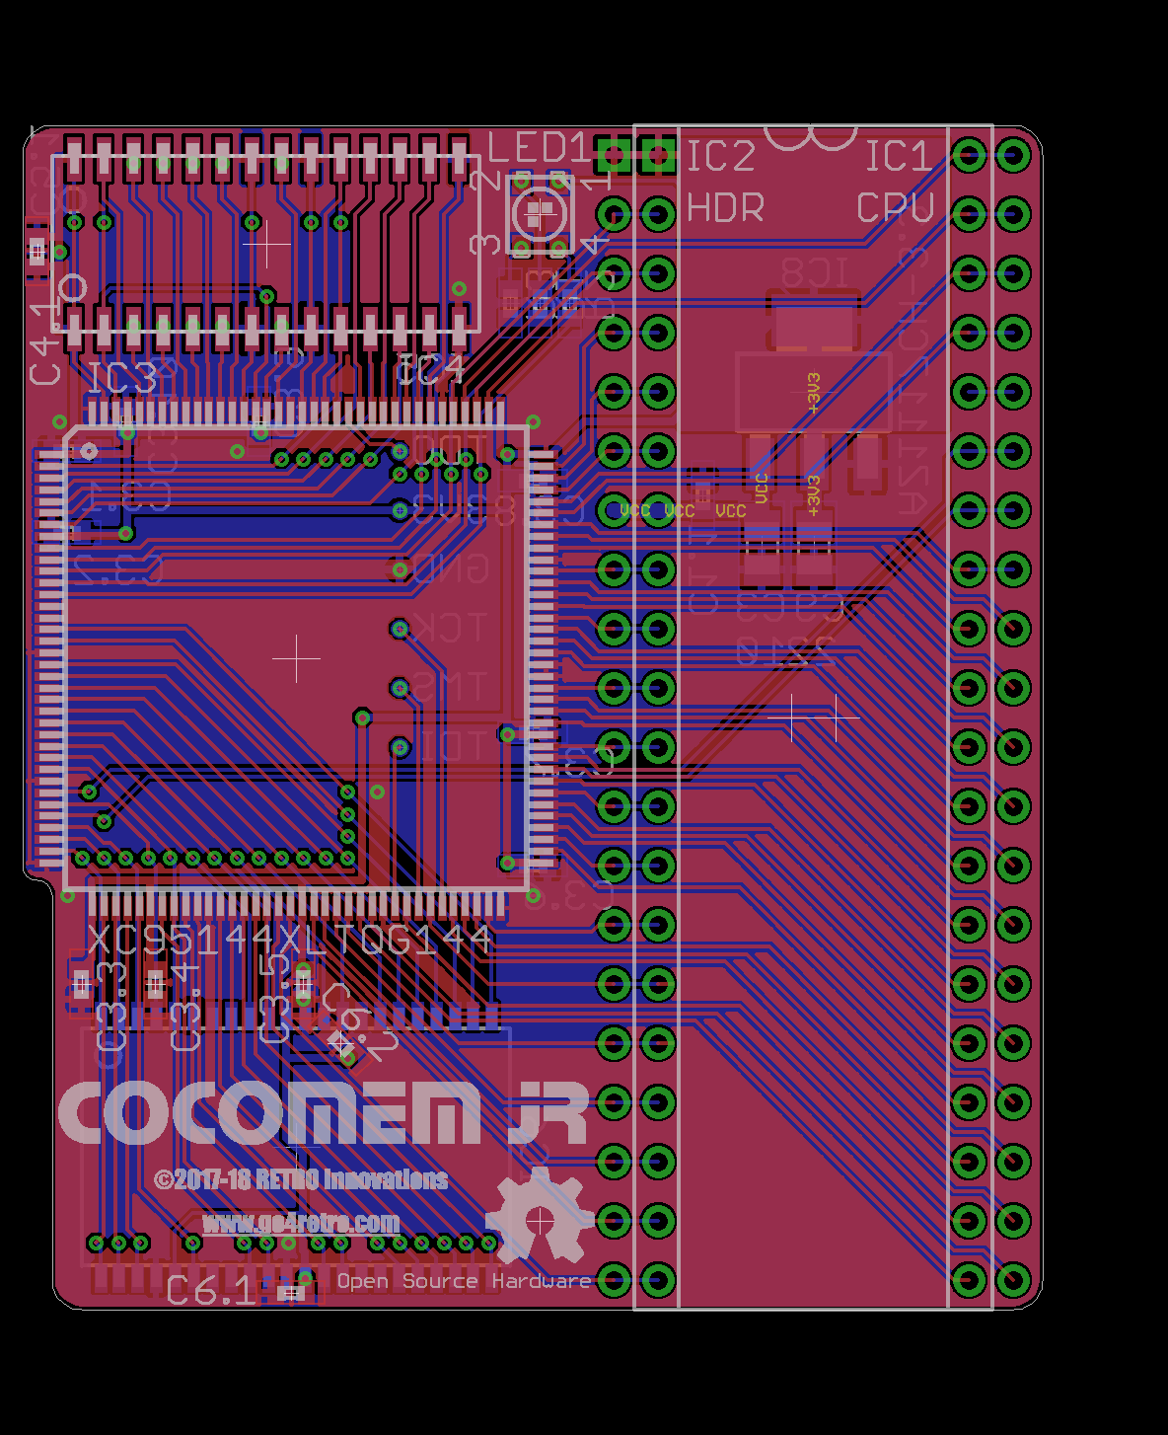2 Megabyte RAM Expansion
* TANDY Color Computer™ 3-compatible MMU
* Installs internal to Color Computer (in CPU socket)
* CocoMEM MMU+ capability (32 tasks, protected memory)
* Internal Color Computer memory can be relocated via MMU

Offered by:

RETRO Innovations

Contemporary Gear for Classic Machines

www.go4retro.com