Recreate childhood game

Stage 1) Game starts automatically, and blocks coming toward the player. The player uses space key to hop, and left and right arrow key to move side to side while in the air.
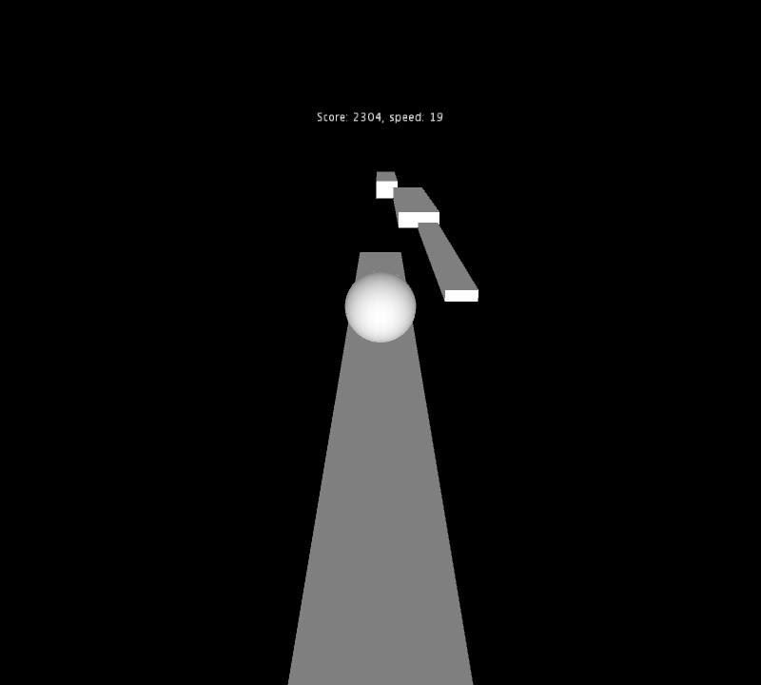

Stage 2) As the player successfully hop from one block to the next, the score and speed gradually increases. As the blocks swooshes by, the player hears the sound of blocks leaving her view.
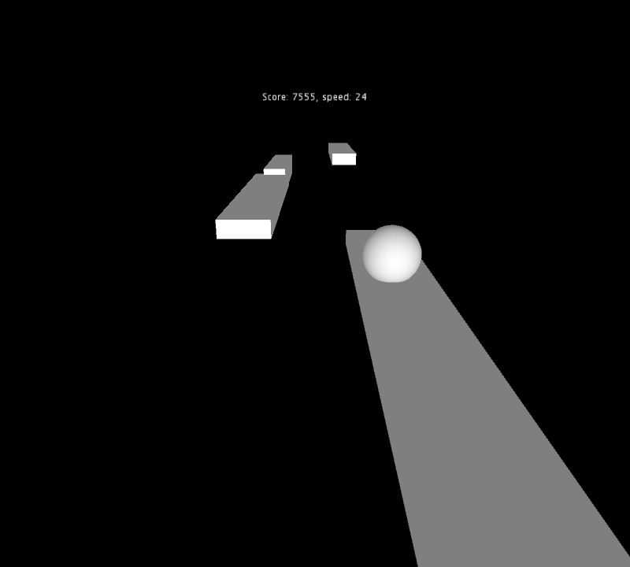

Stage 3) The player misses a jump, the sphere falls out of view, and message “Game Over” is displayed.

