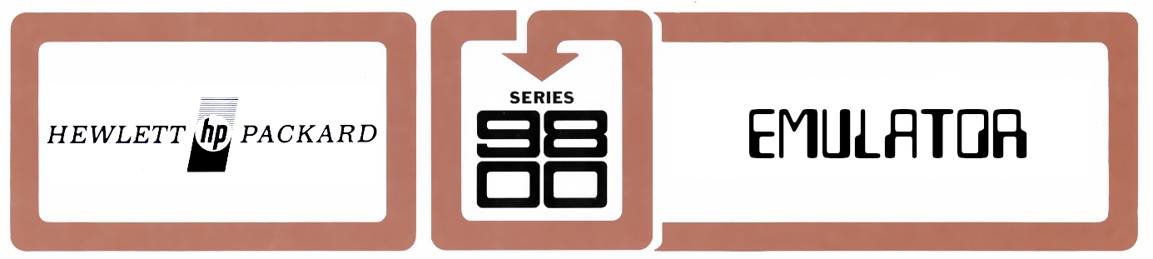

GO9800 – Series 9800 Emulator
Release 2.5
User Manual and Documentation

Copyright (C) 2006-2026 Dr. Achim Bürger

This program is free software; you can redistribute it and/or
modify it under the terms of the GNU General Public License
as published by the Free Software Foundation; either version 2
of the License, or (at your option) any later version.

This program is distributed in the hope that it will be useful,
but WITHOUT ANY WARRANTY; without even the implied warranty of
MERCHANTABILITY or FITNESS FOR A PARTICULAR PURPOSE. See the
GNU General Public License for more details.

You should have received a copy of the GNU General Public License
along with this program; if not, write to the Free Software
Foundation, Inc., 51 Franklin Street, Fifth Floor, Boston, MA 02110-1301, USA.

Disclaimer
GO9800 and the project web site is in no way associated with the Hewlett Packard Company and its subsidiaries.

Hewlett-Packard, HP, and the HP logos are all trademarks of the Hewlett Packard Company. Original software is used in this distribution with permission of the Hewlett Packard Company. This document is intended solely for research and education purposes.

This book was completely written with LibreOffice. All illustrations where created with GIMP.

This book is dedicated to my friend Jon Johnston,
creator and curator of hpmuseum.net,
who died tragically in an accident in April 2016.
Contents
Preface 5
General Features 5

Illustrations

Preface
GO9800 is intended as a complete emulation of the hardware of the famous second family of Hewlett-Packard desktop calculators, i.e. HP9810A, HP9820A, HP9821A, and HP9830A/B.
The emulator is able to run the complete ROM-based firmware of the above models as well as application programs written in the model-specific programming language. Moreover, the user interfaces (display, keyboard, printer), mass memory devices (magnetic card reader, tape drive, disc drive), and other external devices are emulated to recreate the complete functionality of the original systems.
To enhance the realism of the emulation, the appearance of each calculator is graphically rendered and animated, and some of the mechanical sounds (beeper, cooling fan, drive motors, etc.) can be reproduced via audio output.
The emulator is completely written in Java and is platform independent.

General Features
The GO9800 kernel is an emulation of the CPU which was common to all calculators of the 9800-family. All CPU instructions are implemented, including I/O and floating point. The instruction set is briefly described in the U.S. patent 3,859,635. The CPU is emulated on micro-code level, which means that decoding and execution of the instructions is done using the micro-program by the CPU itself. In prior releases (1.x) of the emulator, the instruction set was implemented in JAVA code, based on the (incomplete) description in the above-mentioned patent document. The current micro-code emulation is based on ROM dumps printed in the patent document, and also includes the arithmetic logic unit (ALU). To accomplish this, many hardware elements of the original machines had to be simulated, including all the CPU shift-registers, flip-flops and decoders as well as the eight micro-code and ALU ROMs. The micro-code and CPU are further described in appendix Error: Reference source not found
The CPU emulation also includes the 'I/O-register and gate interface', which decodes and executes CPU I/O-instructions.
The CPU communicates with the memory unit, consisting of read-only memory (ROM) and read/write memory (RWM, today called RAM). The I/O-register is connected to all internal and peripheral devices (display, keyboard, printer, etc.) via the I/O-bus. The complete device I/O protocols are implemented, including service requests (interrupts). Peripheral devices may be attached and detached at runtime.
Peripheral devices work in separate program threads and are rendered in separate windows, so that parallel and real time operation of the calculator mainframe and peripheral devices is possible. The machine firmware, originally residing in ROMs, was extracted from the original hardware and is executed without any modification by the CPU emulation. The ROM areas of the memory are write-protected in the emulator and behave as in the original. Memory is configurable to emulate several memory expansion options. The presence of plug-in ROM blocks can also be configured, and ROM blocks can be exchanged at runtime.
The emulator also contains a complete disassembler, which, when activated, disassembles each CPU instruction prior to execution, dumps the contents of the CPU registers, the I/O register, various flags, and the pseudo registers AR1 and AR2, used for floating point operations in memory. The disassembler can be invoked either interactively or by setting breakpoints or watchpoints in the calculator memory. Disassembler output is displayed in a separate, scroll-able window.
In trace mode, activated either manually in the disassembler window or by a breakpoint, the CPU instructions can be executed step-by-step or in 'slow motion' with variable time intervals.
Disassembly is independent of instruction execution (done by micro-code) and comprises a means for decoding all the micro-instructions which make up a CPU instruction. In this mode the contents of all internal CPU registers A, B, E, M, T, Q, and P as well as the state of the control flip-flops are displayed along with the decoded micro-code.
The user interface is generally keyboard-based, where the key strokes on the host system are translated to the corresponding key codes of the emulated machine. The translation can be visualized at run-time with a graphical key overlay. Additionally, control functions of the emulation, such as window size, sound, and hardcopy, are accessible via drop-down menus.

Part I – Usage of GO9800

Installation and Running
The emulator requires JAVA runtime environment 1.8.0 or higher.
The JAVA runtime may be downloaded from
https://www.java.com/.
The emulator consists of a single JAR-archive, GO9800.jar, which can be placed anywhere in the file system. To run the emulation double-click on the JAR-archive or enter the following command line:
java -jar GO9800.jar

A main application window is opened which contains a menu bar and an emulator console window displaying version and copyright information.
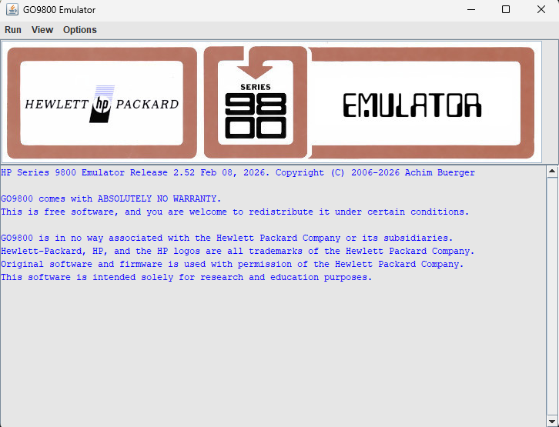Figure 1: GO9800 main application window and emulator console
From the Startup menu, various 9800 series calculator emulators may be initiated. During startup of a specific emulator, various informational messages about configured components and devices are output to the command console.

A typical console output looks like this:
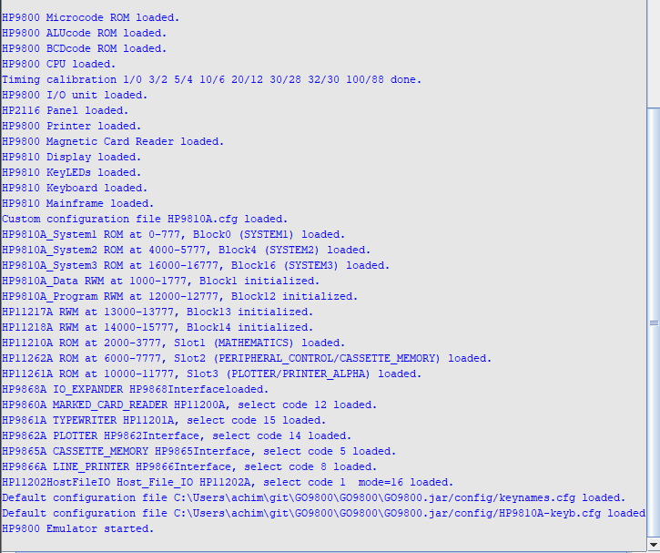Figure 2: HP9810A startup console output

Run Menu

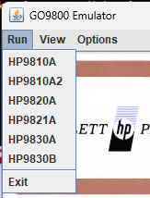
Part I – Usage of GO9800
Installation and Running
Debug-Mode of the Emulator
General Limitations
Know Issues
Emulated Machines
Configuration
Peripheral Devices
Using the GO9800 Console
The HP2116 Control Panel

Part II – Theory of Operation
The HP9800 CPU and Micro-Code
Emulation Speed
Machine Instruction Set
Creation and Execution of Assembler Programs
The Project

