Opener:
title and teaser: 30-40 words

{Main image}


Combine an accelerometer, a gyroscope, an Arduino, and some heavy duty motors together and what do you get? If you follow this guide, you will end up with a ride-able, balancing segway clone (a Seg-bot) for around $500.

Introduction:
1 paragraph or 125 words

The Seg-bot is an attempt to create the experience of a Segway balancing scooter, for less than the asking price of a typical Segway. As with all good DIY projects, this one uses an Arduino microcontroller because it is easy on the bank and so simple to use. From there, we grab a few inexpensive sensors from Sparkfun (a gyro and accelerometer) to measure the angle of our seg-bot, and a Sabertooth 2x25 motor-controller to handle the large power-chair gear motors. Add in a couple of batteries and a few pieces of metal from the hardware store, and you should be in business.

Bio:
2 sentence or 30 words

JD Warren is an electronics tinkerer, ruby (on rails) developer at Isotope11, and author of “Arduino Robotics”. His other projects include various robots, web/radio/infrared control, and home/farm automation.

Overview:

So you probably understand the need for 2 large motors and a motor-controller, but you might be wondering why it is necessary to have both an accelerometer and a gyroscope to determine the angle on the Seg-bot. We'll try to keep this as simple as possible, but the accelerometer can very accurately measure the tilt of the Seg-bot and tell us exactly what angle it is at any given moment... but it suffers terribly from vibrations, bumps, and anytime it is free-falling, causing it to output some very erroneous values (which can cause you to wreck on a Seg-bot). The gyroscope on the other hand can very accurately measure the rate of (angular) rotation, which requires that your starting angle be 0 degrees, and your Arduino must then keep track of every change in rotation to know the actual angle of the Seg-bot (this is prone to error, called “drift”). The gyroscope however, is completely unaffected by vibrations and bumps, and is only affected by actual changes in angle. Thus by combining the two in a clever implementation, you can output a “filtered” angle reading that suffers neither from vibrations that afflict accelerometers, nor the slow but steady “drift” error that hinders the gyroscope. The filtered angle calculated by the Arduino, uses the gyroscope to determine the actual distance traveled each time the sensor is read, and the accelerometer as a stable enough reference point to keep the gyroscope in check. As tested, the filtered angle reading is responsive as the sensor board is tilted, but also unaffected by up/downward motions to simulate vibrations – perfect for the Seg-bot. With the angle reading available to the Arduino, the motor output speed is then calculated proportional to the current angle, also taking into account the value of a “steering” potentiometer that the rider uses to change the direction of the Seg-bot when riding. Oh yeah, there's also a button on the handle-bar that you have to push when riding, to engage the motors on the Seg-bot – if you let go, the Seg-bot stops.

{sensor board closeup}
{motor-controller closeup}
{controls closeup}

List of materials:

- Arduino $30
- Arduino Protoshield $16
- MMA7361 accelerometer (sparkfun #SEN-09652) $12
- LPR530AL gyroscope (sparkfun #SEN-09990) $30
- Sabertooth 2x25 motor-controller $125
- (2) power wheelchair gear motors with wheels $150 (mine were $130)
- (2) 12v SLA batteries $80
- Some metal $25
- Bolts/nuts $8
- (2) 10k potentiometers (Radio Shack #271-1715) $7
- wire $5
- male header pins $2
- female header pins $4
- Main power toggle switch 25A+ SPST (Radio Shack #275-708) $4
- project box (Radio Shack #270-1806) $6
- screw-terminal blocks $4

To put some doubt to rest, you can find good power wheelchair motors on Ebay for under $200/set including wheels with some searching. The set I used on the Seg-bot were $130 including shipping, they came with wheels and the front caster-wheel assemblies that I have yet to use. I have also seen several “broken” power wheel chairs at local thrift stores and on Craigslist for under $100, which usually have perfectly good motors, wheels, and probably most other parts as well. If you don't find something the first time you look, keep looking!

List of tools

- power drill
- reciprocating-saw
- measuring tape
- angle-grinder
- drill-bits
- welder (optional)
- Dremel tool

Sources

- Shane Colton
- John Dingley
- Sparkfun.com/tutorials

Cost: $500 (approximate)

How to Build your Seg-bot:

Once you have acquired all of the parts to build your Seg-bot, we need to start putting things together. We will start with the frame and get a basic shape down, then move to mounting the batteries and potentiometers (for steering and sensitivity) and engage button, then build and install the electronics. Once the Seg-bot is built, we can then upload the code to our Arduino and start testing.

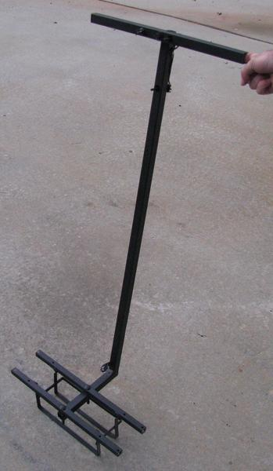

Step 1. Make frame
A. determine motor mounting pattern
This step is probably the most ambiguous one, as the motors that you will find online or otherwise, may not be exactly like the ones that I used. Nearly any power wheelchair (geared) motor will work for the Seg-bot – slight differences the size, shape, and exact specifications of your motors should not keep them from working. The most important thing to look for when building a Seg-bot, is to find a set of motors that have wheels already mounted to the output shafts. Trying to find a set of wheels to fit onto your motors will likely be difficult (trust me), so it is worth a few extra bucks to find a set of motors that come with wheels. Your motors should have a set of mounting holes on the bottom or side, that you can use to secure a base platform to. Once you locate the mounting holes, you can decide the best position in which to place your motors. I determined the best way to mount my motors was facing forward, in order to mount the base platform to the top/rear of each motor.

{photo of seg-bot motors}
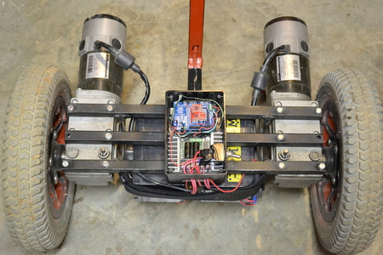

Note: The position of the motors will determine whether or not your Seg-bot will balance by itself. This is not important to the operation of the Seg-bot, my first build will not balance on its own (without some counterweights), but with a rider it balances nicely and is easy to ride. If you want your Seg-bot to balance by itself, it will likely require the gearmotors being pointed upward to avoid a bias in either the front or rear direction.

B. Make a base frame
The base frame is what you will stand on when riding the Seg-bot. I chose to stand on top of my motors and store the batteries between the motors. I measured the width of my Seg-bot base platform to accommodate for the two batteries mounted between the motors. Each battery is approximately 4” wide, so I needed about 10” of free space beneath the base platform, between the motors. Adding in the 4” of mounting space I needed for each motor, my base frame measurement came out to a clean 18”. My motors have three sets of mounting holes spaced evenly apart, so I used three pieces of 3/4” steel square tubing cut to 18” long each to make a base platform. Measure the distance of the mounting holes on your motors, then mark mounting holes on the square tubing. I used the same size bolts as fit into the threaded motor mounting holes (which happened to be 8mm) to secure each piece of square tubing from one motor to the other. Drill holes the same size as your mounting bolts through the square tubing, then mount each piece of the square tubing to the motors using the mounting bolts. When finished, the wheels from both motors should be parallel with each other. You should now have a base frame platform and both motors should be connected together.

    - Mount Batteries
You can either use Lithium or Sealed Lead Acid (SLA) batteries, depending on their cost and availability in your area. I chose to use (2) 12V, 12AH SLA batteries and mount them underneath the base frame platform. The easiest way to hold the batteries beneath the frame was to bend 1/2” steel flat bar pieces (1/8” thick), so they would easily bolt to the bottom of the Seg-bot base. I cut (3) pieces of 1/2” steel flat bar into equal 20” long segments, then bent each piece approximately 5” from each end to a 90 degree angle, forming a “C” shape. Two of these will hang vertically from the base platform to provide a rack for the batteries to rest on, while the third will be mounted to the other two horizontally to provide a front support for the batteries.

{Photo of battery cage}
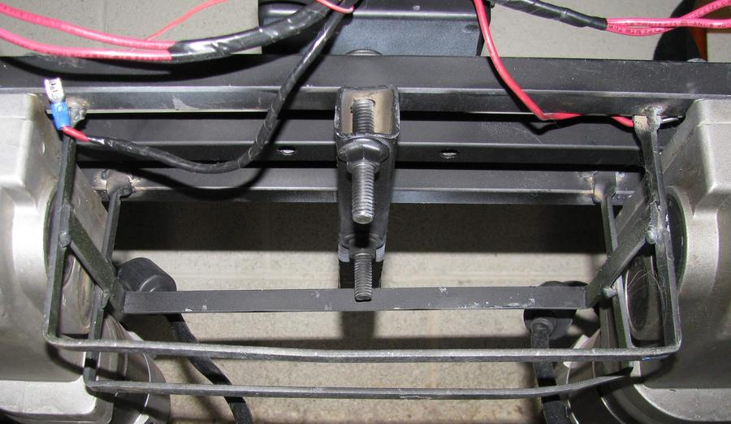

D. Mount handle-bar
The handle-bar is what you will hold on to when riding, so it will need to connect to the base frame that you just built. Because I might be putting some weight on the handle-bar, I decided to use 1” steel square tubing, and make a “T” shaped top to provide a place for both hands when riding. I cut a 72” long piece of 1” square tubing into two pieces – one 52” handle-bar riser and one 20” handle-bar. Drill a hole in the center of the 20” piece and another hole in the top of the 52” piece, about 1” from the end – these will be bolted together using a 3/8” bolt to create the handle-bar.

{Photo of top of handle bar}
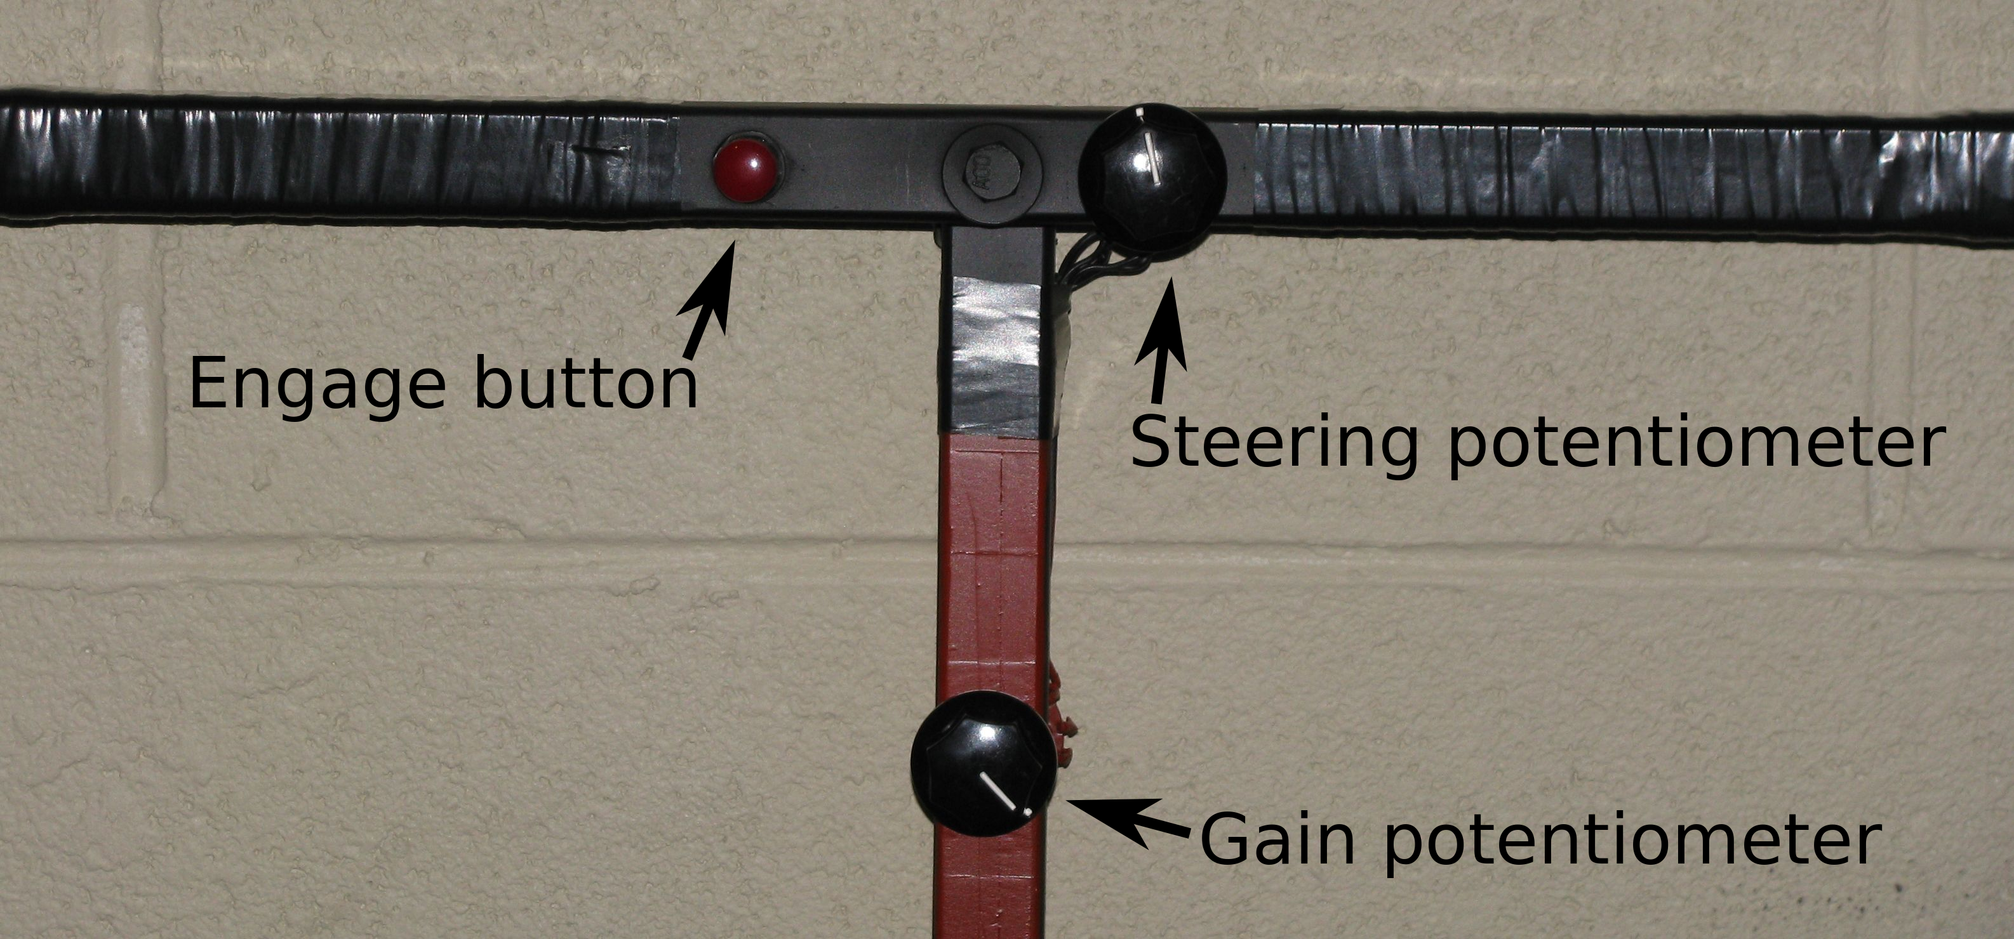
{image from book of “v” cut}
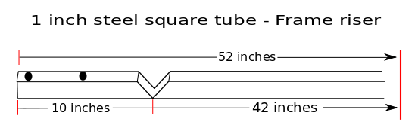

At the bottom of the 52” piece, you will need to make a “V”-shaped cut about 10” from the end so that it can be bent and mounted to the base frame – the amount you cut for this bend will determine the angle of the handle bar for the rider, so cut a little bit at a time until you get the desired angle. You will need to either weld this joint after bending or use a bolt through the two pieces to hold them together and add strength. Lastly, you should mount the bottom end of the handle-bar to the center of the base frame. Measure the distance between the first and last piece of 3/4” square tubing on the base frame and drill two holes on the bottom end of the handle-bar – start 1” from the very end and make your other mark where needed. Now you can use two 3/8” bolts to mount the bottom of the handle-bar to the base frame. This should complete the building of the frame. Time to mount a button and some potentiometers.

Step 2. Mount button and potentiometers
You will definitely need a way to steer your Seg-bot, so a steering potentiometer is in order. I also deemed that an engage button was necessary in order to not cause serious injury to the person riding – if there is no easy way to disable the bot, it would surely get away from you at some point. The Seg-bot will not engage its motors unless the engage button is pressed. Even then, it will not engage immediately, but rather when the user moves the Seg-bot to a “level” position so that there is no jerky movement if the button is pressed when the bot is tilted. There is also a “gain” potentiometer that is used to determine how responsive the Seg-bot is when titled. A beginner will enjoy turning the gain down a bit so it is less responsive to jerky movements from the rider. Once you get the hang of riding your Seg-bot, you will likely turn the gain up all the way and leave it (more responsive = better).

{photo of handle bar buttons/knobs}
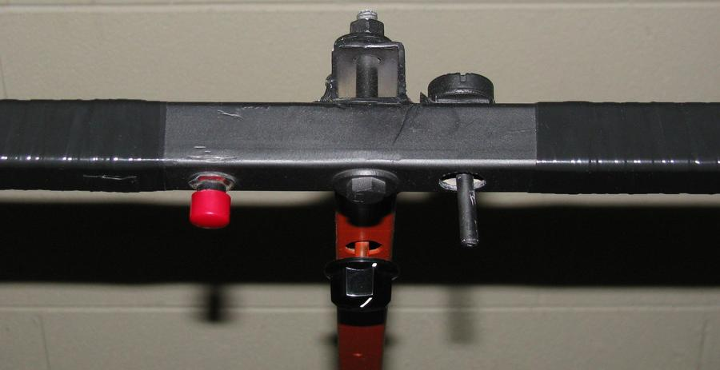

A. drill holes
I chose to mount the engage button on the left side of the handle-bar, about where my thumb would normally rest. I then decided to mount the steering potentiometer to the right side of the handle-bar near where my right thumb would rest – this provides for easy access to the engage button and steering knob when riding. Drill holes for each based on the required size stated on the packaging, then mount the engage button and steering potentiometer to the handle-bar. You will need to repeat this process for the gain potentiometer, though it should be mounted in a less accessible place, like on the handle-bar riser.

B. solder wires to pots and button
After mounting the three inputs, you will need to run the wires from the top of the handle-bar down to the Arduino which will be mounted closer to the wheels. You will need common power and ground wires to run to each switch/potentiometer, and a return signal wire from each sensor, so a total of five wires will be required to go from the handle-bar to the base frame. I didn't want wires hanging all over the Seg-bot, so I chose to run them through the 1” square tubing handle-bar riser from the top down. I cut a small square hole in the 1” square tubing near the bottom using a Dremel tool, in order to pull the wires out and run them to the Arduino.

{Photo of bottom of handle bar with hole cut}
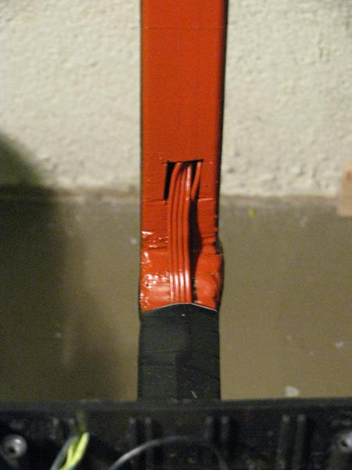

Step 3. Build and Mount Electronics
The easiest way to get your accelerometer and gyroscope connected to your Arduino is to buy a Protoshield and mount the sensors on top of it – you can then plug the shield on any Arduino and it will be connected properly. There is no need to connect every output of each sensor to the Arduino – we will only connect what is needed for our Seg-bot and leave the rest for another day.

A. Build Protoshield for sensors
The accelerometer only needs power (3.3v and GND), the X-axis output connected to Protoshield A0, and the sleep pin attached to D8. The gyroscope only needs power (3.3v and GND) and X-axis output (x4) connected to A1. The Protoshield has solder pads for each Arduino I/O pin, so you can solder wires directly from the sensors to the input pins for a secure connection. To make the sensors portable, I also bought some male/female pin header pairs, and soldered female headers to the sensors and male header pins to the Protoshield – now I can remove the sensors easily and they are not bound to this particular Protoshield, though they are extremely easy to plug in/out as needed. Make sure you always double check the pin labels on the sensors to prevent plugging them onto the Protoshield backwards, which could possibly cause damage.

{photo of protoshield with sensors}
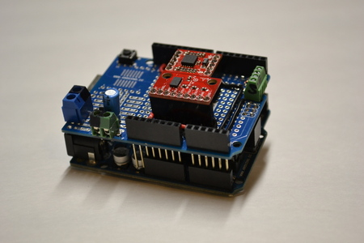
{photo of protoshield with no sensors, show wiring}
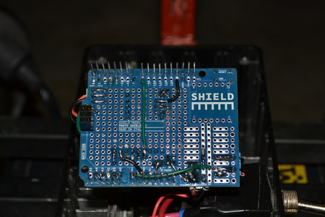

In general, the alignment of gyroscope and accelerometer on the Protoshield does matter. If both of the sensors being used measure both X and Y axises, then you can get away with mounting the sensors however you think they fit best, and then reading the appropriate axis from each sensor (as I did). As I mounted my sensors, I must read the X axis from the accelerometer and the Y axis from the gyroscope to be measuring the same angle. If you would like to read the X axis from both sensors, simply rotate either sensor 90 degrees.

B. Connect power terminals, Aref, and external connections terminal
As you are wiring up the Protoshield, remember to run a wire from the 3.3v power supply pin (from Arduino) to the VCC pin of each sensor and then to the Aref pin on the Protoshield. Likewise, run a ground wire from any Protoshield GND pad to the GND pin of each sensor. Lastly, I added 3 separate screw-terminal blocks to the Protoshield to provide a secure connection from the Seg-bot's sensors to the Arduino. I used (2) 2-position screw-terminal blocks (0.2” spacing) for power - one for the Arduino +12v/GND power wires and the other for the +3.3v/GND voltage reference wires required for the button and potentiometers. The other terminal block is a 4-position but has smaller spacing, using the standard 0.1” breadboard spacing, making it less bulky. This terminal block is used to connect each of the input wires (button, steering-pot, gain-pot) to the Arduino, as well as the Serial interface wire used to connect the Arduino and Sabertooth. Wire each Protoshield input pad (D1, D7, A3, A4) to the 4 pin positions beneath the small terminal block and solder. Then wire each of the power terminal blocks to their appropriate pad on the Protoshield (+12v, GND, +3.3v, GND) – I made use of the GND strip on the left side of the Protoshield and then ran wires to the VIN (+12v) and 3.3v pins.

{closeup of front of protoshield}
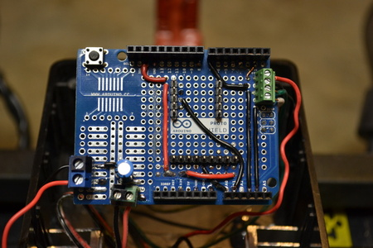

Once complete, you can test your creation by plugging the Protoshield onto your Arduino and uploading the Seg-bot code. You should be able to open the Arduino Serial monitor to see the angle values of the sensors. When you tilt the board 45 degrees to the left, the angle should read “0.45”, and 30 degrees in the other direction should read “-0.30”. Ideally, you would like the two angle readings (gyro and accelerometer) to be in unison or close to it, which will be reflected by the total angle calculation being the same as both sensors, if they are not you may need to do some variable tweaking. One thing I noticed when using different Arduinos with the same sensors, was that the “at rest” voltage of each sensor was slightly different between Arduinos. One reads the accelerometer at 511 and the other at 500 – one reads the gyro at 388 and the other at 391. If these numbers are off in your code, you might have a Seg-bot that isn't quite level, so it is good to check what these values are on your Arduino by opening the serial monitor with your Arduino level, to see what your values are. You can then determine if your values are different than mine, and change them in the code to suit your needs – I call this sensor calibration.

{maybe screenshot of serial monitor}

If you arranged your sensors differently than me, your sensors might be reading in opposite directions, which is no problem, but needs to be compensated for in the code. If your gyro is reading too slow, you might need to adjust the scale variable to make it more responsive. I will address some of the common problems in a chart in the testing section, for now let's move on.

B. Box up Arduino and motor-controller
You will want your Arduino and sensors tucked away from harm's way, so it is best to get a small project box to mount everything important into. The Sabertooth 2x25 has a nice heat-sink built into its casing, so it takes up a bit more room than the Arduino. Radio Shack sells a variety of project boxes, one of which will allow you to mount both your Arduino with sensors and the Sabertooth in the same box. I used small 6mm bolts to mount the Sabertooth to the bottom of one side of the black plastic box, and 4mm bolts to mount the Arduino to the other side. I had to cut a rectangular hole into the side of the plastic box using my Dremel tool to get the motor and power wires to the motor-controller.

{photo of packaged arduino and motor-controller in box}
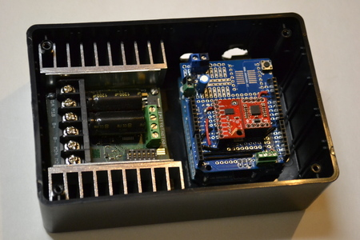

C. Mount box to frame
The project box will also need to be mounted to the top of the base platform using (2) 1/4” bolts, directly in the center. You should still have enough room for both of your feet on each side of the project box. At this point, you can mount the power toggle-switch into the side of the project box. I decided to wrap the metal casing of the switch base with electrical tape to make sure it did not accidentally contact the heatsink of the Sabertooth and short something out. Drill two holes through the bottom of the project box, and through the center piece of 3/4” square tubing on the base frame, using bolts to secure the box to the frame.

D. Set switches on Sabertooth
The Sabertooth 2x25 motor-controller needs a small amount of setup to use with the Seg-bot. The Sabertooth has a small Atmega chip (much like the one used in an Arduino) that is pre-programmed to accept several different input types, depending on the application (analog, R/C, or serial input). There is a 6-position DIP switch on the Sabertooth that, depending on its configuration, will determine how the Sabertooth operates and what type of signal it will look for. We will use the “simplified serial” mode on the Sabertooth as it can directly interface with the Serial port that comes on every Arduino. Simply connect the Arduino serial output (tx) pin D1 to the Sabertooth's S1 input connection, and we can control both motors using a serial data stream. To learn more about the Sabertooth's Simplified Serial protocol, see the product manual from their website:
http://www.dimensionengineering.com/sabertooth2x25.htm

If you are using Lithium batteries, you will need to turn switch 3 off, otherwise to go ahead and set up your Sabertooth for this project, make your jumpers look like the ones below:

{png dip switch image}
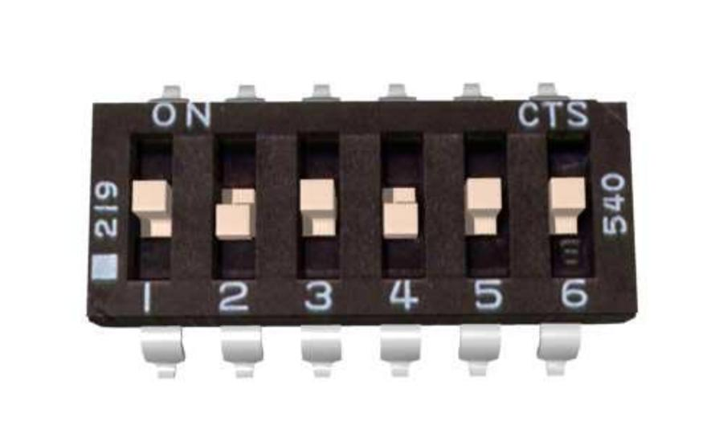

Step 4. Wire it up
A. Connect power and signal wires to Arduino
To connect your Arduino to the Sabertooth and input switch/pots, you will need to follow the schematic. In the schematic, the Arduino should have pin D1 (serial tx) connected to Sabertooth 2x25 input S1. The potentiometers (steering and gain) will need to be connected to analog input pins, I chose A3 and A4. Likewise, the engage button needs to be connected to a digital input pin, so I chose pin D7 to read it.

{png schematic from inkscape}
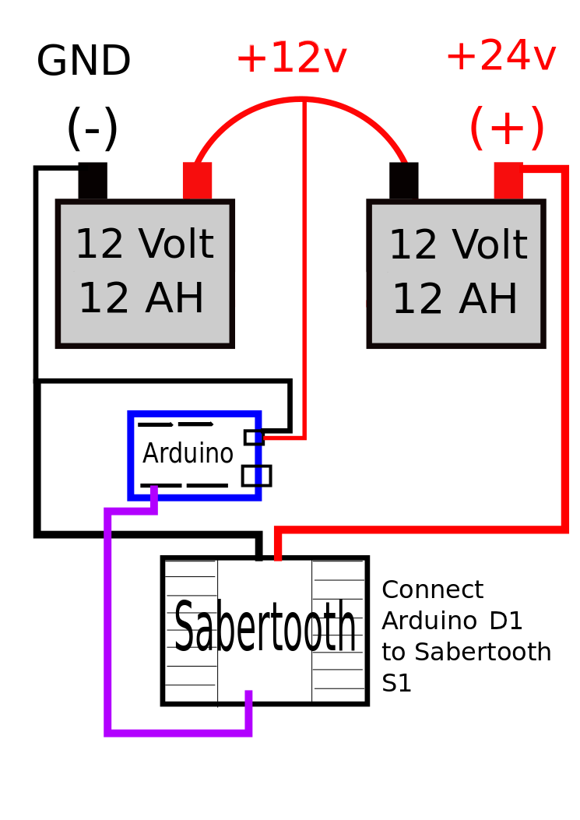

B. Connect motor and battery wires
You will need to connect (2) 14awg (or larger) wires from each motor to the motor-controller at M1A, M1B, M2A, and M2B respectively. You will then need to connect your two 12v batteries in series (connect one battery's negative terminal to the other's positive terminal) to make a single 24v battery pack using the remaining positive/negative terminals, then provide the GND and +24v signals from the battery to the Sabertooth motor-controller. I also connected a smaller “tap” wire to the series connection (to access a +12v source) to power the Arduino with – the datasheet says a 24v supply is too high for the Arduino. I recommend using a 25A-40A fuse in line with the battery Ground supply wire to provide a layer of protection for your electronics.

Step 5. Test
This is the most important step yet, as it will keep you from getting hurt. You need to make sure that you test your fully assembled Seg-bot with the wheels off the ground! I used an old plastic milk crate to set my Seg-bot on, and was able to turn it on and test it without it going anywhere. As it turned out, my motors spun in opposite directions of one another, so I had to reverse the wires of the motor that was spinning in reverse - the motors should spin in the direction that you tilt your Seg-bot. You may have to tweak some variables and reprogram your Arduino several times during testing, so keep a computer handy.

{photo of test segbot on milk crate}
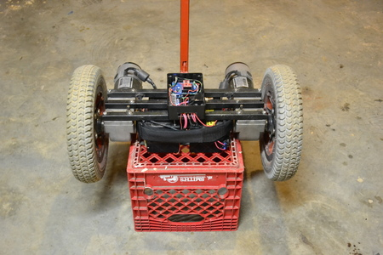

So with wheels off the ground and steering potentiometer centered, turn on the power switch and press the Engage button. You should not see the motors engage until you make the Seg-bot level. Once the motors engage, you should slowly tilt the frame forward to make sure both motors respond smoothly and without jitter, now try reverse. Now try your steering potentiometer to make sure it operates in the correct direction – turn it slowly while tilting your Seg-bot and you should see the motors start spinning at different speeds or even different directions. Make sure that when you tilt the frame forward and turn the steering-pot to the left, that your left wheel spins slower than the right wheel and vise versa. If your steering is reversed, you will need to add a negative sign to your steering variable in the code to fix.

If you are confident that everything is good, you can repeat the test procedure with the wheels on the ground to make sure the Seg-bot responds as expected before attempting to ride. Be careful testing with the wheels on the ground and be prepared to release the engage button (not the Seg-bot!) if you want it to stop moving. If it drives forward when you lean it forward (and vise versa) and it turns left when you steer to the left (and vise versa), then you should be ready to take it for a very careful test drive.

If you are having issues with your Seg-bot, please see this chart of FAQ:
Problem | Possible Cause | Solution
Motor does not respond in the correct direction | Wires are reversed | Reverse wires
Gyro does not respond quickly enough | - Timing calculation is off  - gyro_scale needs tweaking  - reading wrong gyro axis | Set timerVal to be higher than the observed cycle_time value on the Serial monitor, it should be at least 1millisecond higher , but not lower.
Gyro and accelerometer reading in opposite directions | Sensor boards are not aligned the same | Remove negative sign in front of the “-loop_time” variable in the “void sample_gyro()” function.
Steering potentiometer is reading backwards | Power and ground wires are backwards | reverse signs of the two “steer_range” variables in the “void read_pots()” function.
Accelerometer angle value is not correct | Angle mapping is off | Print the “accel_raw” variable to the serial monitor and note the values at 90 degrees and -90 degrees. Change these values in the map command in the “void sample_accel()” function.
Filtered_angle is not responsive enough | Weighted average of sensors is too gyro-rich | Change “gyro_weight” and “accel_weight” percentage variables from 98% and 2%, to 95% and 5%... then test and tweak.
Motors are not responsive enough | Gain set to low or motor values are not responsive enough | Turn up gain potentiometer or change motor out code
Seg-bot does not stay level when turned on | If small amount, sensor board might need slight adjustment, if large amount, sensors need to be re-calibrated | To re-calibrate sensors, place arduino/protoshield on flat table, uncomment calibration code at bottom of sketch, upload code and view serial monitor to see what the accel_offset and gyro_offset should be. Replace the existing variable values with these new observed values, re-comment the calibration code and upload.

Application:

Safety first!
It is best to treat a Seg-bot as a type of power-scooter. If you are not careful or do not understand how it works, it can be very dangerous. This project is not recommended for children or those not physically capable of jumping off of a home-made scooter, should they deem it necessary. The first time you ride one, I recommend wearing a bicycle helmet, just to be safe.

The fun begins when you flip the power switch on the base of the Seg-bot. It doesn't matter if it is perfectly level when you turn it on, as long as you are not pressing the “engage” button the motors will have no power. When you are ready to start riding, press the engage button on the handle-bar with your thumb, and slowly tilt the Seg-bot until you feel the motors engage – which will be when the sensors read no tilt at all. The Seg-bot will engage smoothly and you will then be able to start riding. Slowly step onto the Seg-bot's base and try not to shake or lose your balance. The Seg-bot will respond to any changes in rotation and try to correct its position, so it is best to make slow movements at first, until you learn how to balance comfortably. If at first you feel like you might fall off, simply release the engage button and step off of the Seg-bot (it will stop moving), then try again.

Once you are comfortable standing on the Seg-bot, you should try out the steering knob (opposite the engage button) on the handle-bar, turning the knob with your thumb. As you might guess, turning the knob to the left will make the Seg-bot turn to the left (and vice-versa) - when the steering knob is centered, the Seg-bot will drive straight. Now that you are rolling, you just need to be careful not to go too fast or lose control.

Lastly, keep in mind that the Seg-bot is a powerful and heavy piece of equipment, so be careful operating it around other people or breakable objects.

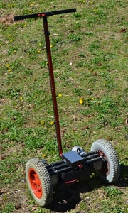
Credits:
photo captions
credits

Label pictures: (finished_product.jpg or step1_1a.jpg)
Use placeholders [insert image step1_1a.jpg here]

