1. For the first assignment, we needed to use curl to post (changing a variable in a form). I changed the header text format to xml instead of txt as can be seen in the two print screens below.

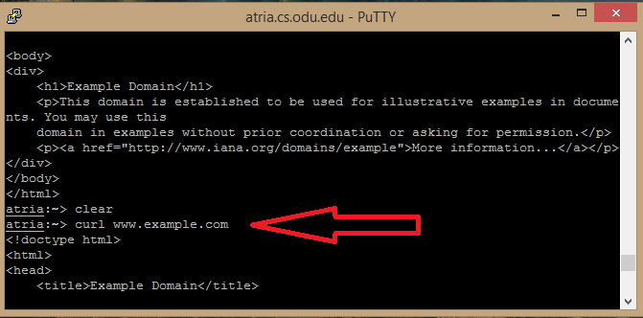

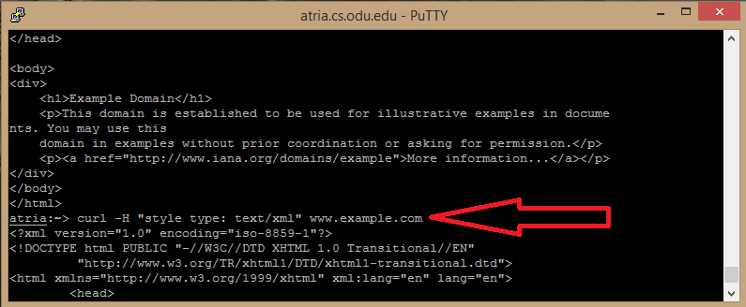

1. The second assignmet called for a python script that extracts links from a webpage, and if those links are pdfs, their byte size should be printed.

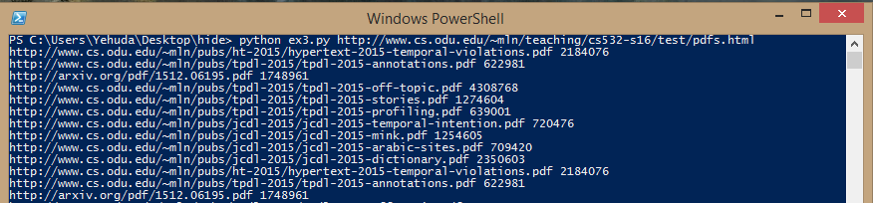

At the time of submission, the program has an error unfortunately- python is printing the names twice. However, the program is able to withstand link shorterners and does not examine whether a url is a pdf based on its name by rather uses requests in order to examine the header of files. It was developed using reading multiple stackoverflow posts, the requests library page, and Or Rahamim, a family member of mine in The Technion, Haifa, Israel, who suggested I abandon the standard urllib2 and use beautiful soup and requests.

3

|  |
| --- |
|  |

IN: 5 POLCB

SCC: 4 AGDH

OUT:1 I

Tendrills:3 JKN

Tubes:0

Disconnected:2 EF