Guthrie Alexander

CS 6316- Machine Learning

HW6

Question 1

1.1

|  |  |  |  |
| --- | --- | --- | --- |
|  | Selected Features | Iterations | Test loss |
| Circle | X1^2, X2^2 | 1750 | 0.000 |
| Exclusive Or | X1X2 | 3662 | 0.000 |
| Gaussian | X1, X2 | 135 | 0.000 |
| Spiral | X2, sin(X2) | 1500 | 0.486 |

Circle:

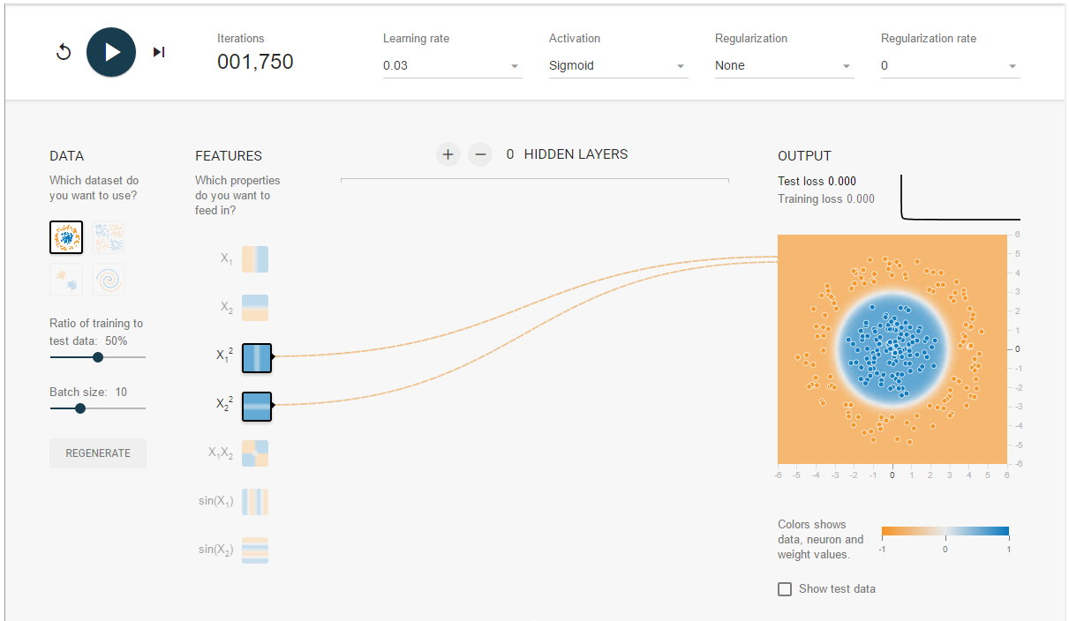

X1^2 and X2^2 worked the best, I think because of how the features were aligned. Other combinations with those two features worked, but they always rely on those two features to reach an ideal test loss. This is due to these two features being a quadratic new feature of the original feature sets.

Exclusive Or:

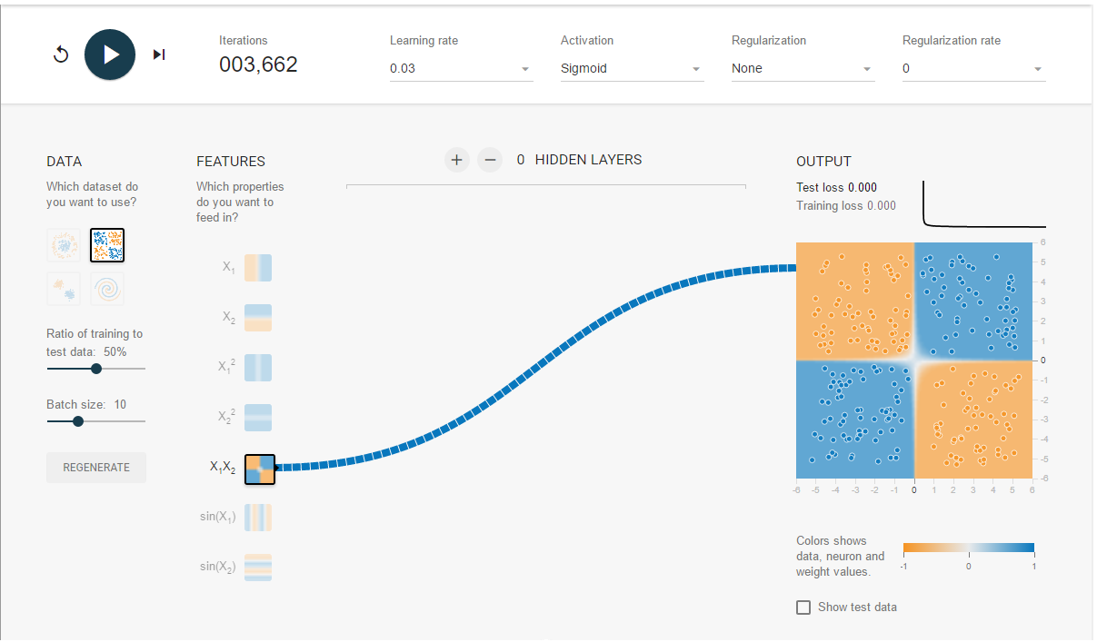

X1X2 was a good match, simply by looking at the way the points were distributed. It makes sense that none of the other features were needed. This is simply because of the nature of how multiplying the two features to get a new phi() feature set works.

Gaussian:

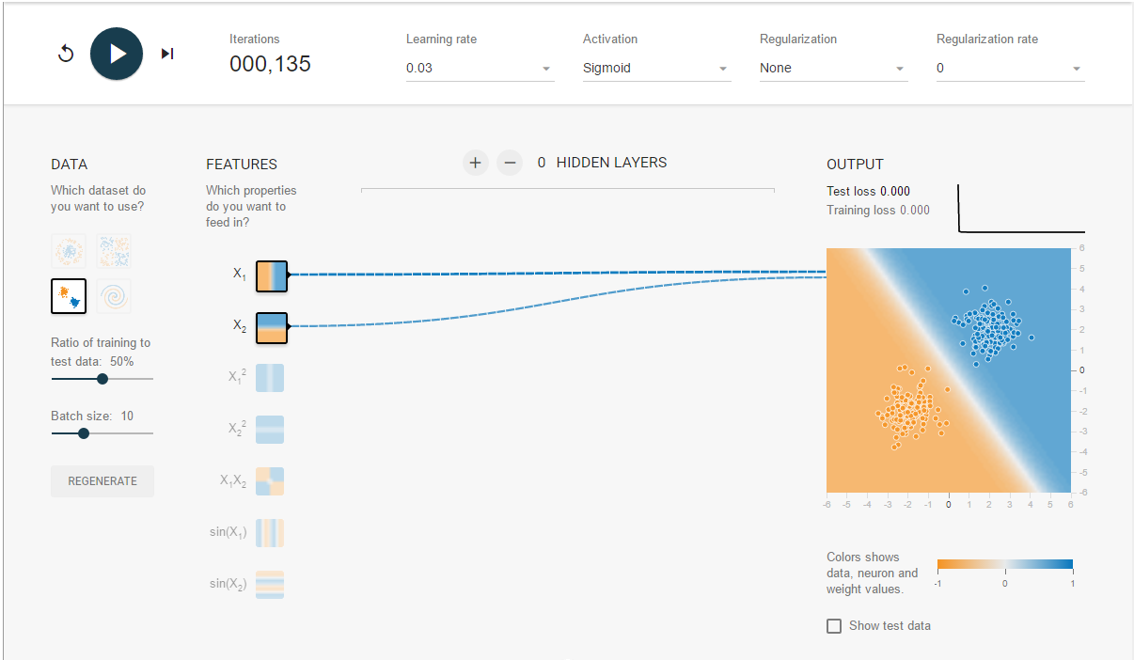

The overlap for positive/negative data points in the two features allows this model to quickly find a boundary line between the two data regions.

Spiral

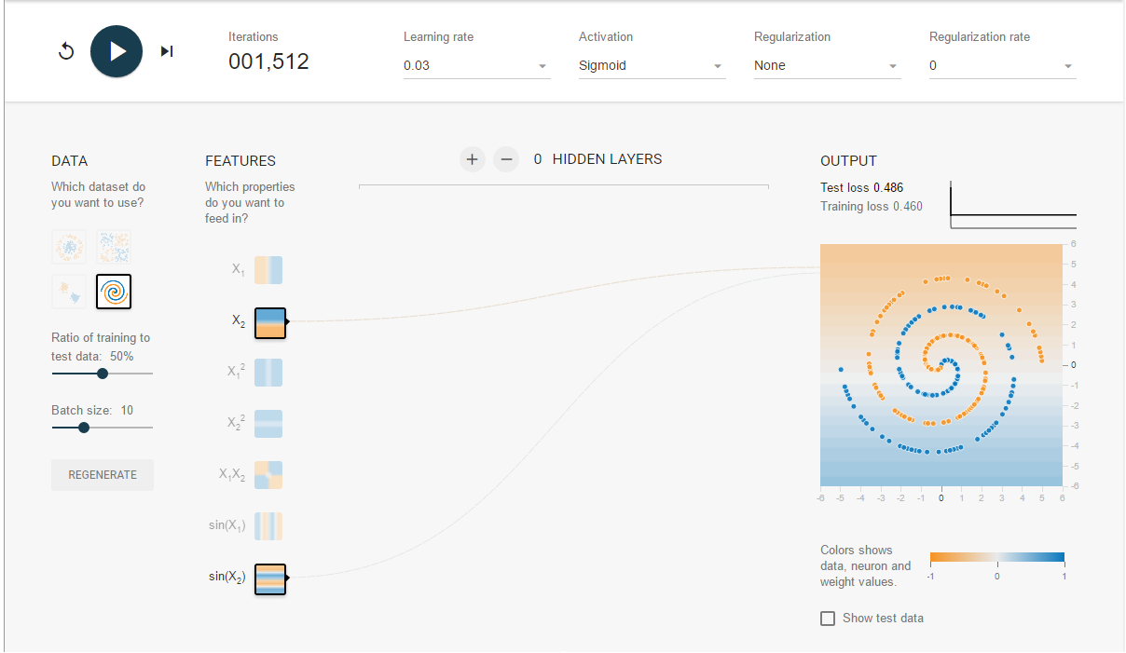

There was no combination of features that allowed for good classification of these data points. This was the best I could do just with a perceptron model (i.e. 1 layer model). The complexity of the data set requires a more complicated model based on more than just a simple perceptron model.

1.2 Regularization

~1000 iterations

|  |  |  |  |
| --- | --- | --- | --- |
|  | No regularization | L1, rate = 0.1 | L2, rate = 0.3 |
| Circle | 0.001 | 0.002 | 0.003 |
| Exclusive Or | 0.001 | 0.004 | 0.014 |
| Gaussian | 0.001 | 0.003 | 0.004 |

**Circle:**

No regularization:

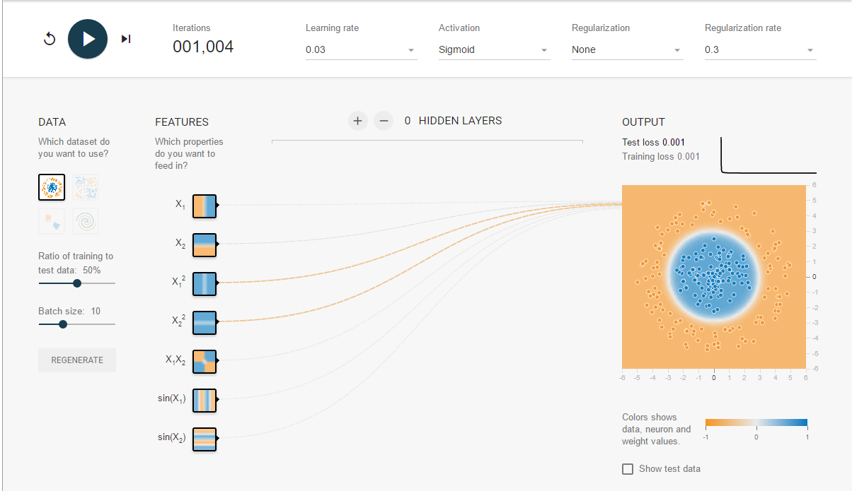

L1 regularization:

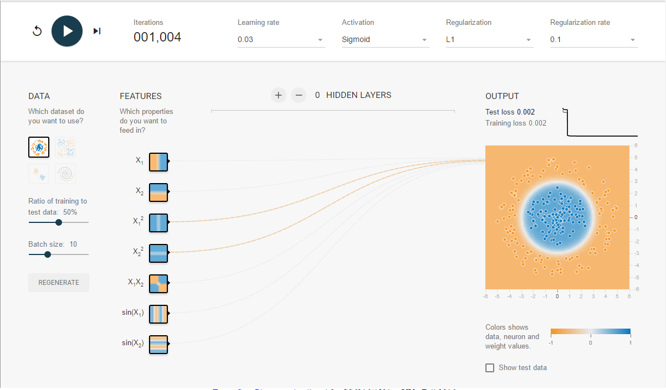

L2:

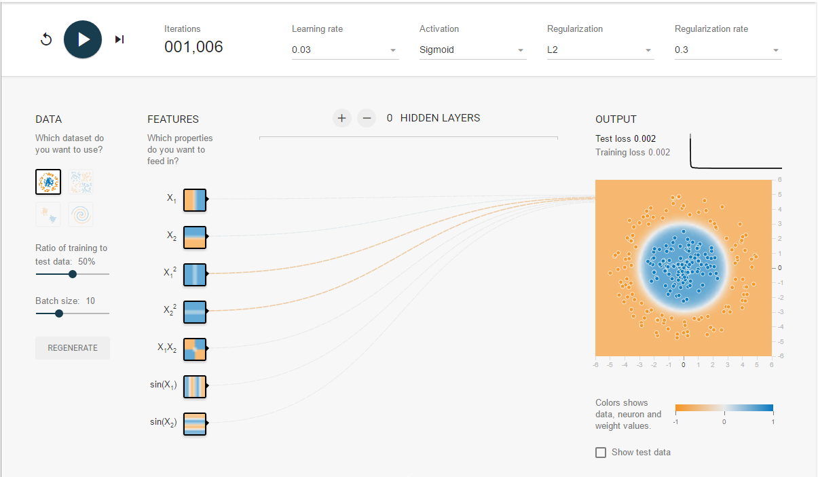

Circle Models: Non regularized works the best because the boundary lines neatly bisect the two different classes, and regularization is not needed, and only creates situations where points are not classified correctly.

Task B (Circle)

Looking at the L1 model, you can see that X1^2 and X1^2 have higher weights than the other features for the Circle Data set. These are the same as my selection in 1.1.

Data Weights  
X1^2: -0.29

X2^2:-0.29

**Exclusive Or**

No regularization:

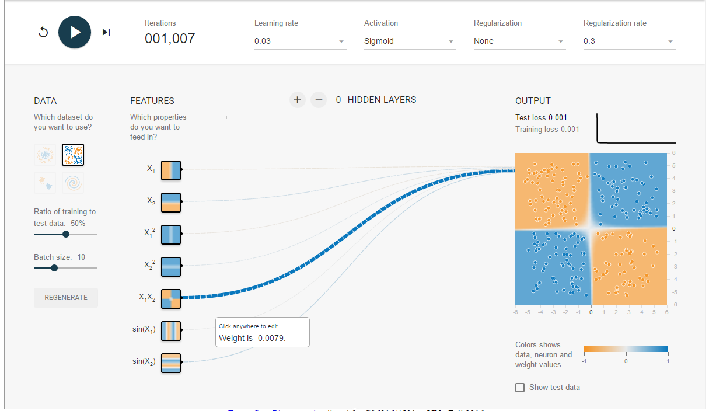

L1:

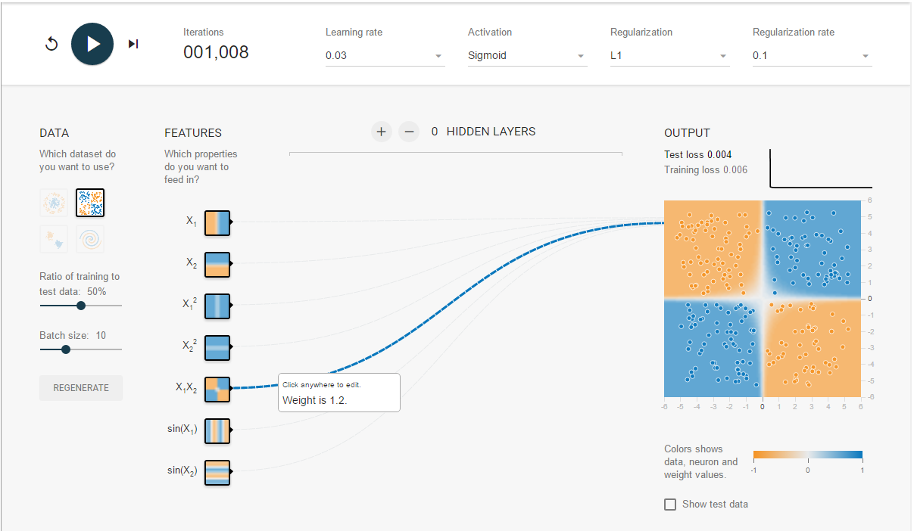

L2:

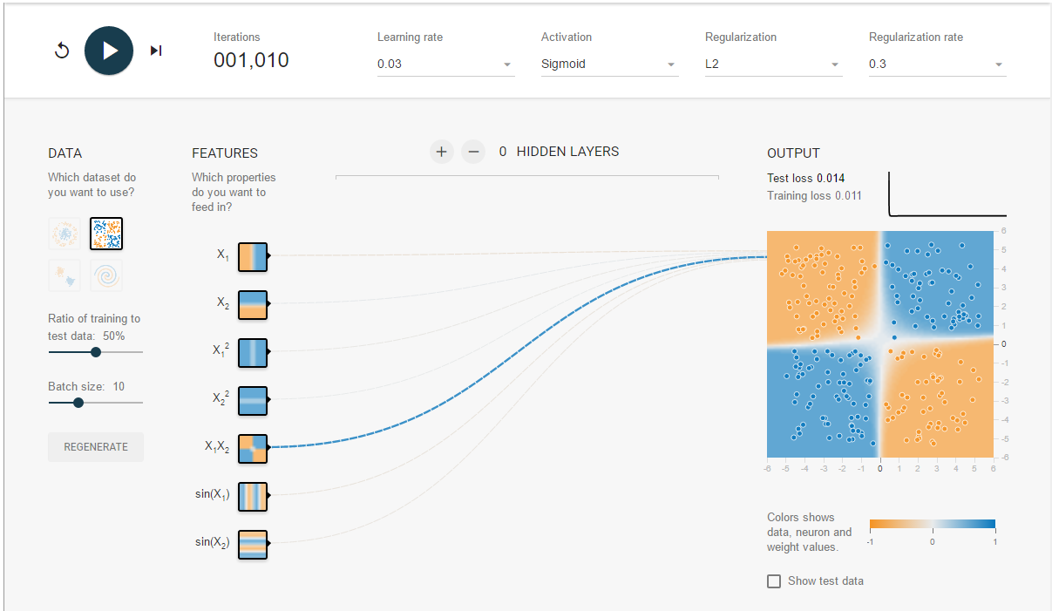

Exclusive Or models: Non regularized works the best again because the boundary lines neatly bisect the two different classes, and regularization is not needed, and only creates situations where points are not classified correctly.

Task B (Exclusive Or): As you can see, the X1X2 feature is the one weighted the highest after L1 regularization, which is the same feature I picked in 1.1

Weight (X1X2): 1.1

**Gaussian:**

No regularization:

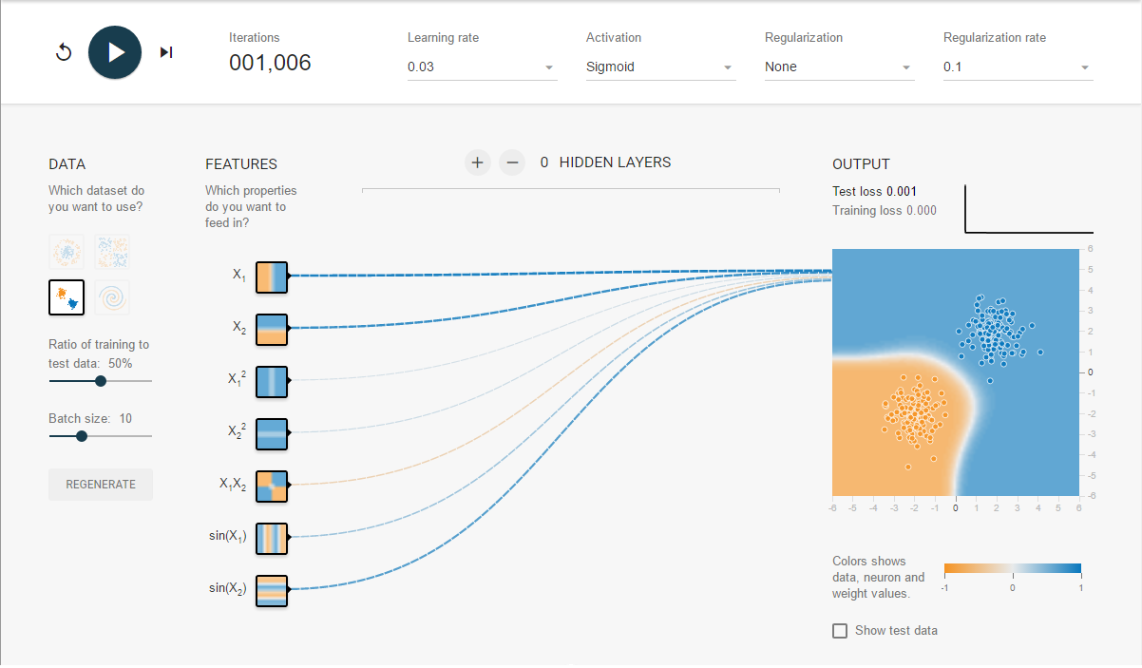

L1:

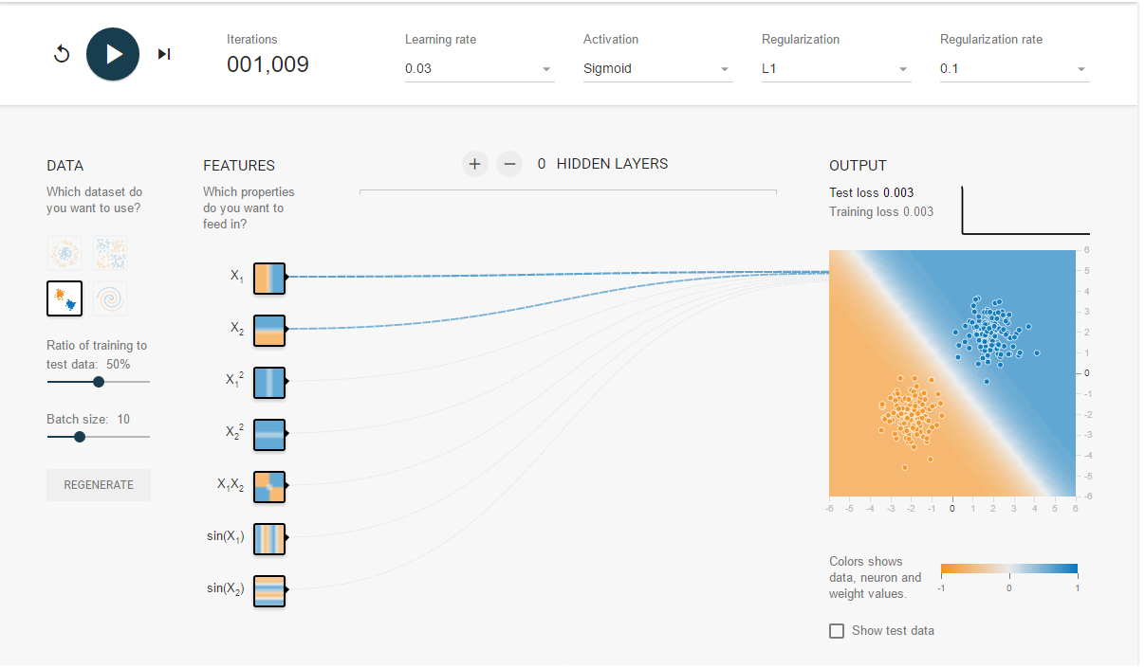

L2:

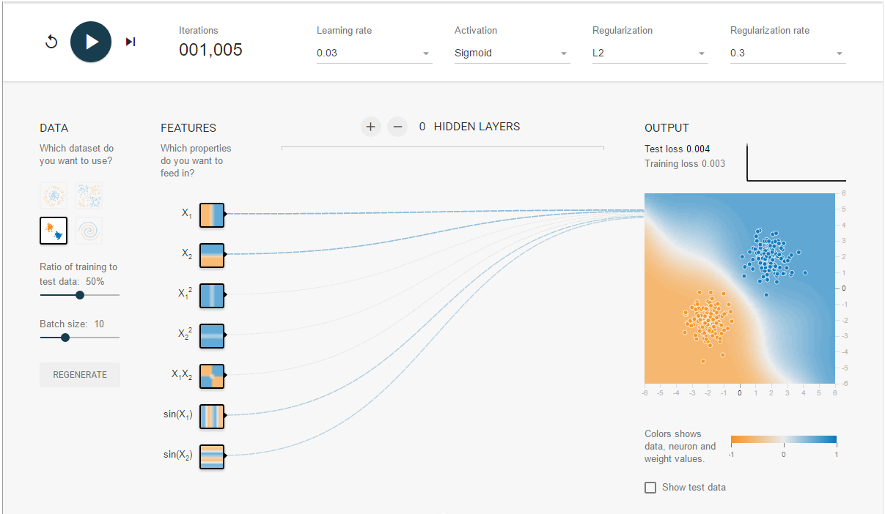

Gaussian models: The boundary line was pretty straight/linear with L1 regularization, but the test loss wasn’t quite as good as it was with no regularization.

Task B (Gaussian):  
As we can see from the L1 Regularized model, the strongest features are X1 and X2, as I selected before.

X1 weight: 0.61

X2 weight: 0.49

1.3

**Circle:**

Sigmoid, 1750 iterations, no regularization

Test loss = 0.002

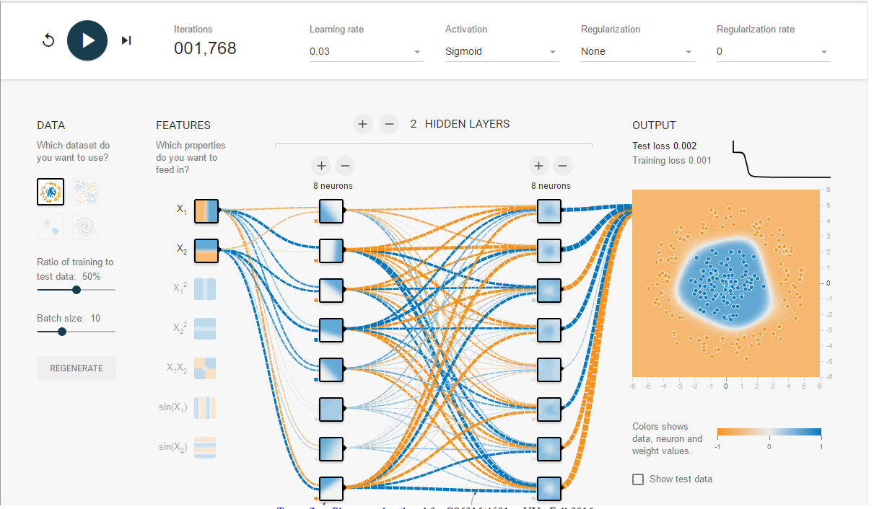

Activation: ReLU, 1000 iterations, no regularization.

Test loss = 0.000

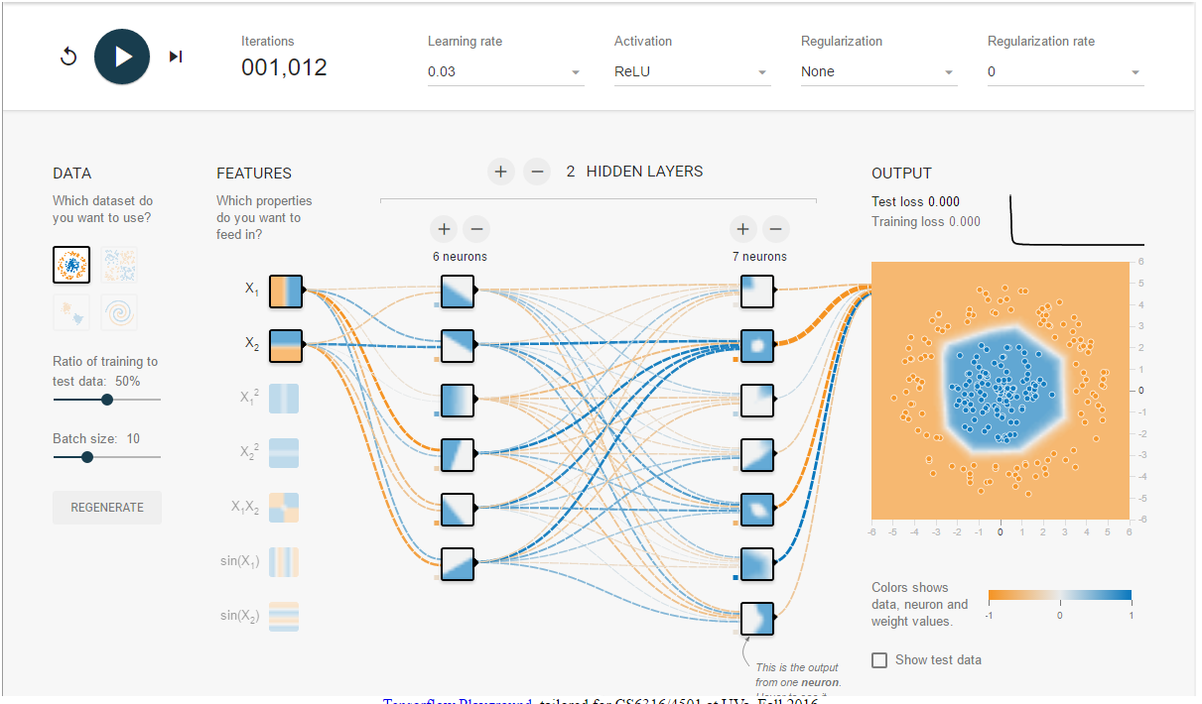

This performs better than the hand-crafted feature solution above (i.e. it gets to a 0% test loss faster)

The changes of using the rectified linear unit activation function (ReLU) as well as the added hidden layers creates a more complicated model, allowing for adjustments needed for forming around a circular data set.

**Exclusive Or:**

Activation: Tanh, no regularization, 487 iterations:

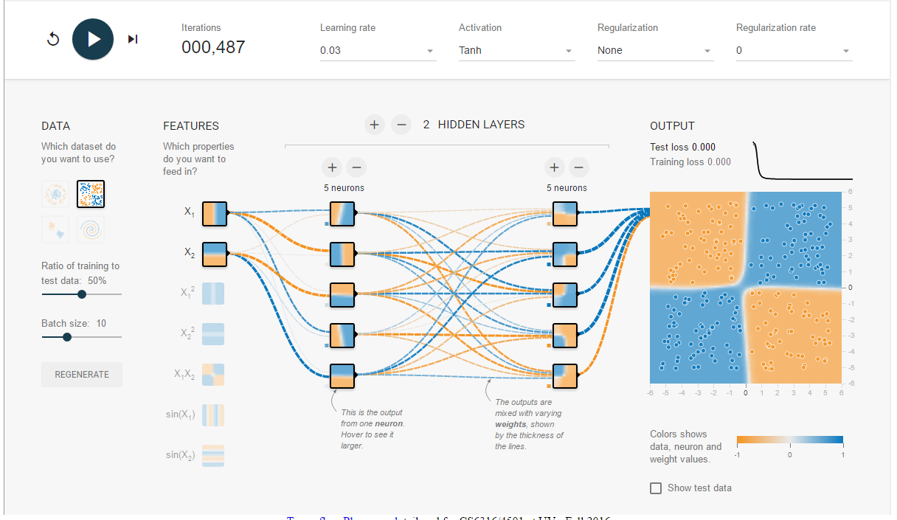

Much, much faster than the hand-crafted solution to this data set.

Tanh activation, which I think is the rescaled version of the sigmoid function, in addition to the hidden layers, allowed for the weights to do most of the work. Instead of taking ~3000 iterations to reach 0.000 test error, it only takes 487. This is mostly thanks to the hidden neurons, each targeting a certain decision boundary that works perfectly with this data set.

Additionally, as we saw before, regularization doesn’t work very well with this particular data set, so we didn’t use it here.

1.4 Spiral Challenge

|  |  |  |  |  |
| --- | --- | --- | --- | --- |
| Input Features: | Network Architecture | Hyperparameters | Iterations | Test loss |
| X1, X2 | 7-7-4 | Tanh, none, 0 | 1000 | 0.3 |
| X1, X2 | 8-8 | Sigmoid, none, 0 | 1000 | 0.53 |
| X1, X2 | 6-6-2 | ReLU, none, 0 | 2000 | 0.024 |
| X1, X2 | 8-8-6 | ReLU, none, 0 | 1000 | 0.07 |
| X1, X2 | 6-8-4 | Tanh | 1500 | 0.09 |
| **X1, X2** | **6-8-4** | **ReLU, none, 0** | **950** | **0.005** |
| **X1, X2** | **8-8-8-4** | **ReLU, none, 0** | **1400** | **0.002** |
| X1, X2 | 8-8-8-6-4 | ReLU, none, 0 | 1000 | 0.097 |
| X1, X2 | 8-8-8-8-8-8 | ReLU, none, 0 | 800 | 0.019 |
| X1,X2 | 8-8-8-7-7-6 | ReLU, none, 0 | 650 | 0.241 |
| X1, X2 | 8-8-8-4 | Tanh, none, 0 | 500 | 0.138 |
| X1, X2 | 8-8-8-6 | ReLU, L1, 0.001 | 1000 | 0.048 |
|  |  |  |  |  |

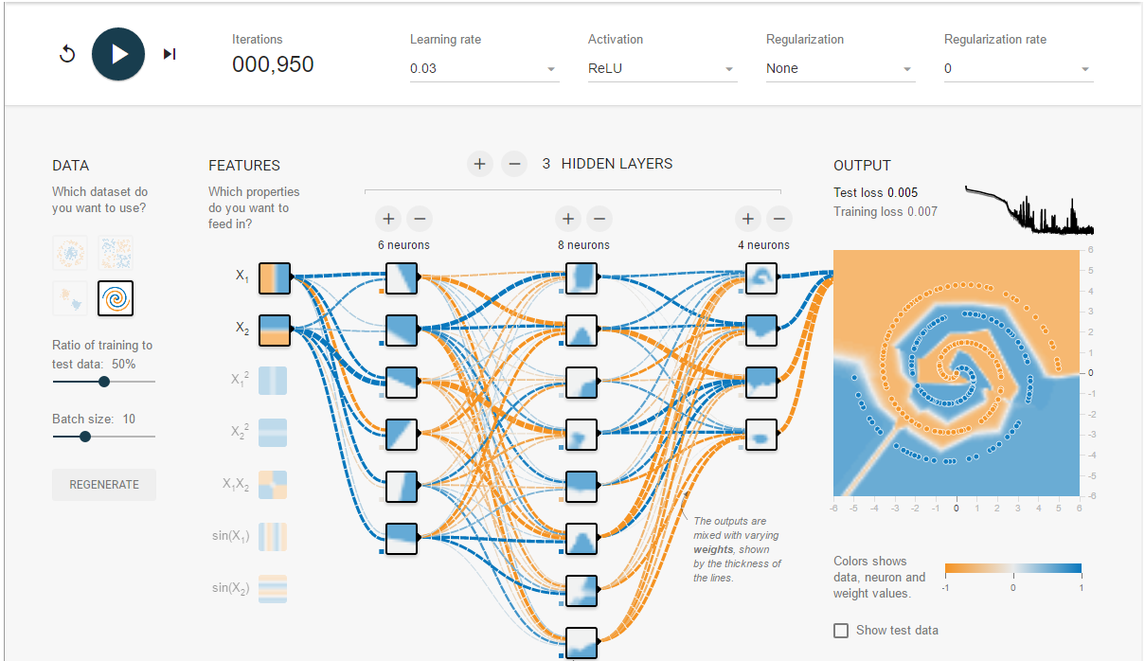

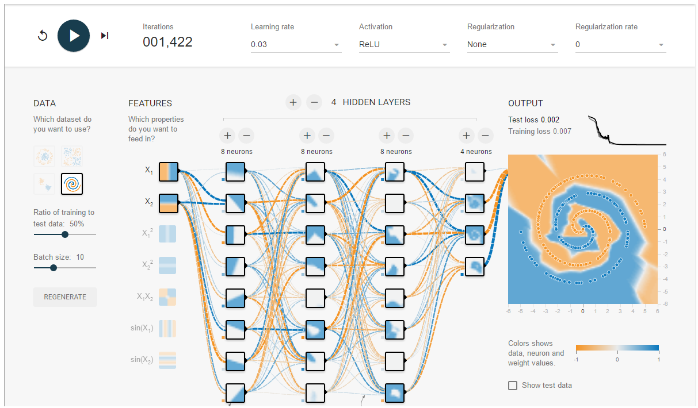

The 2nd screenshot above was the best run of any of my experiments, and it was the most stable. Consistently held at 0.002 test loss. As you can see from the Output graph, the boundary settles nicely around the blue points.

Overall, it seemed the rectified linear unit (ReLU) function, and the addition of multiple hidden layers, aided greatly in the creation of a stable, complicated model to account for a pretty intricate data set. As you can kind of see from the screenshot, the neurons create decision boundaries so that, when all aggregated together, it allows for the nice decision boundary around the spiral curve in the middle of the data set.

Question 2

2.1 Decision tree

Parameters:

Max_features: 250

Min_samples_split: 5

Class_weight: “balanced”

Testing error: 0.16

Max_features: The number of features considered when looking for the best split. So for 50, it will consider 50 different features at each split

Min_samples_split: The minimum number of samples required to split an internal node. In other words, there have to be 5 samples reached at a particular node in order for it to be split into child nodes

Class_weight: Since I selected balanced, it uses the values of y to automatically adjust weights inversely proportional to class frequencies.

2.2 K Nearest Neighbors

5 different values of k:

training error for KNN, k=3:

0.0133040735153

test error for KNN, k=3:

0.0553064275037

\\\\\\\\

training error for KNN, k=4:

0.0193389109861

test error for KNN, k=4:

0.0568011958146

\\\\\\\\

training error for KNN, k=7:

0.0257852146482

test error for KNN, k=7:

0.0582959641256

\\\\\\\\

training error for KNN, k=5:

0.0208476203539

test error for KNN, k=5:

0.0553064275037

\\\\\\\\

training error for KNN, k=6:

0.0241393498834

test error for KNN, k=6:

0.0612855007474

\\\\\\\\

['9.0000' '6.0000' '3.0000' ..., '4.0000' '0.0000' '1.0000']

Best train/test error: k = 3

This is the best option, because the data is distributed in such a way that just having a nearest neighbor algorithm (i.e. k=1) is not sufficient to correctly classify a point, as there is some noise. However, with k=3 there was slightly lower training error than k=5, meaning the classifying is much more successful when you can make sure there are a plurality of a certain label nearby.

The performance has a decent error rate, but not perfect, so I would imagine there is some overlap in the clusters. This would explain the need for having k > 1.

Weighing the distance would allow for closer neighbors to be weighed more heavily than farther away neighbors. This would cut down on possible noise, which is a problem with this data set, and the accuracy would go up (and the test error would go down), improving performance.

2.3 Support Vector Machine

goa5t@Ubuntu-goa5t:~/Desktop/HW6$ python number_recognition.py svm image_data/zip.train image_data/zip.test

test error for svm, kernel = rbf, C=3:

0.0503238664674

\\\\\\\\

test error for svm, kernel = linear:

0.0737419033383

\\\\\\\\

test error for svm, kernel = poly, deg = 2:

0.0572994519183

\\\\\\\\

test error for svm, kernel = poly, deg = 5:

0.0642750373692

\\\\\\\\

test error for svm, kernel = poly, deg = 6:

0.0847035376183

\\\\\\\\

test error for svm, kernel = poly, deg = 8:

0.160438465371

\\\\\\\\

['9.0000' '2.0000' '3.0000' ..., '4.0000' '0.0000' '1.0000']

So it looks like changing the C value has a bigger impact than the kernel. On initial run, “poly” performed the best, but on this run, rbf performed better with a new C value. Next run:

goa5t@Ubuntu-goa5t:~/Desktop/HW6$ python number_recognition.py svm image_data/zip.train image_data/zip.test

test error for svm, kernel = rbf, C=3:

0.0503238664674

\\\\\\\\

test error for svm, kernel = rbf, C=5:

0.0483308420528

\\\\\\\\

test error for svm, kernel = poly, deg = 3, C=3.0:

0.0468360737419

\\\\\\\\

test error for svm, kernel = poly, deg = 3, C=5.0:

0.0468360737419

\\\\\\\\

test error for svm, kernel = poly, deg = 4, C=3.0:

0.0468360737419

\\\\\\\\

test error for svm, kernel = poly, deg = 4, C=5.0:

0.0458395615346

\\\\\\\\

['9.0000' '6.0000' '3.0000' ..., '4.0000' '0.0000' '1.0000']

Increasing the C value definitely has a positive impact. In other words, the hyperplane must be smaller in order to correctly classify all the points, while it hasn’t quite reached the point of overfit yet.

One more run of 6 different models:

goa5t@Ubuntu-goa5t:~/Desktop/HW6$ python number_recognition.py svm image_data/zip.train image_data/zip.test

test error for svm, kernel = rbf, C=7:

0.0493273542601

\\\\\\\\

test error for svm, kernel = rbf, C=5:

0.0483308420528

\\\\\\\\

test error for svm, kernel = poly, deg = 5, C=5.0:

0.0468360737419

\\\\\\\\

test error for svm, kernel = poly, deg = 5, C=7.0:

0.0463378176383

\\\\\\\\

test error for svm, kernel = poly, deg = 4, C=7.0:

0.0458395615346

\\\\\\\\

test error for svm, kernel = poly, deg = 4, C=5.0:

0.0458395615346

\\\\\\\\

['9.0000' '6.0000' '3.0000' ..., '4.0000' '0.0000' '1.0000']

It looks like a 4th degree poly is the best kernel, with a “large” C value.

In theory, SVM seems like it would be a difficult model to use on this data set. As we’ve discovered before, there is a decent amount of noise (i.e. outliers) which would make the tuning of the hyperplane difficult. Also, because the data sets overlap, it would require some sort of dimensional projection in order to adequately separate the points with a hyperplane.

However, it seems like the testing error is fairly low, and performs comparably to KNN, if not better. I think this might be due to there being noise, but tweaking the value of C allows for the hyperplane to account for most outlier points. SVM seems to perform well enough here.

2.4 PCA

PCA, features = 2

test error for KNN, k=3:

0.500747384155

PCA, features = 200

test error for KNN, k=3:

0.0533134030892

PCA, features = 150

test error for KNN, k=3:

0.0548081714001

The advantage of using PCA is to reduce the number of dimensions, particularly ones that don’t hold relevant data. When removing 56 dimensions, the test error was not too much worse than when using KNN with full dimensions. The advantage is performance; you don’t have to account for all dimensions, while still getting an accurate (or similarly accurate) model.

PCA_SVM

PCA, features = 200

test error for svm, kernel = poly, deg = 4, C=7.0:

0.0667663178874

PCA, features = 150

test error for svm, kernel = poly, deg = 4, C=7.0:

0.0572994519183

PCA, features = 50

test error for svm, kernel = poly, deg = 4, C=7.0:

0.0587942202292

(very, very fast)

The speed at which the model is created is much, much faster than before. This is simply due to the decreased number of dimensions, meaning SVM doesn’t have to have data points projected onto different dimensions in order to find an appropriate hyperplane, improving run time.

It also seems the accuracy isn’t tremendously set back by using PCA. I would imagine with some testing we could find a decent test accuracy using this technique (i.e. with PCA) that would take a fraction of the time to run.

Question 3

Q3: 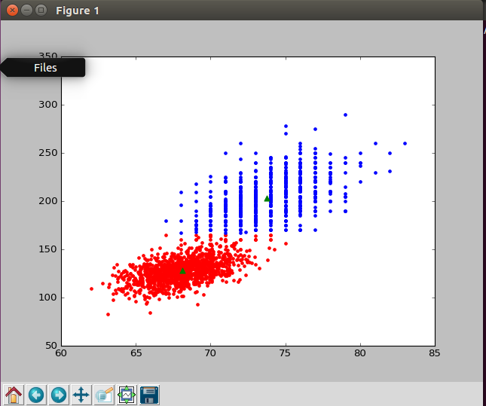

KneeFinding graph:

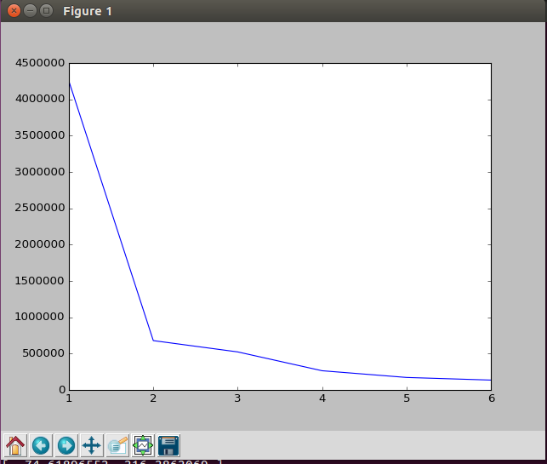

Q5: Purity of k=2:

