DIA3: Decision Intelligence Agentic, Autonomous, & Adaptive

# Strategic Intelligence Question Framework Whitepaper

# Executive Summary

In an era where the complexity of global threats exceeds human cognitive capacity, the need for intelligent, adaptive decision support systems has never been more critical. DIA3 (Decision Intelligence Agentic, Autonomous, & Adaptive) represents a paradigm shift in strategic intelligence analysis, combining classical strategic wisdom with cutting-edge artificial intelligence to answer the most complex questions facing decision-makers today.

This whitepaper presents a comprehensive framework that transforms how intelligence analysts approach scenario analysis, threat assessment, and strategic planning. Through the integration of Monte Carlo simulation, classical literature analysis, and multi-agent coordination, DIA3 provides unprecedented insights into adversary behavior, risk quantification, and strategic positioning.

## Key Capabilities

* **17 Specialized AI Agents** working in coordinated intelligence analysis
* **Monte Carlo Simulation Engine** with 10,000+ iterations for probabilistic assessment
* **Classical Literature Integration** leveraging Art of War and historical strategic principles
* **Multi-Domain Analysis** spanning military, cyber, economic, and political domains
* **Real-time Intelligence Fusion** from structured and unstructured data sources
* **Predictive Analytics** with confidence intervals and early warning indicators

## Strategic Impact

DIA3 enables intelligence analysts to:

* Quantify uncertainty in complex scenarios through probabilistic modeling
* Leverage 2,500 years of strategic wisdom from classical literature
* Generate actionable intelligence with measurable confidence levels
* Support decision-making with data-driven recommendations
* Maintain analytical rigor while accelerating analysis timelines

# The Intelligence Challenge: A Story of Complexity

Imagine an intelligence analyst facing a critical decision: a regional power is showing signs of aggressive posturing, but the signals are mixed. Economic indicators suggest restraint, while military movements indicate preparation. Cyber activities show both defensive and offensive patterns. Traditional analysis methods struggle with this complexity, often leading to either paralysis or oversimplification.

This is the challenge DIA3 was designed to solve. By integrating multiple analytical approaches and data sources, DIA3 transforms complex, ambiguous situations into clear, actionable intelligence with quantified confidence levels.

## The Traditional Approach vs. DIA3

* Linear, sequential analysis
* Limited to human cognitive capacity
* Subjective confidence assessments
* Isolated data sources
* Static threat models
* Multi-dimensional, parallel processing
* AI-enhanced cognitive capabilities
* Quantified probability distributions
* Integrated multi-source fusion
* Dynamic, adaptive threat modeling

# System Architecture: The Foundation of Intelligence Excellence

DIA3's architecture represents a revolutionary approach to intelligence analysis, combining the best of human strategic thinking with artificial intelligence capabilities.

## Core System Components

The DIA3 system is built upon five foundational pillars:

* **Monte Carlo Simulation Engine** - The quantitative backbone providing probabilistic assessment
* **17 Specialized AI Agents** - Domain experts working in coordinated analysis
* **Vector Database** - Knowledge repository containing classical literature and intelligence data
* **Knowledge Graph** - Entity relationship mapping and pattern analysis
* **MCP Tools Integration** - 25 consolidated tools for comprehensive analysis

## System Architecture Overview

The DIA3 system architecture represents a comprehensive integration of multiple analytical capabilities, each working in harmony to provide unprecedented intelligence insights. The system processes data from multiple sources including text documents, PDF files, audio recordings, video files, structured databases, and real-time intelligence feeds.

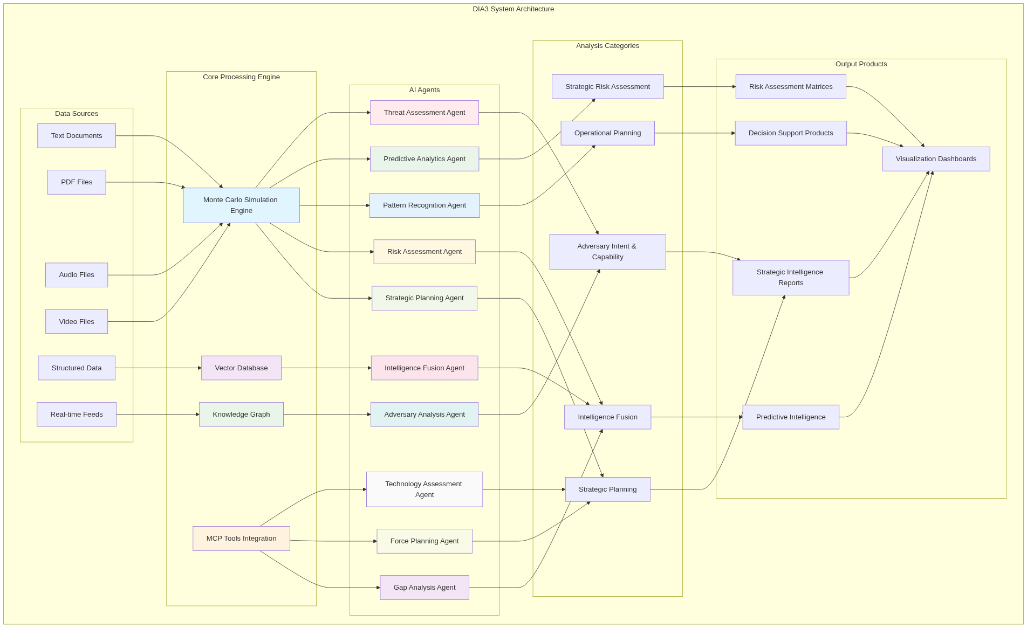

DIA3 System Architecture

## Data Integration Framework

DIA3 seamlessly integrates with existing data infrastructure:

* **Structured Data**: Databases, spreadsheets, formal reports
* **Unstructured Data**: Text documents, PDFs, audio recordings, video files
* **Real-time Feeds**: Open-source intelligence, social media, news sources
* **Historical Archives**: Classical literature, historical conflict analysis
* **Multi-format Support**: Text, PDF, audio, video, and image processing

# The Intelligence Question Framework: A Systematic Approach

The DIA3 Strategic Intelligence Question Framework provides analysts with a systematic methodology for leveraging the system's full capabilities. This framework transforms complex intelligence requirements into structured analytical processes that generate actionable insights.

## Framework Process Overview

The intelligence question framework follows a systematic four-step process that ensures comprehensive analysis and actionable results. This process transforms raw intelligence requirements into structured analytical approaches that leverage DIA3's full capabilities.

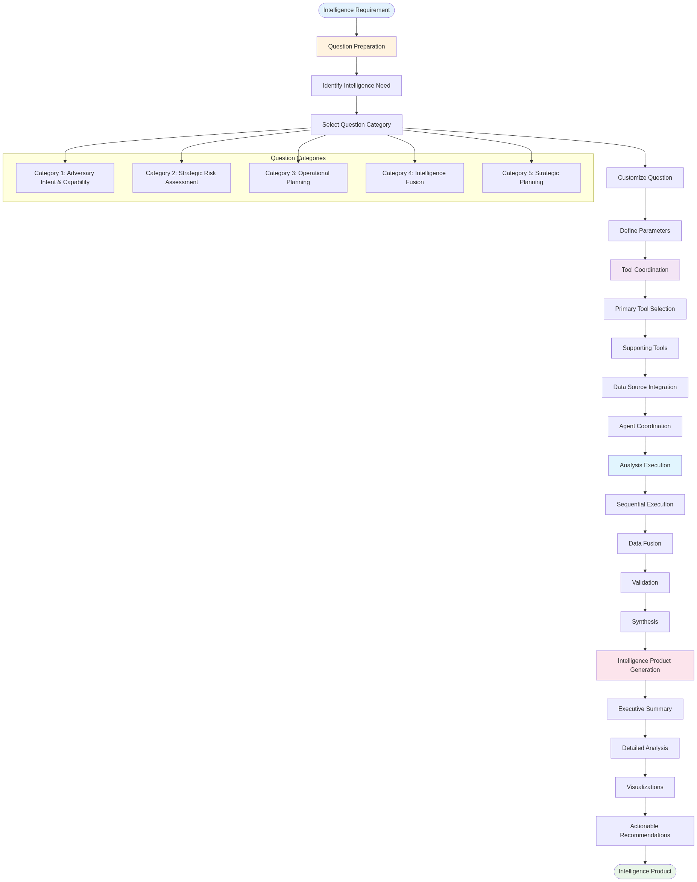

Intelligence Question Framework Process

## Framework Categories

The framework is organized into five primary categories, each addressing critical aspects of strategic intelligence:

* **Adversary Intent & Capability Assessment**
* **Strategic Risk Assessment**
* **Operational Planning & Decision Support**
* **Intelligence Fusion & Predictive Analysis**
* **Strategic Planning & Force Development**

Each category contains specific question templates that trigger coordinated analysis across multiple DIA3 components, ensuring comprehensive coverage of intelligence requirements.

## Framework Categories Overview

The five framework categories work together to provide comprehensive intelligence analysis coverage, with each category building upon and informing the others.

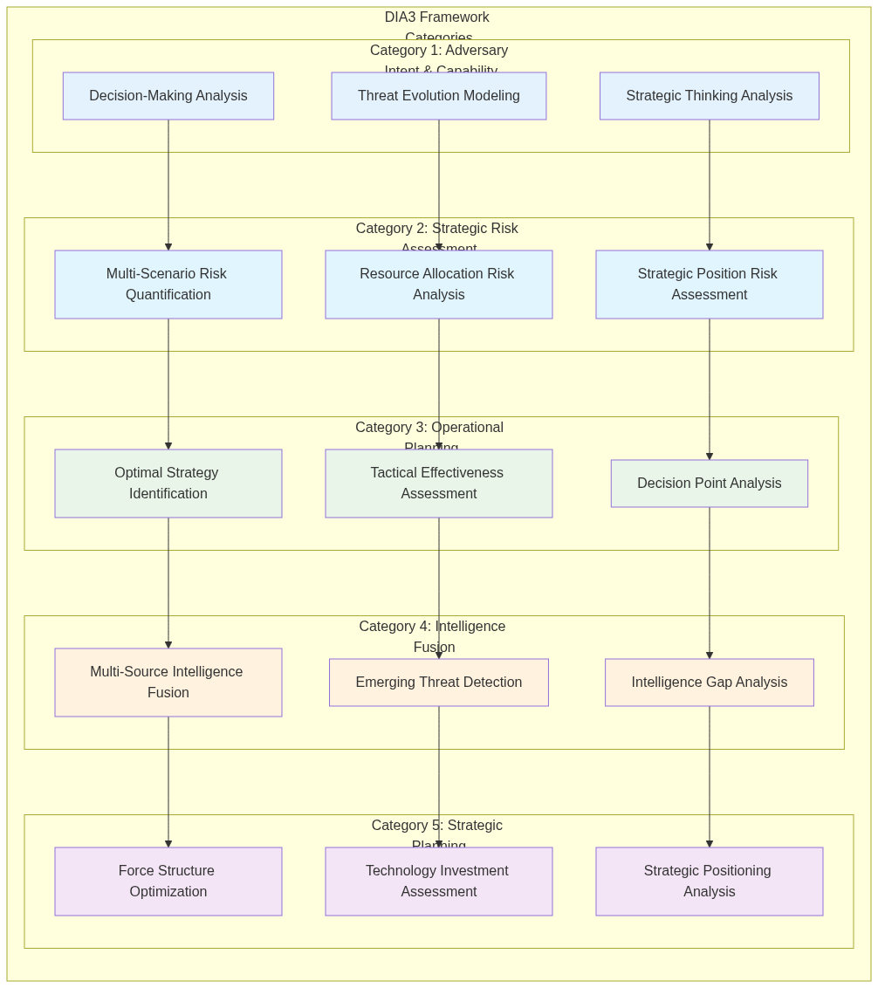

Framework Categories Overview

# Category 1: Adversary Intent & Capability Assessment

## The Art of Understanding the Adversary

In the ancient text "The Art of War," Sun Tzu wrote, "Know your enemy and know yourself, and in a hundred battles you will never be in peril." DIA3 operationalizes this timeless wisdom through advanced analytical techniques that reveal adversary decision-making processes, strategic thinking patterns, and capability evolution.

## Adversary Decision-Making Analysis

* Probability distribution of adversary courses of action
* Strategic intent assessment with confidence intervals
* Capability vs. intent analysis
* Risk assessment matrix with quantified probabilities

## Monte Carlo Simulation Process

The Monte Carlo simulation process forms the quantitative backbone of DIA3's analytical capabilities, providing probabilistic assessments that account for uncertainty and complexity in strategic decision-making.

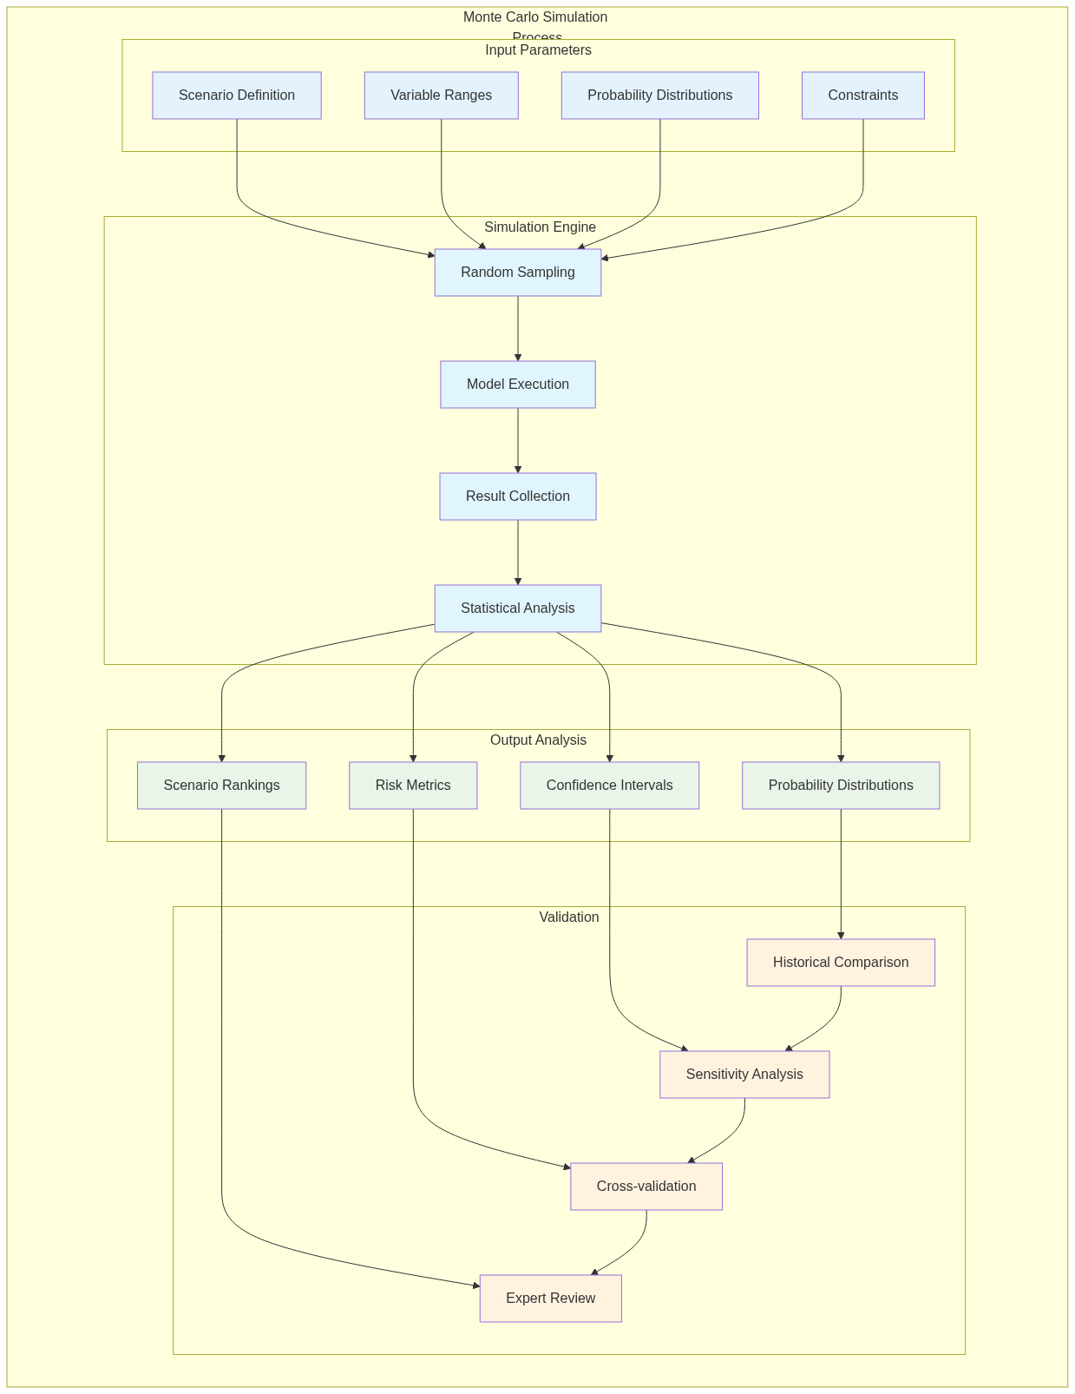

Monte Carlo Simulation Process

## Threat Evolution Modeling

* Threat trajectory analysis with multiple pathways
* Critical decision point identification
* Early warning indicators with confidence levels
* Mitigation strategy recommendations with effectiveness assessment

## Threat Evolution Forecasting Chart

The threat evolution forecasting process combines historical data analysis with current indicators to predict future threat developments across multiple scenarios.

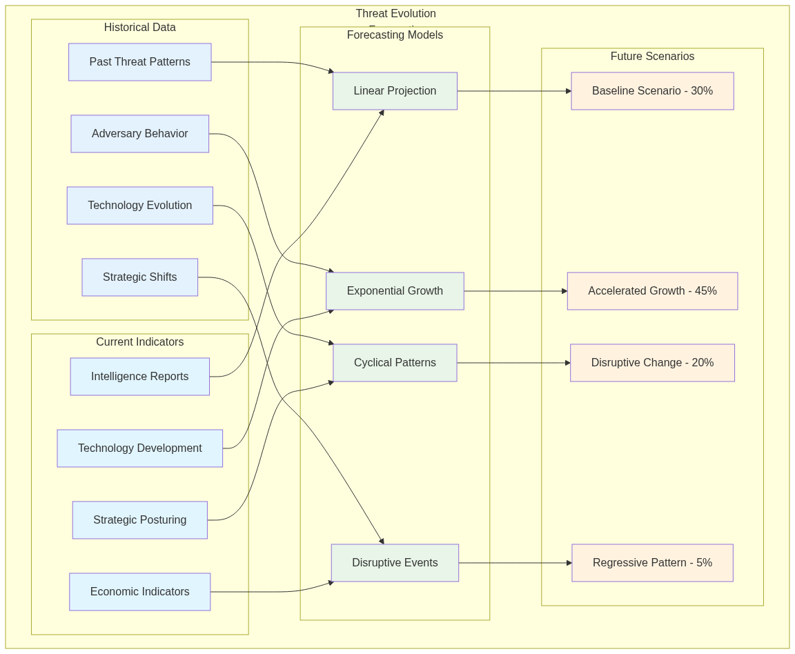

Threat Evolution Forecasting

## Adversary Strategic Thinking Analysis

* Strategic doctrine analysis with cultural context
* Adversary mindset assessment using psychological profiling
* Predictive behavioral modeling with historical validation
* Counter-strategy development based on strategic principles

## Art of War Integration Framework

DIA3's integration of classical strategic literature, particularly Sun Tzu's "The Art of War," represents a unique capability that bridges ancient wisdom with modern intelligence analysis.

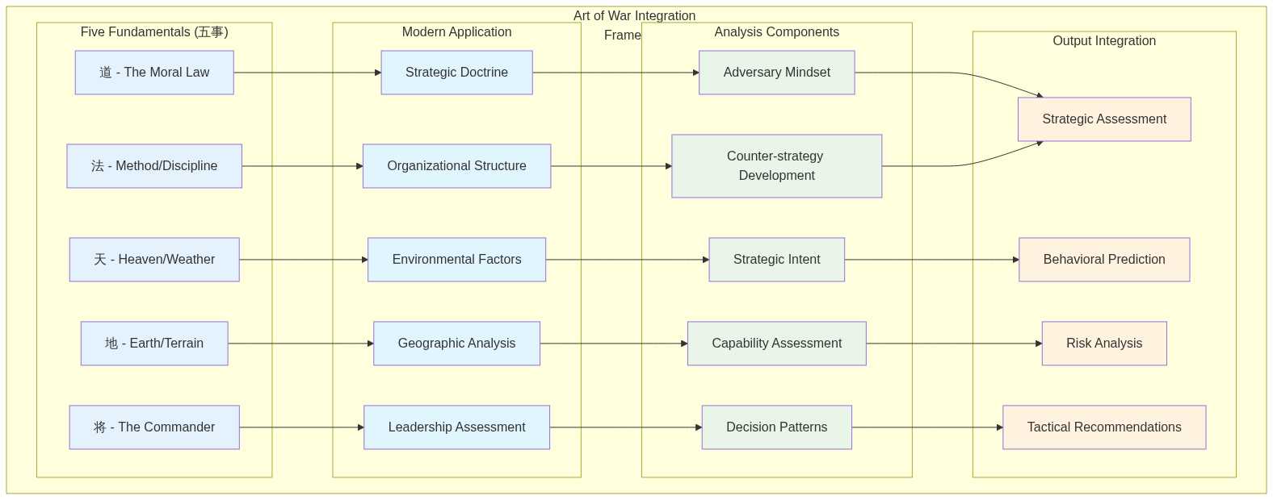

Art of War Integration Framework

# Category 2: Strategic Risk Assessment

## Quantifying the Unquantifiable

Risk assessment has traditionally been more art than science, relying heavily on expert judgment and historical precedent. DIA3 transforms this process by providing quantitative, probabilistic risk assessments that account for uncertainty and complexity.

## Multi-Scenario Risk Quantification

* Risk probability matrix with confidence intervals
* Impact assessment framework with multiple dimensions
* Confidence intervals for all predictions
* Risk mitigation prioritization based on cost-benefit analysis

## Risk Timeline Forecasting Chart

The risk timeline forecasting process provides a temporal view of how risks evolve over time, enabling proactive risk management and strategic planning.

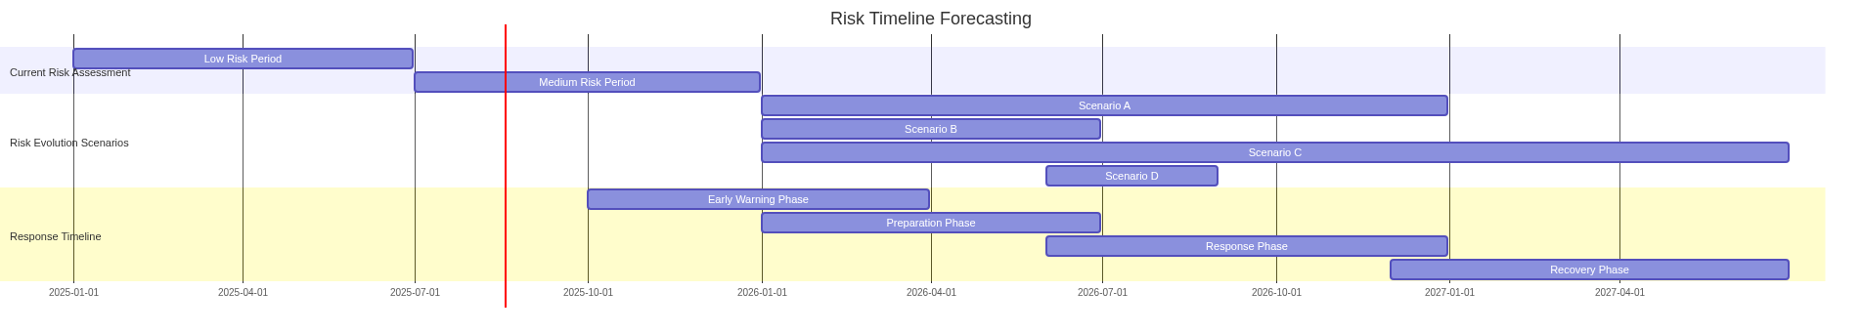

Risk Timeline Forecasting

## Resource Allocation Risk Analysis

* Resource vulnerability assessment with stress testing
* Alternative allocation strategies with performance comparison
* Risk-adjusted performance metrics
* Optimization recommendations with implementation roadmaps

## Strategic Position Risk Assessment

* Strategic position vulnerability analysis
* Historical comparison framework with classical literature
* Risk mitigation strategies with effectiveness assessment
* Strategic repositioning recommendations with implementation guidance

## Strategic Position Forecasting Chart

The strategic position forecasting process evaluates current positions and trends to predict future strategic advantages and vulnerabilities.

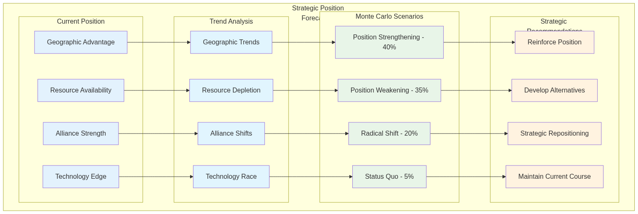

Strategic Position Forecasting

# Category 3: Operational Planning & Decision Support

## From Strategy to Execution

The best strategic analysis is worthless without effective operational planning and execution. DIA3 bridges the gap between strategic insight and operational effectiveness through systematic analysis of tactics, strategies, and decision points.

## Optimal Strategy Identification

* Strategy effectiveness matrix with multiple criteria
* Success probability assessment with confidence intervals
* Resource requirement analysis with optimization
* Implementation roadmap with critical path identification

## Tactical Effectiveness Assessment

* Tactical effectiveness metrics with statistical validation
* Historical performance comparison with contextual analysis
* Improvement recommendations with implementation guidance
* Training and doctrine implications with curriculum development

## Decision Point Analysis

* Decision tree analysis with probability assessment
* Critical path identification with bottleneck analysis
* Success probability at each decision node
* Decision support framework with real-time guidance

# Category 4: Intelligence Fusion & Predictive Analysis

## The Power of Integrated Intelligence

Modern intelligence challenges require integrating information from multiple sources, domains, and time periods. DIA3 excels at intelligence fusion, combining structured and unstructured data to generate predictive insights.

## Intelligence Fusion Process

The intelligence fusion process represents one of DIA3's most powerful capabilities, combining information from multiple intelligence disciplines to create comprehensive, predictive assessments.

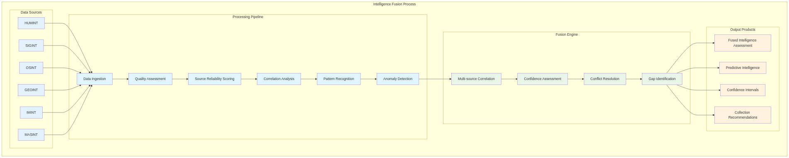

Intelligence Fusion Process

## Multi-Source Intelligence Fusion

* Fused intelligence assessment with source reliability weighting
* Predictive intelligence forecast with multiple time horizons
* Confidence level analysis with uncertainty quantification
* Intelligence gap identification with collection recommendations

## Predictive Intelligence Forecasting Chart

The predictive intelligence forecasting process integrates multiple intelligence sources to generate forward-looking assessments with quantified confidence levels.

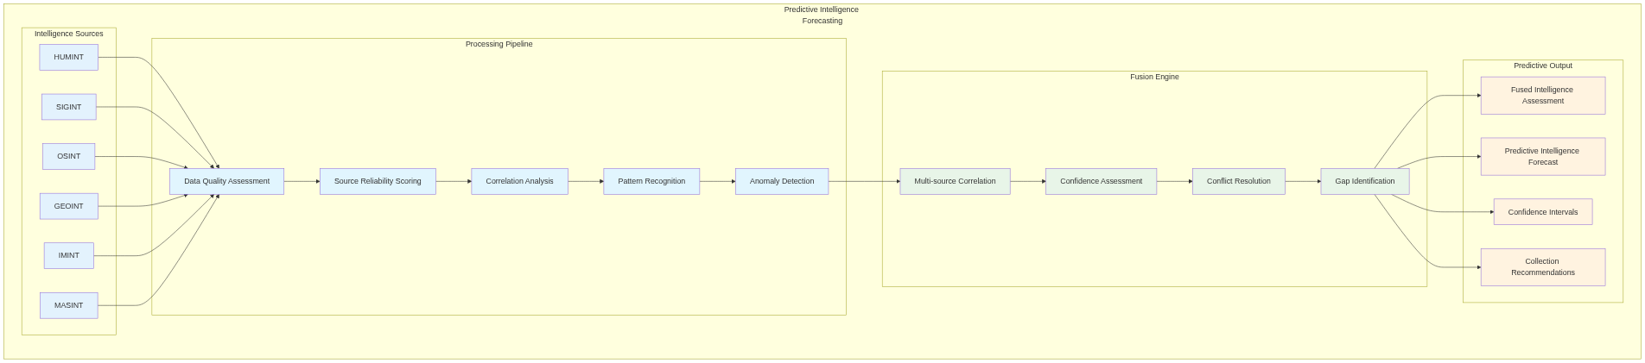

Predictive Intelligence Forecasting

## Emerging Threat Detection

* Emerging threat assessment with early warning indicators
* Probability of threat materialization with timeline estimates
* Response timeline recommendations with resource requirements
* Threat evolution modeling with adaptation scenarios

## Intelligence Gap Analysis

* Intelligence gap matrix with priority ranking
* Collection priority ranking with resource allocation
* Impact assessment for each gap with risk quantification
* Collection strategy recommendations with implementation guidance

# Category 5: Strategic Planning & Force Development

## Building for the Future

Strategic planning requires understanding not just current capabilities and threats, but how they might evolve over time. DIA3 provides the analytical foundation for long-term strategic planning and force development.

## Force Structure Optimization

* Force structure effectiveness analysis with scenario testing
* Optimal composition recommendations with resource constraints
* Success probability assessment with confidence intervals
* Resource allocation optimization with cost-benefit analysis

## Capability Evolution Forecasting Chart

The capability evolution forecasting process analyzes how military, technological, economic, and alliance capabilities develop over time, enabling long-term strategic planning.

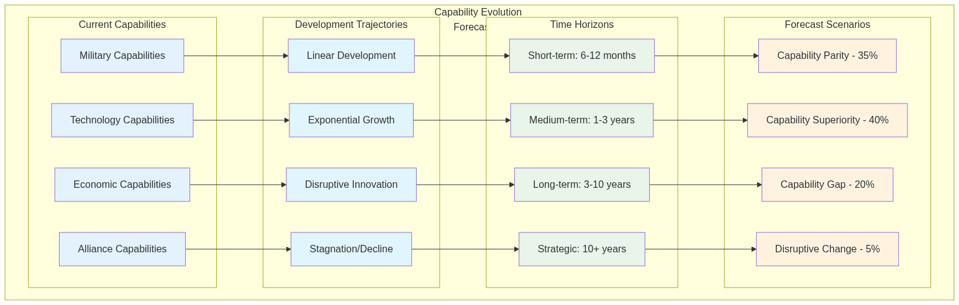

Capability Evolution Forecasting

## Technology Investment Assessment

* Technology value assessment with strategic impact analysis
* Investment comparison matrix with risk-adjusted returns
* Strategic investment recommendations with implementation roadmaps
* Technology evolution modeling with adaptation scenarios

## Technology Adoption Forecasting Chart

The technology adoption forecasting process analyzes how emerging technologies are adopted across different sectors and their strategic impact over time.

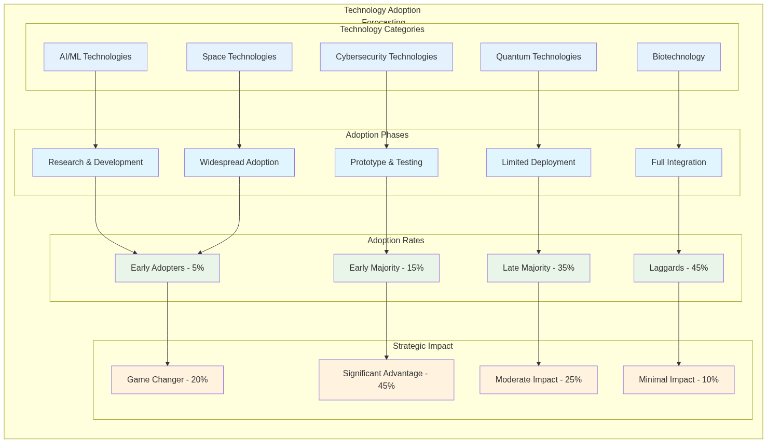

Technology Adoption Forecasting

## Strategic Positioning Analysis

* Strategic positioning assessment with multi-domain analysis
* Geographic advantage analysis with terrain and resource assessment
* Historical comparison framework with classical literature
* Positioning optimization recommendations with implementation guidance

## Alliance Dynamics Forecasting Chart

The alliance dynamics forecasting process analyzes how strategic, economic, technology, and security alliances evolve over time and their impact on strategic positioning.

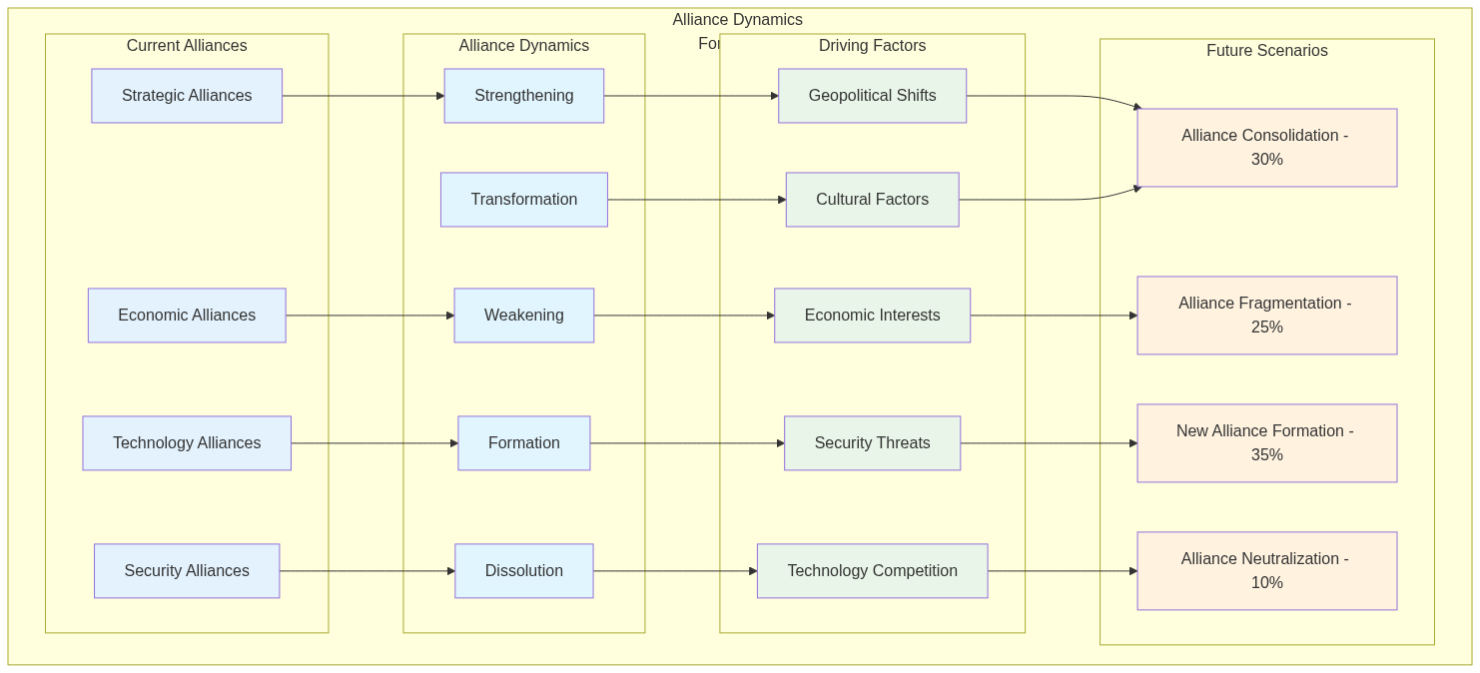

Alliance Dynamics Forecasting

# Implementation Methodology: From Framework to Action

The DIA3 Strategic Intelligence Question Framework provides a systematic approach to leveraging the system's capabilities. This methodology ensures consistent, rigorous analysis while maintaining flexibility for specific intelligence requirements.

## Step 1: Question Preparation

The foundation of effective intelligence analysis is asking the right questions. DIA3's question preparation process ensures that intelligence requirements are clearly defined and appropriately scoped.

* **Identify Intelligence Need**: Determine the specific intelligence requirement and decision context
* **Select Question Category**: Choose the most appropriate category from the framework
* **Customize Question**: Adapt the template question to the specific scenario and constraints
* **Define Parameters**: Specify timeframes, scenarios, constraints, and success criteria

## Step 2: Tool Coordination

DIA3's power comes from the coordinated use of multiple analytical tools and data sources. The tool coordination process ensures that all relevant capabilities are leveraged for comprehensive analysis.

* **Primary Tool Selection**: Choose the main MCP tool or API endpoint for the analysis
* **Supporting Tools**: Identify additional tools for comprehensive analysis
* **Data Source Integration**: Specify vector database and knowledge graph queries
* **Agent Coordination**: Determine which specialized agents to engage

## Step 3: Analysis Execution

The analysis execution process ensures that tools are used in the optimal sequence to generate comprehensive, validated results.

* **Sequential Execution**: Run tools in logical sequence to build comprehensive analysis
* **Data Fusion**: Combine results from multiple sources and methods
* **Validation**: Cross-check results across different methods and data sources
* **Synthesis**: Integrate findings into comprehensive assessment with confidence levels

## Step 4: Intelligence Product Generation

The final step transforms analytical results into actionable intelligence products that support decision-making.

* **Executive Summary**: High-level findings and recommendations for decision-makers
* **Detailed Analysis**: Comprehensive technical assessment with methodology and results
* **Visualizations**: Charts, graphs, and interactive dashboards for clear communication
* **Actionable Recommendations**: Specific next steps and priorities with implementation guidance

# Expected Intelligence Products: Transforming Analysis into Action

DIA3 generates a comprehensive range of intelligence products designed to support decision-making at all levels, from tactical operations to strategic planning.

## Strategic Intelligence Reports

Strategic intelligence reports provide high-level analysis and recommendations for senior decision-makers.

## Predictive Intelligence

Predictive intelligence products provide forward-looking analysis to anticipate future developments and opportunities.

## Predictive Analysis Timeline

The predictive analysis process follows a structured timeline that ensures comprehensive coverage from historical analysis through future forecasting.

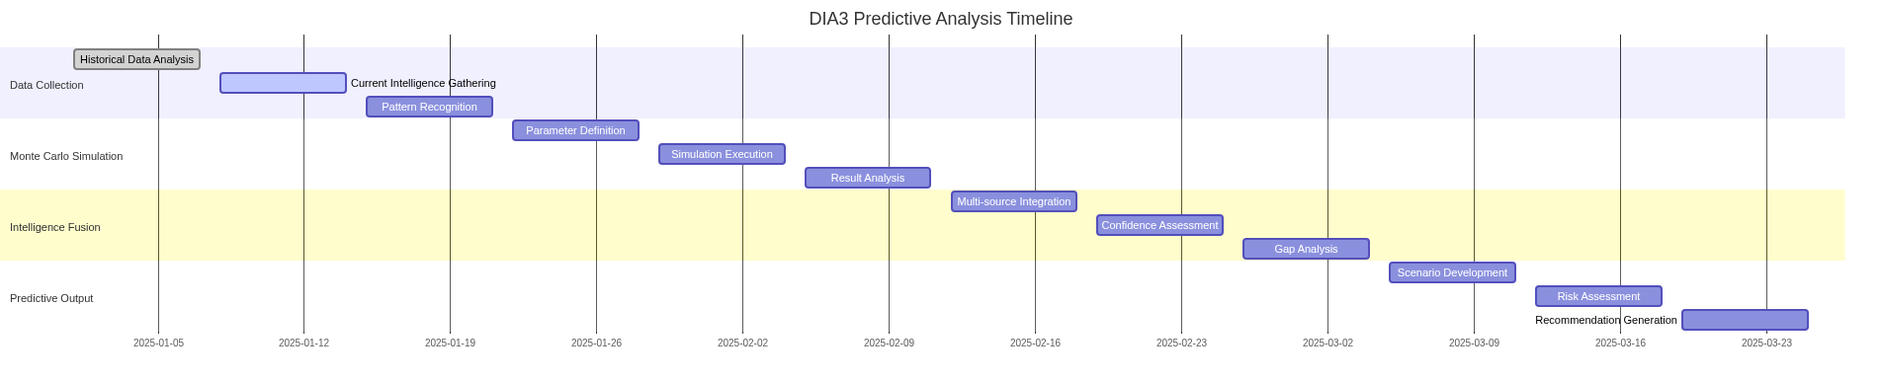

Predictive Analysis Timeline

## Decision Support Products

Decision support products provide structured frameworks and tools to support decision-making processes.

## Decision Tree Analysis

Decision tree analysis provides structured frameworks for complex decision-making processes, enabling systematic evaluation of multiple options and their consequences.

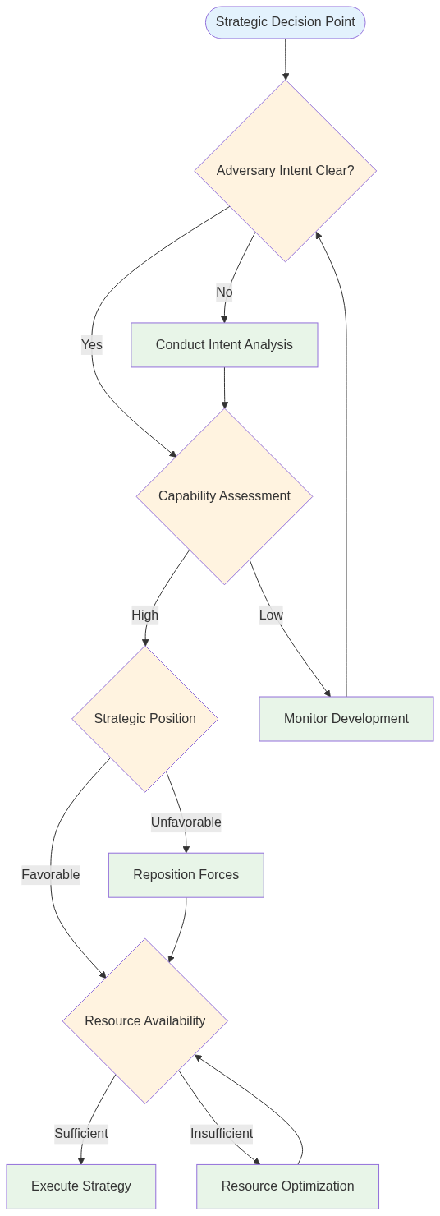

Decision Tree Analysis

## Risk Assessment Matrix

The risk assessment matrix provides a visual framework for evaluating and prioritizing risks based on probability and impact.

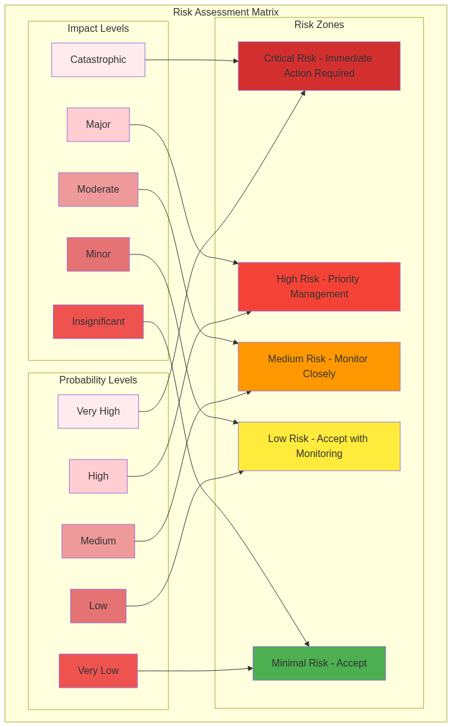

Risk Assessment Matrix

# Best Practices: Maximizing DIA3's Capabilities

Success with DIA3 requires understanding and applying best practices that maximize the system's capabilities while ensuring analytical rigor and actionable results.

## Question Design Best Practices

The quality of intelligence analysis depends fundamentally on the quality of the questions asked. DIA3's question design best practices ensure that intelligence requirements are properly translated into analytical processes.

## Tool Usage Best Practices

DIA3's power comes from the coordinated use of multiple tools and capabilities. Tool usage best practices ensure optimal results and efficient resource utilization.

## Intelligence Production Best Practices

The final step in the intelligence process is producing actionable intelligence products that support decision-making. Intelligence production best practices ensure that analytical results are effectively communicated and utilized.

# Continuous Improvement: Evolving with the Threat Landscape

DIA3 is designed for continuous improvement, with built-in mechanisms for learning from experience and adapting to changing requirements.

## Feedback Integration

Continuous improvement requires systematic collection and integration of feedback from users and stakeholders.

## System Enhancement

DIA3's modular architecture enables continuous enhancement and expansion of capabilities.

# Implementation Resources: Tools and Documentation

DIA3 provides comprehensive implementation resources to support effective use of the system and framework.

## Core Analysis Scripts

DIA3 includes a comprehensive suite of analysis scripts that implement the framework's capabilities.

## Documentation and Guides

Comprehensive documentation supports effective implementation and use of DIA3 capabilities.

## API Endpoints and MCP Tools

DIA3 provides both API endpoints and MCP tools for flexible integration and use.

# DIA3 Capabilities Summary

|  |  |  |  |
| --- | --- | --- | --- |
| **Capability** | **Description** | **Key Features** | **Applications** |
| **Monte Carlo Simulation** | Probabilistic analysis engine | 10,000+ iterations, confidence intervals, scenario modeling | Risk assessment, predictive analysis, decision support |
| **17 Specialized AI Agents** | Coordinated intelligence analysis | Threat assessment, predictive analytics, pattern recognition | Multi-domain analysis, comprehensive intelligence coverage |
| **Classical Literature Integration** | Art of War and historical principles | Five Fundamentals analysis, strategic wisdom application | Adversary analysis, strategic planning, behavioral prediction |
| **Multi-Source Intelligence Fusion** | Integrated intelligence processing | HUMINT, SIGINT, OSINT, GEOINT, IMINT, MASINT | Comprehensive threat assessment, predictive intelligence |
| **Vector Database & Knowledge Graph** | Knowledge repository and relationship mapping | Classical literature, intelligence data, entity relationships | Pattern analysis, strategic context, historical validation |
| **MCP Tools Integration** | 25 consolidated analytical tools | API endpoints, specialized analysis capabilities | Flexible integration, comprehensive analysis coverage |
| **Predictive Analytics** | Forward-looking intelligence | Scenario forecasting, early warning indicators, trend analysis | Strategic planning, threat anticipation, risk mitigation |
| **Risk Assessment Framework** | Systematic risk evaluation | Probability-impact matrices, confidence intervals, mitigation strategies | Strategic decision-making, resource allocation, threat prioritization |

# Framework Categories Summary

|  |  |  |  |
| --- | --- | --- | --- |
| **Category** | **Focus Area** | **Key Questions** | **Intelligence Products** |
| **Adversary Intent & Capability** | Understanding adversary behavior and capabilities | Decision-making processes, threat evolution, strategic thinking | Adversary assessments, behavioral predictions, capability analysis |
| **Strategic Risk Assessment** | Quantifying and prioritizing risks | Multi-scenario analysis, resource allocation, strategic positioning | Risk matrices, vulnerability assessments, mitigation strategies |
| **Operational Planning** | Translating strategy into operations | Strategy optimization, tactical effectiveness, decision points | Operational plans, effectiveness metrics, decision frameworks |
| **Intelligence Fusion** | Integrating multiple intelligence sources | Multi-source correlation, emerging threats, intelligence gaps | Fused intelligence, predictive forecasts, collection recommendations |
| **Strategic Planning** | Long-term strategic guidance | Force structure, technology investment, strategic positioning | Strategic plans, investment recommendations, positioning analysis |

# Implementation Benefits

|  |  |  |
| --- | --- | --- |
| **Benefit** | **Description** | **Impact** |
| **Quantified Uncertainty** | All predictions include confidence intervals and probability distributions | Improved decision-making with understanding of risk and uncertainty |
| **Comprehensive Coverage** | Multi-domain analysis covering all aspects of intelligence requirements | Complete intelligence picture with no gaps or blind spots |
| **Historical Validation** | Classical literature and historical analysis provide context and validation | Robust analysis grounded in proven strategic principles |
| **Actionable Intelligence** | All outputs include specific recommendations and implementation guidance | Direct support for decision-making and operational planning |
| **Scalable Framework** | Flexible system that adapts to different intelligence requirements | Consistent methodology across all intelligence analysis activities |

# Conclusion: Transforming Intelligence Analysis

The DIA3 Strategic Intelligence Question Framework represents a fundamental transformation in how intelligence analysis is conducted. By combining classical strategic wisdom with cutting-edge artificial intelligence, DIA3 enables intelligence analysts to:

* **Generate Comprehensive Intelligence**: Use multiple analysis methods and data sources to ensure complete coverage of intelligence requirements.
* **Quantify Uncertainty**: Apply Monte Carlo simulation and probabilistic methods to provide quantified confidence levels and uncertainty assessment.
* **Leverage Historical Wisdom**: Integrate classical strategic principles and historical analysis to provide context and validation for modern intelligence challenges.
* **Support Decision-Making**: Provide actionable intelligence recommendations with clear implementation guidance and success metrics.
* **Maintain Analytical Rigor**: Follow systematic methodology for consistent, reliable results that can be validated and reproduced.

The framework is designed to be flexible and adaptable, allowing analysts to customize questions for specific intelligence requirements while maintaining analytical rigor and producing high-quality intelligence products. As the threat landscape evolves and new challenges emerge, DIA3's continuous improvement capabilities ensure that the system remains relevant and effective.

The future of intelligence analysis is not about replacing human analysts with artificial intelligence, but about augmenting human capabilities with intelligent tools that can process vast amounts of data, identify patterns, and provide probabilistic assessments that support human decision-making. DIA3 represents this future, combining the best of human strategic thinking with the power of artificial intelligence to create a new paradigm for intelligence analysis.